Using a single command to program the Flash memory in all the FEE64s.
“STOP” the Data Acquisition.
Copy the new .bin (e.g. New_one.bin) file into /MIDAS/Aida. ( refer to http://npg.dl.ac.uk/documents/edoc958/edoc958.pdf for more information on creating .bin files )
Edit the file /MIDAS/Aida/FlashPgm.csh and change the name of the .bin file to match that copied in the last step. The file should be as follows. There are two places to change the file name. One is a comment and the other is in the command “flashcp”.
#!/bin/csh -f
date
hostname
echo "unlocking flash"
/usr/sbin/flash_unlock /dev/mtd2
echo "done"
echo "loading mtd2 with New_one.bin"
/usr/sbin/flashcp /MIDAS/Aida/New_one.bin /dev/mtd2
echo "done"
flash_lock /dev/mtd2 0 -1
echo "Flash /dev/mtd2 locked"
echo "finished"

Save the file.
Open a Browser window connected to the AIDA server. Select the Run Control window. Select the tick box “Act on ALL Data Acquisition Servers?” near the top right of the browser window.
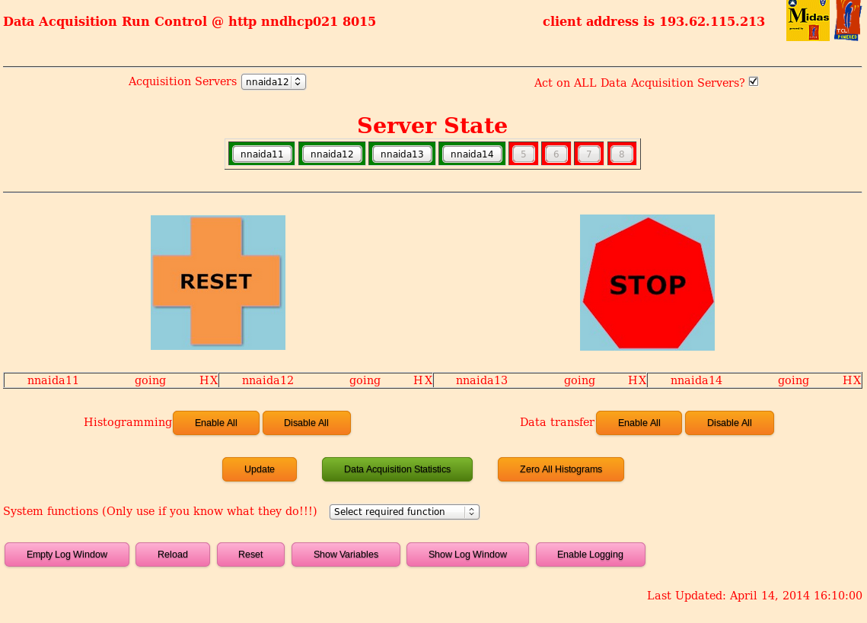
Select the “Program Flash Memories” command from the System functions menu at the bottom of the browser window.
Wait while the operation is carried out.
If all are programmed successfully the report box shown at the end will have an entry for all of the FEE64s and the last line should have the total number successfully programmed.
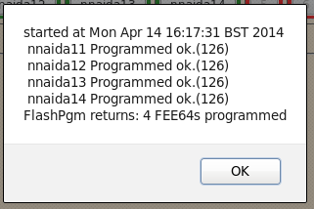
If there is a failure in one or more of the FEE64s then the error message will be shown in the report box. For example where a filename is incorrect…..
