Agata/AMBMin/Sept10/final
Minutes AGATA Management Board

28th -29th September, Cologne, lunchtime to lunchtime.

Present:
A. Gadea
G. Duchêne
E. Farnea Legnaro local project manager
J. Simpson Project Manager and Secretary
P. Reiter
J. Nyberg

1. Apologies for absence
Ch. Theisen, P. J. Nolan

Action JS to contact H-J. Wollersheim and J. Gerl regarding attendance from GSI.
Done

2. Minutes of the last meeting, 30th June – 1st July 2010, GSI, Agata/AMBMin/June10/02D
The draft minutes Agata/AMBMin/June10/02D were accepted as a correct record of the meeting.
Action JS to distribute as Agata/AMBMin/June10/final.
Done.

3. Matters arising from the last meeting and actions outstanding from last phone conference
Action JN to update TDR with in-beam results etc. NIM paper to be prepared.
Outline prepared by JN.
Ongoing. Work needs to be shared. Discuss at the next AMB. Each AMB member to read the relevant section of TDR before the next meeting.

Action PJN to investigate common account issue.
Ongoing. Will take on board at the ASC.

Action Project definition
Ongoing.

Action all investigate available funds in each country.
Action GD, EF, JS, CT to have an initial attempt to allocate funds to items.
Ongoing
Action: JS and AG to prepare a plan (AGATA week).
Done

4. ASC report
19-20th October, Orsay.
Project managers report, Running costs statements will be required.
Extension of LNL campaign.
Presentation of the new AMB structure and membership.

5. Reports from Working Groups
- Status at Legnaro
Two detectors (ATC2 and ATC3) annealed in the last two weeks.
Limited participation in the infrastructure maintenance week (only two engineers from Saclay present on-site for a couple of days).

ATC2 and ATC3 are being cooled down after the annealing. Will then investigate if the annealing was successful.
During the period a spark from the AXIS crate under test caused a power shutdown and the autofill system was not reset properly.

As a result ATC1 and ATC4 warmed up. Again, a working alarm system could have prevented this from happening or would have limited the damage. Fortunately the detectors were not at high voltage. Subsequently, ATC4 has no leaks and ATC1 has some leaks (feedthroughs).

It is a HIGH PRIORITY to get the alarm system working. This is the third time a warm up has happened and it is unacceptable. This causes extra and unnecessary work and if this happens again it could jeopardise the campaign.

PR suggests that no detectors should not be cooled down before the alarm system is ready. An email from P.Jones suggest that Saclay are only waiting for a few “parts”. The work required to complete the alarm system has been estimated to take a short time, maybe two weeks maximum. It is imperative that this work is done as soon as possible.

There are issues with groups within the infrastructure and communication again. Since a few months Ch. Veyssiere is working on another project and the project is missing his direct involvement since he was the main co-ordinator and point of contact. Discussions within Saclay taking place to solve the problem and put new people on the project. The group has done excellent work in the past, it is just the last months when these problems have arisen. It was noted that this was not an original commitment of Saclay since the work was supposed to be done by GSI.

Action: JS to write on behalf of the AMB to W. Korten requesting support and help from the Saclay group and offer any help that may be required.
Done

The scheduling of installation and the access to the area needs to be taken into account.

Action: GD to contact Saclay regarding the overall status and the delivery of the parts.

The work needs to be completed in three weeks otherwise the scheduled run is in danger.
Action: EF to contact Carl Wheldon

Plunger experiments will “all” be scheduled in February. Looks like 90% of the experiments currently outstanding are either AGATA or experiments in the same area.

- Detector module and characterisation
Announced Deliveries, 29 April 2010
- A008 Jun 2010 Germany
- A007 July 2010 Italy
- B004 July 2010 Turkey warranty
- B006 Jun 2010 Italy warranty
- C003 July 2010 UK warranty
- B007 July 2010 Germany
- B008 Aug 2010 Germany
- C008 Aug 2010 UK
- A009 Oct 2010 UK to be replaced by a C-type
- B009 Dec2010 UK
Deliveries, 29 April 2010 – 28 September 2010
- A008 25. August 2010 Germany CAT at Liverpool
- C003 5. July 2010 UK warranty CAT at Saclay
- six detectors behind schedule.
- missing B-type detector.
Update from 7th September on future detector deliveries by Canberra:
September: one B capsule
October: one A & one B
November: one A & one C
December: two B
Update today. The B in September will not be delivered!
Agreed to ship the fifth triple cryostat with two capsules to Legnaro as soon as possible.
Check that there is enough electronics.
Action JS to tell Ian Lazarus.
Done

Status acceptance tests
A008 @ Liverpool
A008 is in Liverpool the FET board PCB is now being mounted. The delay was due to a missing set of the appropriate spacers and contact pins. Having discussed this with Bart it is clear an inventory of parts and central ordering agreement is required to ensure we can minimise delays. The detector will be cooled later this week.
C003 @ Liverpool
Cross talk is pending, resolution looks fine.

ATC5: A005 and C007 mounted, waiting for B-crystal, at IKP
ATC6 at IKP,
ATC7, ATC8 at CTT

Status of capsules
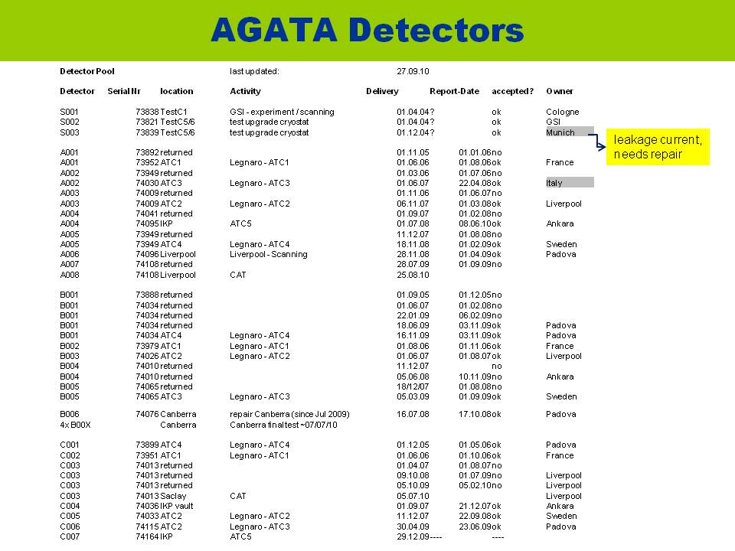
16 plus two capsules under test at the moment.
7 scheduled for delivery by end 2010.

Summary of cryostats.
5 ATC’s from demonstrator,
3 ATC’s (2 Italy, 1 Germany) ready for detectors
1 AdoubleC (UK)
1 double end cap (Saclay)
1 double end cap (GSI)
Schedule double cryostat (information provided by H.G. Thomas, CTT)
-Design studies, prototyping at Cinel until end of 2010
Delivery of three double end caps April 2011 envisaged
Assembly of first double cryostat by Saclay group

Status of scanning
A006 @ Liverpool
The scan of A006 is now complete, the data is presently being prepared for circulation to
the community. Analysis of the data is in progress. Comparison of the data collected between A004 and A006 is in progress. JASS has been installed in Liverpool and is being used to make a detailed analysis comparison with the experimental data.

Orsay
Waiting on crystal delivery for scanning
GSI
New mechanics of the scanning table and laser measurement of the detector position are being installed.

Strasbourg
Half of state-region funds granted (70 k€). Ready to order parts. Crespi's style table to be ready for measurement by mid 2011. New bid early 2011 for second half to install the GSI style scanning system and the data acquisition system for detector validation.

Maintenance of Clusters at Legnaro 13-23 September.
ATC2 replacement of wires in cold part, repair of one missing segment cable.
ATC3 Increased temperature, two vacuum leaks
First annealing of six AGATA capsules
ATC2&ATC3 cooled down, detector tests pending.

Discussion:

Co-ordination of spare parts agreed to be done by Cologne (includes spares at Liverpool and Saclay).

Saclay has requested funds for 2011.
IN2P3 82k€ requested for 2011.
TUD will provide an additional end cap.

Therefore, 2 doubles available in the autumn at the earliest. 4 doubles depends on bids and deliveries.

The test cryostat at GSI should be shipped to Orsay for scanning.
Commissioning of LYCCA, some further beam time before end of year, but unlikely to perform a sensible test of the AGATA detector.

No-one on the AGATA AMB was involved in the Umbrella Proposal recently submitted to the G-PAC. Also rumours of using the detector at MAINZ!!
The AMB agree that this appears to be getting out of hand. Need to have someone at the AMB reporting on the GSI status and plans.
Action JS to email J.Gerl and H-J. Wollersheim, copy P.J.Nolan.
Done

- Front end processing
Digitisers- Milan meeting report was:

12 in use at LNL; 1 awaiting test at LNL; 4 in UK for repair; 1 in Orsay (test bench).

Since then Patrick has repaired 1 complete digitiser and shipped it to Enrico on 17th August, received in LNL on 23rd Aug so I think we have:

Status now: 14 in LNL (12 working; 1 full digitizer to be tested; 2 core cards to be repaired/checked; 1 working segment card)

3 in DL
1 in Orsay.

For the pre-processing- here’s the relevant part of 24/9/10 pre-processing VC notes:

Pre-processing Electronics for ATC5:

Carriers: No change from July status. 30 required: 24 IPN cards now in LNL with 3 further working cards in CSNSM in the test bench and 1 in IPN, 1 partially working (no fast readout) and 4 unusable because of too many attempts to remount components on the non-matching footprints- there is a limited number of attempts to re-solder that can be made before the board is damaged. Remember that AGATA collaboration chose to take this risk of unusable cards at the start of production rather than delaying production run to wait for a rework to the PCB to change to correct footprints.
IPN have now confirmed that this is the final figure- here’s a quote from an email from Joel Pouthas on Friday:
24 boards OK at Legnaro
3 boards OK at CSNSM for tests purposes
1 board OK at IPNO
1 board OK without PCI express at IPNO
4 carriers out of order at IPNO.
We propose to deliver 1 board OK and 1 board OK without PCI express to CSNSM.
We ask Agata collaboration to decide what to do with the boards out of order for which we cannot do anything more at IPNO.
The 6 Padua pre-production cards are closer to working than the last 4 IPN cards (officially “out of service”). Two of the 6 pre-production cards need DPRAMs (memory chips) replaced and they are currently with the company which does this replacement. The rest are in the work queue at Padua waiting for testing- Dino was going to find out the status after the VC meeting. Not all can be repaired, but 4 or 5 are likely to be useable according to discussion at the 31/8/09 LNL meeting.

(It was agreed in previous pre-processing VC meetings that the Orsay test bench could use one of the pre-production carrier cards (as long as they were brought up to date with all the latest modifications), thus allowing Orsay to send one of the newer cards to LNL for use with ATC5. I guess this could apply to all the boards in CSNSM’s test bench once 2 or 3 of the pre-production units are refurbished and available.)

GTS and Linco: Cards delivered. 30 GTS tested and OK (enough for ATC5), New Linco cards still under test (one tested and installed in the system to replace a faulty Linco card so the new batch has no fundamental problems- they just need testing).

Mezzanines: 105 needed. All segment mezzanines (106) are now in LNL.

AG summarised the latest information from the VC that took place last Friday.
There was a plan to implement the new VHDL. Concerns expressed that this needs a period of time to commission and prove reliable. The timescale discussed was very short, as discussed above annealing, detector installation, access to area etc.
The consensus was to postpone this test and commissioning.
GD reported that NK had said that the system is quite unstable and suggested a period for testing and for making improvements.
EF noted that detectors were not fully started before the electronics was changed. System not yet back to the status prior to the tests.

If want to have a period (2 weeks minimum) before the running in February, then test will have to be completed by roughly 15th January 2011.

This information has to be transmitted to the electronics group. The AMB insists of a 2 week gap between any tests and getting the system ready for an experiment.

Discussion of the future development of the electronics to be continued at the AGATA week.

- Data acquisition
-------------
- Design and Infrastructure
No VC since last AMB VC.
DSS maintenance at LNL.

LV PS
Ange and Jean-Luc visit - AXIS crate fused entire experiment hall and they had problems it. EF noted if a prior workplan had of been submitted it would have helped and that the engineers arrived earlier than expected. In the end there are 4 working AXIS (with all voltages). Saclay will now work on supplying complete crates as the problems are probably solved. The collaboration will have a total of 14 crates.

Alarms
See also discussion in Legnaro report.
Bits and pieces on order, should be delivered soon. The Saclay work "dossier" was completed in end August, as there were still some extra info needed over the summer. Should be concluded soon. PLC side seems not to be a problem.

A time slot has to be defined in the near future with LNL locals for final installation.

HV for AGATA
Ch. Veyssière was not clear on some requests, and whether to go ahead. The detector group is willing to help. Ch. Veyssière will write a short summary of "option 1" for a quick check. As the HV change is minor, there will not much testing required prior to the detector. Bench tests to be performed at Saclay then at Cologne or even LNL if suitable.

Mechanics. Upgrading movement taking place for ATC2 and ATC3, replacement of circlips. Parts will be ready at the end of this week.

- Ancillary detectors and ancillary detector integration
Testing extra 7 AGAVA’s in Krakow. Some incompatibilities identified, checking taking place.

- Gamma-ray tracking, simulations and data analysis
GRID meeting took place yesterday and today
JN will circulate the minutes.
Policy of having two copies on the GRID.
GRID co-ordinator needed.

Simulations. EF reported on plunger simulations in progress. These to be presented at the AGATA week.

6. Extension of the LNL campaign
Request to extend the AGATA campaign in Legnaro by 6 months has been received by the ASC from Italy. Latest information is that GSI agree to this delay.
The AMB has been asked by the chair of the ASC to outline the timescales for having a system operational at GSI with 5 triple and 5 double cryostats.
Action JS to summarise the overall status of all parts of the project.

The AMB has also been asked to comment on this proposal.
EF notes the huge effort in keeping the device running but in principle it will be ok.
AG concern regarding the number of LNL LoI’s at the Istanbul meeting.
AG noted the accelerator problems, availability of beamtime, ALPI maintenance and the status of the tandem.

7. AMB organisation
AG summarised the latest plans and organisation. Any comments and suggestions send to AG.
AG to present makeup of AMB and plans to next ASC meeting.
AG has to present plans 7 days before this meeting, 12th October, so comments well before then.
Action AG to send document to the AMB.
Action All to send comments back to AG.
Details of teams discussed. To be discussed and agreed at the next meeting.

8. AGATA project definition
Ongoing, need to put this together urgently.
This is the first and urgent task of the new AMB.

9. The GSI Phase
Design and infrastructure.
Mechanical meeting taking place tomorrow. Status summarised by JS. Presentation of Jonathan Strachan distributed by email. The plans are for a rotating system that takes the next phase of HISPEC (AGATA@FAIR) into account. Funds are available in the UK for most of this project. £30k plus £40k is available in the UK. The current timescales are for completion, installation at GSI in middle September 2011.

EDAQ
The last document from the meeting in Legnaro was circulated to the AMB. Document based on two meeting (Milano and Padova) and a VC last week.
Need to instrument 25 systems for GSI.
Funds for 10 more pre-processing systems available in France. (60% in 2010, 40% to be requested/allocated in 2011). Just missing 40k€ for two ATCA crates. France (CSNSM) to produce.
Funds for digitizers (UK 8 and Italy 3) available and committed. UK is producing.
Funds for GTS is in Italy. Italy to produce 30 GTS cards for next phase. Spain will pay for extra units.
Production of LINCO cards. To decide if they will be built in Italy,
Production of TCLK cards. To decide if they have to be produced and by whom.
Action: AG to check.

All this electronics should be available by September 2011.

Data acquisition costing done by Ch.T and is part of project definition. Needs to be allocated to someone/country to purchase.

Costs for HV, LV, crates, autofill etc. to be allocated and included in the project definition.

The task of summarising the finances and allocation is the role of the resource manager in the new AMB.

Development of the electronics:
Discussions have taken place regarding the development of the AGATA system for the late GSI/Ganil phase and beyond.

Ideas include;
Extended PCI cards-compatible with existing digitizers, replaces pre-processing, GTS, project costs are lower than current system, digitizers may be higher price if “purchased” from UK since will have to cover effort,
Digital preamplifier long term development in Milano. Digitizer half in the cryostat (flash ADCs) and half outside (optical tranceivers).
Compact digitiser + pre-processing cards attached to the cryostat.
Digitiser, in or near the detector.

Presentations and discussions to take place at the AGATA week.

10. Running costs
65k€ Italian contribution to running costs for next 2011.
Cologne running out of running costs. 7.6k€ for example need for reliable HV feedthroughs.

France 26.5 k€ following MoU for 5 ATCs.
17.5 k€ IN2P3, 4.4 k€ GANIL, CEA GD to check with Wolfram.

Spain requesting funds for 2011 (5k€).

Sweden bid in progress. Outcome know in mid November.

Paper to be prepared for the ASC. Need status of running costs for 2010 and a proposed budget for 2011.
Action: JS to send the last paper to AMB for input.
Done

Action: JS and EF to update the document.

11. Finances 2011
Polish 25k€ for three years. 6.25k€ for this year have been transferred.

Sweden: The application is for 2 x 950 k€, which should cover two complete triple ATC’s with the necessary electronics and DAQ equipment. The outcome of the application will be announced in mid November 2010. details

UK £240k (committed to digitizers and mechanics)

France IN2P3 300k€ capital per year, CEA 140k€/year is the usual request. 50k€/year Ganil.
Note in France 350k€ is maximum from IN2P3 to include travel, running costs etc. so the amount left for capital maybe less (220k€/year).

Italy typically requests 100k€ /year (not including capsules or running costs).
In Italy the referees have approved one capsule for next year. Unfortunately, funds frozen at the moment, one capsule pending.
10k€ GTS, 65k€ running costs approved. 22k€ R&D digital pre-amplifiers. 40k€ for PCI express/processor development (on GALILEO funds). 2k€ for Core pre-amplifiers in Milano.

Germany bid in 2011 for three year period starting in mid 2012.
Germany GSI, 250k€ for AGATA@GSI should be available.
Action AG to check with J.Gerl.

Spain. 10k€ this year for GTS. Bidding process to start in 2011 for 2012. Bidding for 1M€ covering everything.

Spain bidding for funds (capital and effort) for the AGATA@GSI target chamber.

12. Next AGATA Week
Week of 22nd November.
Start lunchtime on the Monday
Action AG to update email sent by JS last week outlining the programme
13h-14h: Registration
Welcome & status of the project
AGATA Demonstrator at Legnaro : status and installation
AGATA organisation
After break start parallel sessions.
Electronics development (specialist grouping)
Data analysis, grid etc. p.m.
Tuesday 23rd
DAQ, run control, data flow a.m.
Infrastructure a.m.
GSI related issues, infrastructure, mechanics a.m.
GSI DAQ a.m.
FEE, pre-processing p.m.
Wednesday 24th
Detectors, Characterisation, PSA a.m.
Simulations p.m.
Complementary detectors p.m.
Thursday 24th
ACC 9-10.30 business meeting
Action: JS to contact ACC
11-12 GSI status
Action: JS to ask Mike Bentley and Wolfram to suggest speakers
12-13 Legnaro presentation of first experiment
14-16 status and LoI’s
16.30 Ganil general presentations
9-13 Ganil LoI’s
Action AG and Sean Freeman to organise the LNL sessions and call for LoI’s
Action AG and Gilles deFrance to organise the Ganil sessions and call for LoI’s
Action: AG to update the draft programme, send to AMB for comments and send to AGATA-ALL by 8th October.

13. AGATA Technical Publication, TDR
Agreed to looks at each section and send parts to JN and JS.
Aim to have a full template by next video conference.
Action JN to send around template.
Done.

14. AOB
Second meeting of laboratory directors, PAC Chairpersons and AGATA on 12th November in Legnaro. JS, AG and PJN will represent AGATA.

EU bid to Crisp was prepared and submitted at short notice. Bid for implementation of the preparatory phase, included NEDA, Exogam2, ELI, AGATA. The electronics was a common theme for all these projects. Typically bid was for engineering support.
FAIR did not support it, see email distributed by AG. Reason is that AGATA is not officially part of FAIR. This makes the bid difficult and will not work since it now only supports SPIRAL2 and ELI.
W.Korten is chasing this up with the FAIR management.

The AMB thanked John Simpson for all his hard work as AGATA project manager and chairperson of the AMB for 8 years and wished Andres Gadea good luck for the future.

J. Simpson thanked all members of the AMB for all hard work and support over the years. AMB members are and were J. Eberth, R. Krücken, D. Bazzacco, W. Korten, Ch. Theisen, G. Duchêne,
E. Farnea, A. Gadea, J. Nyberg and P. Reiter.

Suitable refreshment was then taken!

15. Date and location of next meeting and dates of phone conferences.
1st December, Paris (IN2P3 or Orsay, GD to book a room).

Phone conferences / Lyon system (GD to organise)
13th October, 14.00 CET
27th October, 10.00 CET
8th November, 10.00 CET

