Agata/AMBMin/Sep06/final
Minutes AGATA Management Board

21st/22nd September 2006 Orsay

Present:
D. Bazzacco
A. Gadea
G. Duchêne
P.Reiter
J. Simpson Project Manager and Secretary
J. Gerl ASC representative
W.Korten ASC representative

P. Desesquelles PSA discussion

1. Apologies for absence
R. Krücken, J. Nyberg

2. Minutes of the last meeting on 13th July 2006 at GSI
The draft minutes Agata/AMBMin/Jul06/04D were accepted as a correct record of the meeting.
Will be distributed again as Agata/AMBMin/Jul06/final.

3. Matters arising and actions from the last meeting
Action: DB to update the full cost document for a system with new electronics and DAQ costs.
Stick with 800k € (exc. tax) for now. Need to update the full costing once more realistic numbers are known.

Action JS. To clarify the situation regarding the “drawings” supplied by CTT and to try and stress the importance of reducing this delay.
Done. Reply was an even longer delay, see item 6(a).

Action JS. To contact CTT regarding the delivery of asymmetric end caps. These (at least one) are required for the first scan which may be this autumn.
Done. Delivery end of September. Which colour should be delivered first? Blue? Yes.

Actions: J. Gerl to provide a short document about how to proceed for the MoU
J. Gerl to check what the German ministry exactly requires in the MoU
Funds in Germany for the pre-processing are to be identified.
See ASC report, item 4.

Italy (1), UK (1), Germany (1) to order HV controllers from Saclay, when the quotation is available. Sweden and Turkey to order from CCT with cryostat. All future orders should pass through CCT.
Action: JS to contact CTT and Bo Cederwall and Ayse Atac with this suggestion.
Done. No conclusion yet, see item 6(a).

Several readjustments of the finances were proposed.
Action: JS to update spreadsheet and summarised these changes to comment.
Done, see item 5.

AMB proposes to keep the spacing on cryostats between MDR connectors compatible with the large casing.
Action: GD to state that to CTT.
Done, email distributed on 11th September.

DB proposed to hold a full data processing team meetings prior to the next AMB to review the design and status and to ensure all issues are discussed.
This agreed to be essential since we are a critical stage in the project.
Action DB to organise.
Done see item 6(c)

Action: DB to organise another Ge+digitizer test if needed. Test site to be decided (IPHC or Padova). See item 6(c).

Funds are required to continue employment of an engineer in Poland. Can this funding be found in EURONS?
Action: AG to ask Krakow people to contact WK.
Ongoing

Action: All to update major milestones on the project for discussion at the next AMB.
Ongoing

Action: JN to prepare some rate and data storage estimates.
Ongoing see item 6(f)

Action: JS to chase up the drawing of the flanges.

Done
Check that the date and location for the next AGATA week is OK since it is believed that many Orsay personnel will be in Dubna for an experiment.
Action: GD
Done 15-19th January 2007, Orsay, see item 8.

The final technical report on AGATA was discussed. This document is stated as a requirement of the MoU and as part of the EURONS project.
Action JS to initiate preparation of this document in 2007 by the AMB.
Ongoing

4. ASC report and discussion

ASC working on new organisation structure for AGATA after the demonstrator phase. New version to be produced.

PR reported that the German funds for one triple will be given to Cologne. There are conditions regarding the new MoU and host laboratories (GSI). Clarification of the demands from BMBF and other countries is required.

Romania have indicated that they wish to bid for one capsule.

The ASC are to discuss running costs for 2008 and beyond.

Next ASC meeting in January 2007.

5. Funding status and capital allocation

Action: ALL to send JS financial statements for 2005 as soon as possible.
Information from Munich, Cologne and UK only. The rest to reply.
Include demonstrator capital and other expenditure.
Information required by the next meeting. JS to send out reminders.

Italy have bid for 3 capsules for 2007.

Several readjustments of the finances were proposed.
Action: JS to update spreadsheet and summarised these changes to comment.

Move miscellaneous items to infrastructure (asymmetric end caps to detectors).

The cost does not include 130 MDR cables (~17k€).
Action: GD to investigate if these funds can be found in France (Ganil).

Decided that France takes 4 pre-processing units from Germany.

Action: JG to find the funds in Germany for pre processing and the additional 103k€.

Action: JS to make these changes and update and circulate.

GD stated that the development costs for pre-processing are more than in the full spreadsheet (~100k€ short).
Action: GD to find out exactly funding in France. If funds not available for the 3 pre-processing units then these may have to go back to Germany.

Digitizers orders.
UK 7.
Munich have ordered 4 from CCLRC Daresbury.
Sweden ordering in discussion. Bo awaiting letter from JG supporting letter written by JS.
Action JG.
France, tendering for one module to be purchased by IPHC, in progress.
Turkey no news.
Action: JS to contact Ayse.

JS to ensure UK purchases preamps through CTT.
Action: PR to discuss this with CTT and how to proceed.

Spares?
PR to discuss with the detector group what is a sensible level of spares that are required and where these should be held (host labs, test sites). These items could be running costs.

Action all: Send JS effort used in the project in 2005. JS to remind all of what required.

6. Reports from Working Groups

  - Detector module
Summary overheads distributed by P. Reiter.
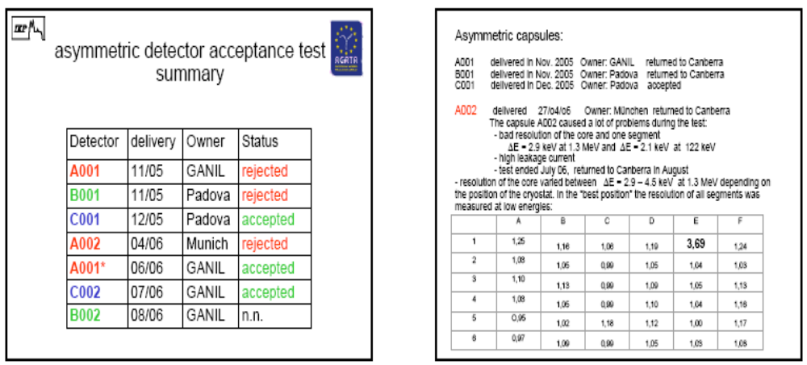

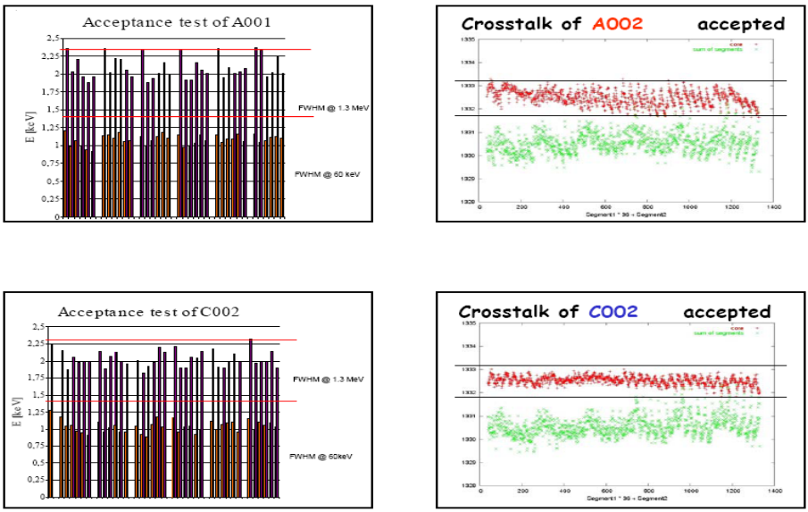
Issue of naming scheme was discussed. Agreed that a careful record of capsule and crystal labels is required.
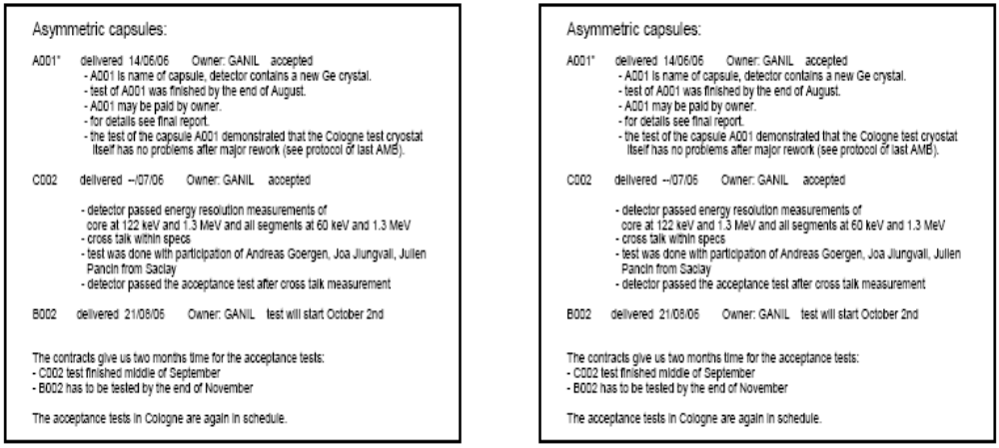
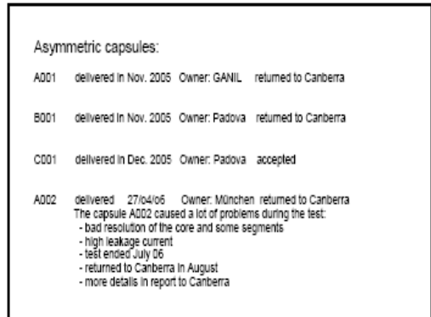

No news on the status of B001.

CE aim to deliver two more capsules before end of year.

Action: PR to chase up CCT re delivery of triple cryostats, test cryostats and end caps.

PR has spoken to CTT. First triple not before April 2007. Optimistically one more every 4-6 weeks. Delay caused by delivery of mechanical parts from CINEL.

This seriously affects the plans for testing in Legnaro.

Test cryostat May.

PR checked on schedule of asymmetric end caps (Blue one first if this helps). Delivery expected this month.

COLOUR convention:

A red, B green and C blue

Sweden is in the process of ordering detectors. JS wrote a letter explaining CE as a single supplier. Discussion with CE regarding transportation costs and the specification (dated May 06) are in progress. The specification can be obtained from:
http://npg.dl.ac.uk/documentation/AGATA/specifications/

Action: PR to chase up the problem regarding the specification with the J. Eberth and then CE.

Sweden to order a triple cryostat. JS written regarding single supplier CTT.

JS has ordered a test cryostat. Delivery May 2007.

  - Detector performance

Characterisation report submitted by Andy Boston:
Detector Characterisation Group
Status report – September 2006

Detector Scanning

Liverpool Scanning system
S002
The scan of the symmetric prototype detector s002 was completed in mid July 2006. This detector was fitted with GANIL differential preamplifiers on the segments. The detector was found to perform excellently. Details of the tests of this detector can be found in the s002 report document. The detector data recorded from both the singles and coincidence measurements is in the process of being pre-sorted. The full 360 degree face of the detector has been scanned utilising the grid documented in the Liverpool Scan proposal document.
- MTsort format pre-sorted data will be circulated by Matt Dimmock. Expected completion end September.
- Root format pre-sorted data will be circulated by Sarah Rigby. Expect completion mid October.
Following the scan the energy resolution of the detector was re-measured and was found to be the same as when it was received. The detector was shipped to Orsay in mid July. The detector has recently been cooled and testing has commenced.

S003
The detector was received from Orsay in mid-July.
The scan of the symmetric prototype detector s003 is in progress, it will complete by mid November 2006. This detector is fitted with Italian differential preamplifiers on the segments. The detector was found to perform excellently. Details of the tests of this detector can be found in the s003 report document.
MTsort format pre-sorted data will be made available by Matt Dimmock
Root format pre-sorted data will be circulated by Sarah Rigby.

Summary
The scan of the next AGATA detector will be able to take place in January 2007 as we plan to use the table in mid November – early December to scan a SmartPET planar germanium detector. We can receive the detector prior to the scan as it takes three weeks to complete our initial tests The system will be fully available during 2007.

Orsay Scanning System
The scanning system is assembled and is in the process of being commissioned. The lab has been fully setup with the infrastructure necessary to handle AGATA detectors

GSI Scanning System
The s003 detector will transfer to GSI after completion of the scan in Liverpool, to allow commissioning of the scanning system.

MGS Database
A theoretical data set calculated using MGS is available for download.

In Beam Experiment
The analysis of the in beam experimental data is in progress. The initial results from the experiment have being produced utilising the theoretical pulse shape database, a report has been produced detailing this work. The results indicate that work is required to improve he agreement between the true pulse shapes and the theoretical database.
Joa, Matt and Sarah are working on the detailed comparison between the experimental scan data and the theoretical database in order to improve the agreement.

Outstanding Work
Validation of the MGS pulse shape database with the experimental pulse shape database is the priority of the group. The PhD thesis of Matthew Dimmock will focus on this. Joa Ljungvall will expedite this for the initial data analysis from the in beam experiment.

Update of scanning plan:
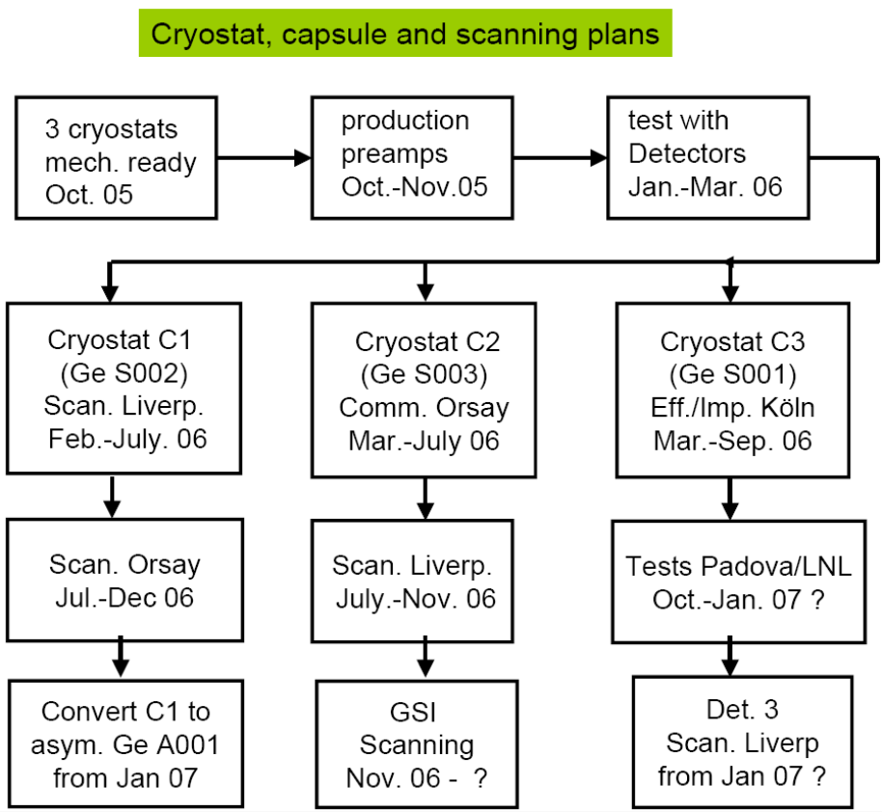

Italy will get S001 in GSI test cryostat. DB will keep in contact with Andreas Linnemann.

Pulse Shape Analysis

P. Desesquelles presented the status of the work of the PSA team.
Status of implementation of codes.
Status of analysis of Cologne experiment using Miniball algorithms, matrix algorithm. Results comparable, improvements to matrix algorithm have been identified and will be implemented. Need to improve the comparison of real and MGS5 simulated signals.

DB summarised analysis of Cologne experiment as done at Padova by Francesco Recchia using grid search method of R. Venturelli. For single segment events, energy resolution of 1382 keV line is 5.5 keV, corresponding to 6 mm (FWHM) position resolution. Results presented by Francesco at Zakopane 2006.

Identified a need for close communication between all those working on the data and PSA. Clearly at an interesting time in the project. Need to ensure when comparing algorithms etc. all data is being analysed under similar conditions.

  - Data processing

Recent meetings
Orsay April Electronics
Orsay June Run-control
Padova Sept Electronics
Tests
Cologne July Digitizers (segment)
Orsay July Integration GTS-Pre Proc
Not done
Cost updates
Spending plans (OK for digitizers)
Status reports
---------------------------------------------------------
Digitizers
Segment boards 6 exists (cologne tests)
Core board delivery 28th Sept
Mechanics OK
Manufacture plans
Patrick Coleman-Smith co-ordinating
Orders partly placed, see item 5
More tests with AGATA detectors needed to decide on gain (also at the preamplifier level)
------------------------------------------------------
Tests in Cologne 10-13th July

Segment digitizer board tested with S003 (GANIL preamps + pulser)
Energy resolution problems due to short MWD shaping
Noise measurements (on channel 4 with gain increased factor of 2)
- No input (DFT ok)
  - 0.4 keV digitized wave
- connected to detector (DFT ok)
  - 7.8 keV digitized wave
  - 1.0 keV after MWD (trapezoid 6+2+6 μs; peaking 7.5μs)
  - 0.14 keV after BLR (exp-average 40μs)
Long traces (10 ms) with TNT2 (core+3 segments)
–Energy resolution not too good
–Very noisy core and noisy segments
–Need to understand where from (TNT2, detector, conversion boxes, …) because TNT2 data used to benchmark algorithms
Unfortunately: No measurement without input; no measurement with ¹⁵²Eu
Need a way to write out very long traces from digitisers
•PJCS to check with RAL eng. a solution for 80 ms (16 MB) using MEMEC board

-------------------------------------------------------------
GTS
Mezzanine V1 (Virtex2)
–tested
–Integration into PreProc. carrier board (July 24-26)
•OK after solving usual troubles
•Cannot check data integrity because no readout from carrier
–1 board sent to Kraków for AGAVA (no further news)
Mezzanine V2 (Virtex 4 + TDC)
–Prototype tested
–Production of 5 more pieces to test Trigger mini-tree
–Series production moved to 2007 (major components purchased now)
•Trigger processor
–VHDL code developed at Legnaro by Luciano Berti
•Multiplicity trigger on partitions synthesized and tested
•Coincidences among partitions exploiting the PPC in the Virtex4, on test
---------------------------------------------------
Integration of GTS mezzanine into pre-processing ATCA carrier board 26 July Orsay
---------------------------------------------------
Pre-processing hardware
Segment mezzanines
- 2 prototypes version 1 available
- 6 boards version 1.5 produced and being populated (without review as agreed at the AGATA week)
Core mezzanine
- 2 prototypes available
ATCA carrier board
- 3 modules built, 2 AGATA, 1 DESY
- Running: Power supply; Clock and Trigger distribution over one carrier; RocketIO link over backplane, PPC access to memory @ 50 MHz, …
- Not (yet?) running; PPC access to memory @ 100MHz, Gb Ethernet RocketIO @ 2 Gb
Readout to DAQ
- Not yet working
- Present design cannot reach throughput spec.
---------------------------------------------------
Pre-processing firmware
- MGT
  - Standalone test OK (several days without errors)
  - OK but need further tests during digitizer/pre-proc integration
- ENERGY
  - MWD+BLR
    - Synthesizable VHDL code available
    - Testes by DB, acceptable but BLR to be improved

      - TRIGGER (local)
–VHDL available (MWD trigger)
–Tested by DB, need to implement simpler LE

- READOUT Mezzanines to DAQ
–OK (Carrier + GTS + 2 Segment + 1 Core )
–Cannot check data integrity because carrier readout not available

---------------------------------------------------
Tests of MWD software (DB)
Behavioural version of Orsay and IReS codes run in ModelSim SE
–1 Ms long TNT2 waves (10ms each) from a Clara clover detector stitched together for a total duration of 3.5 seconds
–Simulation very slow: Orsay 8 h, IReS 20 h (ref. C++ code 6 m)
–Both give similar energy resolution at high energy (1.9 keV) because they are just different implementations of the same algorithm
–Both need to improve the BLR (automatic threshold)
–Resolution at low energy still a problem: 1.4 keV instead of 1.1
  - Available data (from clover) is not very good
  - Fourier spectra rather dirty
  - MWD filters don’t cut well high frequencies
–Need AGATA data from 152Eu source and, ideally, AGATA digitisers
Need to work at algorithmic level e.g. deconvolution of other poles in transfer function of preamplifier (not yet measured for AGATA)

---------------------------------------------------
DAQ, Run control and GUI

- NARVAL ready to receive data from PP
- First draft of run control as agreed in June distributed by G Maron 20th September
- Need to clarify
  - Role of GUI (Jurek)
  - Slow control (Vic)
- Teams need to need again soon
---------------------------------------------------
Full Chain Integration tests Orsay November 2006

•Milestones checked in October 26 VC
•Digitiser modules delivery to Orsay week 46
•Tests start on November 13
–Clock&sync from GTS to Digitisers (through carrier and core mezzanine)
–Datalink Digitisers-to-Preprocessing
–Readout from carrier (traces are enough for this test)
•Then start checking MWD, Integrity, …
•Availability of French engineers from outside Paris is problem (economical)
---------------------------------------------------
Problems
Engineers agree that mezzanines and ATCA carrier need major reworking.

- May not able to complete development according to Demonstrator timescale
- Help from outside needed
- After July visit, Marco Bellato offered to review PreProc. modules
–Carrier checked ---fundamental problems in design and routing
–Segment mezzanines could not be imported into simulation

- Meeting September 18 in Padova to discuss solutions;
–Option proposed including help from Padova:
•use GTS mezzanine (V2 with Virtex4) for core and segment mezzanines, just modify input to optical fibres (and remove TDC)
•Collaboration Orsay, DESY and Padova to redesign (parts of) carrier
•Help from Padova conditional to routing of new design done at CERN (expensive but safe)
–Option proposed by Orsay
•Ok to use GTS (V2) but with commercial company which promises to teach Orsay people in exchange of intellectual property and production for AGATA
•Carrier modified according to suggestions but work done at IPNO

- However, main problem is firmware:
  - Sébastien Lhenoret, main VHDL expert at CSNSM, leaves the project (moves to CEA) end of this year
  - 2 new positions asked to replace him; meanwhile knowledge transferred to Bruno Travers who, sometimes in 2007, should pass it over to the new guys
---------------------------------------------------
Based on common experience (and confirmed by GD for TNT2 case) DB states that, once HW ready (and we are not yet so far), development of firmware takes at least another full year. Therefore, the CSNSM proposal for solving the situation will not meet our timescale.

VHDL expertise urgently needed. Preferably in France to be close to the hardware development.
Action: WK to investigate effort in Saclay.

Delays in pre-processing, hardware and software, were discussed.
Most optimistic;get new mezzanine in 4 months and if new expert VHDL engineer then there could be working system in not less than 6 months. However, more likely there will be greater delays.

Collaboration with DESY is noted, but DB requests that this kind of initiatives are communicated to the WG-leader and AMB in proper time.

The AMB agreed that Intellectual property rights should remain with the AGATA collaboration.

There is a need for a project plan.
Action: JS to talk to Ian Lazarus regarding the pre-processing

Clearly a need to discuss the full project plan and any overall delays after the integration tests in November. AMB must meet soon after then.

  - Ancillary detectors and ancillary detector integration

Mechanical and electrical test at Krakow (GTS with AGAVA)

Krakow have run out of EURONS money.

No new news from key experiments. Working on an RFD simulation.

VME interface tests in September and October. Need to test with GTS mezzanine, discussions with Marco required.

24k€ OK for 6 modules.

  - Design and infrastructure

JS has distributed the status of the design by email on 20/9/6 (repeated 23/9/6).
Approval of flange design for manufacture is awaiting final decision on the cryostats design. Cryostat design/CTT awaiting final design of the high voltage box.

Proposed installation of Hector detectors have been received from Milano.

Khalid Fayz has resigned from CCLRC. Interviewing for a new engineer Daresbury took place on Monday. In the meantime any queries regarding mechanics to J.Simpson or Robert Griffiths (R. Griffiths@dl.ac.uk).
Design meeting/phone conference needed soon to clarify the design.
Action: JS to organise.

MDR cables
Do they have to be halogen free?
Legnaro yes. AG to discuss with Legnaro safety people.

PR stated that halogen free MDR cables do not exist however G. Pascovici has found halogen free tubes in which the MDR cables could be inserted in looms.

Action: PR to send detailed drawings of the chosen cable and connector to JS and
R. Griffiths. GD also to check with George Pascovicci.

High voltage box status.
Design of high voltage box in progress. Master board from Saclay will not fit into the latest box (trapezoidal shape) designed by Ivan. Saclay to estimate whether a new trapezoidal master board may fit in the new box. Expect answer by 5/10/6 when next video conference takes place.

Metallic casing of the box discussed. To check that last CTT cryostat drawings are used for the box design.
Action: GD

STEP file to be sent to AG for search of industrial solution in Italy.
Action: GD

Propose a final video/phone conference to agreed final design.

A plan of testing of the high voltage was discussed. Production of the final working box (trapezoidal shape) maybe February next year.

Test of the high voltage with a real detector should also be scheduled.

Final cost of high voltage box is being estimated.

Low voltage power supplies.
Technical draft has been discussed. Saclay starting a tendering procedure.

PLC hardware
Technical draft 5/10/6 plus cost estimates.

Autofill hardware
Technical draft by 5/10/6 plus cost estimates.

GUI
Technical draft mid October plus cost estimates.

Aim to pull all documents together by end of October.

  - Data analysis

JN reported by email that he has started to work on data rates and storage.

  - EURONS

WK Eurons meeting will be in December. Will require reports in November for activity in 2006.

Any follow up JRA should be presented at this meeting.

Action: AG to prepare a request for EURONS funding for engineering effort in Krakow.

7. Commissioning of the demonstrator at LNL and project plan

Overall AGATA plan is required as discussed in item 4. To be discussed and decisions to be made at the next meeting.

Installation in Legnaro.

Will buy material for flanges this year from a company in the UK.
JS to check ask R. Griffiths to liaise the UK company to ensure there are no problems.

Machining of flanges will be done in Milano, Padova and Legnaro.

Will machine a prototype in plastic.

Will send plastic and first flange to UK for test.

Ready to place order for optical fibres. Need to clarify the length (75m?).
Action: GD to ask Peter Jones and then give approval to AG.

Action: PR to check the MDR connector and cables length tests (10m?)

DB keen to do further tests before final decision on length is made. DB will specify the tests required. These tests maybe be performed in Padova/Legnaro when they have a detector.

8. Next AGATA week

15-19th January 2007, Orsay,

9. Ge production

Proposal for virtual institute has been rejected.
JG investigating other funding possibilities.

GSI have made available the rooms required.

10. Organisation of the AMB

What to do with detector performance and RK?
Action: JS to speak to RK.

Detector Characterisation to detector module working group.

11. AGATA beyond the demonstrator

Some news in items 4 and 5.

From the ASC minutes in June 2006
In view of the available information ASC recommends a provisional scheduling for the physics campaigns at LNL (2008), at GANIL (2009) and at GSI (2010). Due to possible delays, in particular for the commissioning phase, this planning will be confirmed in due time. Each campaign should last for about 12 months, but not less than two PAC periods in each of the three laboratories.

12. AOB

- Greta/Gretina
Phone conference notes still being exchanged.

- Publications
Continue to send to JG for inclusion on the web site.

13. Date and location of next meeting and dates of phone conferences.

Next Meeting
14th December 2006. Cologne 09:00.

Phone conferences
12th October, 10:15
26th October, 10:15
16th November 10:15
4th December 10:15

John Simpson
26th September 2006

