Agata/AMBMin/Feb09/final
Minutes AGATA Management Board

9th – 10th February in Orsay room M030 of building 100 IPNO
Start 13:30 9th, Finish at 13:00 10th.

Present:
D. Bazzacco
A. Gadea
G. Duchêne
E. Farnea
J Nyberg
P. Reiter
J. Simpson Project Manager and Secretary
Ch. Theisen
W. Korten ASC representative

1. Apologies for absence
None

2. Minutes of the last meeting 27th November, 2008 in Legnaro Agata/AMBMin/Nov08/04D

The draft minutes Agata/AMBMin/Nov08/04D were accepted as a correct record of the meeting.
Will be distributed as Agata/AMBMin/Nov08/final.

3. Matters arising from the last meeting and actions outstanding from last phone conference
Action All WP leaders to identify a person to take responsibility to link to the AGATA.org portal. Discuss progress at the next meeting.
DAQ Eric Legay and CT, Detectors PR, Bart, PR also ask Andy, Infrastructure GD, Data analysis JN plus?
Ongoing for the others discuss at next meeting

Final financial statement required by ASC for the demonstrator phase.

Produce statement for next ASC (12-13th March 2009).
Action: All to send statements by 16th January, 2009.
UK and Sweden only so far.

ALL TO SEND STATEMENTS TO JS by middle of next week please.

Recent issue, Turkey has identified a tax issue. The detectors if returned to Germany, then Germany liable for Import Duty, for detectors circa 120k€! Can be exported for 24 months, then would have to be returned.
There are also tax issues for other items.
The project has problems resulting from this to fully fund the demonstrator. Have sufficient funds for three triple cluster system. DAQ for example is short of funds.

Action all (expect Peter who has found out the position in Germany) to find out if problems exist and if solutions can be proposed form discussion in own countries.

Expenses needed to complete demonstrator phase and who will provide funds.
DAQ, GRID, Xilinx Express Licence, Digital Oscilloscope
Action all to input to the list and define who pays.

CT sent information on the DAQ budget.
JS to look at these figures and summarise when all financial statements are submitted.

Running Costs
Action from ASC. JS to discuss with EF how to operate. See item 7.

AGATA Week
Cologne will host, week of 30th March – 1st April.
Action: JS to email AGATA all.
Done
Action: PR to start to set-up web page.
Done.

Physics Workshop
Legnaro. Weeks of 18th 25th May. 2-3 days (not 21st May). Propose 18-20th May.
Action: AG and SJF to define a date. Done.
18-20th May agreed. AG to sort out some details. Once all is fine will send around an email announcement. To start at noon on the 18th, up to 20th May. Announcement to be sent out.
Done.

Action PR to discuss with RK re exchange of capsules with Italy.
Ongoing.
Just a written agreement needed. Remove action.

EDAQ plans for the next phase meeting
Action JS to send out announcement, after dates confirmed by PR.
Confirmed: The extension of the AGATA week for an EDAQ meeting with 50 persons can be hosted at Cologne April 2nd. The room is booked. So you may proceed.
Done

Who to invite? List needed from CT and DB. Send to JS
Done. All agreed OK.
Action: JS to send out.
Done

4. ASC Report

Meeting with GANIL management (PJNolan/WK attended). Long shutdown second half of 2011 and into 2012 for SPIRAL2 work. Agreed that this is not a good time to move AGATA. Best time to GANIL second half of 2012. Possibilities for a move to GSI are under discussion. GSI are favourable to host but beam time is an issue. More thought and discussion needed.

France and Sweden to sign up to the MoU, also Bulgaria?

5. Reports from Working Groups

- Detector module and characterisation
Status report added to minutes as Annex 1.
Paper on AGATA detectors (cross-talk measurement and resolution) submitted to NIM (B Bruyneel et al.,)
DB presented latest on oscillations seen in Legnaro. Agreed a meeting of experts required to brainstorm this problem. Origin of these oscillations is not understood.
Action: EF to organise a meeting (week) of experts when convenient. Week 13 looks the most likely, the week after the in beam test.

- Front end processing
PSA
- EVO meetings started.
- Next EVO 11th Feb. to plan to have a real meeting before week 12
- Implemented in Narval
  - Data pre-processing
    - Gain matching of energies
    - Baseline subtraction and gain matching of traces
    - No cross-talk correction yet
    - CFD time alignment
  - (very) simple Grid search
  - Still using symmetric signal basis (2mm 5ns)
  - Asymmetric basis calculated (M. Schlarb TUM) but not translated
  - Asymmetric basis being calculated by C. Unsworth at Liverpool
Pre-Processing
- 7 Digitizers (4 in AGATA mode)
- 5 ATCA carriers, the 6th being debugged
- 7 GTS, central clock and time-stamp; no trigger
- 21 segment mezzanines
- Core functionalities in GTS and segment mezzanines
  - DB has agreed with pre-processing team members that he will analyse the data to see if core mezzanine really needed. Will make a proposal following this analysis.
- PCI express readout
  - With standalone programme, saving raw data of 7 mezzanines (14 kB/event/detector)
  - Local event builder based on timestamp
- Readout to Narval completed last week
  - 64 bit driver
  - Local event builder same as the standalone programme
Production
- ATCA carrier
  - 2 prototypes expected today at IPNO
  - JTAG-chain test done at IPNO
  - Set up (and training) in Padova starting week 9
  - New software eng. (Frank Salomon) at IPNO
- Segment Mezzanine
  - PCB production for all
  - First production batch (20-30 modules) to be tested from mid march
- GTS
  - PCB’s ready
  - Prototypes went out for population last week
Firmware to do (some progress since last time)
    - Minimize latency in the MGT pipeline by proper processing of sync return bit
    - Pipelined processing of events to remove the 25 μs/event dead time (è 20% at 10 kHz, 70% at 50 kHz)
    - Detection and characterization of pile-up and saturated signals
    - Qualification of the exponential-average automatic baseline restorer
    - Fix order of segments
    - Per-channel controls of the processing-parameter à to test
More Firmware (same as last meeting)
    - Not so urgent but essential for real experiments:
        - Diagnostics of operation: inspection of signals, generation of useful statistics (counting rates, pileup, BLR thresholds, error rates) …
        - Capture of long (at least 100 kS) traces
      - Also to be done but implying major rewrites of the processing firmware:
        - Time over Threshold
        - Capture of PSA traces after deconvolution
        - Online calibrations of energy and traces
Slow Controls
- Carrier and mezzanine are now setup with a single command procedure
- Diagnostics done with ChipScope (rather complicated)
- Progress has been made at Orsay but a lot of work still to be done.
- Will use current system until new version ready.
Major Open Problems
- Connection to ancillary detectors
- User-affordable operation of the system
  - Version 1 of the VHDL
  - Slow controls
  - Diagnostics and system integrity check
  - PCI express readout
  - Processing firmware
  - Documentation
- Maintenance

- Data Acquisition
For pictures see CT’s presentation.
Source Week 51 Test
- Priority since last AMB. Prepare for week 51 test
- Present Italian staff+XGrave+E.Legay+CT
- Mostly debugging of data flow on infrastructure side
- Data taken from disk (2 crystals), up to EB
  - Narval Robust; time stamped event builder
  - ADF2
  - RC, GUI, etc, … not used because lack of time … and some key peoples missing
  - GRU server not used
..week 51 debrief and preparation for week 8
    - Very positive test. Peoples feeling responsible for something.
    - The test pushed people (unfortunately not all of them)…
    - Orsay team scheduling visit at Legnaro themselves
    - GRU problem solved (problem with root thread)
    - Infrastructure stuff (network, IPs, DNS, Zabbix, DSS access … ) : visit of E. Legay and Y. Aubert on week 4
    - Connect RC with data flow (done week 6)
    - Connect with Jurek’s GUI (done week 6)
    - Connect FEE to DAQ using PCI express (done and tested week 6).
    - Tracking : Debugging with real data; GRU spectra, more debugging in progress
Still to do
- Standard topology for test
- Some ADF issues
- Sent workstation to Legnaro (should arrive 16th of Feb.)
- Disk writer
- Week 8 source test. Target = full chain up to disk with RC, GUI, …
  - Present from France : X. Grave, N. Dosme, O. Stézowski, Ch.T.
- What about data analysis? See item 5(f).
Administration
- Orsay meeting week 4.
        - More and fastest reactions
        - Weekly administrator schedule
- Not that efficient, can still be improved
Hardware and funding
- One switch bought urgently by IPNO
- Still need for 6 TC demonstrator
  - 9 Pizza Boxes
  - 2 switches
  - 1 small disk array
  - 60 TB AGATA storage
- All this hardware should have to be bought be Turkey itself or with Turkish money (order at IPNO)
- Latest news are not so encouraging. Process is slow and outcome not guarantied
- NO DAQ HARDWARE FOR MORE THAN 3 TC
- URGENT HELP FROM ASC NEEDED
See discussion of use of remaining Swedish money, item 7.
Slow control
- Digitizer Slow Control Installed and operational
- Log messages sent to Log Collector and then Log book
- Some problems with carrier switch (solved)
- EDAQ meeting week 8. 19th of Feb.
- Introduction (Christophe and/or Dino) 10 min
- Short presentation of network and infrastructure (E. Calore, confirmed) 15 min
- Short presentation of web services (Pietro / Michele?) 15 min
- Digitizer slow control status (Vic, confirmed) 20 min
- ENX and the slow control for Orsay mezzanines (Nicolas, confirmed) 20 min
- Mezzanines GUI (Nabil, confirmed) 20 min
- GTS slow control (Joel, confirmed) 10 min.
- The carrier slow control (Damiano?) 20 min
- Discussion on the carrier, GTS and Trigger slow control (All)
- One needs to encourage slow-control
  - Periodic meeting
  - A Slow Control team would help a lot
Documentation
      - Full reorganisation of wiki
      - People finally writing useful documentation
      - Source code policy: cannot put all codes at the same place because intellectual property. Source codes belong to employer and have to « stay » in the native country
Conclusions
- More details in our EVO meeting minutes
- Impressive progresses since last December
- Data Flow + RC bricks were well prepared
- Need now to debug/experience the system.
- SC issues
- Hardware and funds issues

- Ancillary detectors and ancillary detector integration
AGAVA
- Foreseen a final production of 10 modules
- First 3 already populated and tested AGAVA-GTS functionality
- Delivery waiting for front-panel mechanics
- Will be delivered to LNL (3 modules purchased)
- Plan for AGAVA + GTS:
    - Development of the PRISMA and DANTE front-end readout
    - One AGAVA + GTS to be delivered to GSI
Development of PRISMA and DANTE Readout
- PRISMA and DANTE Read-out hardware defined
- Required already complementary detector
block format (ADF). Who does it?
- Working on fast-trigger/reset cycle for PRISMA and standard trigger cycle for DANTE (late trigger from Digitizers)
- Other detectors foreseen in short-term:
    - Silicon detectors?
Complementary Detector News:
- GASPARD SPIRAL2 Si array for direct reactions will have finally a version to work with AGATA.
- HYDE HISPEC Si array design ongoing: to be check for AGATA compatibility → foreseen a thick Si layer
- NEDA SPIRAL2 neutron-detector array conceptual design ongoing: compatible with AGATA 3π

- Design and Infrastructure
For pictures and spectra see email from Gilbert.
Low Voltage:
Series production
Delivery of 3 boxes planned
    - 1 in week 3 delayed to 4
    - 2 in week 5 delayed to 6
First unit to be tested in Saclay on week 5, sent to LNL on week 6 and fully tested in real conditions at LNL on week 7
The following units to be tested in Saclay and sent to LNL before week 12
Problems encountered by AXIS
    - 1 in week 7
The test at LNL on week 7 is postponed to week 10
    - The following two units to be received early enough to bring all 3 units in LNL for the test on week 10
Hope the three units to be ready for the in-beam test. Backup solution exists to power three digitisers for the source run
High Voltage:
Test in Cologne (Jan 28-29)
Core FWHM measured
  - Test performed by increasing progressively the # of crystals powered with AGATA HV boxes
With and without Profibus connected
  - Compared with FWHM with ORTEC HV module + CTT HV filter
  - FFT spectra measured
One crystal (red A003)
  - At 60 keV
    - ORTEC: 1.32 keV
    - AGATA: 1.34 keV
    - AGATA no Profibus: 1.29 keV
    - FWHM within uncertainties
  - FFT
    - With Profibus (red)
    - Without Profibus (green)
NO MAJOR EFFECT OF Profibus
Two crystals (blue C005)
  - At 60 keV
    - ORTEC: 1.30 keV
    - AGATA: 1.31 keV
  - FFT
    - With Profibus (green)
    - Without Profibus (red)
Three crystals (green B003)
    - FWHM OK
    - FFT OK

ATC#2
    - NO BASELINE JUMP
    - AGATA HV on ATC#2 for LNL
      - Control and ramp of HV
      - HV shutdown (presently missing on ATC#1)
      - 1st DSS full implementation (HV, AXIS, Autofill, PLC, GUI) in week 11
Production
  - PCBs: order sent late Jan.
  - Population: order to be sent by mid-Feb.
  - 6 mechanics to be produced by Liverpool (January design)
  - 15 boxes including HV filter to be tested together as a Profibus chain at Saclay (April)
  - Delivery in April
AUTOFILL :
Valve Control Crate
  - Still in progress, should be ready for late Feb
  - Ivan unavailable up to Feb 21
  - Maintenance PC to be installed in LNL on week 10
  - VCC to be installed and tested in LNL on week 11
A request for temperature readout to higher accuracy (<1°C). DSS GUI to be modified.
Full DSS:
All DSS deliverables are tested (except VCC)
Waiting for installation
EMC:
Proposal from A. Richard
  - Collaboration agrees to implement the modifications proposed
If feasible
  - Visit at LNL of A. Richard, A. Charois + one IN2P3 engineer
Experts report with proposed solutions
  - IN2P3 engineer offers to supervise the modifications
Agreed to be a good idea if proposed solution accepted and feasible.
  - Measurement of noise level by A. Richard after implementation
  - Richard not available before April

- Gamma-ray tracking, simulations and data analysis
Report on reactions for the in-beam commissioning distributed by email by Johan Nyberg.
Aim:
Run the first in-beam experiment with AD
Take data through the whole system with one triple cluster detector (TCD)
“Simple" setup with no ancillary detectors
Determine the position resolution by measuring the Doppler broadening of γ-ray peaks at two target to detector distances, ~40 mm, ~140 mm (idea by F. Recchia et al.)
Requirement:
Large v/c → inverse kinematics reaction
Narrow angular and energy distribution of the recoils → fusion-evaporation xn reaction
Large cross section
Well defined source position
Small and well known beam spot on target
Life times in the range 0:1 ps < τ < 50 ps for v/c ~ 5-10 %
Possible Reactions discussed, see paper by JN.
Populating ⁹¹Zr and ⁸⁶Sr.
Issue of isomeric states discussed..
To do:
Mechanics for positioning the TCD accurately at 90⁰ at two distances (~40 and 140 mm); target chamber?
Target: ¹³C, ¹²C, ⁹Be
Online data analysis. This needs to be addressed. GRU server for singles spectra. No other online package yet.
Action JN to discuss with Olivier regarding a translation of data to root format.
Action CT to discuss with C. Finck and Ganil person.
Action AG to talk to Jurek Grebosz.

Have already decided a tandem beam (^{80,82}Se). All to send JN thoughts and any ideas of better reactions/nuclei. But looks like we will do the ⁸²Se on ¹²C.

Decided that run will be ⁸²Se on ¹²C at the minimum distance.

- EURONS
Nothing to report.

6. Installation of the demonstrator at LNL and project planning

Progress since last meeting
- Following the “mounting test” (beginning of December), ATC1 was left mounted on the structure and kept cold using the autofill system (minor problems) Has enabled some problems on the autofill to be fixed. Now can do 3 fills per day keeping with the low voltage on. Seems to last 9:30 hours.
- Local infrastructure: working on DetLab, started redefining layout for DAQ control room and for electronics lab (at the Tandem building)
- Grounding: as discussed already, major issue! To be discussed again after the Detector/Preamplifiers Working Week
Some news
- Sent an e-mail to Director of LNL officially requesting 15 days of beam time (period April-July 2009) to be divided into 3-4 tests. News, director not made a decision yet. PAC have requested a list of tests, reactions etc. that we will require.
- Set up web calendar for activities in Legnaro (or with impact on Legnaro activity), should probably advertise. Calendar can be accessed from http://agata.pd.infn.it
EF has emailed this information to AGATA-ALL.
- Participation to the test(s): it is probably advisable to limit the general participation to the test(s). The rule should not apply to students! They should let us know when they are coming. EF to co-ordinate efforts for help. Experts and students required at this stage. Seniors will get in the way.
- Suggestion: access permission to LNL should be requested for long periods, not only for the specific week! Reduce the amount of paperwork! Check radiation status. JS to discuss with AG and EF again.
- At the INFN CSN3 scientific committee it was announced that Italy has signed the new MoU

7. Funding status, capital allocation and running costs
EF needs comments on running cost proposal.
Action all to feedback to EF requirements.

Need to agree a proposal at the ASC.
Include missing pre-amplifiers (GSI cryostat).
PR to estimate list of spares needed for scanning sites.

All to send EF the information on available running costs.
Germany, have asked for 30k€, will know in June.
France, unlikely to get funds until MoU signed.
Italy has 20k€. (15k€ already gone for LN₂)
Sweden no running costs in 2009.

Action EF to prepare paper for ASC with proposed usage of running costs in 2009, including actual need in LNL and other laboratories.
Saclay does not need running costs in 2009.

The Swedish money for demonstrator ends 1st March.
Sweden urgent needs bill from CTT, CEA. JN to contact them directly.
Remaining will be ~31k€. Trying to transfer these funds to Italy but time required is a problem.
DAQ has urgent items needed, switches total 5k€, disk array 10-15k€. Could also buy 2 work stations ~2k€. Digital oscilloscope for users?
Agreed that JN goes ahead with purchases with what can be ordered now in Sweden.

8. Next AGATA week and physics workshop
Programme was discussed.
PR to put the general plan on the web page ASAP.
PR to separate programme for AGATA week from the EDAQ future meeting on 2nd April and send programmes to AMB for information.
JS to ask if anyone wants to attend from GRETINA.

Email regarding AGATA physics workshop has been sent.
All to email AG any suggestions regarding talks, technical updates etc.

9. Location of AGATA for second physics campaign
Discussed in ASC report, see item 4.

10. Future funding and responsibilities
Responsibilities; discuss who will be involved via teams and discussion at the AGATA week.
Ideal to have funds in the place where items are to be produced.

10. Project Manager’s Report
JS to prepare a draft and distribute to the AMB.
Please comment and edit as soon as possible after that.

11. TDR
Submitted to EU. What to do with it now?
All agreed that it should be updated, commissioning included etc. For IN2P3 would like an updated version by mid May, which would include some test results and updated electronics. Could add an addendum at this stage. For electronics the technical co-ordinator in France could be approached for help.

Aim to publish a final report by the end of the year.

Some aspects of the project need more details to be recorded.

12. AOB

13. Date and location of next meeting and dates of phone conferences.

28th -29th May 2009 lunch time to lunch time at Daresbury.

Phone conferences / Lyon system (GD to organise)
6th March 2009 at 10:15
20th March 2009 at 10:15
17th April 2009 at 10:15
7th May 2009 at 10:15

Annex 1

Status of AGATA detectors, deliveries, available detectors

Summary:
Thirteen AGATA detectors are available:
  - A001, A002, A003, A005, A006
  - B001, B002, B003, B006
  - C001, C002, C003, C005

Four AGATA detectors are not available:
  - at Ankara: A004, B004, C004
  - at Canberra for repair: B005

Location and usage of available detector:
- Three asymmetric triple clusters ATC:
  - ATC1 at Legnaro: A001, B002, C002
  - ATC2 at IKP: A003, B003, C005
  - ATC3 at IKP: A002, B006, C003
- Customer acceptance test: A005 at CEA, A006 at CEA, B001 at IKP
- Scanning: C001 at Liverpool

What happened since last AMB meeting:
- Asymmetric ‘agata’ like detector (A type) for TU Darmstadt passed CAT successfully at IKP December, 2008.
- B006 transported back from Saclay to Cologne mounted in ATC03
- Redelivery of Swedish detector A005 at November 16, 2008, picked up by Saclay group, CAT was performed at CEA Saclay, energy resolution ok, slightly microphonics
- C003 acceptance test ok, slightly microphonics, mounted in ATC3
- delivery of A006, transported to CEA Saclay for CAT
- delivery of B001, January 2009, failed CAT at IKP, February 2009

Details:

Detector Pool |  |  | last updated: | 06.02.09
Detector | Serial Nr | location | Activity | Delivery | Report-Date | Ok ? | Owner
S001 | 73838 | TestC5 | Legnaro Electronic test | 01.04.04 | ? | ok | Cologne
S002 | 73821 | IKP vault | IKP cryostat test | 01.04.04 | ? | ok | GSI
S003 | 73839 | TestC6 | Orsay - Scanning | 01.12.04 | ? | ok | Munich
A001 | 73892 | returned |  | 01.11.05 | 01.01.06 | no
A001 | 73952 | ATC10034 | Legnaro - ATC1 | 01.06.06 | 01.08.06 | ok | France
A002 | 73949 | returned |  | 01.03.06 | 01.07.06 | no
A002 | 74030 | IKP vault | IKP - Commissioning ATC3 | 01.06.07 | 22.04.08 | ok | Italy
A003 | 74009 | returned |  | 01.11.06 | 01.06.07 | no
A003 | 74009 | ATC10035 | IKP - Commissioning ATC2 | 06.11.07 | 01.03.08 | ok | Liverpool
A004 | 74041 | returned | Canberra - Repair | 01.09.07 | 01.02.08 | no
A004 | 74095 | Ankara | accredition | 01.07.08 |  |  | Ankara
A005 | 73949 | returned |  | 11.12.07 | 01.08.08 | no
A005 | 73949 | Saclay | Saclay - CAT | 18.11.08 | ---- | ---- | Sweden
A006 | 74096 | Saclay | Saclay - CAT | 28.11.08 | ---- | ---- | Padova
B001 | 73888 | returned |  | 01.09.05 | 01.12.05 | no
B001 | 74034 | returned | Canberra - Repair | 01.06.07 | 01.02.08 | no
B001 | 74034 | TestC4 | IKP | 22.01.09 | 06.02.09 | no
B002 | 73979 | ATC10034 | Legnaro - ATC1 | 01.08.06 | 01.11.06 | ok | France
B003 | 74026 | ATC10035 | IKP - Commissioning ATC2 | 01.06.07 | 01.08.07 | ok | Liverpool
B004 | 74010 | returned |  | 11.12.07 | ---- | no
B004 | 74010 | Ankara | accredition | 05.06.08 | ---- | ---- | Ankara
B005 | 74065 | returned |  | 18/12/07 | 01.08.08 | no
B006 | 74076 | IKP vault | IKP - Commissioning ATC3 | 16.07.08 | 17.10.08 | ok | Padova
C001 | 73899 | TestC3 | Liverpool - Scanning | 01.12.05 | 01.05.06 | ok | Padova
C002 | 73951 | ATC10034 | Legnaro - ATC1 | 01.06.06 | 01.10.06 | ok | France
C003 | 74013 | returned | IKP - to be repaired | 01.04.07 | ---- | no
C003 | 74013 | vault | IKP - Commissioning ATC3 | 09.10.08 | ---- |  | Liverpool
C004 | 74036 | Ankara | accredition | 01.09.07 | 21.12.07 | ok | Ankara
C005 | 74033 | TestC4 | IKP - Commissioning ATC2 | 11.12.07 | 22.09.08 | ok | Sweden
A0040* | 74064 | IKP vault | IKP CAT done | 28.10.07 | 22.12.08 | ok | Darmstadt
 |  |  | on 16/07/08 all Ankara detectors went to Ankara, before acceptance of A004/B004 for "accreditation"

Status of second Asymmetric AGATA Triple Cluster
In September A003, B003, C005 were mounted in ATC 2. Cluster suffered from HF oscillations. E.g. frequencies of 43 or 73 MHz: amplitudes Red – A003 : 500 mV and
Green – B003: 1000 mV

However good energy resolutions in situations without oscillations:
Core energy resolution values FWHM :
 | 60keV | 1.17MeV | 1.33MeV
A003 Red core | 1.16keV | 2.21keV | 2.35keV
B003 Green core | 1.26keV | 2.15keV | 2.28keV
C005 Blue core | 1.26keV | 2.23keV | 2.35keV

Segments average energy resolution FWHM:
 | 60keV | St. dev. | 1.33MeV | St. dev
A003 Red | 1.14 | 0.08 | 2.10 | 0.13
B003 Green | 1.06 | 0.07 | 2.08 | 0.11
C005 Blue | 0.97 | 0.06 | 2.04 | 0.12

Second cluster detector is affected by high frequency (20-100 MHz) oscillations.

Changes after AMB meeting, before Christmas 2008:
HF-Filter for PT100:
No improvement

Modified warm preamps, rise time change (Nov 08):
All segment preamlifiers of ATC1 and ATC2 have been adjusted to the specified rise time > 30ns, much shorter rise times of 10 to 30 ns have been observed before,
in cold state the rise times are expected to be even 20% lower,
clear and significant improvement on stability of system, modifications were also done for ATC1 at Legnaro.
Remaining oscillation amplitudes of ATC2 @ 40/70MHz:
Red – A003 : 60 mV
Green – B003: 50 mV
Blue – C005: 30mV

ATC2 was warmed up during Christmas break and the following modifications were done before cooling down beginning of January 2009:
- Dominant Pole compensation on Milano segment preamplifiers
- Modification of wiring of core cables in cold part:

Results improved behaviour of ATC2 with respect to HF oscillations

Oscillation amplitude:
Red – A003 : 15 mV
Green – B003: 30 mV
Blue – C005: 8mV

The following energy resolutions (table 2) are measured in a not oscillating period
core |  | 1.17MeV | 1.33MeV
Red core |  | 2.25keV | 2.33keV
Green core |  | 2.16keV | 2.20keV
Blue core |  | 2.25keV | 2.38keV
Table 3: Core and segment resolutions in ATC2 after all the changes

General remarks on sensitivity of ATC2 to HF oscillation:
Several observations were made concerning the relationship between grounding and oscillation:
- Amount of connected detectors is crucial for stability of the triple detector, one or two detectors are running always stable, interplay of three systems is the problem.
- Sensitivity to cupper shielding is observed but not conclusive
- test with cupper shields isolated vs connected: both behaved similar.
- MDR connectors: loose screws were found (manufacturer problem) which has an influence.
- Removing one set of MDR cables from one detector: increases stability.
- PT100 very sensitive, sometimes insensitive. Not conclusive
- ground connection with the frame holding the detector Not conclusive
- Oscillations can be triggered by small external vibrations, but also stopped by small vibrations!
- un- and replugging the preamplifiers was occasionally stabilizing the detector.
- potential temperature effect: the signals of all cores are clean and stable right after switching on LV after it was switched off. The longer the LV has been switched off the longer it takes for the oscillation to appear
- Green detector (B003) seems to dominate the oscillation: the amplitude of the oscillation is highest in B, the signal is phase shifted by 180° in A & C

ATC 2 was used for successful HV module test together with infrastructure group

After HV test, ATC2 was warmed up, grounding scheme of cold PCBs modified, resistivitiy for heating cold part is mounted.
Next step: check performance of detector in temperature range up to 120-130 Kelvin

Test of AGATA High Voltage Supply on Asymmetric Triple Cluster 2 with
A003 (red), B003 (green) & C005 (blue)

IKP Cologne, 28. - 29.01.09
Participants: Pete Jones, Andre Bouty, Yannick Mariette, Ivan Kojouharov, Tobias Engert, Andreas Wiens, Bart Bruyneel, Peter Reiter, Christian Veyssiere, Alexandre Obertelli

The measurements were performed with the Asymmetric AGATA Triple Cluster #2 equipped with three crystals: A003 (red), B003 (green) and C005 (blue). The core contacts were equipped with AGATA single output preamplifiers including a pulser. The segments were equipped with Milano pre-amplifiers. The differential output signals were converted in single ended signals by special NIM converter modules. Dedicated NIM modules convert the differential core signal (i) to a single ended signal and (ii) contain the Programmable Spectrometric Pulser PSP. Both core signals were connected via MDR cables to the converter boxes. The pulser signal of the PSP was switched off and was not employed for the test measurements. At the beginning the detectors were biased with ORTEC 660 dual 5kV bias supplies and CTT HV filters. Energy spectra were recorded using a standard ORTEC 572 spectroscopy amplifier with 6μs shaping time and a PC based MCA system with 8k channels.

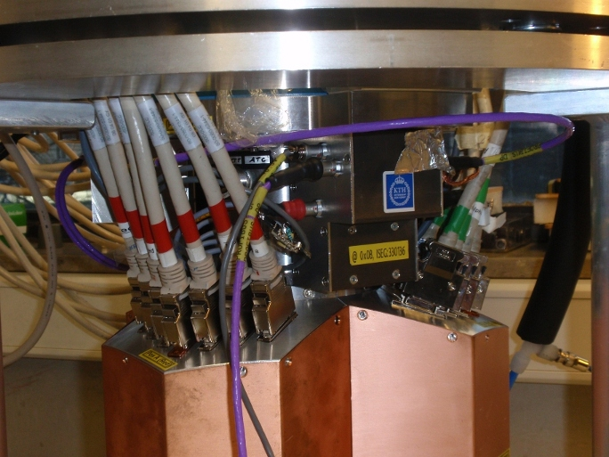

First test just one detector (red – A003) was equipped with high and low voltage. The signal was clean up to full HV (4500 V).

Red Core FWHM ORTEC @ 60 keV: 1.32 keV
AGATA HV: 1.34 keV
AGATA HV without Profibus: 1.29 keV

The energy resolutions as well as the FFT spectra show just minor changes between the configurations with connected and disconnected Profibus. The FWHM is almost the same for ORTEC and AGATA HV supply.

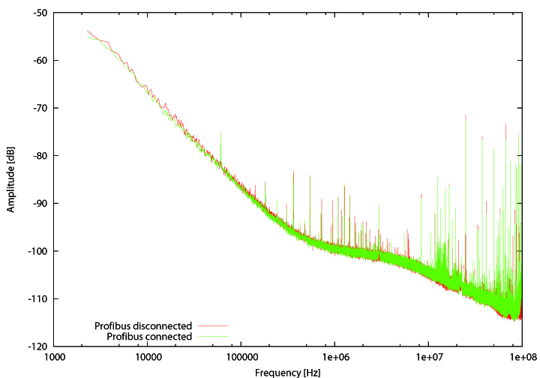
Figure 3: Red detector (A003) with connected (red curve) and disconnected (green curve) Profibus

Detector C005 (blue) was connected as second detector. This had no influence on the first (red) detector. Neither FWHM nor FFT spectra were affected by the second detector.

Blue Core FWHM ORTEC @ 60 keV: 1.30 keV
AGATA HV: 1.31 keV

The energy resolutions are very similar for ORTEC and AGATA HV supply. The FFT spectra are the same for the configurations with connected and disconnected Profibus also on the blue detector C005.

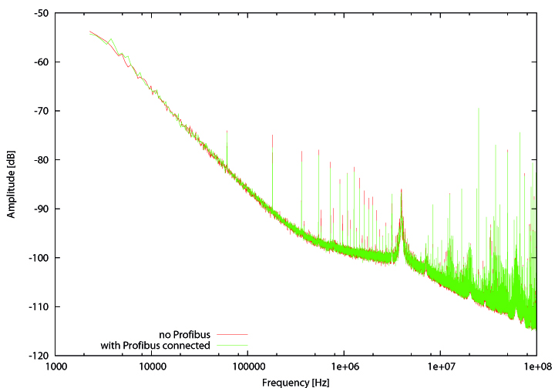

In the next step all the three detectors were ramped via AGATA HV supply. The FFT spectra for the red core are shown in figure 5 where the influence of the amount of powered detectors is investigated. The spectra are similar for one, two and three powered detectors.
The instability of the baseline has not been observed in the tests in December and this described test of the HV boxes.

Crosstalk analysis of ATC2

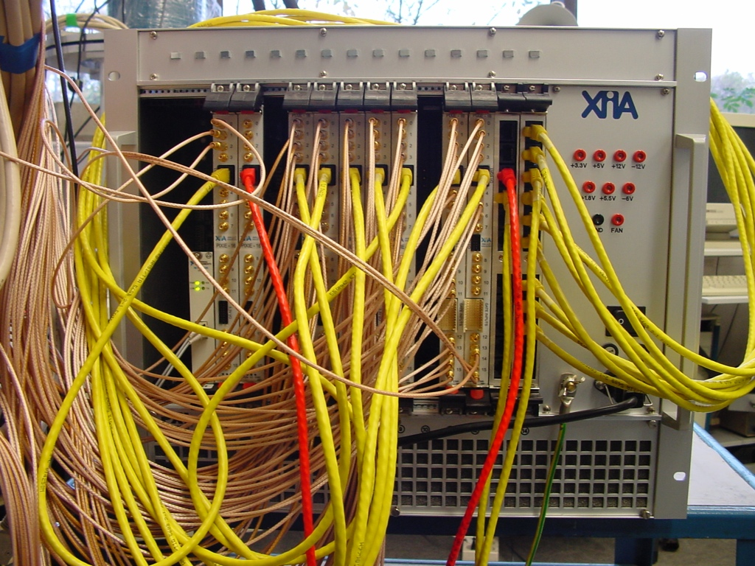
Three different kind of data was recorded with PIXIE 16 modules. Approximately 500 Gbyte of listmode data (20 ns traces), 300 Gbyte of traces (20 µs) and 100 Gbyte of short traces (2 µs) were taken. Caesium and Cobalt sources were placed around the detector to get enough statistics in all segments with a reasonable count rate below 10 KHz in core. For the third detector six segments were missing, due to missing electronic module.
Linear correlation between core energy and segment response on the 10-4 level. The segment data used for the plot are mean value for different core energies.

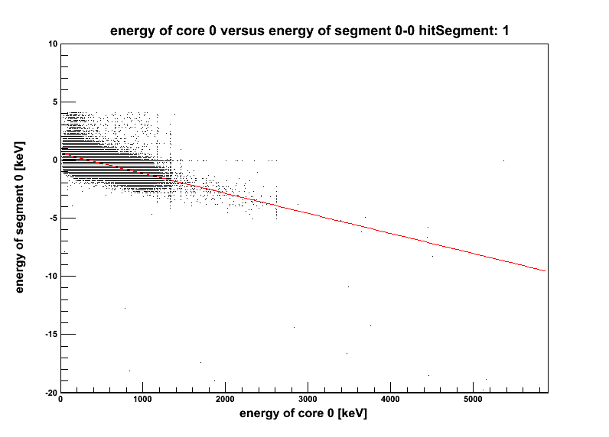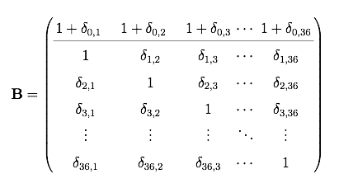

10920 individual matrix elements of cross talk correction matrix determined employing single method.
Expected cross talk contributions ~ 10⁻³ (blue areas) observed within the detectors, cross talk level between detectors <10⁻⁵ (yellow areas).

Figure shows values of matrix elements of
105 x 105 matrix.
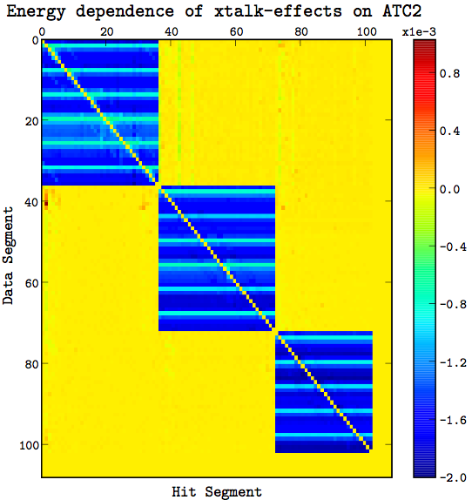

Status of third Asymmetric AGATA Triple Cluster

The third AGATA triple detector was electronically tested and annealed at IKP by CTT. The detectors A002, B006, C003 were mounted. Before mounting some bumps were observed at the B006 capsule. The detector was powered up in week 6, 2009 for the first time. All channels showed signals. Individual detectors do not oscillate. However: leakage current of two segments of B006. Ongoing tests.

Status detector test A005 at CEA
The AGATA detector A005 was tested at CEA Saclay, from December 2008 to February 2009 in the Saclay test cryostat equipped with AGATA preamplifiers. The energy resolution was measured with a standard Ortec 571 spectroscopy amplifier at 6µs shaping time with 241Am, 60Co and 57Co sources and a PC based MCA system. The detector was biased with the nominal HV of +5000V. The measured resolution of the core and the segments were within the specifications (see Tab. 1, Tab. 2 and Fig. 1).

Core FWHM at 122 keV = 1.12 keV
FWHM at 1173 keV = 2.08 keV
FWHM at 1332 keV = 2.23 keV

 | A | B | C | D | E | F
1 | 1.23 | 1.15 | 1.02 | 1.26 | 0.98 | 1.21
2 | 1.13 | 0.98 | 1.08 | 1.02 | 1.02 | 1.06
3 | 1.09 | 1.01 | 0.90 | 0.96 | 0.99 | 1.09
4 | 1.04 | 0.99 | 1.03 | 0.99 | 1.19 | 1.09
5 | 1.02 | 1.04 | 0.98 | 1.00 | 1.03 | 1.02
6 | 1.01 | 0.94 | 0.87 | 0.95 | 1.03 | 1.02
Table 1: Segment resolution at 59.5 keV (in keV FWHM). The average resolution at 59.5 keV is 1.04 keV FWHM.

 | A | B | C | D | E | F
1 | 2.24 | 2.19 | 2.11 | 2.20 | 2.01 | 2.21
2 | 1.95 | 2.11 | 1.95 | 1.90 | 2.22 | 1.93
3 | 2.02 | 1.95 | 1.89 | 1.97 | 2.06 | 2.07
4 | 1.96 | 1.92 | 2.04 | 2.00 | 2.25 | 2.04
5 | 1.96 | 2.00 | 2.02 | 2.06 | 2.04 | 1.89
6 | 2.01 | 1.93 | 1.99 | 2.03 | 1.99 | 2.09
Table 2: Table 1: Segment resolution at 1332.5 keV (in keV FWHM). The average resolution at 1332.5 keV is 2.03 keV FWHM.
Crosstalk
Unresolved problems, needs more investigations

Acceptance test of detector B001
The test of the capsule B001 was performed in the Daresburry test cryostat equipped with GANIL preamplifiers. All energy resolutions were measured with a standard ORTEC 572 spectroscopy amplifier with 6μs shaping time and a PC based MCA system. The detector was biased with 4500V.

Core resolution (4000 V): ΔE = 2.90 keV at 1173.2 keV
ΔE = 3.00 keV at 1332.5 keV
(4500 V): ΔE = 3.23 keV at 1173.2 keV
ΔE = 3.26 keV at 1332.5 keV

Segment resolution at 59.6 keV:
 | A | B | C | D | E | F
1 | 1,15 | 1,07 | 1,07 | 1,08 | 1,18 | 1,05
2 | 0,93 | 0,92 | 0,95 | 0,98 | 1,01 | 0,94
3 | 0,99 | 0,99 | 0,96 | 0,98 | 0,97 | 0,97
4 | 1,04 | 1,05 | 1,02 | 1,08 | 1,12 | 1,07
5 | 1,07 | 1,09 | 1,08 | 1,13 | 1,17 | 1,12
6 | 2,62 | 1,02 | 0,94 | 2,72 | 0,99 | 1,00

A resolution of 3.26 keV at 1,33 MeV was measured on the core signal with a shaping time of 6 µs.
The resolution was also measured with a shaping time of 3 µs: 2.70 keV at 1,33 MeV.
The improvement of the resolution from 6 µs to 3 µs indicates leakage currents.

All the segments were measured at 60 keV. The segments A6 and D6 are far out of specification. Therefore these segments were checked for leakage currents.

Core | 6 µs | 2,88
 | 3 µs | 1,89
A6 | 6 µs | 2,62
 | 3 µs | 1,49
D6 | 6 µs | 2,71
 | 3 µs | 1,86

This behaviour of the two segments indicates leakage currents as well.

The segment A6 is unstable in time. A good energy resolution of 1,13 keV and 1,33 at 60 keV has also been measured. The change occurred without any obvious reason.

Conclusion

The AGATA detector B001 does not meet the specification concerning the resolution measured for the core and two segments. The reason might be a damage of the contact or the implantation layer of A6 and D6 which is causing the leakage current. We recommend returning the detector to Canberra.

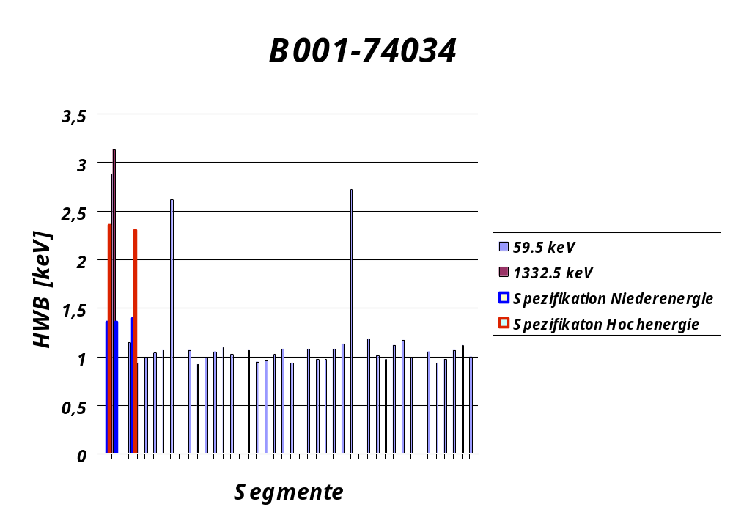

Status report of C001 TUM-test cryostat

C001 detector was used at Liverpool for scanning, suffered from warm up under HV.
Test cryostat and detector C001 was shipped back to Liverpool in January 2009, started operation

Import of turkish AGATA detectors

Detectors A004, B004, C004 at Ankara can be shipped back to Cologne, Germany or other country?
In Germany the situation with german customs is the following: Only limited temporary usage of up to 24 months is possible without payment of 19% VAT. An extension beyond the 24 months can only be approved for a limited time period based on a well defined reason. E.g. delays at the customs office.

No customs (Zollbefreiung, for university, research reason)
however taxation Wareneinfuhrumsatzsteuer equivalent of 19% VAT,
based on §553 Zollkodexdurchführungsverordnung, vorübergehende Verwendung
Hauptzollamt Köln/Wahn
Hr. H. Luckas,
phone 02203-3580111
e-mail: holger.luckas@ZAK-Wahn.bfinv.de

