AGATA Pre-processing Hardware.

Contents
1. Contents 1
2. Introduction 2
3. Overall design philosophy 3
4. Functionality and interface specification 5
4.1. Functionality 5
4.2. Interfaces 6
4.2.1. Inputs 6
4.2.2. Outputs 7
5. Advanced Switching Backplanes 7
6. Implementation 8
6.1. Overview 8
6.1.1. Functionality 9
6.2. Mezzanine Implementation 10
6.3. Core and segment Mezzanines 10
6.3.1. Core and segment Mezzanine card input stage: 10
6.3.2. Core and segment mezzanine processing: 10
6.3.3. Slow control: 11
6.3.4. Self Test and diagnostics (mezzanines): 11
6.3.5. Data readout from mezzanine to carrier: 12
6.3.6. Mezzanine to carrier interfaces 12
6.4. GTS mezzanine: 12
6.5. Trigger/Control Sequence: 13
6.6. Diagrams of Mezzanines 14
6.6.1. Diagram showing segment mezzanine (above) 14
6.6.2. Diagram showing Core mezzanine (above) 15
6.6.3. Diagram showing mezzanine optical links to/from digitiser (above) 15
6.6.4. Diagram showing GTS Mezzanine (above) 16
6.7. Carrier Implementation 16
6.7.1. Introduction 16
6.7.2. Crate description 17
6.7.3. Card structure- Physical aspects: 17
6.7.4. Acquisition Data Path 18
6.7.5. Trigger system 18
6.7.6. Clock management and reset system 19
6.7.7. Hardware management 19
6.7.8. Local FPGA Management 19
6.7.9. Power supply management 19
6.7.10. Slow control 19
6.7.11. Power supplies 20
6.7.12. Self Test & Diagnostics 20
6.7.13. Embedded software 20
6.7.14. Carrier diagram 20
7. Summary of connections 21
8. Maintenance 25
9. Approximate Costings 26
10. Timescale and manpower 27
10.1. Original GANT Chart 28
APPENDIX A Advanced Switching for the AGATA readout chain 29
APPENDIX B Digitiser to Pre-Processor Interface Document 40

Introduction

The job of the AGATA pre-processing hardware has been discussed and refined in several meetings and this document reflects the situation following the June 2003 discussions in Munich. It was updated again in February and November 2005 during the design process to include more detail. In essence the role of the pre-processing system is to take data from the digitiser system, extract all the useful data which can be calculated on a per-channel basis in real time, and pass on these parameters, along with the leading edge of the digitised trace from the incoming pulse, to the Pulse Shape Analysis (PSA) system. The pre-processing also interfaces with the Global Trigger and Clock system from which a clock for the digitiser and timestamp information is derived. In some cases the front end data rate might exceed the processing capacity in the PSA, or one of the following data acquisition systems (tracking, event building or tape server). The global trigger mechanism can be used to reduce the front end data rate in these cases by pre-selection based on criteria such as multiplicity (number of active crystals) or coincidence with ancillary detectors or coincidence with beam pulses. The Global Clock and Trigger mechanism also provides the path for control and status reporting. The pre-processing hardware receives and transmits all control/status data for both itself and its associated digitiser.

The overall philosophy is explain in a little more depth in the next section. The functionality and interface specifications are defined in section 4. Initially a phased implementation (mezzanines mounted first on CPCI carriers, then later on ATCA/AS carriers) was planned so as to make best use of available technology which will be current when the AGATA demonstrator system is built (and later when the full AGATA system is built). This approach allowed us to defer the decision to use ATCA until we could see whether it gained market acceptance. In this context the emerging technology of Advanced Switching backplanes is a key element and is allocated a section of its own. In December 2004 the proposed 2 stage approach (CPCI, then ATCA) was replaced and a decision made to go straight to ATCA because delays had taken us past the planned ATCA decision date (mid 2004).

This document is the final draft. It has been revised following the meeting in Orsay (3/9/03) and revised again following discussions at the AGATA week in Italy (15-19 September) and after email discussions since September 2003. It takes into account the December 2004 decision to go straight to ATCA. The design will be frozen following the Feb 2005 AGATA week and any changes agreed during the AGATA week will be incorporated in this document.

Overall design philosophy

A schematic diagram is shown below. The local level processing hardware elements (digitiser, pre-processing and PSA) are shown and also their interfaces to global level processing. The pre-processing electronics is shown in dark green.

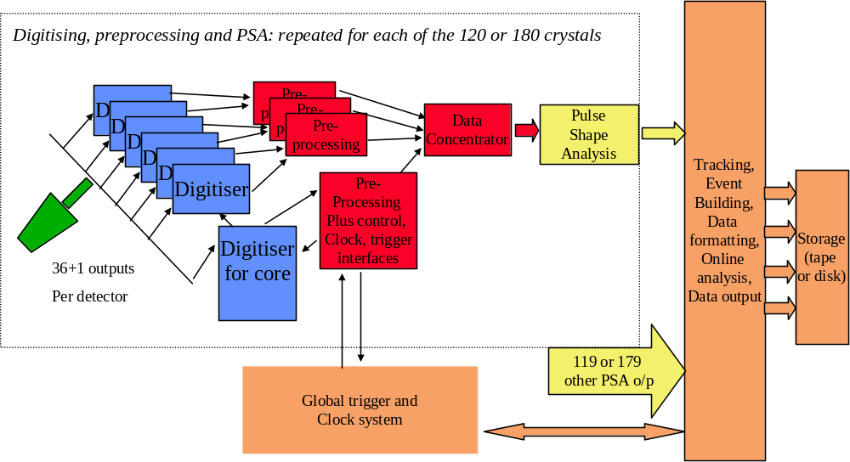
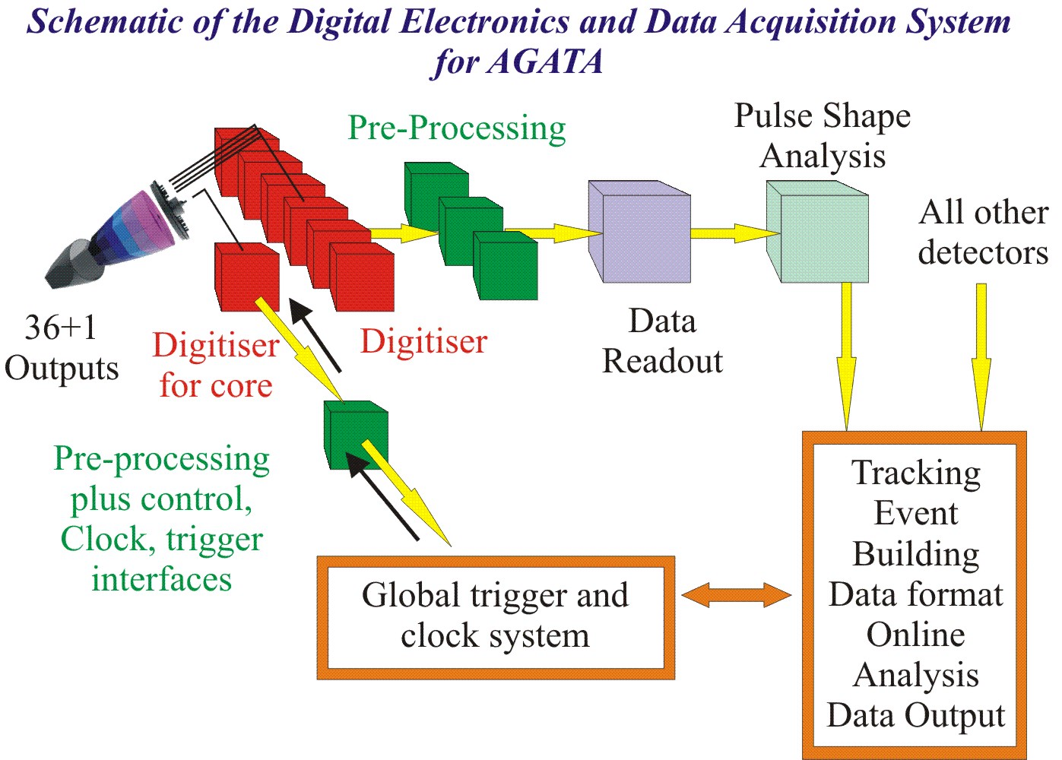

The overall design philosophy treats each crystal (core plus 36 segments) as a separate entity. Within that entity the core is treated differently to the segments. The core signal is formed by the superposition of the charge released in all the interactions in all 36 segments of the detector. So it can be used as a trigger for the whole crystal.

The counting rate in the core contact is much higher than that in any of the segments; to a first approximation it is 36 times higher (without taking into effect the segments affected by induced charge from neighbouring segments). Since the segment electronics is triggered by the core, the rate at which the segments collect data traces is the same (high) rate as the core contact. The processing rate for traces in the segments will, therefore, be the same as in the core, although many of the traces will contain no data and will be rejected by a zero suppression algorithm.

The need for triggering in the core requires special interconnections with the segment electronics and also with the global triggering system. Since this connection is already made for the triggering, it will be used also as the interface point for receiving the clock, timestamps and control commands and for reporting status. So the core contact electronics will be the master and the segments will be controlled from it.

The fibre links from the digitiser electronics will mainly be unidirectional (transferring data from digitiser to pre-processing). However, the core contact fibre will be bi-directional (full duplex) so that clocks and control signals can be sent to the digitiser. Examples of control signals would be the offset for the baseline compensation DAC and synchronisation test pulses. One slow fibre will be provided for each group of 6 segments to control the offset DAC at the digitiser segment inputs (and any other parameters requiring a feedback path from the pre-processing- the necessity for this link will be reviewed after the prototype tests).

The pre-processing hardware will take the incoming data streams and store traces started by the crystal level trigger information derived from the core contact (and optionally validated by the global trigger system too). The traces will be processed to extract parameters such as energy, time and preamplifier time over threshold (pion overload energy, based on the preamp “inhibit” signals sent on the top (D15) data bits from ADCs), before passing on the leading edge of the pulse trace to the PSA, along with the parameters. Other pre-processing that could reduce PSA processing effort can also be performed if discussions with the PSA group identify any useful parameters, for example rough “seed” values might well help the iterative PSA algorithms converge to a solution more quickly and zero suppression of empty segment traces can be performed. A data concentrator is shown at the output of the pre-processing, feeding all the data from one crystal out down one data link, providing a single interface point to the PSA for each crystal.

The digitising speed will be 100MHz, so the pre-processing hardware will be designed to cope with 100MHz clock rates.

The Global Trigger and clock System (GTS) interface provides the system clock, a mechanism for broadcast/multicast commands and a trigger system. The trigger system can be used to reduce the counting rate, for example by a multiplicity filter or by a coincidence requirement with an ancillary detector or with beam pulses. Where rate reduction is not required, the pre-processing runs in triggerless mode which means that all the processed data are sent on to the PSA stage. In this case a software trigger is performed downstream, after PSA and tracking The maximum delay (latency) which can be accommodated in the pre-processing hardware while the GTS trigger decision takes place has implications for the amount of storage required in the pre-processing. It is estimated that up to 20us of trace length could be needed for processing and therefore the maximum trigger latency will be 20us. Lower values can be configured, but coincidences with more than 20us delay will be detected in software triggers.

During 2005 a new requirement arose for a fast (<1us) trigger signal to be used by ancillary detectors. The delays (latency) introduced by the serialisers/deserialisers and the transfer from digitiser to pre-processing are about 500ns, so the fast trigger can’t be generated in the pre-processing since the trigger algorithm itself will add at least 300ns more latency. It will be implemented in the digitiser and the signal will be available at the digitiser. It will also be transmitted via a synchronous fibre from the digitiser core (no serialising/deserialising) to the pre-processing, and will be available via a Lemo00 (fast NIM) output from the pre-processing cards as well as from an isolated output on the digitiser cards.

Functionality and interface specification

Functionality

The pre-processing hardware will contain these conceptual blocks:
- Fibre data receivers and transceivers with serialiser/deserialiser logic to interface with the digitiser electronics
- Groups of processing elements to find, store and process traces from groups of 6 segments.
- A processing element to trigger segment electronics based on observing the core contact input data stream and the global trigger interface. This part will also store and process traces from the core contact
- Global trigger/clock system interface
- Data concentrator and PSA interface

The pre-processing hardware will be reprogrammable using Xilinx FPGAs. (The optimum device family will evolve with time- in 2003, a Virtex 2 Pro would be the best, but they will be obsolete by the time the full AGATA is built!)

In addition to the normal control interface via the Global Trigger and Clock system, there will also be an interface via the host bus system (e.g. PCI-Express) and an Ethernet control port.

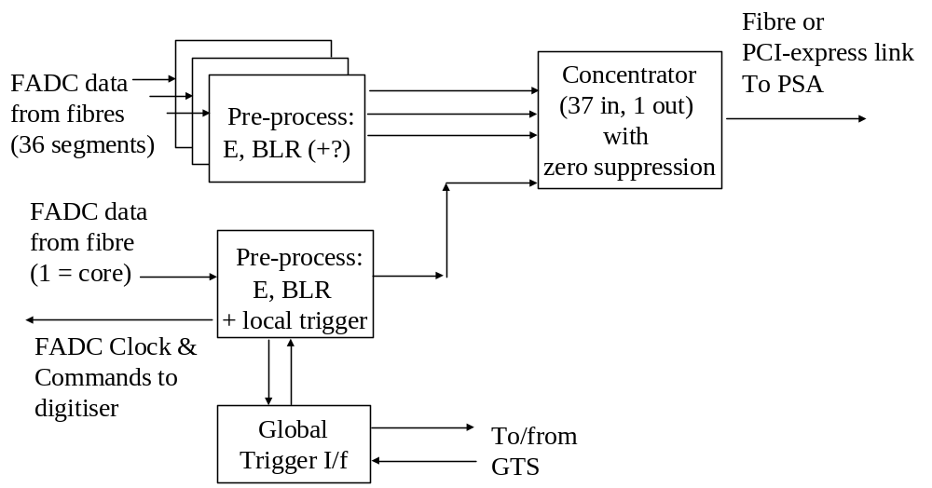

Physically these blocks will be implemented using a carrier/mezzanine system. The mezzanines for the core and segments will contain the fibre data receivers, transmitters, serialiser/deserialiser logic and processing elements. Another mezzanine will handle the interface to the global trigger/clock system. The carrier card will handle the data concentration and PSA interface. These modules are all described in detail later (section 6)

Interfaces

A summary of the pre-processing interfaces is given here. The interfaces to the digitiser, GTS and PSA are defined in detail in other documents:
- “Digitiser <-> Pre-processor Interface Document v1.0” (Bruno Travers)
- “AGATA Global Trigger and Synchronisation Hardware v1.2 October 2004” (Marco Bellato)
- PSA interface specification is not yet written

Inputs

- Digitiser Interface
  - 36 digitised segment ADC signals in groups of 6 with 6 additional fibres whose use is described below (12 way multifibre per group of 6 segments)
    - Transmitted over unidirectional multifibre connections.
    - Data is converted to/from serial format before/after transmission.
    - Data rate will be 80 or 100MHz, 2 bytes wide; 1.6G bits/sec of data per digitiser which requires a link data rate, including balancing bits etc. of about 2Gbits/sec. (NB this is rate is independent of counting rate- it comes from digitising 100% of the incoming signals regardless of whether they contain pulses. Thus it is independent of all physics considerations and can only be increased by upgrading the ADC.)
  - Offset Acknowledge from segment: indicates that offset has been updated (uses MGT)
  - Spare high speed channel from segment with MGT
  - 4 low speed logic channels from segment (100MHz clock with coded missing pulses)

  - 2 digitised core ADC signals (no further spare ADC channels)
    - Transmitted over bidirectional (multi)fibre connections.
    - Data is converted to/from serial format before/after transmission.
    - Data rate will be 80 or 100MHz, 2 bytes wide; 1.6G bits/sec of data per digitiser which requires a link data rate, including balancing bits etc. of about 2Gbits/sec.
    - The 2 links are connected to the 2 digitiser channels set up to use different gain ranges (6/20MeV) and in the event of an error the digitiser channel attached to the working fibre will be reconfigured to the more important gain range for the experiment in progress.
  - Synchronous fibre from core: fast trigger signal to ancillary detectors (no MGT)
  - Synchronous fibre from core: sync return signal (no MGT)

- Global Clock and Trigger interface
  - Transmitted over bidirectional (multi)fibre connections to GTS mezzanine.
    - Data rate is <TBD>
    - To be defined in discussion with GTS team (led by Marco Bellato)

Outputs

- Global Clock and Trigger interface
  - Transmitted over bidirectional (multi) fibre connections from GTS mezzanine.
    - Data rate is <TBD>
    - To be defined in discussion with GTS team (led by Marco Bellato)

- PSA Interface
  - 1 data stream from the whole crystal
    - Data Rate up to 370Mbytes/sec (i.e. 3.7Gbps including balancing bits). If zero suppression is used then the maximum output data rate is reduced to 160Mbytes/sec (i.e. 1.3 Gbits/sec data over a 1.6 Gbits/sec link)
    - Details of interface will be implementation dependent.

  - Output Data Parameters to PSA
    - Identifier word (which detector, which segment?)
    - Timestamp (48 bits or less if the data is sent in timeframes)
    - Event number (4 bytes)
    - Leading edge of the trace (600ns)
    - Energy word, and confidence/quality factor word
    - Other parameters with quality/confidence factors

- Output to Digitiser
  - Control commands received from Global Clock/Trigger system
  - Separate fibre for pure 100MHz Clock for digitisers- no associated commands are sent on this fibre and no clock recovery is needed in the digitiser (The clock itself is recovered from the incoming GTS command serial bit stream by the GTS mezzanine)
  - A fibre for the sync pulse (used to line up all the clock in all channels)
  - Offset correction values (sent via shared low rate (10Mbits/sec) fibres 1 per 6 segments and via a dedicated high speed (1Gbit/sec) fibre for the core)

Advanced Switching Backplanes
Conventional backplanes use a single bus over which data are transferred. The basic problem of such systems is that the data transfer bandwidth of the whole crate is defined by the backplane bus limitations. Various clever protocols have been developed to transfer data synchronously and some even send data synchronously using both clock edges. Bus widths have been increased from 32 to 64 bits and parallel local buses have been implemented (for example VSB in VME crates). These tricks allow data rates of several hundred Mbytes/sec in the fastest versions of VME and Compact PCI (CPCI). Indeed the fastest version of Compact PCI would have been sufficient for a single crystal prototype system for AGATA pre-processing. However for the AGATA demonstrator its is necessary to find something faster.

Advanced switching backplanes overcome the bandwidth problem by implementing many fast serial point to point connections, These connections set up simultaneous high speed independent data paths between processors, data sources and data sinks within a crate. So now the data transfers can all take place in parallel rather than one after the other over the single backplane. The point to point links are differential pairs and often use special high speed connectors to support the GHz serial data rates.

New concepts in Advanced switching backplanes include the topology of the point to point links and the routing protocols. The simplest topology is a star configuration with a special packet routing switch at the centre of the nodes; the most complex is a mesh where any node can talk to any other. Other topologies exist too (e.g. dual star with 2 packet switches or a ring where nodes talk only to neighbours). Packet routing protocols permit sending data packets with built-in source and destination information rather than memory mapping over a backplane. Multiple destinations and routing information can be included.

Many Advanced Switching backplanes are under development and it is important for AGATA to select the right one. After watching the market for over 1 year we have decided to go straight to the PCI Express AS switching backplane. The reason for abandoning the 2 stage proposal (initially CPCI, evolving into PCI Express, but using the same mezzanines) is that the debates about the design took longer than expected and during that period the PCI Express format has reached a sufficient level of maturity to offer a safe solution at a reasonable price without a “disposable” intermediate step.

Fuller information and a detailed discussion of the benefits of AS backplanes for AGATA’s pre-processing are given in Appendix A.

Implementation

Overview

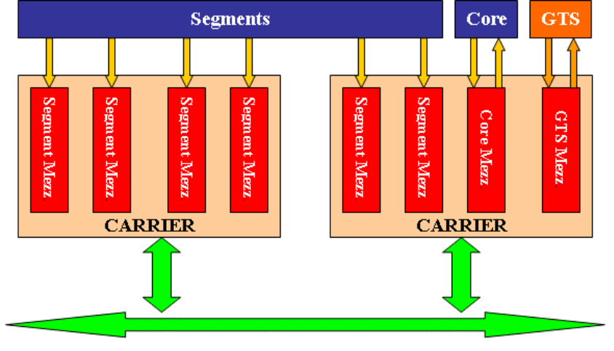

The design will be implemented using a mezzanine based approach, using CMC form factor.

The mezzanines will be mounted on ATCA carrier cards. They will accommodate 4 CMC mezzanines on each carrier. It is not our job to develop the ATCA infrastructure- but we have watched the market evolved as we expected to the point where the infrastructure is now (Jan 2005) available. As expected the telecoms market is adopting ATCA and so the infrastructure we need has become available as well as the security of using a standard adopted by a large commercial market.

Functionality
The role of the pre-processing is to take the continuous data stream from each of the digitiser’s ADCs and extract useful information to be passed on to the PSA.

The useful information is, as a minimum, a set of traces corresponding to a gamma-ray’s interaction in the detector. So, the first task is to decide which part of the incoming data stream is useful- this is achieved by running a digital trigger algorithm on the detector’s core contact data stream. When this trigger finds a pulse in the data it extracts a data trace and generates a local trigger output which indicates to all the segment electronics that they should also extract a trace from the data stream. Traces are stored locally, within each pre-processing channel.

At this point there are 2 options for how the pre-processing behaves. If the AGATA system’s data handling bandwidth can handle the full data from all gamma rays generated during the experiment then the pre-processing will just go ahead and put the traces in an output buffer. However, for reasons of either financial constraints in the AGATA EDAQ or over-ambitious raw gamma ray count rates it may be necessary to make a judgement on the usefulness of the pulses detected by the pre-processing, saving only the best ones. In this case the pre-processing enquires via the GTS about whether other detectors were also active in coincidence with this one and whether the GTS system’s criteria for saving the data are met. In this mode of operation the traces are held in each channel’s local memory for up to 20us while the GTS makes a decision. Either an event reject or an event accept response is generated for each local trigger based on the GTS decision. If the EDAQ bandwidth matches the gamma ray rate then no GTS trigger decision is made and the event accept signal is generated for all detected pulses.

For events which are accepted, the pre-processing stores a trace of the digitised leading edge of the pulse from the core and all 36 segments in a buffer waiting to be sent to the PSA.

NB- a lot of the segments will have no pulse and at this point we could save bandwidth by an intelligent zero suppression system. However, it is planned that the PSA will be powerful enough to make its own, more intelligent, zero suppression decisions and accept the full pre-processing bandwidth.

In addition to selecting useful portions of the incoming data steam using a trigger algorithm, the pre-processing will also apply other algorithms to the data streams.

The first of these algorithms is the Moving Window Deconvolution (MWD) algorithm to determine the gamma ray energy by filtering the incoming pulse digitally. In view of the high counting rates (at least on the core), it is expected that MWD with adaptive shaping will be used- this is more complex than the fixed shaping times in existing FPGA implementations of MWD.

The second algorithm is associated with the preamplifier’s inhibit signal. The inhibit is activated when the preamp is saturated by a pion (much higher energy than the gamma rays). The preamplifier recovers by injection of charge from a constant current source, so the length of the recovery time (i.e. the width of the inhibit pulse) is directly proportional to the energy deposited by the pion. The Inhibit from the preamps is sent from the digitiser in the previously unused to ADC data bit (D15). The width of the inhibit pulse is counted by the pre-processing (n x 10ns). The ADC baseline value immediately prior to the pion is known by the MWD algorithm and so it can be subtracted from the calculated pion energy to improve the accuracy.

Other algorithms might well be useful too. It would be possible to calculate time in the pre-processing- for example the trigger algorithm might be able to interpolate between clocks to generate an improved timing relative to the local trigger clock. It would also be feasible to calculate the timing in each segment relative to the local trigger so as to be able to recover data from piled up events where the core signal sees 2 events superimposed. Often in such cases the sets of segments active in the 2 events will be different, and the 2 events can be separated by segment timing relative to the local trigger.

The FPGAs in the prototype will be generously dimensioned for maximum flexibility (at a very small cost penalty) so that all options can be investigated before deciding on the devices to be used in the production version.

In addition to the trigger system described above, a CFD will be implemented in the digitiser to provide a fast (latency-free) trigger for use by ancillary detectors. The CFD output will be sent to the preprocessing over a fibre and then made available to ancillary detector trigger logic from the pre-processor.

Mezzanine Implementation

The following paragraphs describe the implementation of mezzanines in more detail. There are 3 types of mezzanine- the core, segment and GTS cards. Core and segment are very similar, differing only in detail such as the input fibre receiver footprint and the extra processing for finding triggers in the core. The GTS mezzanine is completely different, interfacing with the GTS system rather than the digitiser.

    - Mezzanine Size:
The ATCA carrier cards accept 4 CMC format mezzanines. Connection between CMC and carrier card is achieved by two connectors, each 114 pins (Manufacturer Mictor, distributor: Tyco).

Core and segment Mezzanines

Core and segment Mezzanine card input stage:
The input to the segment mezzanine from the digitiser will be via 12 fibre multi-fibres with 6 used for data transmitted from the digitisers. The other 6 inputs will be connected at both the digitizer and pre-processing ends, but have not yet been allocated a use. They are reserved for future use. (6 way multi-fibres are not available, so we get these spare lines for free). The fibre data receivers will produce one LVDS data stream for each input. For the core mezzanine it is planned to use almost the same PCB as the segment mezzanine but with a different subset of components mounted, different layout for fibre receivers/transmitters and a different program in the FPGA. The fibre link between core mezzanine and digitiser will comprise a quad transceiver (8 fibres) of which 2 will receive ADC data, generating LVDS data streams after deserialisation and 6 will be used to transmit and receive control signals at 100 Mbits/s from and to the digitizer part, for example the 100MHz clock, a Synchronisation pulse, ADC input offset and the output of the digitiser’s CFD algorithm.

Core and segment mezzanine processing:
The LVDS serial data streams will be deserialised using Rocket i/o ports in Xilinx Virtex2 Pro FPGAs. Data will be clocked into FIFO memories using the recovered clock from the serial link. At the FIFO output the clock can be either the global clock as received from the Global Trigger System (GTS) or that recovered from the incoming data. The FPGAs will not only receive but also process the data, using the MWD algorithm to calculate energy on all 38 input signals. The core signals will also be examined using a CFD algorithm to look for triggers. There was some discussion as to whether a DSP is useful at this point too- it wasn’t clear that fast floating point operations will be needed in the processing so the option of adding a DSP was noted in case it is found to be necessary during the design process, but it is not included in the costings. After some preliminary design work it was found that thermal constraints on the FPGAs force the data processing system to be split into 2 packages. A first FPGA (type XC2VP7) will deserialise the data stream via the Rocket I/O and handle the slow control via the embedded PowerPC. This FPGA will just send data to another larger FPGA (type XC2VP40) which will make all data processing and send results to the carrier board.

The output of these FPGAs could optionally be compressed if necessary to help reduce bandwidth, for example by transmitting only differences between successive samples. The core mezzanine has less channels but more processing (trigger algorithm and higher rate MWD operation) so is dimensioned the same as the segments. The main processing device chosen (XC2VP40) uses the same footprint as 3 other FPGAs. 2 are smaller (and cheaper) FPGAs (XC2VP20 and XC2VP30) and one (XC2VP50) is larger. Reducing or increasing the FPGA size if necessary when the algorithms are implemented is simply a parts list change with no PCB rework.

In order to set the baseline correction DACs in the digitiser channels, a baseline value must be transmitted from the pre-processing to the digitiser. Two methods are possible for transmitting this data. First, for the prototype, we will add a single fibre per group of 6 segments from pre-processing to digitiser. This fibre adds cost and complexity to the system so the need for it will be reviewed during prototype tests. An alternative is to send the baseline DAC value from each mezzanine to its carrier and then on to the centre contact TX fibre (in this case only the centre contact has a TX as well as RX fibre). The baseline information is transmitted over a special bi-directional 3 wire serial interface between carriers and mezzanines which allows for time sensitive data to be transmitted (the response time of the local Ethernet is not guaranteed on the ms timescale required for baseline correction). The 3 wire serial interface is connected between carriers by the local TCLK port alongside the trigger and timestamp information. This time-sensitive link will be retained anyway in the pre-processing to provide a fast communication path between channels.

Details of the control of the baseline offset DAC must be defined soon with the digitiser group and also the preamplifier group since the preamplifier reset will change the baseline dramatically at high counting rates, and we must remain within the digitiser ADC’s safe input voltage levels.

Slow control:
On the carrier the Ethernet connection (RJ45) will be connected to a media converter and then, using Media Independent Interface (MII), connected to a software switch in the FPGA power pc on the carrier card. From the carrier card, MII links will connect the Ethernet to the other mezzanines. In this way the high current external interface for Ethernet is only done once. The software switch is a standard switch implemented by Xavier Grave within his own Linux implementation (this software is completed). 4 signal pairs per mezzanine are reserved for Ethernet connected to the power PC (PPC) embedded in one of the on-board Virtex 2 Pro chips which will act as master. This PPC will run Linux and include a simple web server for control. 32Mbytes external RAM are included for this PPC. Some of this memory can be used for the traces to be collected in diagnostic mode when the rate doesn’t matter. 16Mbytes = 8Mwords = 8.10⁶ * 10.10⁻⁹ = 800ms.

Self Test and diagnostics (mezzanines):
A JTAG port will be provided for boundary scan data path testing and also for FPGA programming. Extensive self test and diagnostics will be built in to enhance the system reliability and fault detection/correction performance. Temperature monitoring will be provided. DACs will be connected to the FPGAs to allow visualisation of data as analogue signals to help debugging. The resulting inspection line(s) will be available on the front of the mezzanines via Lemo 00 or similar connectors. A USB interface is also planned in order to have a standalone debug system.

The segment and core mezzanine provide external memory that can be used, for example, to store long traces. For the segment card, six 64k-bloc memories are embedded allowing a 3.9ms trace for one channel or 650µs for 6 channels. Concerning the core board, three 64k-bloc memories are available.

Data readout from mezzanine to carrier:
The mezzanines will not have large derandomising memory, so the design should accommodate a maximum throughput rate of twice the expected maximum average rate. Average rate is 200bytes x 6 channels x 50kHz (60Mbytes/sec) so the maximum throughput should be 120Mbytes/sec. To accommodate this bandwidth, a 32 bit data width bus will run at 100 MHz with 4 control signals (about 400 Mbytes/s).

Since the trigger algorithm response can not be shorter than 1 µs and the GTS Validation timing can not be longer than 20 µs, the internal FPGA memory can store up to 20 events waiting for readout (1 event = 6 traces + 6 energies + TimeStamp + EventNumber).

Several options have been discussed in order to handle this rate. The use of high rate serialised data is not possible because the connectors are not designed for GHz operation. So rates of up to 100MHz are possible. One option would be to have 48 bit wide data path from the mezzanine FPGAs (16 bits/FPGA) which would transfer 300Mbytes/sec at 50MHz. These 48 bits could be serialised/deserialised onto 9 LVDS pairs of signal lines using, for example, DS90CR481/482 which could simplify the carrier PCB routing.

The data will be checked in the carrier’s Virtex 2 Pro to ensure consistency of the timestamps. The use of an event number in addition to the timestamp was discussed and it was found that it could give useful information to PSA, for example during synchronisation checks. So event numbers will be transmitted to the carriers by the GTS mezzanine when the GTS system provides a trigger. In triggerless operation an event number is not meaningful so a dummy event number (either locally incrementing counter in GTS mezzanine or maybe fixed data value) will be transmitted in the event number field.

Mezzanine to carrier interfaces
In each of the 114 pin connectors, 10 pins are used for power supplies and their grounds, leaving 104 pins for signals:
- Data readout path,
- Trigger path ( Timestamp, local trigger…)
- Slow Control (Ethernet)
- GTS clock
- Communication signals between mezzanines(“Message” and “Broadcast”)

For full details, refers to the “Summary of connections” chapter.

GTS mezzanine:
The GTS interface will be handled by a special mezzanine card which will interface to the GTS system and distribute trigger signals to the whole crystal. The internal (TCLK) interface of this mezzanine is described below; the external (GTS) interface is specified elsewhere [AGATA Global Trigger and Synchronisation Hardware v1.2 October 2004].
The TCLK port will be implemented at the back of the crate due to limited front panel space. It will use the user defined part of the ATCA backplane.

The GTS mezzanine will send information to/from a local TCLK (Trigger and Clock) port . The port will distribute the following information to the other carriers and hence to the mezzanines:
- Global clock (recovered) (transmitted via dedicated connectors)
- Local (Crystal level) trigger
- Trigger Validation
- Timestamp (sent 8 bits at a time to save pins)
- Event Number
- Communication signals between mezzanines ( “Message” and “Broadcast”)

It will also receive flow control (backpressure) signals from each carrier when, for example, the core mezzanine or the carrier buffers reach some predefined point such as ¾ full.

Trigger/Control Sequence:
The mezzanine connected to the core contact will handle the triggering and control. When it detects a possible event it generates a local trigger request which is sent to the GTS mezzanine. In response to this request the GTS mezzanine will generate a local trigger and latch a timestamp which are distributed to all the mezzanines (via the local GTS port in the GTS mezzanine). The GTS mezzanine also sends a trigger request to the GTS through the GTS hierarchy and if the trigger condition is met, it receives a trigger validation from the GTS within 20us. The trigger validation (or rejection) is passed to the carriers and back to the other mezzanines along with a timestamp identifier (matching the timestamp of the original local trigger from GTS). When running in triggerless mode the trigger validation is automatically generated by the core contact mezzanine a fixed delay after the local trigger.

It was agreed in June 2004 to make the trigger decisions in the GTS mezzanine rather than replicating the logic in each of the segment and core mezzanines. Therefore the timestamp will not be continuously broadcast by the GTS mezzanine. Instead it will be used as a data label and sent with the local trigger (and again with the validation or reject signal). Note that the centralised decision mechanism means that explicit rejections must be sent for events which are not validated. An event number is required by the software so will be sent with validations as well as the timestamp value. The revised system is sketched below.

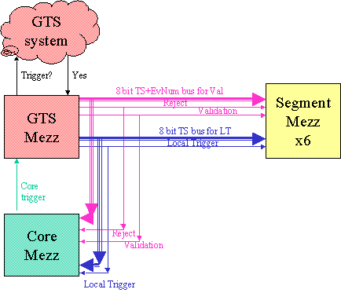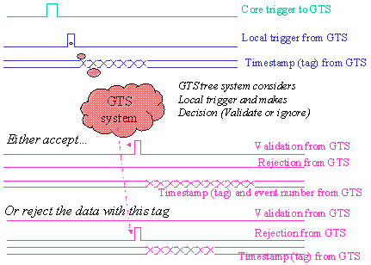

The core and segment mezzanines are now simpler because they don’t have to keep track of time. They can only measure time indirectly by using the local trigger as a time reference and measuring relative to the local trigger. A consequence of this is that the local trigger must be distributed to all mezzanines with low skew and a fixed relationship to the 100MHz system clock.

The actual value of the timestamp must be captured by the GTS with low jitter too, but distribution to mezzanines of the timestamp value is not time-critical because the essential time information is carried in the local trigger signal. To avoid contention when events overlap there will be 2 different 8 bit buses from GTS to the other mezzanines for the local trigger timestamp and for the validation timestamp.

The time between triggers is limited by the physics of charge collection in the Ge to at least 1us. So we have time to transmit a timestamp(6 bytes) + event number (4 bytes) within the shortest inter-trigger gap.

The local triggers will be time ordered, but it cannot be 100% guaranteed (yet) that the GTS will send the validations (or rejections) in strict time order. This is, however, a design objective and will be implemented if possible in GTS.

Diagrams of Mezzanines

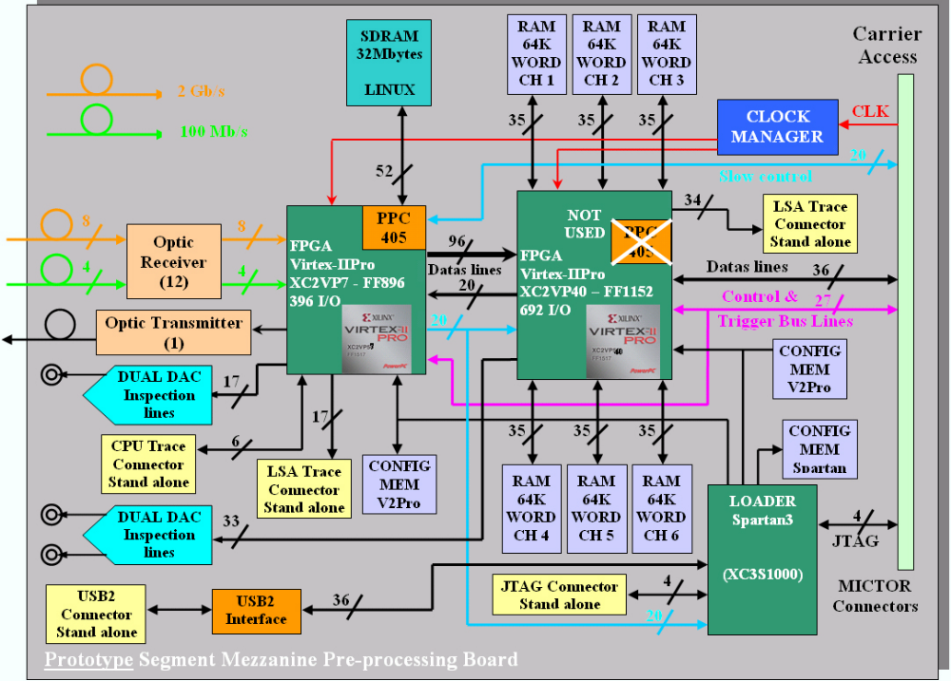

Diagram showing segment mezzanine (above)

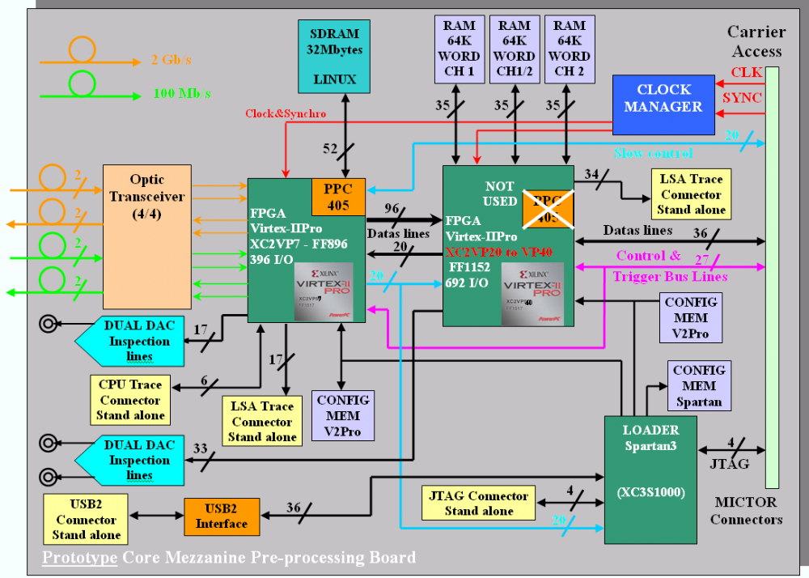

Diagram showing Core mezzanine (above)

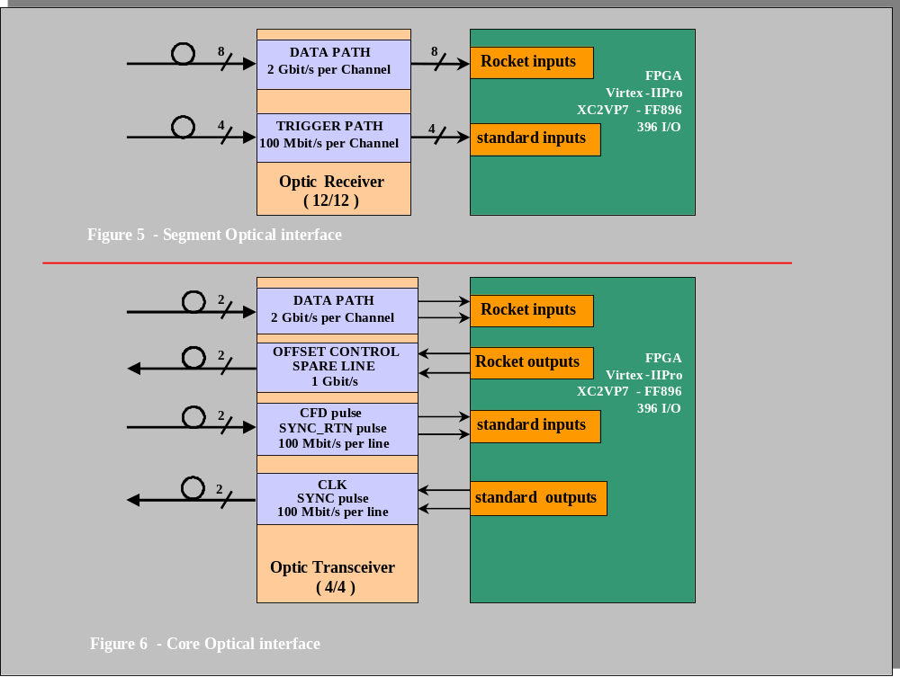

Diagram showing mezzanine optical links to/from digitiser (above)

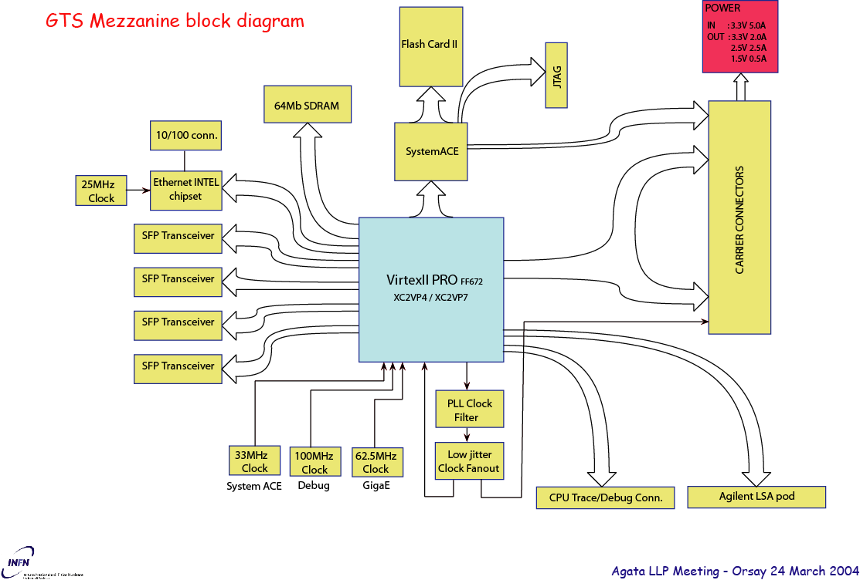

Diagram showing GTS Mezzanine (above)

Carrier Implementation

Introduction
The aim of the carrier board is to retrieve physical data from the mezzanine cards that contain the actual Local Level Processing Hardware. One carrier board will hold four mezzanines. One crystal will need one core mezzanine, one GTS mezzanine and 6 segment mezzanines. Hence, two carriers will exactly equip one crystal. The main functions of a carrier are the following:

- Retrieve acquisition data from the mezzanines and send it to the PSA facility through the high-speed ATCA lines of the backplane.
- Provide enough buffer storage (FIFO) to cope with random event occurrence and variable data consumption rate.
- Provide a communication system between the GTS and the other mezzanines, including those located on another carrier (through the TCLK port).
- Manage a ‘clean clock’ derived from the GTS mezzanine and distribute it to the rest of the hardware.
- Provide communication between the central slow control system and the mezzanines. This includes VHDL code and software download, calibration data and procedures etc.
- Derive and distribute the low voltage power supplies from the -48V available from the backplane.
- Provide debug and test facilities.

Crate description
Several types of ATCA crates can be used. The two main selection parameters are the width (slot count) and the nature of the backplane. The width can be 23 or 19 inches, containing 16 or 14 slots. The backplane can offer either a dual-star or a full-mesh interconnection scheme. No choice has been made at this time and the card prototypes will be designed to accommodate the largest possible configuration (16 slots / full mesh).

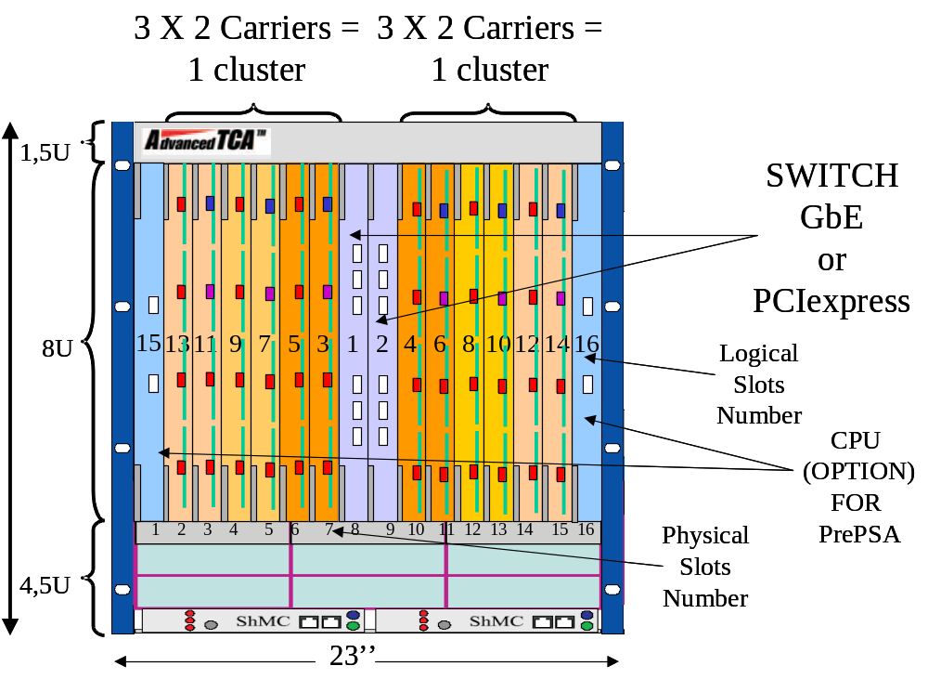
Diagram showing 23” crate 16 slots configuration

Each carrier card will provide four full-duplex serial links, each comprising two “lanes”. Each lane has a 2.5 Gbit/s (i.e. 250 MB/s) of raw data transfer bandwidth. The four links will be connected as follow:

- Two links will be routed to the two central slots of the crate (logical numbers 1 and 2). These slots will hold the Hub boards of the chassis. These two connections are provided as a standard in a dual-star backplane
- Two links will be routed to the two extreme slot-positions in the crate (i.e. logical numbers 15 and 16). These links will allow for an optional enhancement of the configuration with two local CPU boards. It should be noted however that a crate with 16 slots (23 inches) would be necessary in this case. A full-mesh backplane would increase the bandwidth between carriers and CPUs but is not mandatory since the CPUs can also communicate through the Hubs.
- All slow control links are performed through the “Base Fabric” infrastructure provided by the ATCA backplane (see slow control).

Card structure- Physical aspects:
The carrier card will comply to the ATCA standard i.e. 8 U (316 mm) in height and 280 mm in depth. Four mezzanine cards (74 x 149 = format PMC) will fit on the carrier. They will be located on the front of the card in order to provide a direct access to the fibre optics connectors to the external ADC system. Connexions between carrier and mezzanines will be provided by a set of two Mictor connectors (114 pins). Two additional connectors are provided for the power supplies on the Segment Mezzanines.

Acquisition Data Path
The mezzanine boards communicate with the carrier through a 32 bit / 100MHz parallel bus. An elastic buffer is provided after the mezzanines in the FPGA of the carrier through implemented FIFO memories. Simulations are planned in order to reduce the capacity (maybe to 0). The data parallel bus is bi-directional to allow for high speed communication between the mezzanine and the carrier FPGA. Communication can also be done through another path (Ethernet or message/broadcast).

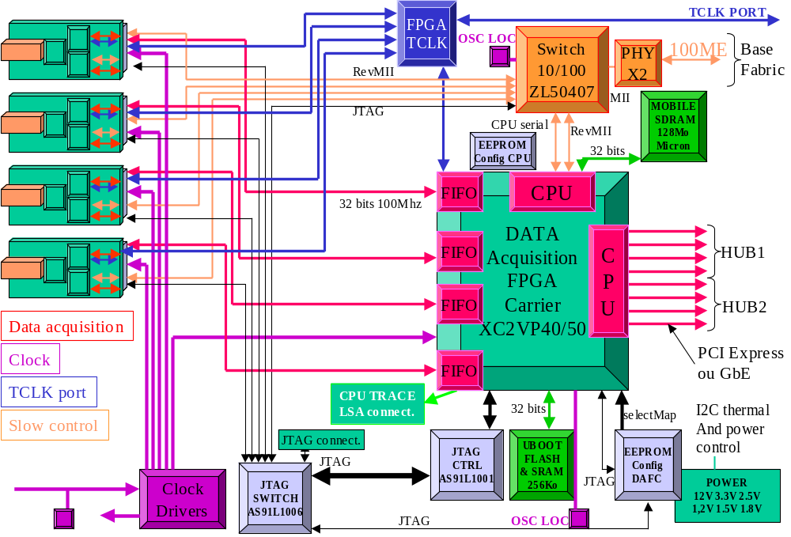
Carrier card: logical structure

Trigger system
The general trigger mechanism is the following:

- The core mezzanine detects a trigger condition based on the signal of his core-electrode and issues a Trigger-Request (TR) signal to the GTS mezzanine.
- The GTS mezzanine, upon receipt of the TR signal, issues (immediately) a Local-Trigger (LT) signal, together with a locally calculated Time Stamp (TS) to all segment and core mezzanines. Concurrently, it issues a request to the Central Trigger System (outside of the crate).
- After a certain time (to be defined), the Central Trigger System sends a Validation or Abortion signal and an event number if appropriate. The command is then broadcasted by the GTS mezzanine to segments and core. The original TS is also sent at the same time, together with the event number. It is not clear so far whether the order of received validations will be the same as the order of the trigger requests. (Many requests may occur before the first validation comes back and different validations could have different durations).

The carrier board will provide the hardware connections between GTS and local mezzanines as well as with mezzanines located on another carrier. Buffering and latching will be adequately provided to insure that all data are dispatched with equal logical delays. A special FPGA (SPARTAN 3) is dedicated to this function. The link between two carrier cards will be performed by a bus called TCLK-PORT. This bus will be located on the back of the card in the so-called Region 3 of the ATCA backplane. A dedicated connector will provide this function, together with a custom designed backplane section on the crate.

The message and broadcast busses allow for quick communications between the GTS system and all the mezzanines (like general start/stop abort, synchronisation). The protocol and functions will be defined in a later stage. An additional 8 bit + control bidirectional bus has been introduced for private communication between the master and slave carriers.

Clock management and reset system
Each carrier board has a local, autonomous clock generator. This clock will serve as a master clock to the main FPGA and the slow-control system (Ethernet and Embedded Power PC). The clock signal issued by the GTS card will be buffered and distributed by the carrier to all mezzanine cards (using a Motorola low jitter clock manager). However, a multiplexer will allow the selection of a locally generated clock for debugging purposes (for example if no GTS board is present/working).

Hardware management
The hardware management is performed by the shelf manager and the I2C buses which is connected to all carrier Boards. This allows for resetting, interrupting, changing carrier configuration etc.

Local FPGA Management
The code for the carrier and for the mezzanines FPGA will be loaded from the shelf management system via the backplane. The provided I2C interface may be used for this purpose. The system and protocols remain to be designed but the aim is to be able to reconfigure (reload) the whole hardware configuration by software, without any physical intervention. It should be kept in mind that a complete update will involve 2500 to 3000 programmable components.

Power supply management
All ATCA crates offer as a standard and advanced management system for the power supply.
All voltages are monitored by the ATCA shelf manager through I2C buses.

Slow control
The slow control system is entirely based on the 10/100 Ethernet protocol. The carrier board is accessed from the outside world through the Base Fabric Interface of the backplane. This interface is provided by each of the two central switch boards (logical slots 1 & 2). A Zarlink switch chipset assures the carrier to backplane interface and provides up to 8 local Ethernet busses (in the form of reverse MII interfaces). Four are used to communicate with each mezzanine and one with the local carrier FPGA. The slow control protocol is locally managed by the embedded PPC within each FPGA.

The high level layers of the protocol (application) will be defined later (Start/Stop, Calibration, Configuration, Command/Status, Debug…)

Power supplies
The aim of the power supply system is to convert the -48V available from the backplane into the various low voltages required by the mezzanine boards and locally by the carrier components. Most of the voltages are generated by local DC/DC converters. The core supply voltages of the Rocket I/O interfaces are provided by linear regulators fed from the local 3.3V.

The following table summarizes the requirements.
Name | Voltage | Usage | Current | Generated from | Note
P3V3 | 3.3V | Carrier + all Mez. |  | - 48V (back plane)
P2V5_RIO_x | 2.5V | Carrier (rocket-IO) |  | + 3.3V | (1)
P2V5 | 2.5V | Carrier + all Mez. |  | + 3.3V
P1V8 | 1.8V | Carrier eeproms |  | + 2.5V
P1V5 | 1.5V | FPGA Core |  | + 2.5V
P1V2 | 1.2V | FPGA Core (Spartan) |  | + 2.5V
P1V5M_y | 1.5V | Mez. FPGA Core |  | + 2.5V | (2)
P1V2M_y | 1.2V | Mez. FPGA Core (Spartan) |  | + 2.5V | (2)
P12V | 12V | Carrier + GTS Mez |  | + 3.3V
- One individual linear regulator for each Rocket/io (total 8)
- One individual supply for each mezzanine

Self Test & Diagnostics
(to be documented)

Embedded software
(to be documented)

Carrier diagram
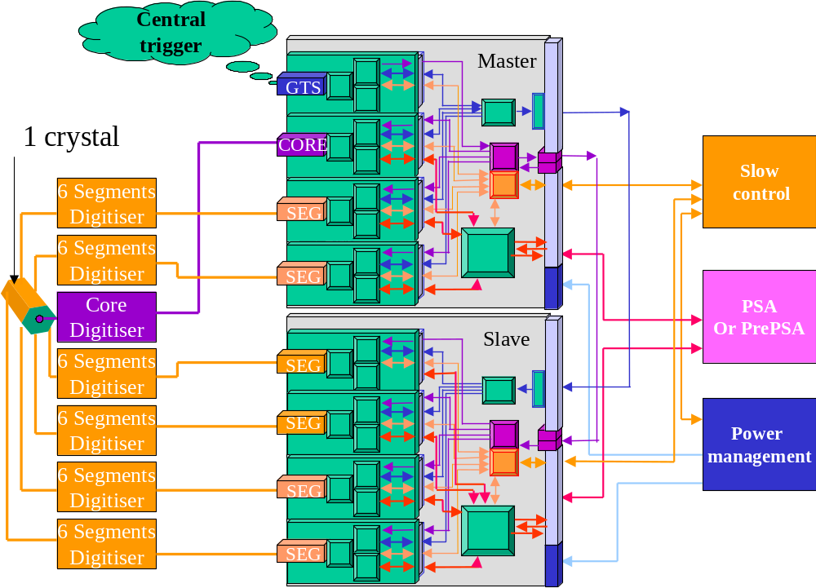
Diagram showing 2 carriers and 8 mezzanines.

Summary of connections
MICTOR CONNECTION BETWEEN MEZZANINES AND CARRIER
Signal | Segment dir | Core dir | Notes

DATA READOUT PATH
DATA[31..0] | OUT | OUT
DATA_CLK | OUT | OUT
DATA_RDY | OUT | OUT
DATA_RO | IN | IN
DATA_ACK | IN | IN

ETHERNET MII
COL | IN | IN
CRS | IN | IN
MII_CLK | IN/ OUT | IN/ OUT
MII_DATA | IN/ OUT | IN/ OUT
MII_RST | OUT | OUT
TX_CLK | IN | IN
TX_ER | OUT | OUT
TX_EN | OUT | OUT
TXD[3..0] | OUT | OUT
RXD[3..0] | IN | IN
RX_ER | IN | IN
RX_DV | IN | IN
RX_EN | OUT | OUT
RX_CLK | IN | IN

CLOCK
SYST_CLK<P> | IN | IN | Clock from GTS
SYST_CLK<N> | IN | IN

SYNCHRONISATION
SYNC<P> | IN | IN | Used for clock and data synchronisation
SYNC<N> | IN | IN
SYNC_RTN<N> | Not Used | OUT
SYNC_RTN<P> | Not Used | OUT

TRIGGER PATH
VALIDATION[1..0] | IN | IN
TRIGGER REQUEST[1..0] | NOT USED | OUT
LOCAL TRIGGER[1..0] | IN | IN
LT_DATA[7..0] | IN | IN | Timestamp : 6 bytes
LT_SYNC[2..0] | IN | IN | Timestamp strobes
TV_DATA[7..0] | IN | IN | Corresponding LT timestamp+Ev. Number: 9 bytes
TV_SYNC[3..0] | IN | IN | Corresponding LT timestamp +Ev. Num strobes

BROADCAST
BCAST_DATA[7..0] | IN | IN | Messages from GTS to all Mezzanines
BCAST_STROBE[1..0] | IN | IN

MESSAGE
MSG_DATA[7..0] | OUT | OUT | Messages from Mezzanines to GTS
MSG_STROBE[1..0] | OUT | OUT

LLP STATUS
BACKPRESSURE | OUT | OUT | Status of the mezzanine boards
GLOBAL_RESET_1 | IN | IN
LLP_STATUS[7..2] | OUT | OUT

GTS STATUS
GLOBAL_RESET_0 | IN | IN | Status of the GTS board
GTS_STATUS[7..1] | IN | IN

DATA DESKEW
DATA DESKEW[1..0] | NOT DEFINED | NOT DEFINED | NOT DEFINED

FPGA PROGRAMMATION
TCK | IN | IN
TMS | IN | IN
TDI | IN | IN
TDO | OUT | OUT
FPGA_PROG | OUT | OUT
FPGA_INIT | IN | IN
MEZZANINES PPC PROGRAM DOWNLOAD
SERIAL_TX | IN | IN
SERIAL_RX | OUT | OUT

I2C CONTROL BUS
I2C_SDA | INOUT | INOUT
I2C_SCL | IN | IN |  | Shelf manager link
MEZZANINE IDENTIFICATION
CONF[1..0] | OUT | OUT |  | Mezzanine ID (used by carrier card)

FRONT PANEL CONNECTIONS
SIGNAL | DIRECTION | NOTES
SEGMENT MEZZANINE
SERIAL ADC DATA IN ( x6 channel ) | IN | Optical fibre : 2 Gbits/s per channel on RocketI/O
Spare Logic signals ( x4 channel ) | IN | Optical fibre : 100 Mbits/s per channel on standard inputs
OFFSET ACK | IN | Optical Fibre: 1Gbit/sec
SPARE (not yet allocated; normally powered down) | IN | Optical Fibre: connected to RocketI/O
OFFSET CONTROL | OUT | Optical fibre : 10 Mbits/s
ANALOGUE INSPECTION (x3) | OUT | From DACs to front panel connectors
DIGITAL INSPECTION (x3) | OUT | From FPGAs to front panel connectors
USB2 PATH | IN | For standalone debug
CORE MEZZANINE
SERIAL ADC DATA IN ( x2 channel; low/high gain ) | IN | Optical fibre : 2 Gbits/s per channel on RocketI/O
SYSTEM CLOCK | OUT | Optical fibre : 100 Mbits/s
CFD Pulse (for ancillary) | IN | Optical fibre : 100 Mbits/s per channel on standard input
SPARE | OUT | Optical fibre : 2Gbits/sec on RocketI/O
SYNC Return | IN | Optical fibre : 100 Mbits/s
SYNC Pulse | OUT | Optical fibre : 100 Mbits/s
ADC OFFSET CONTROL | OUT | Optical fibre : 1Gbits/s
ANALOGUE INSPECTION (x4) | OUT | From DACs to front panel connectors
DIGITAL INSPECTION (x4) | OUT | From FPGAs to front panel connectors
USB2 PATH | IN | For standalone debug

TCLK PORT with notes
SIGNAL | GTS/CORE CARRIER | SEGMENT CARRIER | NOTE
CLOCK
CLOCKGTS | OUT | Not used | Clock from GTS
CLOCKIN | IN | IN | Clock in from back
SYNC
SYNCGTS | OUT | Not used | SYNC from GTS
SYNCIN | IN | IN | SYNC in from back
TRIGGER PATH
VALIDATION[1..0] | OUT | IN | Validation from GTS
LOCAL TRIGGER[1..0] | OUT | IN | Local trigger from GTS
LT_DATA[7..0] | OUT | IN | Timestamp : 6 bytes
LT_SYNC[2..0] | OUT | IN | Timestamp strobes
TV_DATA[7..0] | OUT | IN | Corresponding LT timestamp + Ev. Number : 9 bytes
TV_SYNC[3..0] | OUT | IN | Corresponding LT timestamp + Ev. Number strobes
BROADCAST
BCAST_DATA[7..0] | OUT | IN | Messages from GTS to all Mezzanines
BCAST_STROBE[3..0] | OUT | IN | Messages from GTS to all Mezzanines
MESSAGE
MSG_DATA[7..0] | IN | OUT | Messages from Mezzanines to GTS
MSG_STROBE[3..0] | IN | OUT | Messages from Mezzanines to GTS
LLP STATUS
BACKPRESSURE | IN | OUT | OR of all segment mezzanines
GLOBAL_RESET_1 | IN | OUT | Reset from LLP
LLP_STATUS[7..2] | IN | OUT | Status of LLP
GTS STATUS
GLOBAL_RESET_0 | OUT | IN | Reset from GTS
GTS_STATUS[7..1] | OUT | IN | Status of GTS

TCLK PORT CONNECTIONS
Signal name | Signals | Source | Destination | Level | Notes
Trigger validation  Tv<1:0> | 2 | GTS Mez. | Slave carrier, all Mez. | LVTTL 2.5 (local)  LVDS (Remote) | (1)
Trigger validation Synchronisation  Tv_sync<3:0> | 4 | GTS Mez. | Slave carrier, all Mez. | LVTTL 2.5 (local)  LVDS (Remote) | (1)
Trigger validation Data  Tv_data<7:0>  timestamp +  Evt-Number | 8 | GTS Mez. | Slave carrier, all Mez. | LVTTL 2.5 (local)  LVDS (Remote) | (1)
Local Trigger  Lt<1:0> | 2 | GTS Mez. | Slave carrier, all Mez. | LVTTL 2.5 (local)  LVDS (Remote) | (1)
Local Trigger synchronisation  Lt_sync<2:0> | 3 | GTS Mez. | Slave carrier, all Mez. | LVTTL 2.5 (local)  LVDS (Remote) | (1)
Local Trigger timestamp  Lt_data<7:0> | 8 | GTS Mez. | Slave carrier, all Mez. | LVTTL 2.5 (local)  LVDS (Remote) | (1)
Backpressure | 1 | Slave Carrier | GTS Mez. | LVTTL 2.5 (local)  LVDS (Remote) | (2)
Reset from LLP  Global_Reset_1 | 1 | Master  Carrier | Slave carrier,  GTS Mez. | LVTTL 2.5 (local)  LVDS (Remote)
Status of LLP  LLP_Status <7:2> | 6 | Slave Carrier, all Mez. | GTS Mez. | LVTTL 2.5 (local)  LVDS (Remote)
Reset from GTS Global_Reset_0 | 1 | GTS Mez. | Slave Carrier, all Mez. | LVTTL 2.5 (local)  LVDS (Remote)
Status of GTS  GTS_Status <7:1> | 7 | GTS Mez. | Slave Carrier, all Mez. | LVTTL 2.5 (local)  LVDS (Remote)
Message synchronisation  Message_sync<3:0>  (sync answer to GTS. Driven by GTS) | 4 | GTS Mez. | Slave Carrier, all Mez. | LVTTL2.5 (local)  LVDS (Remote) | (1)
Message data  Message_data<7:0>  (answer to GTS) | 8 | Slave Carrier, all Mez. | GTS Mez. | LVTTL2.5 (local)  LVDS (Remote) | (1)
Broadcast  Synchronisation  B_cast_sync<3:0>  (message form GTS) | 4 | GTS Mez. | Slave Carrier, all Mez. | LVTTL2.5 (local)  LVDS (Remote) | (1)
Broadcast data  B_cast_data<7:0>  (message form GTS) | 8 | GTS Mez. | Slave Carrier, all Mez. | LVTTL2.5 (local)  LVDS (Remote) | (1)
Message Carrier master to/from slave  msg_car<9:0> | 10 pairs | Master Carrier | Slave Carrier | LVDS | (3)
Clock in/out | 2 pairs | GTS Mez. via fan-out on carrier | Slave Carriers, all mezzanine | LVPECL 2.5 (local)  LVDS (Remote) | (4)

(1) Also has internal connection on master carrier to core and segment mezzanine.
(2) Logical OR of all segments mezzanine backpressure signals.
(3) Allow direct message between Master & Slave Carriers
(4) Internal connection to mezzanine within Carrier. Transmitted to slave Carrier via backplane.

Host Interface

In addition to the connections described above which will exist for all host systems, the carrier must also have an interface to the host bus (CPCI Express(AS)). The host interface will either be the entry point to the PSA directly or via another PSA interface.

Maintenance

This is a key issue and several ideas were raised:
It is important to involve one or more engineers from the host lab in the design/testing phase so that local support people feel some ownership and also understand the system.
Self test and diagnostics must be built in everywhere
- We need to decide what is our repair policy- will we employ someone to do repairs? Will we employ a company to do repairs (and possibly commission cards too)? Note that the volume of repairs in a 6000 channel system could create a significant workload.

- Deliverables must include not only hardware, but full documentation (circuit descriptions, user manuals and commented code with documentation for VHDL).

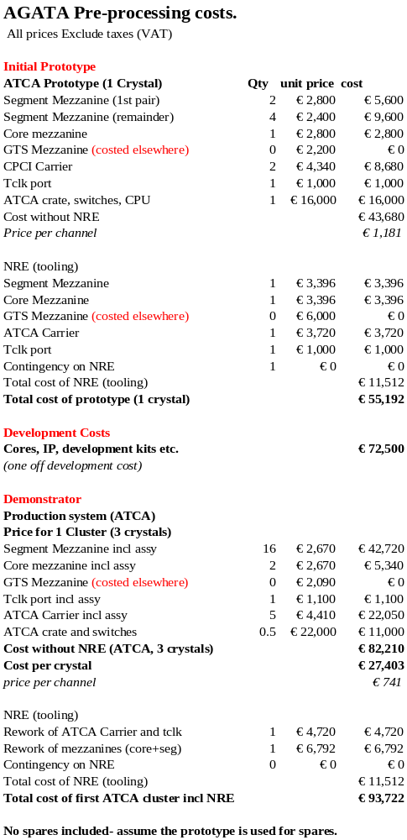
Approximate Costings

Costs updated November 2005- total cost has dropped due to not including GTS or contingency

Timescale and manpower
All the following figures assume 100% effort devoted to AGATA- we are unlikely to get this (typically 50% to 75% is realistic) so elapsed time is likely to be longer than the man months figure.

Core/Segment Mezzanine hardware 9 man months
FPGA 2x9 man months
So with 3 people working in parallel this could be ready to test in 1 year.

ATCA Carrier hardware 12 man months
FPGA 9 man months
Linux Software for PPC 12 man months
So with 3 (or 4) people working in parallel this could be ready to test in 1 year although the full software will take longer with only 1 person available 50% of the time.

GTS Mezzanine hardware 9 man months
FPGA 6 man months
So with 2 people working in parallel this could be ready to test in 1 year.

Digitiser Mezzanine: CSNSM Orsay (hardware and FPGA)
Carrier: IPN Orsay (Hardware, Software, FPGA)
GTS Mezzanine: Padova/LNL (hardware and FPGA)

Timescales
Some preparatory work was done during 2004 including discussions about interfaces with the other engineering teams and discussions about costs with AMB. The decision to freeze the design has been hard to make as a result of these discussions, which means that we had no clear start date. Assuming that design work started in Feb 2005 and there are no further changes to the specification, prototype delivery dates (ready for the start of testing) are expected to be:

Core and Segment mezzanines (hardware and FPGA firmware) Q1 2006
GTS Mezzanine (V2Pro hardware) Ready now (Autumn 2005)
GTS Mezzanine (V4 hardware) Q1 2006
GTS Mezzanine (FPGA firmware) Ready now (Autumn 2005)
ATCA Carrier (hardware and FPGA firmware) January 2006
(all delivery dates/status in red revised in November 2005)
Testing of each part individually will be complete by end March 2006

Testing of all parts together (including digitiser and PSA) will take April 2006- Summer 2006.

Manufacture of Production units (mezzanines and carrier) will start in autumn 2006 with deliveries of tested units late 2006/early 2007.

Original GANT Chart
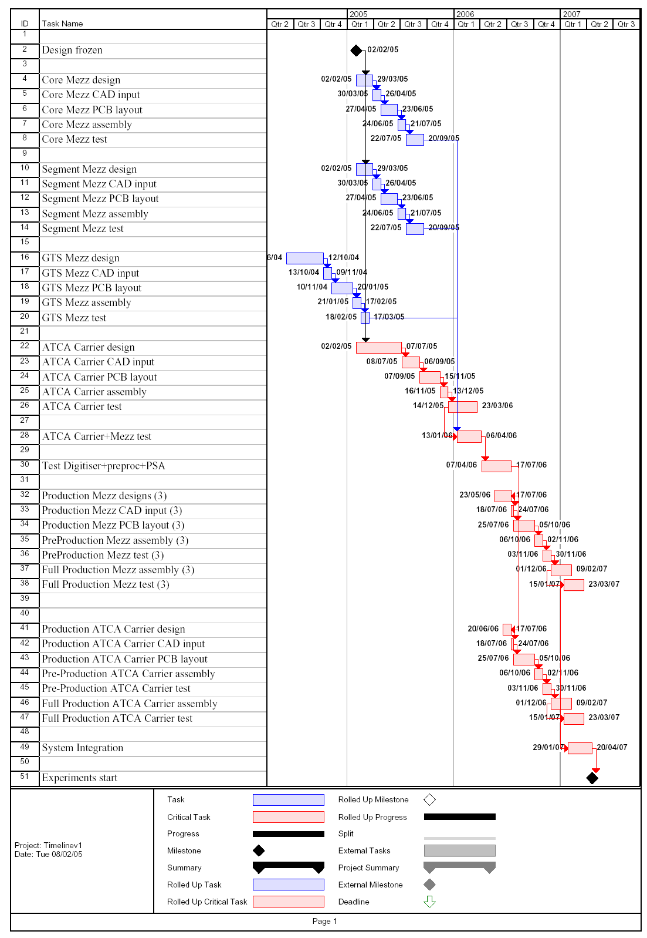

APPENDIX A Advanced Switching for the AGATA readout chain

Proposal of this document
- Highlight the Advanced Switching (AS) features of PCI Express technology in the context of the AGATA readout system and Pre-Processing Farm Interface.
- Propose an event reassembly protocol that exploits AS benefits.

Relationship To Other Research & Practice
This document is part of the Hardware Level Processing Proposal for the AGATA Experiment to be presented at the first AGATA week in Legnaro, 15-19 Sep. 2003.
A basic knowledge of the PCI Express technology is assumed.

Foreword
Without delving into deep detail of the AGATA structure, a DAQ column can be sketched as shown in the following figure:
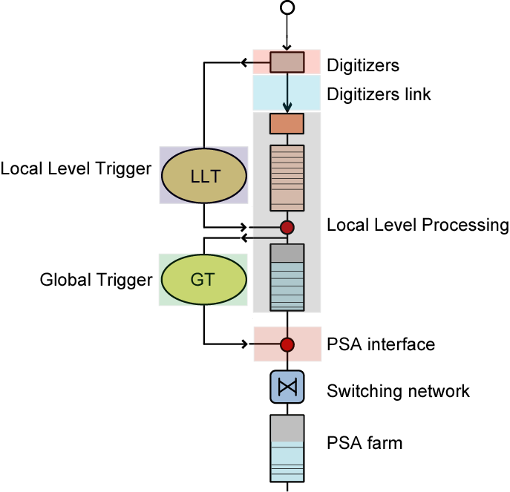
Fig. 1 – The AGATA readout column
This sort of digital pipe highlights the data flow starting from the digitizer of a single channel down to the Pulse Shape Analysis farm where position estimation is carried out. Interaction with two types of trigger is also underlined. By associating this data flow scheme to each single detector channel of which AGATA (or the demonstrator) is comprised, the modularity and scalability of the system is exploited in a two dimensional space: on the x dimension we have the detectors while on the y dimension we have the different functions to be performed on the data. By factorizing these functions into subsystems whose performance is independent of each other we can exploit the upgradeability of the system to its maximum extent. By replicating these columns we exploit scalability, according to the evolving needs (prototypes -> demonstrator -> final system). The complete columnar model of detector channel is reported in figure 2, where the interaction with the Global Trigger and Synchronization (GTS) Network is detailed.

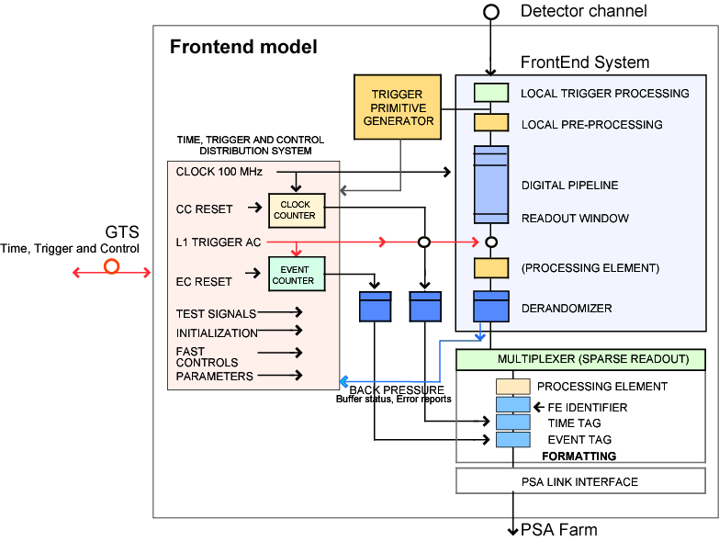
Fig. 2 – Model of a detector channel

Thus, by aggregation of m channels, the model for a hardware pre-processing unit turns out to be as in the following figure
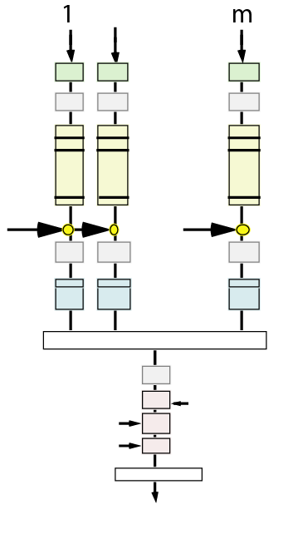
Fig. 3 – Model of a Hardware Level Processing (HLP) unit

and hence the model for a individual detector would be as the following:

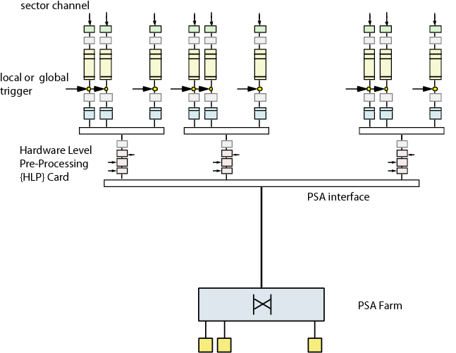
Fig. 4 – The Detector model

The target of this discussion is to illustrate how the mapping of the bottom part of this block diagram might be accomplished in a seamless way by referring to an emerging technology known as PCI Express Advanced Switching

PCI Express Advanced Switching

PCI Express is designed to provide a standards-based, high performance, highly pin-efficient scalable architecture. PCI Express increases performance and reliability required in distributed systems. When combined with the new ATCA specification, PCI Express provides not only a standardized form factor, but with the power and flexibility to meet the system requirements of computing and networking products including servers, communication products, storage systems, and industrial control. PCI Express architecture is ideal for systems that require a high speed, pin-efficient, and scalable bus. It is also targeted to address a wide array of systems, from desktop PCs to chassis based telecom systems such as storage, routers, and high-end compute platforms.

Layer 1: Rather than a shared-bus architecture, PCI Express specifies a point-to-point system. The basic data transmission unit is two pairs of LVDS wire, called a lane. The two LVDS pairs are simplex communication in opposite directions, which eliminates data collisions. PCI Express utilizes 8 bit/10 bit encoding for clocking, which eliminates issues related to clock skew as well as reduces pin count. Currently, PCI Express specifies 2.5 Gbits/sec per lane. This performance is scalable; bandwidth can be linearly multiplied by adding more lanes. The PCI Express specifications allow a number of lane widths (1,2,4,8,12,16,32) to allow not only efficient simplified routing, but also the ability to grow as bandwidth requirements increase. In addition, PCI Express is architected not only to allow for higher speeds utilizing copper, but also to use higher-speed media such as fibre for future generation systems.
Layer 2: PCI Express’ Data Link layer, provides reliable data transmission, both in terms of data sequencing, as well as data integrity. This is accomplished via sequence numbering and cyclic-redundancy check (CRC), respectively. PCI Express employs a credit-based flow control to reduce bus bandwidth waste. Credit-based flow control eliminates bandwidth-robbing polling by allowing devices to transmit data only when the receiving device has the resources to accept all of the data.

The PCI SIG, PCI Express’ governing body, developed two related standards, Base and Advanced Switching:
- Base’s primary goal is to remain driver- and OS-code compatible with PCI while providing a high-speed, low-pin-count serial connection.
- AS relaxes the code capability requirement in order to standardize advanced features required for distributed systems.
ADVANCED SWITCHING FEATURES
Compatible with PCI Express L1/L2
Uses same physical interface (L1)
2.5-Gbit/s link, up to 32 links/connection
Uses same data link layer (L2)
Different protocol layer than PCI Express Base
AS uses peer-to-peer architecture
PCI Express AS requires new applications
PCI Express Base supported through PI tunnels
Source Routing
Switches don't require unicast routing tables
Peer-to-peer doesn't require central route management
Switches can notify source of delivery failure
Protocol Interfaces (PI)
Allow high-performance tunnelling of any protocol, including PCI Express Base (PI8)
Used for AS features like multicast and congestion management
Virtual Channels
Support in-order and bypass queuing model
Implement class-of-service (CoS) support
Events
Handle congestion and power management
In-band high-availability support like hot-swap

Table 1 – Features of the AS layer

One of the more significant changes in AS is the need to work in the new high-end topologies. In order to address the need for reliable, high-speed bandwidth and processing, systems are looking less like the host-based topologies found in PCs, and more like truly distributed computing systems. CPUs in these systems cannot afford the more cumbersome host intervention. Instead, routing is accomplished not by memory mapping, but rather by path routing as shown in figure 5.
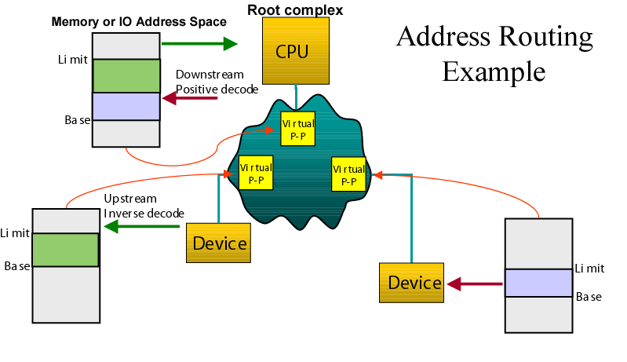

Fig. 5 – Address routing in PCI Express
Path routing, as done in the AS layer, circumvents the host control by specifying the destination relative to the switch (figure 6). This more efficient scheme allows for more efficient bus utilization and reduces latency.

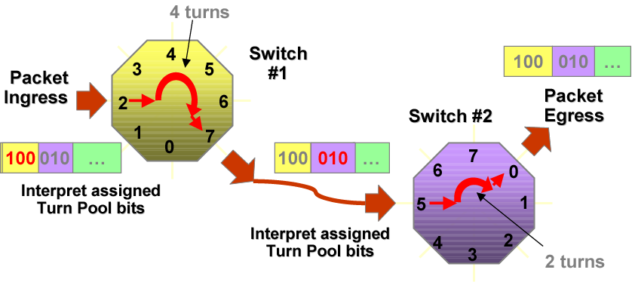

Fig. 6 – AS Unicast routing avoids need of switching tables in the switches

The AS layer natively supports broadcast and multicast communications, a key feature in the multiprocessing environment (figure 7). The AS header specifies a multicast group ID that indexes a multicast routing table implemented in the switch and managed by software. The table specifies which ports are associated to each ID, as shown in fig.7 for multicast ID 2.
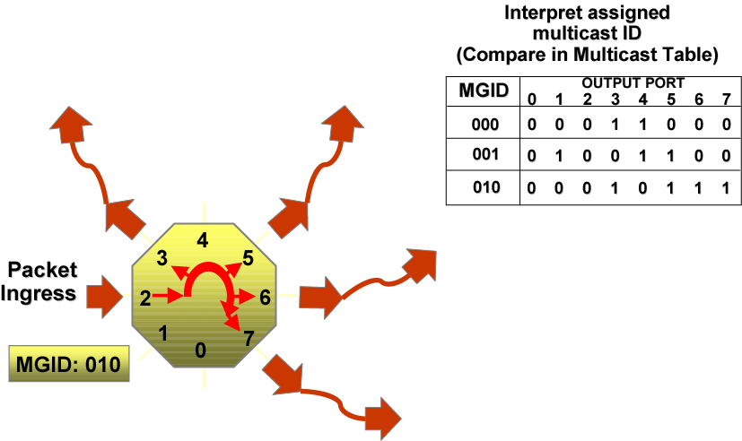
Fig. 7 – AS Multicast routing

PROTOCOL INTERFACES
Standard PIs
Spanning tree generation/Multicast
Congestion management (CM)
Segmentation and reassembly (SAR)
Device management
Event reporting
Companion PIs
PI8 - PCI Express Base
Simple load/store (SLS)
Simple queue packets (SQ)
Secure data transport (SDT)
Vendor-specific
30 reserved PIs
255 PIs total

Table 2 – Protocol Interfaces of the AS layer

Another significant addition in AS is Protocol Encapsulation. This feature allows AS Systems to tunnel other protocols intact within the AS fabric and then quickly reconstitute the protocol. This provides a high-performance, switching fabric that allows legacy systems to extend their lifespan. AS specifies other capabilities such as multicast, peer to peer, and multi-host necessary to distributed systems.

Proposal

Going back to the model of the individual detector readout (reported here for ease of reference)

Fig. 8 – Model of the Detector

It’s easy to realize that this scheme is essentially a classic multiple producers – multiple consumers configuration in which the token produced and consumed is the detector event, whose fragments are distributed among some of – possibly all – the producers (the Hardware Level Processing cards). Therefore the very first task of consumers (PSA Farm) is having the single fragments of each event reassembled in their own memory queues before pulse shape processing. This is the well known event building stage.
It is straightforward to recognize that a barrel shifting approach, as shown in the following figure 9 for a 4x4 case, would map directly from theory to practice by exploiting the AS features of PCI Express.
By assigning a virtual channel (VC) from each source to every destination we establish the mesh of required connections among HLP cards and PSA farm processing units. By using the event number – a well known parameter to every HLP card, distributed synchronously by the Global Level Trigger and Synchronization Network – modulus the number of processing units in the PSA farm, we fix the upper limit of the round-robin mechanism.
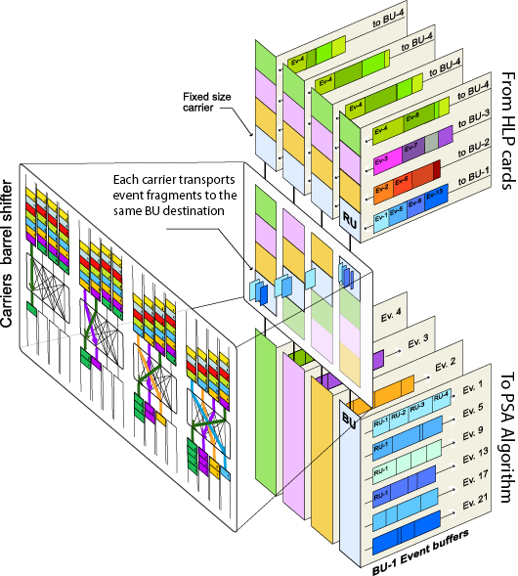
Fig. 9 – Barrel Shifting based on AS

In this way the path based routing of the AS layer, as shown in figure 6 is automatically obtained from the event number without the intervention of any external agent which knows where to route the appropriate fragments. It is worth noting that the credit based flow control of the AS layer implicitly constitutes a back pressure mechanism – a vital feature of a distributed readout. In fact this type of flow control allows the delivery of packets from source to destination if sufficient memory space is assured at the recipient. This means that a congestion in one of the processing units of the PSA farm would automatically translate to a stop signal on all the HLP cards.
The readout proposed above is a push-type mechanism with an implicit feedback; actually the amount of data flow is automatically regulated by the aggregated speed of data processing in the PSA farm.
Instead a pull-type mechanism exploits data requests in the opposite direction, from consumers to producers, but normally relies on an external control agent that keeps track of free processing units and routes events to them.
With AS, a fully distributed approach becomes possible and no external agent is required. AS allows a peer-to-peer approach by keeping distinct the memory spaces of each single processing unit. By means of the multicast mechanism, as shown in figure 7, each processing unit of the PSA farm can notify all the sources of the will to book the readout of next event in the HLP cards queues.
In this way, all the HLP cards can keep updated and synchronized a queue of free processing units where fragments of events have to be downloaded. A transparent memory access from each of the processing units to all the HLP card queues would complete the event building. This is schematically shown in the next figure.

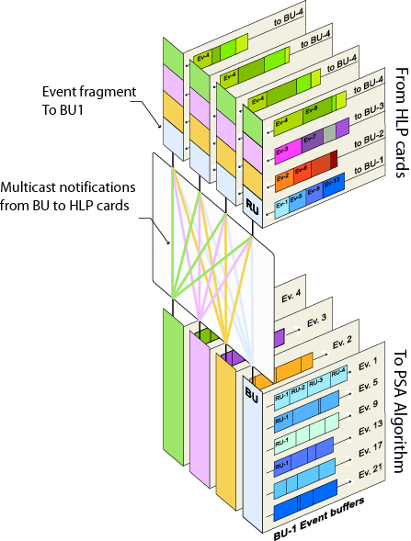
Fig. 10 – Distributed Event Building based on AS

This policy corresponds to a fair queuing rule at every machine, where requests arriving earlier are served before later arrivals. While this scheme is basically a distributed fist-come-first-serve scheduling policy, it is worth noting that any other known distributed scheduling mechanism can be implemented by relying on the native support for distributed multiprocessing of PCI Express AS hardware protocol. The most suitable solutions in the AGATA readout would be a subject of investigation, based essentially on parameters like the actual topologies used, typical loads of the network, hardware and software latencies, round trip times, constraints on costs, etc.

Conclusions

A new hardware based protocol supporting advanced switching techniques is being proposed as an extension of the PCI Express technology. Coped with a high bandwidth medium, this new protocol has potential benefits for highly distributed and interconnected systems, as in the case of the readout system of AGATA. While the concept of event building by means of switching architectures is an established practice in the nuclear and high energy physics experiments, the interest for this new protocol is manifold, due to its strong hardware support for distributed processing, the transparent distributed memory management, the scalability of bandwidth, the standardization. In the past, due to limitation in the switching structures, the most common practice was to buffer fragments at the level of sources (HLP cards) and to send them at destinations where a sort of batch event building could take place. What AS is promising instead is the possibility to make event building on an event basis and transparently through distributed memory access. This might turn out to be a great simplification on the quite complex data flow management and processing.
The early adoption of AS is unknown, as is for the time to market of the first silicon products. Many things remain unclear, for the time being, as per the possible use of AS in AGATA and to which extent. It is not clear also to which extent the features of AS can be complemented (or replaced) by custom built features in the Base PCI Express protocol, a possibility that might prove useful due to the static nature of AGATA readout interconnections. These reasons induce the need of an extensive investigation on the subject.

Comments

AS offers major advantages in throughput and functionality only available in a fabric-oriented architecture. At the time of writing, the AS specification are not yet available, but are expected to be released in the third quarter of 2003 and hardware isn't expected until later in the year. The PCI Express Base standard has been released since April 2002 and the first chips are becoming available now. PCISIG (www.pcisig.com) handles PCI Express Base, while AS will probably wind up with its own special interest group (SIG).

References
[1] Minutes of the AGATA Local Level Processing meeting, Liverpool, 24-25 February 2003.
[2] IEEE 802.3z / IEEE 802.3ab specifications
[3] M. Bellato et al “The CMS Event Builder Demonstrator based on GigaEthernet Switched Network”, CHEP 2000 Conference, http://chep2000.pd.infn.it/pres/pre_b307.pdf
[4] CMS TRIDAS Project, Technical Design Report, vol. 2: “Data Acquisition and High Level Trigger”,
December 15 2002, CERN/LHCC 02-26 CMS TDR 6, also available at http://cmsdoc.cern.ch/cms/TDR/DAQ/daq.html
[5] PCI-Express specifications v. 1.0

APPENDIX B Digitiser to Pre-Processor Interface Document



Digitizer to Pre-Processor interface document v1.0

Bruno Travers 25 /10/2005
Interfacing the Digitiser with the remote LLP will be done using different types of optical fibre cable. The maximum cable length needed will be 100 meters (328 feet). Figure 1 shows the requirement for one crystal.

SEGMENT CARD #1
#2
#3
#4
#5
#6
X6
X6
12 channel ribbon fibre
single fibre
DIGITISER
8/12 channel ribbon fibre
ZL60102
12 channels receiver
ZL60101
12 channels transmitter
ZL60301
8 channels transceiver
ZL60301
8 channels transceiver
4RX/4TX
4RX/4TX
HFBR-1414
HFBR-2416
low cost TX
low cost RX
CORE CARD
Fig.1 : General view

- Core mezzanine => Digitiser interface.

This interface is an eight channels optical link that complies with the POP4 MSA technical specification. (For more information, please visit www.popoptics.org).
We are using a ZL60301 transceiver manufactured by ZARLINK. This transceiver will be plugged into a 100-position FCI Meg Array plug.
It will accept industry standard MTP ribbon fibre connector, as defined in the POP4 specification. We can use either an eight or a twelve fibres ribbon cable.
Figure 2 show the optical channel assignment for the POP4 compliant transceiver.

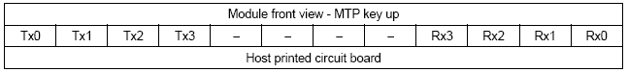
FIG 2: Optical channel assignment

The allocation of the core link signals to the optical channels is defined in figure 3.

CORE
DIGITIZER
CLK
SYNC
ADC OFFSET
SPARE
ADC1
ADC2
CFD
SYNC RTN
Tx0
Tx1
Tx2
Tx3
Tx0
Tx1
Tx2
Tx3
Rx0
Rx1
Rx2
Rx3
Rx0
Rx1
Rx2
Rx3
ZARLINK ZL60301 4RX/4TX
ZARLINK ZL60301 4RX/4TX

FIG 3: Core interface detailed

  - CLK :

100MHz master clock signal provided by the GTS. No MGT involved.

  - SYNC :

Used for the clock and data alignment mechanism. This is a copy of the CLK signal with a missing pulse. This is a 100 MHz signal. No MGT involved.

  - ADC OFFSET :

This signal is used to increase the dynamic range of the acquisition system. The bit rate on this signal will be 1Gb/s using the 8B/10B encoding. It is handled by a virtex2pro MGT.

  - SPARE :

This signal will be provided by an MGT. This is a free high speed channel.

  - ADC1 :

This is the low gain CORE data channel. The bit rate on this signal is 2 Gb/s using 8B/10B encoding. It is handled by a virtex2pro MGT.

  - ADC2 :

This is the high gain CORE data channel. The bit rate on this signal is 2 Gb/s using 8B/10B encoding. It is handled by a virtex2pro MGT.

  - CFD :

Fast trigger signal dedicated to the ancillary detector’s electronics. This is a CLK like signal with a missing pulse. This is a 100 MHz signal. No MGT involved.

  - SYNC RTN :

Used for clock and data alignment procedure. This is the SYNC signal loopback. It is a 100 MHz clock signal with a missing pulse. No MGT used.

- Segment mezzanine => Digitiser interface detailed.

This interface is a twelve channels optical link that complies with the SNAP12 Multi Source Agreement specifications (visit http://www.physik.unizh.ch/~avollhar/snap12msa_051502.pdf).
On the segment side, we are using a ZL60102 12 channel receiver manufactured by ZARLINK. The transmitter reference is ZL60101. Both will be plugged into a 100-position FCI Meg Array plug.

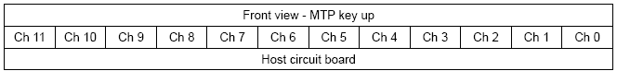

FIG 4: Optical channel assignment (apply to Rx and Tx module).

Figure 5 shows the allocation of the segment link signals to the optical channels. We can see that the channel allocation is in reverse order at the segment mezzanine side. We should do that in order to use a straight optical ribbon cable.

SEGMENT
DIGITIZER
OFFSET ACK
OFFSET
ZARLINK
ZL60102
12RX
ZARLINK
ZL60101
12TX
HFBR-1414 low cost TX
HFBR-2416 low cost RX
ADC2
ADC3
ADC4
ADC5
ADC6
Ch11
Ch9
Ch7
Ch5
Ch3
Ch1
ADC1
Ch10
Ch8
SPARE
Logical Signal 1
Logical Signal 2
Logical Signal 3
Logical Signal 4
Ch6
Ch4
Ch2
Ch0
Ch0
Ch2
Ch4
Ch6
Ch8
Ch10
Ch1
Ch3
Ch5
Ch7
Ch9
Ch11

FIG 5: Segment interface detailed

- ADCn :

There are the six segment data channels. The bit rate of this signal is 2Gb/s using 8B/10B encoding. There are handled by virtex2pro MGT.

- OFFSET ACK :

This signal will inform the pre-processing hardware when an offset command has been applied. The bit rate of this signal is 1Gb/s using 8B/10B encoding. It is handled by an MGT. When unused, we can put this channel in powerdown mode.

- SPARE :

This signal will be handled by an MGT. This is a free high speed channel. When unused, we can put this channel in powerdown mode.

- Logical Signal n :

There are low speed free channels. There are expected to be 100MHz clock with missing pulse. If unused, there will be put in a static “0” state. There are handled by virtex2pro standard IO.

More on high speed interconnect and parallel optics here: http://www.paralleloptics.org/

- OFFSET :

This signal is used to expand the dynamic range of the acquisition system. The bit rate will be 10Mb/s. It will be an “UART like” communication channel. The data format is detailed in figure 6.

START
Bit 0
Bit 1
Bit 2
Bit 3
Bit 4
Bit 5
Bit 6
Bit 7
STOP
STOP
8 bits data
Message start A5 h
Message length
Message
Checksum
55 h
ADC id.
Bit 7
Bit 0
0/1
0 => ADC offset cmd
1 => Reset cmd
MSByte offset value
LSByte offset value

FIG 6: Low cost link data format and protocol.

The segment interface will provide this low cost link using a single fibre cable and agilent receiver and transmitter. The fibre can be any of 50/125 µm, 62.5/125 µm, 100/140 µm and 200 µm HCS® fibre optic cable.

The transmitter is the HFBR-1414. This is a high power 820nm AlGaAs emitter housed in a ST port package.

The receiver is the HFBR-2416. This is a PIN photodiode associated with a low noise transimpedance preamplifier housed in a ST port package. It is specified for data rates up to 175MBd and its output is analog.

This was changed in draft 3 to allow for full rate data collection in some cases.
Assume that the gammas detected in the core will each undergo 2 Compton-scatters and a photoevent (or 3 Compton scatters), so total count rate is 50kHz x 3 active segments to be processed. In addition, traces from 4 neighbours of each active segment will be sent to PSA. So, assuming no segment overlap, the maximum output data rate is: (1+ (3 x 5)) x 50kHz x 200bytes = 160Mbytes/second per crystal.

