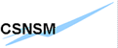



24/01/2005 draft0

AGATA DAQ Technical Design Proposal

A. Korichi¹, N. Barré², Ch. Diarra²,X. Grave², H. Harroch², E. Legay¹, G. Maron³
1 CSNSM Orsay, IN2P3/CNRS, Université Paris sud, France
2 IPN Orsay, IN2P3/CNRS, Université Paris sud, France
3 LNL Legnaro, INFN Italy
Contents
I Dataflow
I.1 Agata DAQ block diagram 3
I.2 Dataflow general description 3
I.3 Estimated rates and throughputs for the demonstrator 4
I.4 Dataflow detail description 4
I.4.1 Front-End Electronics 4
I.4.2 PSA 5
I.4.3 Event Builder 7
I.4.4 Tracking 8
I.4.5 Data Storage 8
II Technologies for farming and trends 9
II.1 Blade computing 9
II.2 Processor architecture comparison 10
II.3 I/O Technologies 12
II.4 Storage 13
II.5 The network 13
II.5.1 Ethernet 14
II.5.2 Infiniband 14
II.5.3 Infininband Ethernet comparison 15
III Dataflow software 16
III.1 Narval general description 17
III.1.1 Narval classes 17
III.1.2 Narval interface 18
III.2 Configuration system 19
III.3 Performance monitoring system 19
IV Infrastructure software 20
IV.1 The operating system 20
IV.2 Administration tools 20
V Demonstrator infrastructure 20
VI Development infrastructure 21
VII Estimation cost for the DAQ of the AGATA demonstrator 22
VIII Time scale and human resources 24

This technical proposal has been written on the basis of “A DAQ Architecture for Agata experiment” as presented by Gaetano Marron at the Agata Meeting , Padova May 2003 and the draft 1.0 –19 january,2004, written by Gaetano Marron as submitted to the collaboration during the Agata DAQ meeting in Orsay.
In the present document, we adopt the same general principles as discussed and approved during the agata week (24th of June 2004 at Orsay).

The Orsay group (CSNSM and IPNO) is in charge of the development of the data acquisition system for the demonstrator and the final configuration of AGATA in the ADP group in which X. Grave is team leader for the DAQ.
We have considered the following milestones:
- Development phase with the following goals :
  - Software development in an independent way of the underlying hardware
  - The necessary R&D on emergent technologies such as Infiniband
  - Different architectures tests for the final Agata DAQ

- The AGATA demonstrator architecture can be built with existing technologies according to the cost and available funds.

- The final Agata data acquisition architecture for which the necessary performances must be fulfilled for 180 detectors, the dataflow, the resulting PSA, tracking and storage.

The final data acquisition will receive the data from the 180 AGATA crystals and process them in 3 stages. Firstly several parallel processors will compute the Gamma ray interaction position (PSA), energy and time, merge the resulting data and order these data according to timestamps. The ordered data will be sent to the second part of the processing which reconstructs the gamma ray tracks around the whole detector shell using a large farm of processors. The third stage of the data acquisition processing will be devoted to merge the data from the tracking farm with a specific format and transmit this to the support drives for storage.

In the following sections, we will successively refer to the three mentioned phases (development, demonstrator system and the Agata system).

I Dataflow

The core function of the DAQ system is to process the dataflow from the detectors up to the data storage. It includes the dataflow from the front-end electronic (FEE) to the DAQ computing farm: pulse shape analysis (PSA farm), event builder system (EB), tracking reconstruction (Tracking farm), and the data archiving in a transient storage system or/and to a permanent storage system. The DAQ system also includes software packages performing the overall control of the system: Run control, data monitoring, system performance monitoring, and configuration system. It also includes management software for farm infrastructure

I.1 AGATA DAQ block diagram
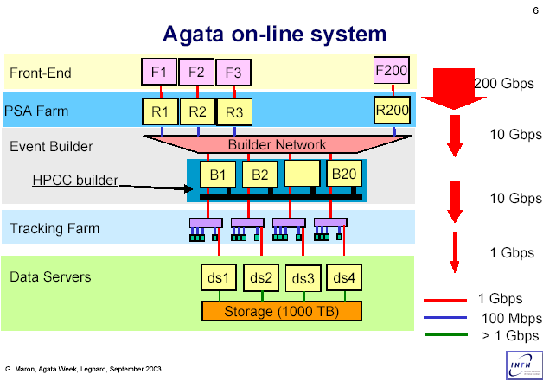

I.2 Dataflow general description

Four slices basically compose the system and each slice has a dedicated task: PSA Farms, Event Builder, Tracking Farms and Data Servers.
In this context we define a farm as an independent collection of PCs (may be with special form factor: blade, 1U, Workstation) linked together by a high performance network switch when necessary. The number of PCs per farm depends on the required computing power.

Data are flowing from the front end into the PSA farms (one farm/detector). The outcome of the PSA calculation is then sent to the Event Builder slice where the contribution of each detector is collected and finally merged to form an Agata event. This event is then sent to the Tracking Farms (or optionally to a storage device if the tracking is not required or performed off-line). Processed events are then staged temporary into large disk array and made available to be transferred via wide area network or backed up in conventional tapes.

I.3 Estimated rates and throughputs for the demonstrator

Estimated assuming a configuration with 5 triple-clusters i.e. 15 detectors. We have taken into account events corresponding to a cascade of Mγ = 30 transition Eγ = 80+n*90 keV :
Each detected gamma involves, on average, 1.3 detectors. This figure depends on the multiplicity of the gamma cascade (in the extreme case of Mγ = 1 the value is 1.85 detector/γ)

With an event rate of 10⁵ events/s, as simulated by D. Bazzacco, one gets:

Number of fired detectors  Requested by the trigger | Event rate (kHz) | Singles rate (kHz)
k_{d}=1 | 83 | 14
2 | 57 | 12
3 | 33 | 8.7
4 | 15 | 5

Triggering on k_{d} = 4 detectors, is equivalent to Mγ >= 3 and reduces the rate of singles by a factor of ~3

I.4 Dataflow detail description
I.4.1 Front-End Electronic
The FEE is composed by the digitiser system and the pre-processing system as can be seen in the figure below.
The DAQ Dataflow comes from the Front End Electronic (FFE) which treats each crystal (core+36 segments) as a separate entity. The core signal is formed by the superposition of the charge released by all the interactions in the 36 segments of each detector. This signal can be used as a local trigger for the whole crystal.

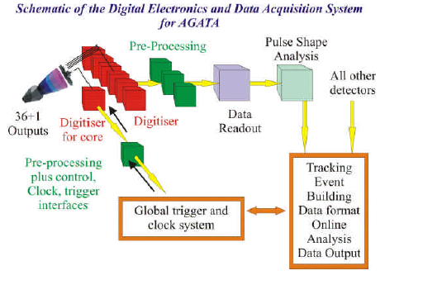
The digitiser’s ADC continuously codes at 100 MHz sampling rate of the analogue outputs of the 36 segments plus the core and transmit the data stream to the pre-processing through fibre links. In order to reduce the amount of data, a local trigger based on the core signal as mentioned above, is used. The segment data will be processed to extract parameters such as energy, time stamp and the 60 first sampling of the pulse trace (600 ns) before the PSA is performed. A data concentrator at the output of the pre-processing feeds all data from one crystal out to PSA.
At 50 KHz event/ crystal and 200 bytes per segment plus the core we end up with a 370 MB/s throughput per crystal at this stage. This rate can be reduced to 110 MB/s with the Zero suppression for the non useful information. In addition, other pre-processing that could reduce PSA processing effort can be performed in the data concentrator board. For example, if one determines whether the event corresponds to a one or a multi-hit event, one would also reduce the rate. In the case of a single hit event, the data are processed to get the x, y, and z position of the hit in the segment and reduce the amount of transmitted data up to an estimated 80 MB/s, which makes easier the transfer through only one single GbE link.
The ATCA board, housing two PowerPC at ~2 GHz and 6 Gigabit Ethernet interfaces, acts as the data contrator of the very first pre-processing level. The computing power would be large enough in order to perform zero suppression and perform PSA with simple algorithms.
For more detail see AGATA Pre-processing Hardware document.

I.4.2 PSA
As discussed in the PSA meeting, the size of the PSA farm will strongly depend on the algorithms performances. To date several algorithms investigations are under way (neural networks, matrix inversion, genetic algorithms and wavelets for pattern recognition). We can imagine a program (dispatcher), which will send the data to the adequate PSA algorithm.
The possible algorithms run in parallel and the dispatcher determines the event configuration for each hit detector. For each hit segment it must:
- Determine the number of interactions: 0, 1, 2 or 3 etc.
- Check whether the 0 interaction segment does not correspond to a neighbour hit segment in order to perform zero suppression

With enough CPU power, the dispatcher can run in the front-end crates and uses the appropriate algorithms that do not need the farm processing power in order to perform PSA. This will considerably reduce the data flow between the front-end and the PSA farm.
The data will be sent via network links to the PSA farm. One can imagine a simple case with one PSA farm per detector before considering other possible configurations.
The data from the PSA will be sent to a single or multi-server Event Builder (EB) through a network link, such as Gigabit Ethernet or Infiniband (IB). If one uses TCP/IP over Ethernet, the TCP/IP stack encoding/decoding in the EB processors would reduce the processing power available for event building. A TOE (TCP Off load Engine) based NIC which decodes the protocol by hardware will bring enough bandwidth for data reception (from the PSA) and distribution (to the tracking farm). In this case, the EB processors will be entirely dedicated to event building. In case of multi-server EB, several 1 Gbps links will be used to split the data throughputs in each server. In the other case, the single multi-processor server for the EB should have one or two 10Gibabit Ethernet port to handle the PSA data flow (900 MB/s)
If one uses IB, all the IB protocol is manage by the IB HCA (InfiniBand Host Channel Adapter). IB can transfer data from application to application without any CPU processing neither kernel overhead. MPI, a well known message passing protocol can be efficiently implemented over IB. Hence all the available processing power is dedicated to event building.
IB configuration requires an IB HCAs in each blade processor and an IB switch per farm. This solution can be developed and tested with a minimum amount of material (1 eight port IB switch and 4 HCA). We can imagine all mixed Ethernet and IB configuration for performances and cost. The Agata DAQ software must transparently support IB networking architecture.
Note that he data flow between PSA and EB is not an issue for the demonstrator which means that the 1 Gb/s link (as seen in the following figure) can be set to 50 Mbps
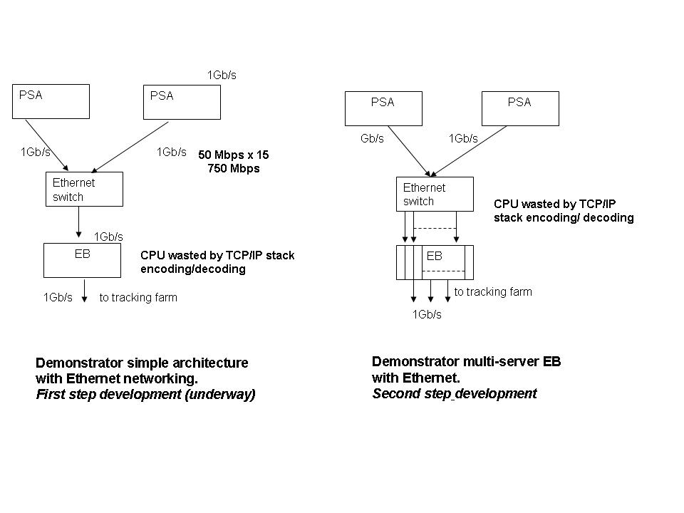

PSA processing power
If one considers 1s/events/detector for PSA with a genetic algorithm (for kd >=4), we have to gain a factor of 500 in order to perform PSA for a 10 kHz event rate with 20 CPU’s. This gain should be achieved with the expected improvements of CPU power and PSA algorithm performances.
The PSA algorithms will be tested with different processor architectures. The best result could lead to a significant reduction of the processor number per a farm and, therefore at substantial cutting of the demonstrator and Agata DAQ cost. The Alice DAQ team at CERN made comparisons with different architectures: Pentium, Xeon, Itanium from Intel, Athlon, Opteron from AMD and this is illustrated in the following figure.

This figure shows the CPU performance (for a given benchmark) as a function of CPU speed for different systems. It clearly demonstrates that the Opteron in the x 86 family is the best choice. However, these results strongly depend on the used algorithm
Furthermore, we consider the long lifetime of the AGATA detector (10-15 years).This means that, the DAQ will evolve and the software must support mixing architectures hence the development system has to mix architecture: Xeon (Intel), Opteron (AMD), PowerPC (IBM). As Xeon32 is available on desk-stop in every Lab, we only need to equip the development system with Opteron, PowerPC and Xeon64.

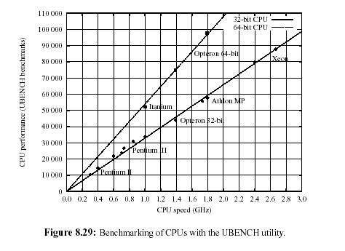

I.4.3 Event Builder

The Event Builder (EB) can be either a farm or a single multiprocessor host. In the case of a farm, one can use Ethernet to send the data from the PSA to the EB and the tracking farm. The EB will be composed of Builder Units (BU).

Events will be grouped by time slots in the front-end and buffered. After data shrink in the PSA a new buffering is performed. Buffers are dispatched to BU for event building (event assembling). Since fragments of the same event are in different BU, a HPCC (High Performance Computing and Communication) system may be necessary to allow the BU to collaborate and gather the event fragments.

The main advantage of this system is the possibility to use cheap BU (blade or 1U servers) for the EB. In case of failure, we hot plug a (cheap) spare BU in order to continue the event building procedure. Another advantage is the possibility to continue using Ethernet (without any additional cost) from the PSA to the tracking for data flow. The HPPC network will only link BU for event fragments assembling. The HPCC will require a small number of IB switch ports and one HCA per BU.
The disadvantage of an EB farm can be associated with the complexity of the EB algorithms. Using a single multiprocessor node as EB will greatly simplify the event building algorithms and also reduce development time. However, this EB node will be expensive and thus the spare EB (in the order of a farm price). A comparison between two options for the event builder functionality can be seen as follow:

1- A single computer to implement the EB functionality has the following advantages:
- reduce the complexity of the algorithm
- reduce the complexity of the network
- reduce the architectural complexity
- easy to maintain
With the following drawbacks:
- this machine is a single point of failure
- need high internal bandwidth

2-A multi-server Event Builder has the following advantages:
- No single point of failure
- reduce the needed bandwidth of the network
- Natural scalability

With the following drawbacks :
- Event building algorithm is a little more complex
- increase the architectural complexity

I.4.4 Tracking

The tracking farm can use the same type of calculation nodes as the PSA farm. Each node will be able to process any event buffer from the EB since each event in a buffer is present in its totality. The EB can then use a simple algorithm to dispatch the event buffers to the tracking farm, which is composed of tracking units (TU).
If the EB is a single node, it can send the event buffers through IB to dedicated nodes, which will then dispatch them by Ethernet to the TU. In case of many tracking crates, we would use one event dispatcher node/crate.

If the EB is composed by several BU, a dedicated group of tracking crate can be associated with 1 or n BU. The data will be sent by each BU to the trackers as described above.

An event dispatcher in the tracking farm can also use a simple round robin algorithm or a more sophisticated load balancing mechanism.

CPU for γ-ray tracking:
Several tracking performances were performed by A. Lopez-Martens (with a non optimized code) using a combination of 2 algorithms (back and forward tracking). The tracking was performed in a 180 AGATA configuration and for the same cascade of γ as mentioned in section I.3 (ranging from 80 to 2240 keV). The tracking of 1000 events requests 4, 14 and 22 ms/event, for Mγ=1, 10 and 25 respectively.

I.4.5 Data storage

The Agata data storage architecture can be based on a two-stage hierarchy of storage. The primary storage proposes a large enough disk space to store all the acquired data from two successive experiments (about 2x60 Terabytes). It is made of array of hard disk drives capable of sustaining a 140 Mbytes/s data throughput. RAID arrays (Redundant Array of Inexpensive Disks), based on Fibre Channel and Serial ATA (Advanced Technology Attachment) are available today. This will provide adequate performances and security for data with low cost. These solutions will be tested and benchmarked with the development system.
The secondary storage is realized in an offline manner, independent of the data taking. Three strategies are possible:
- Each experiment back-ups its data on its own magnetic support, SDLT or LTO (200Gbytes per cartridge ➔ 300 cartridges per experiment). We can easily expect a 500Gbyte capacity cartridge in 2008.
- Hierarchical data storage such as CASTOR at CERN or HPSS from IBM, where data automatically migrate from disk storage to magnetic tapes in robotic devices. This is very expensive and needs strong support manpower as in a computer centre.
- Back-up the data of one experiment, through the network, to a computer centre.
This operation takes 10 days with a Gigabit link and only 1 day with a 10 Gigabit/s network link which can be expected to be available in 2008.

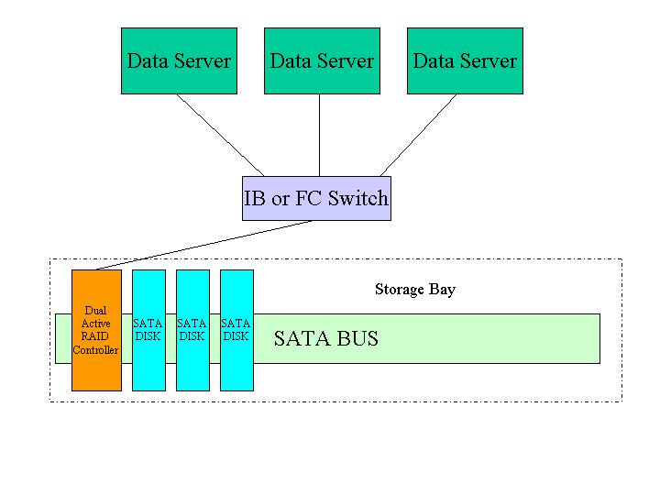
For the storage of AGATA DAQ, we propose the investigation of Data Servers with Lustre or GPFS files systems. Infiniband (IB) or fibre channel (FC) options are good candidates for the Storage Area Network (SAN). It is possible to connect several storage crates to the switch. Instead of a single RAID Controller, a dual-active RAID Controller is better because it supports transparent fail over. Also when using a RAID 5, broken disk is automatically substitute by another disk without any shutdown. Hence security, mirroring becomes useless, moreover it increases cost and slows data writing.
Note that the switch is not necessary if one chooses, for example, Data Direct Networks (DDN) solution for example. In this case, one would be able to connect Data Servers directly to DDN RAID Controller due to its own 4 inputs. If necessary, one can use 2 DDN RAID Controllers to have 8 inputs.
In order to start the study of such architecture, we need IB/FC interface and several SATA disk as development equipments.
For the demonstrator, a more simple architecture and low cost system can be used.

II Technologies for farming and trends

II.1 Blade computing

AGATA will need a huge computing power: the equivalent of a supercomputer power. The cost of such a supercomputer is too high. However, the needed power for AGATA can be provided by rackable computers. These computers have a pizza box shape and are very thin. Today up to 42 of them (84 CPU) can fit in a standard 42U (2m height) crate. 1U (1.75 inch or 4.4 cm) is the unit used in the rack-world. There are mainly two rackable computer form factors: 1U servers (1U to shorten) and blade servers (blade). A 1U computer is a complete computer in a flat format suitable for racking. The rack is just a mechanical holder. Unlike a 1U, a blade will need an enclosure (crate) to be plugged in. The crate has a back-plane and hot-plug slots for the blades. A blade is thinner and denser than a 1U but can also be thicker depending on the number of embedded processors. The blades in a crate will share the redundant and hot-plug power units, blowers and network switch installed in the crate. Removing power and fans from the blades reduce failures.

In summary:

- Blades are cheap and this allows one to have several spares and in case of fails it will be possible to hot-plug the necessary one
- Blades are dense since one can have up to 28 processors/crate
- The crate configuration avoids cabling problems and takes small space in a computer room.
- To build a farm, one just needs to fill the crates with blades and rack-mount the crate.
- The Blades are reachable through the network from a standard desktop or workstation.
- In general management software helps to manage the Blade farm.
- 1U are cheaper (based on the per unit price because they don't need a chassis) and have in general more powerful processors. They are less reliable than blades because most failures come from power suppliers or fans and need more connectors and cables.
- Blades and 1U are in general dual-processors boxes. Quad-processors exist but are more expensive today.

II.2 Processor Architecture comparison

For AGATA computing boxes (blades/1U form factor or workstations), one must use a good power/price ratio processors such as the adopted by a large number of manufacturers: Intel (Xeon, Itanium), IBM (PowerPC/Power) and AMD Opteron. The others are not very widely used and/or expensive.

- Intel processors are the most used ones the world. There are a lot of blades manufacturers using Intel Xeon. There are announces and projects about Itanium 2 blades with high cost

- IBM PowerPC processors equip both IBM workstations and blades. Apple also uses a customized version of the PowerPC processor to build 1U servers.
The new PowerPC architecture processor has great performances and will equip major video game systems: Sony PS3, Microsoft Xbox and Nitendo Game Cube. This means that one can expect a drop of the processor price. There are not yet blades or 1U Power5 servers. So, we will only test PowerPC970 for PSA farm.

- AMD's Opteron have very good performances and are adopted by the main computer manufacturers (IBM, HP, SUN…) great success among all the computer companies.
All the Intel and AMD processors cited are X86 (IA-32) compatible.

In the near future all processors will include 2 or more cores. In this case we will have more powerful blades or 1U at affordable prices and hence can reduce the number of blades to buy.

In the following table, a comparison between different processors which can be used for AGATA farm is given

 | Intel Xeon EM64T | Intel Itanium 2 | AMD Opteron | PowerPC970 | Power5 | Power5
Speed(GHz) | 3.6 | 1.6 | 2.4 | 2.0 | 1.65 | 1.9
Cache (MB) | 1 | 6 | 1 | - | - | 1.9
32/64 bits | 32/64 | 32/64 | 32/64 | 32/64 | 32/64 | 32/64
Cores  Threads/core | 1  2(HT) | 1  1 | 1  1 | 1  1 | 2  2(SMT) | 2  2(SMT)
Mem bandwidth (GB/s) 1/2CPUs | <=6.4 | <=6.4 | 6.4/12.8 | 8/16 | 6.4/12.8 | 6.4/12.8
IO bandwidth GB/s 1/2CPUs | <=6.4 | <= 6.4 | 6.4 /12.8 | 8 | 4.4/4.4 | 4.4/4.4
FPUs | 1 | 1 | 1 | 2 | 2 | 2
SPECint_base2000 | 1443 | 1140 | 1346 | 800 | 1200 | 1390
SPECfp_base2000 | 1450 | 1998 | 1428 | 840 | 2121 | 2576
SPECint_rate_base2000 | 31.5 | 26.1 | 29.5 | 17.2 | 60.4 | 74.4
SPECfp_rate_base2000 | 24.8 | 38.8 | 31.1 | 15.7 | 82.1 | 125
Power or thermal dissipation | ? | 112 | 89 | 55 | ? | ?
Power | 100 ? | 130 |  | 51 | ? | 160@1.8

N.B.: Higher SPEC means better performances

SPEC mentioned here can be improved by 10 to 20% (and even more) on some servers by using:
- CPUs with different cache size
- the right OS (using Linux-64 bits for example)
- code/compiler optimisation

Among all the available processors, we have decided to try the Opteron, the PowerPC G5 and the Power5.
Note that the new Spanish Centre of Supercomputing will use 2282 dual-processor JS20 (IBM) blades based on the PowerPC970FX (generation 90nm).

The Intel option is temporarily ruled out because in multi-processing configuration the processors share the same bus to access the memory and I/O devices through a MCH (Memory Controller Hub). This can lead to bus contention and then reduce the system throughput. The Xeon EM64T is a Xeon with Extended Memory 64 bits extension Technology. The Itanium 2 is a "true" 64 bits processor with EPIC (Explicitly Parallel Instruction Computing) technology. There are few blades and 1U server with Itanium 2 but this may change in the future. Note that NASA is building a 10240 Itanium2 processor Linux supercomputer.

The Opteron is a 64 bits processor. It has an integrated Memory Controller and implements the HyperTransport I/O bus. All the connections are point to point connexion. In multiprocessing mode, there is no bus sharing. Adding more processors, increases memory and I/O bandwidth since one gets more links to memory and I/O devices. Each processor has an exclusive link to the memory at 6.4 GB/s. Each processor supports up to 3 HyperTransport links. The link between a CPU and another CPU or an I/O device is performed over the HyperTransport which has enough bandwidth to support 10 Gb Ethernet, Fibre Channel, Infiniband, PCI-X, etc.

The IBM Power5 processor is a dual cores chip with SMT (symmetric multi-threading).
It has demonstrated a high computing performance. IBM sells powerful workstation based on it from 2 to 16 ways.

The PowerPC G5 (G5) is based on IBM Power architecture. It is manufactured by IBM and optimised for vector processing thanks to the Velocity Engine. The G5 has 2 double precision floating-point units and 2 Integer units. This makes it a good candidate for calculating. Like the Opteron, each processor (in Dual processor configuration) has it own FSB, which operate at half the CPU speed, and has 2 unidirectional 32 bits data path. A 2.0 GHz G5 then has 1*32*2/8 = 8 GB/s memory bandwidth.

II.3 I/O Technologies

For AGATA the I/O rate is expected to be very high which means that a fast network to handle the data rate is needed. The network will link computing nodes through network switches. We will use 1 or 10 Gigabit-Ethernet when possible and a faster communication channel when required (Infiniband for example).

To keep a maximum throughput we must avoid bottlenecks at each level of the network and computing nodes. Several possible reasons of bottlenecks can be identified such as:
1) Slow software (DAQ, algorithms …)
2) TCP/IP stack decoding/encoding
3) Slow I/O buses linking communication interfaces to the CPU
In order to overcome these problems one has to:
- Build a fast DAQ and fast algorithms software
- Use Ethernet boards with a TOE (TCP/IP Offloading Engine) and a low latency
networks such Infiniband, which processes the entire protocol stack in hardware on the HCA (Host Channel Adapter).
3) Use RDMA (Remote Direct Memory Access) enabled I/O bus with sufficient bandwidth between the CPU and the NIC (Network Interface Card), HBA (Host Bus Adapter) or the HCA (Host Channel Adapter).

Most of the available computers use the parallel bus PCI-X (Peripheral Component Interconnect-Extended) for which a maximum bandwidth is 1 GB/s (PCI-X 64bits/133MHz). Thus, PCI-X is a bottleneck for 10 Gb Ethernet (1.25 GB/s). Future versions PCI-X 2.0 (or PCI-X DDR) and PCI-X QDR will be respectively twice and four time faster than today’s PCI-X. However, the trend is to use faster serial I/O buses to replace the PCI-X.
Some of these buses have scalable bandwidth by defining a base bandwidth 1X and providing a higher bandwidths nX by using more links/lanes. All these considerations are important for the choice of the servers for AGATA. The I/O technologies for AGATA should be:
- Gbit Ethernet,
- Infiniband when Ethernet becomes to slow and CPU consuming,
- Fibre channel to connect to the storage arrays,
- PCI-Express when connecting 10 Gb Ethernet, Infiniband or Fibre Channel board to a server motherboard.
There are servers equipped with HyperTransport (Opteron based for example). PCI-Express will be available soon on servers.
The following table shows a comparison between different I/O technologies.

Feature | Infiniband (NGIO) | PCI-X | Fibre Channel | 1Gb & 10Gb Ethernet | Hyper-Transport | Rapid I/O | PCI-Express (3GIO)
Bandwidth/link  (Half Duplex)  Gb/s | 2.5, 10, 30  (1X, 4X, 12X) | 8.51 | 1,2.1,4 | 1, 10 | 12.8,  25.6,  51.2 | 16,32 | 2.5, 5, …, 80  (1X, 2X, …, 32X)
RDMA support | Yes | No | No | ? | No | No | No
QoS | Yes | No | Yes | Yes | No | No | No
Maximum packet payload | 4KB | N.A | 2KB | 1.5KB,  9KB jumbo | 64B | 256B | 256B
Interconnect type | PCB, LAN | PCB | storage | LAN | PCB | PCB | PCB,  connectors
Application | Clusters, IPC, HPC, SAN | I/O | DAS/NAS/SAN | LAN | IPC, I/O | I/O | I/O

II.4 Storage

Two possible choices can be compared today: SCSI or SATA devices.
The SCSI is a parallel bus with actually a bandwidth of 320 MB/s (Ultra320 SCSI). Ultra640 SCSI will also be available but the new SAS (Serial Attached SCSI) should compromise this choice. The current SAS transfer rate corresponds to 300MB/s, 600MB/s (in 2007-2009) and 1200MB/s beyond 2010.
SATA (version1) transfer rate is 150 MB/s but SATA2 (which will be available soon) corresponds to 300 MB/s and SATA3 (available~2007) will give 600MB/s.
Even if SCSI is the recommended option according to the above performances, one should consider SATA since it has good performances and is much cheaper than the SCSI option. The evolution of SAS (which has interesting features such as full-duplex, port aggregation, dual-port disks and compatible with SATA disks), should be considered for the final choice.

II.5 The network

Network allows computer nodes to exchanges information remotely.
Today, the most popular networking protocol for LANs (Local Area Networks) is Ethernet which has enough speed for most applications. Its components are cheap with good interoperability between different vendors’ solutions and a very good backward compatibility. When more speed or low latency is required (clustering, High Performance Computing …), other networks protocols are more suitable (Infiniband, Myrinet …). The latency is the time needed to send one packet from host to another. In this proposal we will mainly focus on Ethernet and Infiniband

II.5.1 Ethernet

Ethernet exists with 4 speeds (in bits/s): 10, 100 (Fast Ethernet), 1000 (1 Gigabit Ethernet or 1GbE) and 10000 (10 Gigabit Ethernet or 10GbE). Most desktops/workstation or servers are shipped with the 1GbE NIC (Networks Interface Card). This speed is enough for most today’s applications. For a large bandwidth, 10GbE may be used (on data servers for example).

A TCP/IP-Ethernet based LAN is build around switches with multiples Ethernet ports to connect to the computing nodes NICs through copper cables or fibre. Routers allow data forwarding between hosts of different LANs.

The main used protocol over Ethernet is TCP/IP (instead of the raw protocol) because sending or receiving data, to or from a NIC, requires CPU (host processor) power consumption:
- For building the TCP/IP packets
- For copying/reading data to or from the NIC

This means, that at high networking I/O rate, the CPU will spend most of its time for I/O and not for data processing. One can overcome this by using:
-Ethernet jumbo frames (9KB max or more instead of 1.5KB max) which reduce CPU interruption rate
-a NIC with an embedded TOE (TCP/IP Offloading Engine) in which the TCP/IP processing is performed by the TOE (an ASIC or a network processor plus firmware) on the NIC instead of offloading the CPU from TCP/IP processing.
-RDMA: avoids the buffer to buffer copy operations used in today's TCP/IP protocol processing by providing the application's destination buffer address along with the data itself.

NICs with TOE and/or RDMA are expensive because not widely used and RDMA is not a transparent technology such as TOE. Both ends nodes must be RDMA capable. Cost is expected to drop in 2006 according to analysts.
40GbE Ethernet (40-GbE /OC-768) could emerge in 2008. Hundred GbE is also prospected.

II.5.2 Infiniband

Infiniband (IB) is a low latency vendor independent serial interconnect technology for data centres. IB is the only standard I/O technology that natively supports 10 Gb/s (up to 30Gb/s now) performance to each node, RDMA, QoS and CPU offload in hardware. Low latency is needed in clustering and High Performance Computing (HPC) when nodes need to frequently exchange many messages with immediate delivery. Other low latency interconnect solutions exist (Myrinet, SCI …) but there are slower or vendor-dependent.

IB enables true "zero copy" between systems thanks to the RDMA. The RDMA allows remote host to place data directly into the buffer of an application program without any involvement from the operating system. This hardware mechanism reduces latency and makes CPU available for other tasks.

Equipment interconnected by IB elements forms a “fabric” which is composed of:
- an IB switch
- One or several servers (hosts) in which each host must have a HCA (Host Channel Adapter) to connect to the switch.
- Optional I/O arrays in which each I/O controller of the array must have a TCA (Target Channel Adapter) to connect to the switch.

The wire between the switch and the HCA or HBA can be copper or fibre like for Ethernet.

II.5.3 Infiniband Ethernet comparison:

IB and 10GbE need a high bandwidth connexion bus to talk to the CPU. PCI-X becomes a bottleneck for these fast I/O technologies. The full capabilities of IB and 10GbE will be realized when PCI-X 2.0 @16 Gb/s (and latter PCI-X QDR @32Gb/s) or PCI-Express (up to 80 Gb/s) based NICs or HCAs will be available. Alternative solutions for PCI-X bottleneck are the following:
1) Avoid PCI and use servers with embedded NICs or HBA on the CPU mother board. Data are then transmitted directly from the IB or Ethernet device to the CPU through a higher speed I/O link such as Hyper Transport or Rapid IO.

2) Use servers with enough PCI segments to connect two or more NICs or HCA in order to deliver the necessary aggregated bandwidth.

In any case the server must provide sufficient memory bandwidth in order to support the Ethernet or IB throughput.

Bellow is a table in which a comparison of IB, Gigabit Ethernet, Myrinet and Fibre Channel is given in terms of performances and prices.

 | Host Card Cost | End-to-End Latency* | Switch Cost  (per port) | Switch Latency* | CPU Overhead
Infiniband (4X)10 Gb/s | > 700 euros | 5 – 7 µs  (<1KB packet) | >300 euros | 160 – 200 ns | 3%
Ethernet 10 GB/s | > 5 000 euros (NIC with fibre) | >60 µs for 1GbE | ? | 10 μs ? or  35-40 µs ? | 80% ?  (1 GbE)
Myrinet 2GB/s | > 500 euros | 5.5 – 9 µs | >300 euros | ~200 ns | 6%
Fibre Channel  2 GB/s | > 700 euros | ~40 µs | ~1000 euros | ~1-2 µs | ?

* Latency increases with packet size. For 1 KBytes packet the End-to-End (host latency) is about 13 μs for IB, 22 us for Myrinet and 80 μs for GbE. The host latencies given here are obtained by using MPI.

III Dataflow software

Narval (Nouvelle Acquisition Real Time Version 1.2 Avec Linux) as AGATA Data Acquisition is proposed.
Narval is based on the Ada95 technology and therefore written in an Object Oriented way and is also a distributed software. All the processes of the acquisition system are a part of only one program and inherit (in an OO way) from an actor class. For the distributed code we use the fully transparent approach of the Annex E of the Ada95 ISO standard. For the raw acquisition's data we use pure TCP/IP protocol between actors.
Narval is a good choice for the following reasons:

- Narval has a development team dedicated to acquisition systems. The main idea behind the conception of Narval is to have an easy way to manage data flow which means that it is a fully distributed system. Actors wherever they are acts like threads of a same application and they can run on different systems (different combinations of hardware and OS) without any differences.

- Since it is developed with an OO language and it is a distributed acquisition system it is very easy to configure and one can change the configuration quite easily.

- Since it is developed with the Ada95 language, which is an international standard (ISO/IEC 8652:1995) it is very portable (no change is required when porting from Linux to Solaris for example). Ada has a few important features and advantages which give to Narval a good robustness/maintainability such as: strong typing, OO programming, very good compiler (GNAT from Ada Core Technology) and task friendly (thread are natives in Ada)

Narval supports different kind of hardware such as VME (with embedded CPU or MXI branch), PCI, cPCI and VXI and it is used in different laboratories or facilities: Tandem at Orsay, Ganil (as a slave acquisition of the Ganil Acquisition System for the AZ4PI experiment), CERN at ISOLDE and B3-Los Alamos (by a CEA group).
Due to its OO programming Narval is very modular and one can build a specific acquisition for a specific experiment with a few pieces called Actors. One can distinguish three kind of actors: producer, intermediary and consumer. It is also very easy to design a new Actor simply by taking over one already existing actor.
To demonstrate the scalability of Narval software and prove its ability to deal with the event builder throughput (in the case of multiserver EB about 90 MByte/s continue for each builder unit), a test up to 14x14 (means 14 input units and 14 Builder Units which are the maximum number of available processors in the same builder unit) to prove the event builder performances will be done as soon as a blade center is at Orsay. This will be the starting up test. More sophisticated tests should be performed involving more blade centers and including no square event building (e.g. 15 x 2, 15 x 3, etc.). Results of these tests will be reported to the collaboration.
In case the system does not fit the requirements alternative software should be tested with other existing acquisition systems such as: MIDAS (Daresbury), CODA (from Jlab for which sources are available but not support), Date4 (Alice experiment) and CMS or ATLAS DAQ.
Some preliminary tests of a point-to-point NARVAL communication have been performed for Narval TCP/IP performances. The obtained results with two types of computers with a gigabit Ethernet board on each:
- Desktop Dual G5@2GHz
- Desktop Dual Xeon@2.6GHz
Results as obtained on the screen for G5 as sender and Xeon as receiver:
Number of Bytes: 7.13636000000000E+09
Time: 62.666110000 seconds
Data Flow: 1.13879096691976E+08 Bytes/second
1.08603569690681E+02 MegaBytes/second
Same results for Xeon sender and G5 receiver :
Number of Bytes: 7.09004000000000E+09
Time: 64.495491000 seconds
Data Flow: 1.09930785704073E+08 Bytes/second
1.04838166908334E+02 en MBytes/second
We have also performed similar tests with G5 to G5 link (using lent xserve boxes) and we have obtained similar results.
In all cases a 2.6 Linux kernel on each desktop was used. NARVAL was configured with 2 actors (a producer and a consumer) dedicated to bandwidth tests.
No CPU power was used since we were running on the computer and the main bottleneck was clearly coming from the network bandwidth.
There is no hacking of the kernel due to the 2.6 Linux version which is not the case with a 2.4 Linux kernel as the performances drop down.

III.1 Narval- general presentation
In this section, the related details of NARVAL are described. First of all, one can class a Narval process as an active actor or not. The inactive process is an actor for the configuration of the acquisition system: the chef_orchestre and lanceur_programme are two inactive processes. The active actors correspond to the one that handles the main data flow of the acquisition (producers, intermediaries and consumers)
III.1.1 Narval Classes:
Actor description: Actor is the root class of the Narval class tree. It is a remote type, which means a pointer on an actor can be shared by different process on different computers (thanks to Annex E in the Ada95 ISO standard). It has all the necessary methods to configure and handle the running modes of Narval.
The Chef_Orchestre actor: This actor is unique in the Narval architecture and inherits directly from the main actor class. It manages the whole system: state machine coherence, configuration and dispatches the orders to all the others actors. From the main configuration file it deduces the number and the location of the Lanceur_Programme that have to be launched.
The Lanceur_Programme actor: it launches all the actors that will handle the data of the experiment. It also gives termination orders to these actors (unique/machine).
The producer: The producer collects and manages the data provided by the different boards supported by Narval. One can distinguish a producer which reads : VME, VXI and cPCI boards and data from files or tapes in raw and IN2P3 formats
The intermediary: An intermediary can be viewed as a software switch, which can operate in different modes such as a :
- dispatcher (receives from one source and dispatches on multiple consumers)
- event builder (takes data from multiple sources and dispatches on 1 or multiple consumers)
- data compression/de-compression function
The consumer: A consumer can receive data from the two first kind of actors (producer and intermediary) as presented above with a main functionality in data treatments for histograms or storage.

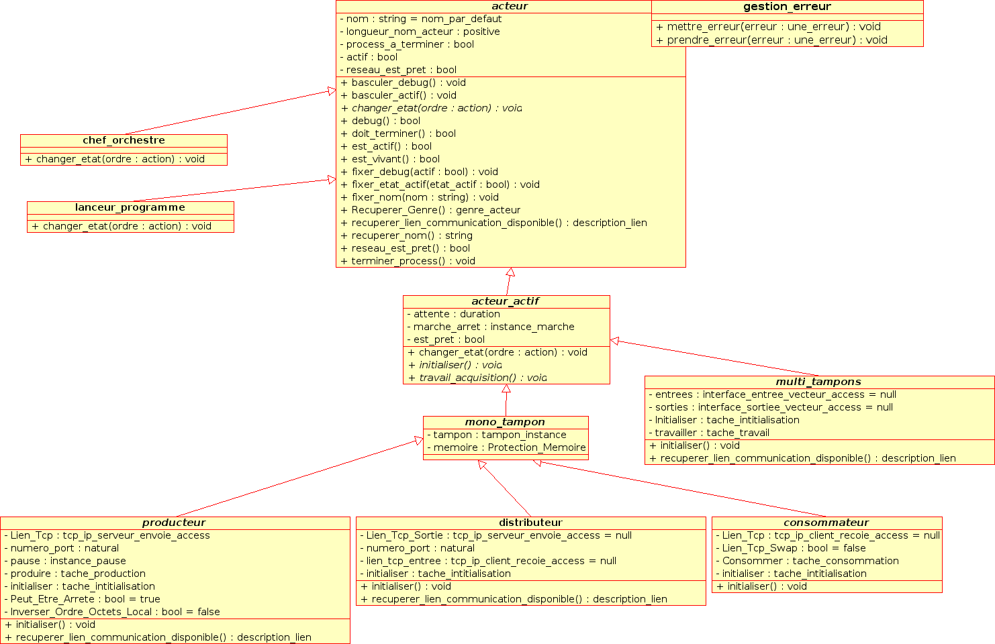

Narval class diagram as described in the text.

III.1.2 Narval Interface
The Narval interface is based on an embedded web server that communicates with the Chef_Orchestre in order to know the status of the acquisition and diagnostics the non performed functions (available orders, etc...). The web server is based on the AWS (Ada Web Server) component, which also supports SOAP protocols and web services.

A simple Example:

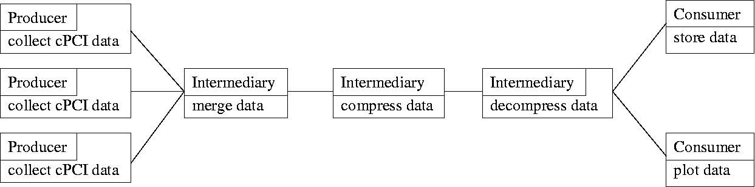

Narval Agata DAQ proposal:

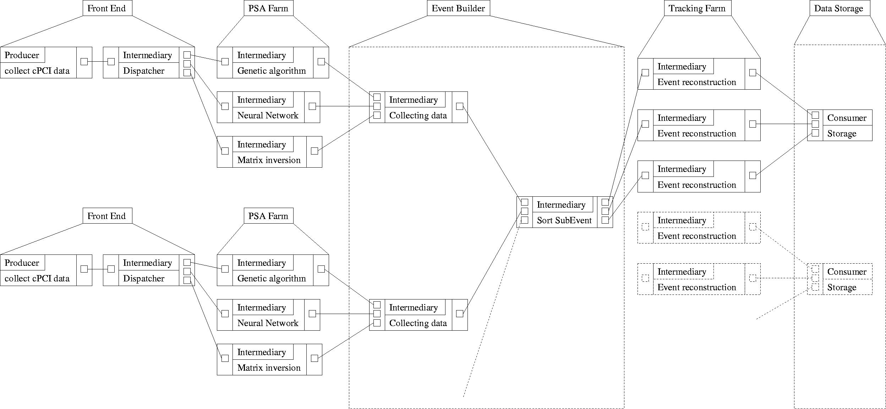

III.2 Configuration system
Narval supports two kinds of configurations:
- ASCII file first Narval configuration language. Here for compatibility reason
- XML file
The ASCII file was the first configuration file for Narval and is cited for compatibility reason as it will gradually disappear. The configuration language is selected by the file extension ".conf" or ".xml". When the user has selected the configuration file, Narval checks its validity (syntax, grammar, data flow point of view ...) before launching all the needed actors for the DAQ scheme as described in the configuration file using ssh commands.
III.3 Performance monitoring system

The performance of a large system such as AGATA Data acquisition, including a huge number of processes distributed on thousand processors needs to be continuously monitored.
The package software for Narval performance monitoring is under development. This package will collect and archive relevant parameters for each Actor. Again, since Narval is OO designed, every actor inherits the ability to report monitoring information. It will be compatible with SOAP and the operator can obtain statistics and summary data using a web browser.

IV Infrastructure software

IV.1 The operating system

When possible each running node in the farm will use Linux as the operating system. Linux kernel is an Open and Free software and widely used in research organisations and institutes which means that the Linux skill is available in many laboratories and in AGATA potential experimental sites.

For the development and the maintenance, less effort will be needed to learn a new operating system. And in case of a first level maintenance or assistance, it will be easy to find a colleague with a minimum knowledge on Linux.

IV.2 Administration tools

The farm may be composed of hundreds of nodes. It will require a collection of adequate tools for the system and network administration: installation, configuration, patching, updating/upgrading, backup/restoring, monitoring, hardware and software failure detection, security management, etc…
Free and hardware depending tools exist and we will test all of them in order to select the best one.
The management system to use in the final configuration should allow (remotely via a brother or a dedicated GUI):

- A friendly-user interface with graphical reporting of status and workload
- Hardware control : power on/off, boot/reboot, and hardware inventory
- Remote console
- Node health monitoring : resources utilisation (CPU, memory, networks, …)
- Remote installation and configuration of nodes
- Distributed command execution
- Configuration file management
- Event/error monitoring and automated responses

The management software (free or open source) we will investigate is the following:

CSM/xCat (Cluster Systems Management /Extreme Cluster Administration Toolkit) from IBM

CMU (Cluster Management Utility) from HP

Ganglia from UC Berkeley
- OSCAR from Open Cluster Group

These tools correspond to our needs and requirements.

V Demonstrator infrastructure

The demonstrator will be composed of 15 detectors. Taking into account the numbers in table 1 and limiting to 200 Hz (using present PSA algorithm) the maximum counting rate per detector, we obtain the following figure that defines the DAQ demonstrator block diagram.

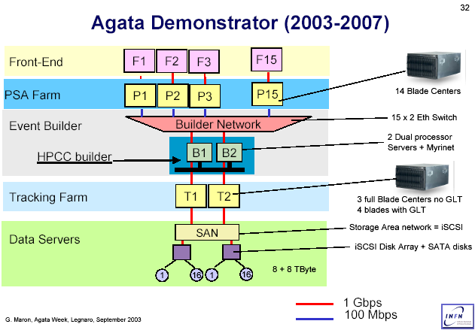

DAQ block diagram for the Agata demonstrator

As proposed, we will use blade technology or 1U form factor as computing power basic building block. A fully equipped blade center featuring 28 CPU fully interconnected via 2 gigabit Ethernet switches can provide up to 3 KSI95. Scaling up according to the Moore law, this number grows to 7 KSI95 in 2007. The DAQ infrastructure for Agata demonstrator in 2007 can be composed by:
- A fully equipped blade center per detector to perform on-line PSA analysis
- A 24 port gigabit Ethernet switch
- A partially equipped blade centre (10-12 CPUs) or a top-end quadric-processor workstation for event building and tracking farm
- In the case of Event Building farm, An Infiniband network
- A couple of high performance servers to manage the storage area network (SAN) and related disks and RAID controllers

VI Development Infrastructure

The DAQ system for the Agata demonstrator has to be developed between 2005 and 2007 in order to be operational early 2008. All the DAQ components (CPUs, switches, etc.) should be acquired during 2007 providing an integration phase and system commissioning of few months. An extra cost for the development phase should be then foreseen.
The minimum equipment and development infrastructure is estimated as:

- A fully or equipped blade centre (14blades => 28 CPU)
- 4 1U bi-processor to perform, with the above blade centre, the PSA analysis, tracking analysis and Event Building in different configurations.
- One 24 port gigabit Ethernet switches
- One 8 port infiniband switch
- 5 HCA (1PMC, 2PCI, 2blade form factor)
- 1 Terabyte of SATA DISK
- 1 FC/SATA controller

In this case, different architectures for the Agata DAQ will be tested.

The software infrastructure for the demonstrator will be organized as follow:
- Main data flow handling. This include
- Front End software infrastructure
- PSA software infrastructure, excluding PSA algorithm itself
- The integration of the algorithm within the on-line software frame will be performed by a group with on-line people and PSA experts.
- Event building infrastructure
- Tracking infrastructure. Same approach as PSA farm
- Data Storage handling
- Run Control
- Monitoring

VII Estimation cost for the DAQ for the Agata Demonstrator:

We assume the costs are constant from now to 2007 which means an increased performance. We even assume form factor (1U and Blade) remain the same as now and number of CPU per board remain 2. We can expect, in 2007, CPU with multiple cores (Power6, Opteron).

Commercial solution cost comparison for the development :

 | Apple | IBM | HP | DataSwift
Farm (PSA, Tracking) | 1U  2.6/node | Blade – 1U  2.0/node +  2.5 (crate) | Blade  3.2/node +  2.4 (crate) | Blade  2.8/node +  4.7 (crate)
 | -
Gigabit switch | 1 | 4 | 1 | 1
Infiniband switch + interface |  | 10(24ports) | 10 | 7(8ports)
storage

We estimate 10 k€ for testing the storage system with 1 Terabyte of SATA disks, FC interface and RAID controller. We received several formal proposals from IBM, DataSwift (a Taiwan technology integrator) and Apple and we are still waiting for other offers.

We are now equipped with 1U and blade servers, PowerPC and Opteron processors Ethernet and Infiniband networks and we will be able to perform different test for the different AGATA DAQ architectures as mentioned above. Most part of this will be reused in the demonstrator.

Total cost for development in 2005:
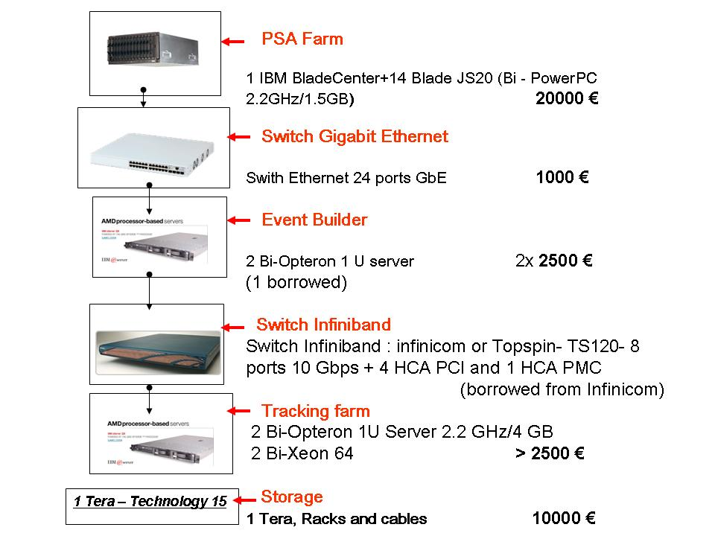

Total cost for the development phase 41000€

First estimation from G. Maron sounds realistic but depends on the price of a PSA farm which is estimated to be 30 k€ in 2007 (instead of 40 k€ today) and on the PSA algorithm performance.

PSA Farm | 30 k€ x k x 15
Event Builder (Farm) | 22
Gigabit switch | 1x15
Tracking Farm | 30
Run Control | 12
Storage 15 Terabyte | 30
Total for demonstrator (2007) | 109 + 450 = 559 if k=1

k is the number of farm per detector, depending on the PSA algorithm performance
If k=0.33 (1 PSA farm per cluster of 3 crystals) the cost is 109 + 150 = 259!!!!!
This could be split to

- 118 k€ in 2006 : 1PSA farm (30) + EB (22) + 1 Tracking FARM (30) +
Network (9) + Run Control (12) + Storage (15)

- and 441 k€ in 2007 : 14 PSA farm (410) + Network (6) + Storage (15)

VIII- Time scale and human resources

Assuming to have all the required man power and assuming the real job starts 1st January 2005, the development time schedule for the Agata demonstrator DAQ is the following:

Summer 2005 | DAQ for 1 detector with Run Control and minimal storage system
Winter 2005 | PSA infrastructure in place for 1 detector
Spring 2006 | Event builder in place
Summer 2006 | Tracking system in place  DAQ debugged and running for a tripled cluster
Winter 2006 | Storage system in place  DAQ debugged and running few detectors at limited rate (due to the missing computing power of the PSA farm)
Spring 2007 | All DAQ components received, system integration started
Summer 2007 | Commissioning of the system

The development is concentrated in Orsay (IPN and CSNSM) in collaboration with Legnaro.

The development is distributed as follow in France:

Site | Task | FTE required per year | FTE available at the host site | FTE to be found
Orsay-France  IPNO &CSNSM | Main Data Flow  - FEE  - PSA frame  - Evt Building  - Tracking frame  Farm infrastructure  - PSA farm  - Evt builder  - Track. Farm  - Storage | 1.5  2 | 1 (IPN)  0.2 (CSNSM)  1 (IPN)  0.5 (IPN)  0.5 (IPN) | 0.3 (CSNSM)

