Report to the STFC Oversight Committee of 8th July 2009

The AGATA Spectrometer

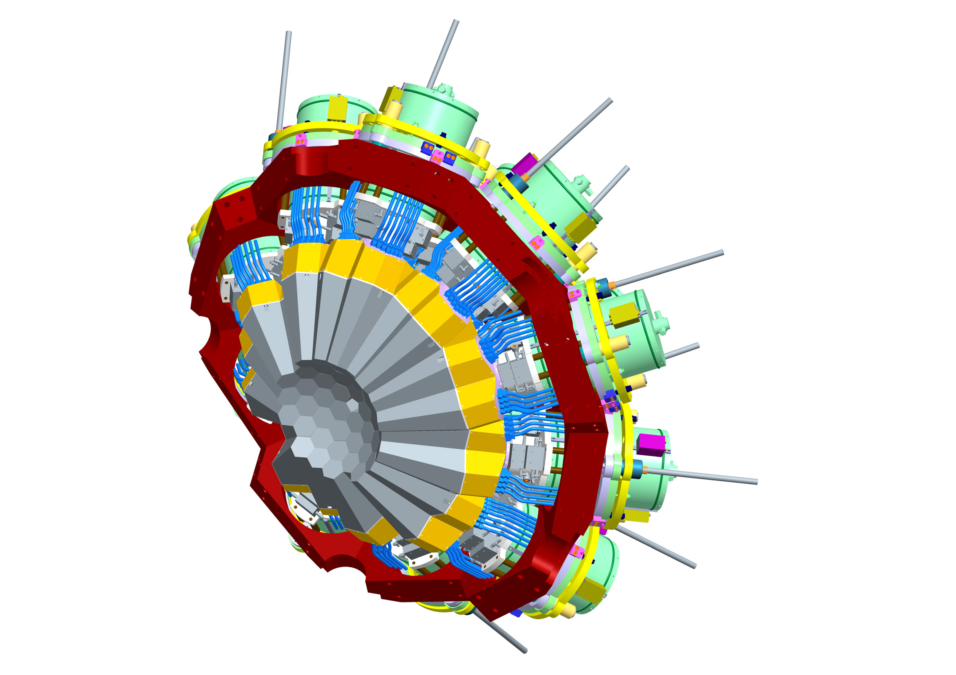

The University of Liverpool
The University of Manchester
The University of Surrey
The University of the West of Scotland
The University of York
STFC Daresbury Laboratory

Contents
- Executive summary
- Summary of the status of the project
- The UK contribution to AGATA
- The AGATA Memorandum of Understanding
- Project management and operation
- Overview of any call on contingency/WA
- Project programme by Work Package
  - WP1 Detector-specification measurement and cryostat assembly and commissioning
    - Description of the WP
    - Commentary on the activities to date
    - Programme of work for the next 6 months
    - Financial statement
    - Resource usage
    - Milestones
    - Gantt chart
  - WP2 Interaction position determination using pulse-shape analysis
    - Description of the WP
    - Commentary on the activities to date
    - Programme of work for the next 6 months
    - Financial statement
    - Resource usage
    - Milestones
    - Gantt chart
  - WP3 Experiment simulations and verification of tracking
    - Description of the WP
    - Commentary on the activities to date
    - Programme of work for the next 6 months
    - Financial statement
    - Resource usage
    - Milestones
    - Gantt chart
  - WP4 Support for setup and running of initial experiments
    - Description of the WP
    - Commentary on the activities to date
    - Programme of work for the next 6 months
    - Financial statement
    - Resource usage
    - Milestones
    - Gantt chart
  - WP5 Electronics and Graphical User Interface (GUI)
    - Description of the WP
    - Commentary on the activities to date
    - Programme of work for the next 6 months
    - Financial statement
    - Resource usage
    - Milestones
    - Gantt chart
  - WP6 Mechanical design
    - Description of the WP
    - Commentary on the activities to date
    - Programme of work for the next 6 months
    - Financial statement
    - Resource usage
    - Milestones
    - Gantt chart
  - WP7 Project management
    - Description of the WP
    - Commentary on the activities to date
    - Programme of work for the next 6 months
    - Financial statement
    - Resource usage
    - Milestones
  - WP8 Equipment procurement and running costs
    - Description of the WP
    - Commentary on the activities to date
    - Programme of work for the next 6 months
    - Financial statement
    - Milestones
    - Gantt chart
- Financial statement, whole project
- Overall project plan
- Risk register
- Publications and conference presentations

1 Executive summary

AGATA is a European collaboration formed to build the next-generation gamma-ray detector array for nuclear-physics studies. The array is called AGATA. The AGATA collaboration includes more than 40 institutes in 10 countries. The AGATA Demonstrator has been developed over the past few years. It consists of 15 detector capsules that are mounted in five triple cryostats. In addition there is one triple cryostat that contains the prototype detector capsules. All of the necessary electronics and data-acquisition components have been developed along with the infrastructure to support the operation of AGATA. At present, AGATA is being commissioned at the INFN laboratory at Legnaro in Italy using both source and in-beam tests. It is expected that a physics programme will commence at Legnaro in 2010 using AGATA. It is envisaged that subsequent to operation at Legnaro, AGATA will be deployed at other major European accelerator laboratories, where physics campaigns will also take place. Following Legnaro it is expected that AGATA will go to GSI in Germany and GANIL in France. The AGATA collaboration is currently negotiating the timing of these campaigns with GANIL and GSI.

The complete AGATA array is designed to consist of 60 triple cryostats (180 detector capsules). In the current phase of development the collaboration is aiming for an additional 15 triple cryostats (45 detector capsules). This will be achieved by members of the collaboration supplying the detector capsules together with their related electronics, data acquisition, mechanics, infrastructure etc.

The AGATA collaboration is governed by a Memorandum of Understanding (MoU). To cover the phase beyond the Demonstrator, a new MoU was agreed by the collaboration and it has been signed by all partners including by STFC for the UK. The MoU defines the roles of the partners including capital, running costs, and manpower contributions. In the MoU the UK contribution is agreed as 20% of the capital, which corresponds to nine detector capsules (three triple clusters).

The bid to STFC was consistent with the MoU, requesting nine detector capsules. However the award made (the current grant) was for a reduced level of capital, covering three detector capsules, one triple cryostat, electronics, and running costs. It was recognized that the UK has specific expertise in mechanical and electronics design. Consequently the award included funds for UK mechanical engineers and designers to take responsibility for the mechanical structures for AGATA at the laboratories where it is sited, and for UK electronic engineers to take responsibility for the design and commissioning of the digitiser modules. In addition the UK project has funds to support detector assembly and maintenance, detector characterisation, simulations (Monte Carlo) of the detector performance with typical reactions, and commissioning the system with sources and in-beam.

The collaboration is in the process of implementing the new MoU. The AGATA Steering Committee is now chaired by Prof. Paul Nolan. The AGATA Project Leader is Prof. John Simpson, who also chairs the AGATA Management Board. A consultation is underway within the collaboration about the future role of the AGATA Management Board now that AGATA is moving to a phase of both physics campaigns and development, with the increasing number of detectors. The MoU also includes provision for an AGATA Collaboration Council. This new body will be launched at the start of the physics campaign at Legnaro.

The current UK AGATA project started in September 2008. Progress has been made on all of the work packages. A UK AGATA Management Committee has been setup which meets every three months to review the status of the project. A start has been made on the purchase of equipment items: three detector capsules have been ordered, and work towards ordering the triple cryostat and the electronics is well advanced. The change in the £/€ and £/$ exchange rates since the project was approved is a cause for concern. The three PDRAs funded by the project have been appointed and have started work (1st July for the PDRA at UWS), the three project students were also all appointed. Unfortunately the student at York has dropped out, and a new student is being recruited to start in September 2009. The other new post associated with the project is a technician who will work in the detector laboratory in Liverpool. Recruitment is underway with an expected start date of September 2009.
The project is split into 8 work packages, listed below.

- WP1 Detector-specification measurement and cryostat assembly
and commissioning
- WP2 Interaction position determination using pulse shape analysis
- WP3 Experiment simulations and verification of tracking
- WP4 Support for setup and running of initial experiments
- WP5 Electronics and graphical user interface (GUI)
- WP6 Mechanical design
- WP7 Project management
- WP8 Equipment procurement and running costs

In Work Package 1 all the items for the detector laboratory in Liverpool have been ordered, and work has started on the first AGATA detector capsule in a test cryostat. The team are repairing an asymmetric detector capsule in a test cryostat since a number of detector channels have failed. Once operational this detector will be scanned in Liverpool as part of the detector characterisation work. In Work Package 2 work is continuing on analysing data in order to characterise the pulse-shape response of the detectors. Progress has been made on the comparison between the experimental results and those from electric-field simulation packages. The UK has developed the pulse-shape basis data set that is being used in the first in-beam tests in Legnaro. In Work Package 3, progress has been made in getting together a suite of codes in order to carry out Monte-Carlo simulations. In Work Package 4, John Smith (UWS) is acting to coordinate UK physicist effort at Legnaro during the commissioning phase. This has gone well to date with the UK being held by the collaboration as an example of how to organise the right expertise to be available at Legnaro at the correct times. A number of UK personnel, including students, have gained considerable expertise in the operation of AGATA over the past few months. In Work Package 5, effort has concentrated on supporting the electronics installation and operation at Legnaro. Work has started within the collaboration to agree to a plan to increase the number of electronics channels over the next few years as the number of detectors increases. The first collaboration meeting to discuss this issue, organised by Professor John Simpson, took place in April 2009 in Cologne. In Work Package 6, support has been given to Legnaro during the first installation of detectors in the mechanical frame. Some issues arose where mechanical elements moved more than expected and these have required UK engineering effort and expertise. A start will be made on the mechanical design for the frame for the next host laboratory once a final decision has been made about its location.

The next six months will see the completion of the commissioning of the AGATA Demonstrator at Legnaro, and the start of the Legnaro physics campaign. Work on all the work packages will follow the plans outlined in this document, which have been defined in close co-operation with the wider international collaboration.

2 Summary of the status of the project

Overview
AGATA is a European collaboration to build the next generation gamma-ray detector for nuclear-physics studies based on the concept of gamma-ray tracking in highly-segmented detectors. A gamma-ray tracking system involves accurately measuring the positions and energies of all the gamma-ray interaction points, in all of the detector segments. The position of the first interaction defines the angle of emission of the gamma ray from the source (the site of the reaction), relative to the detector. Accurate determination of this angle is particularly important when detecting radiation emitted by recoiling product nuclei, since it determines the extent of the gamma-ray energy spread arising from the Doppler shift. The angular definition in AGATA, compared with Gammasphere or Euroball, will result in an order of magnitude improvement in spectral response. Since most of the gamma rays interact more than once within the crystal, the energy and angle relationship of the Compton-scattering formula will be used to track the path of a given gamma ray. The full energy can then be reconstructed by summing all the individual energies deposited for a particular gamma ray. As a result, very high detection efficiency can be obtained in a 4π tracking spectrometer since there are minimal dead areas.

The research and development phase
The AGATA collaboration has defined that the full 4π array will be realised in phases. In 2003, a Memorandum of Understanding (MoU) was signed by laboratories in 10 European countries. The purpose of the MoU was to establish the AGATA collaboration, together with a framework to organise the project and to manage this first research and development phase. The MoU defined the first phase of the project in which all the necessary research and development is carried out, in order to prove the concept of tracking. This phase of the project has involved the development of highly-segmented germanium detectors, digital electronics, pulse-shape analysis to extract energy, time and position information, and tracking algorithms to reconstruct the full interaction.

The milestones of the research and development phase are as follows.

- Development of a highly-segmented (36 fold) encapsulated germanium detector
- Development of a cryostat to hold a cluster of segmented detectors
- Design and development of digital electronics
- Development of algorithms for energy, time and position
- Development of tracking algorithms
- Design and manufacture of associated infrastructure
- Construction of the Demonstrator and performance of in-beam and source tests

AGATA will be sited at different laboratories, taking full advantage of the different beams and facilities available, in order to maximise the breadth of science that can be addressed. This is true for both the AGATA Demonstrator and for the full array, upon completion. During the research and development phase, the AGATA collaboration decided to perform a series of commissioning experiments using the AGATA Demonstrator at the stable-beam facility at Legnaro National Laboratory in Italy, followed by the first physics campaign.
The collaboration produced a Technical Design Report at the end of 2008 in which the technical developments are given in detail. This report is available from: http://npg.dl.ac.uk/AGATA/TDR/TDR_EUJRA.pdf

General information on AGATA is available via the main AGATA web site at http://www-w2k.gsi.de/agata/ and at http://npg.dl.ac.uk/AGATA/

The research and development phase in now in its final stages, with AGATA presently being commissioned at Legnaro in a series of gamma-ray source and in-beam tests. A very brief overview of the current status is given below.

Detectors
For the research and development phase, 18 detector capsules have been ordered: 15 of the asymmetric geometry of the full 4π instrument and 3 symmetric capsules (these were developed as prototypes). These detectors are provided by the company Canberra France. In March 2009, 12 of these were fully operational, 2 were under acceptance test by the collaboration, 3 in Turkey (status to be determined), and 1 was at Canberra France for repair. Five triple cryostats have been ordered from the company CTT. Three triple clusters are fully assembled, one of which has been used in-beam in Legnaro. The plan is that a second triple cluster will be used in an in-beam test in late June 2009.

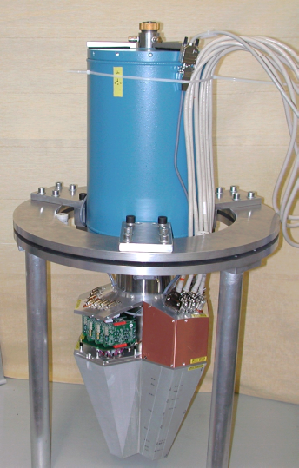 | 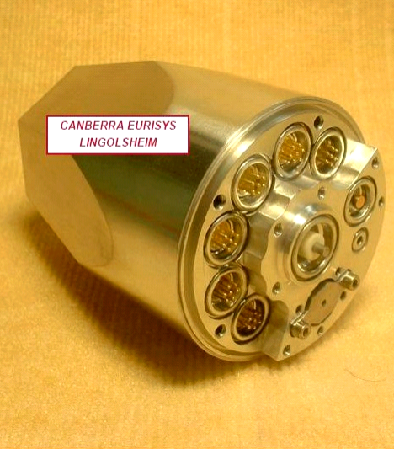
Figure 2.1 An AGATA triple module and an individual capsule.

Detector characterisation, pulse-shape analysis and the development of algorithms for position determination is, and remains to be, a major component of the project. The Liverpool scanning system, still the only operational system in the international AGATA collaboration, has characterised the three symmetric prototype detectors. The pulse shapes obtained have been used to improve the performance of the electric-field simulation codes MGS and JASS, in order to provide the first complete basis data set of pulse shapes for the collaboration from a symmetric detector. These codes have been used to provide a basis data set of pulse shapes for use with the first asymmetric detectors now in use at Legnaro. The data sets for asymmetric detectors will be verified following scanning of the detectors which is presently ongoing. Initial results from the scanning of the first asymmetric detector (C001) have been made available to the international AGATA collaboration.
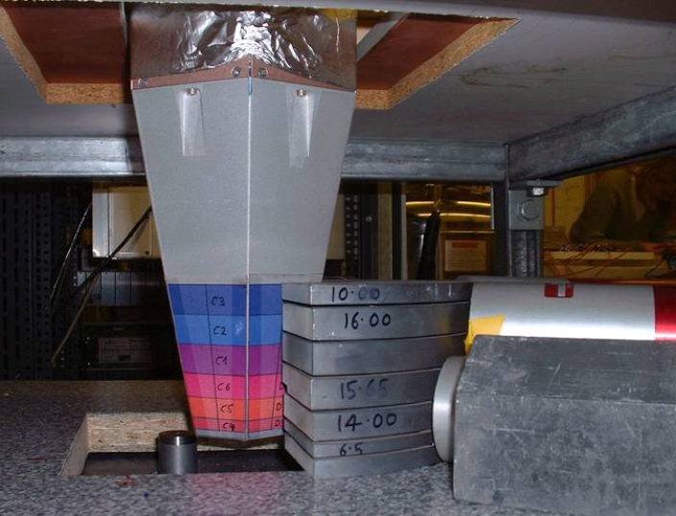 | Figure 2.2 An AGATA single cryostat on the Liverpool scanning system.

Electronics and data acquisition
The electronics system is specific to AGATA and is being designed, built and commissioned by the collaboration. In the electronics chain, each of the 37 signals from each detector (36 segments plus one central contact) is digitised. In order to carry out this digitisation as early as possible, “digitiser” units are placed close to the detectors. The digital information is then transferred via optical cables to pre-processing units. In the pre-processing system, pulses are detected and their energies are calculated. Each pulse detected on the core contact of a detector is time-stamped and the Global Trigger System (GTS) is informed of its existence.

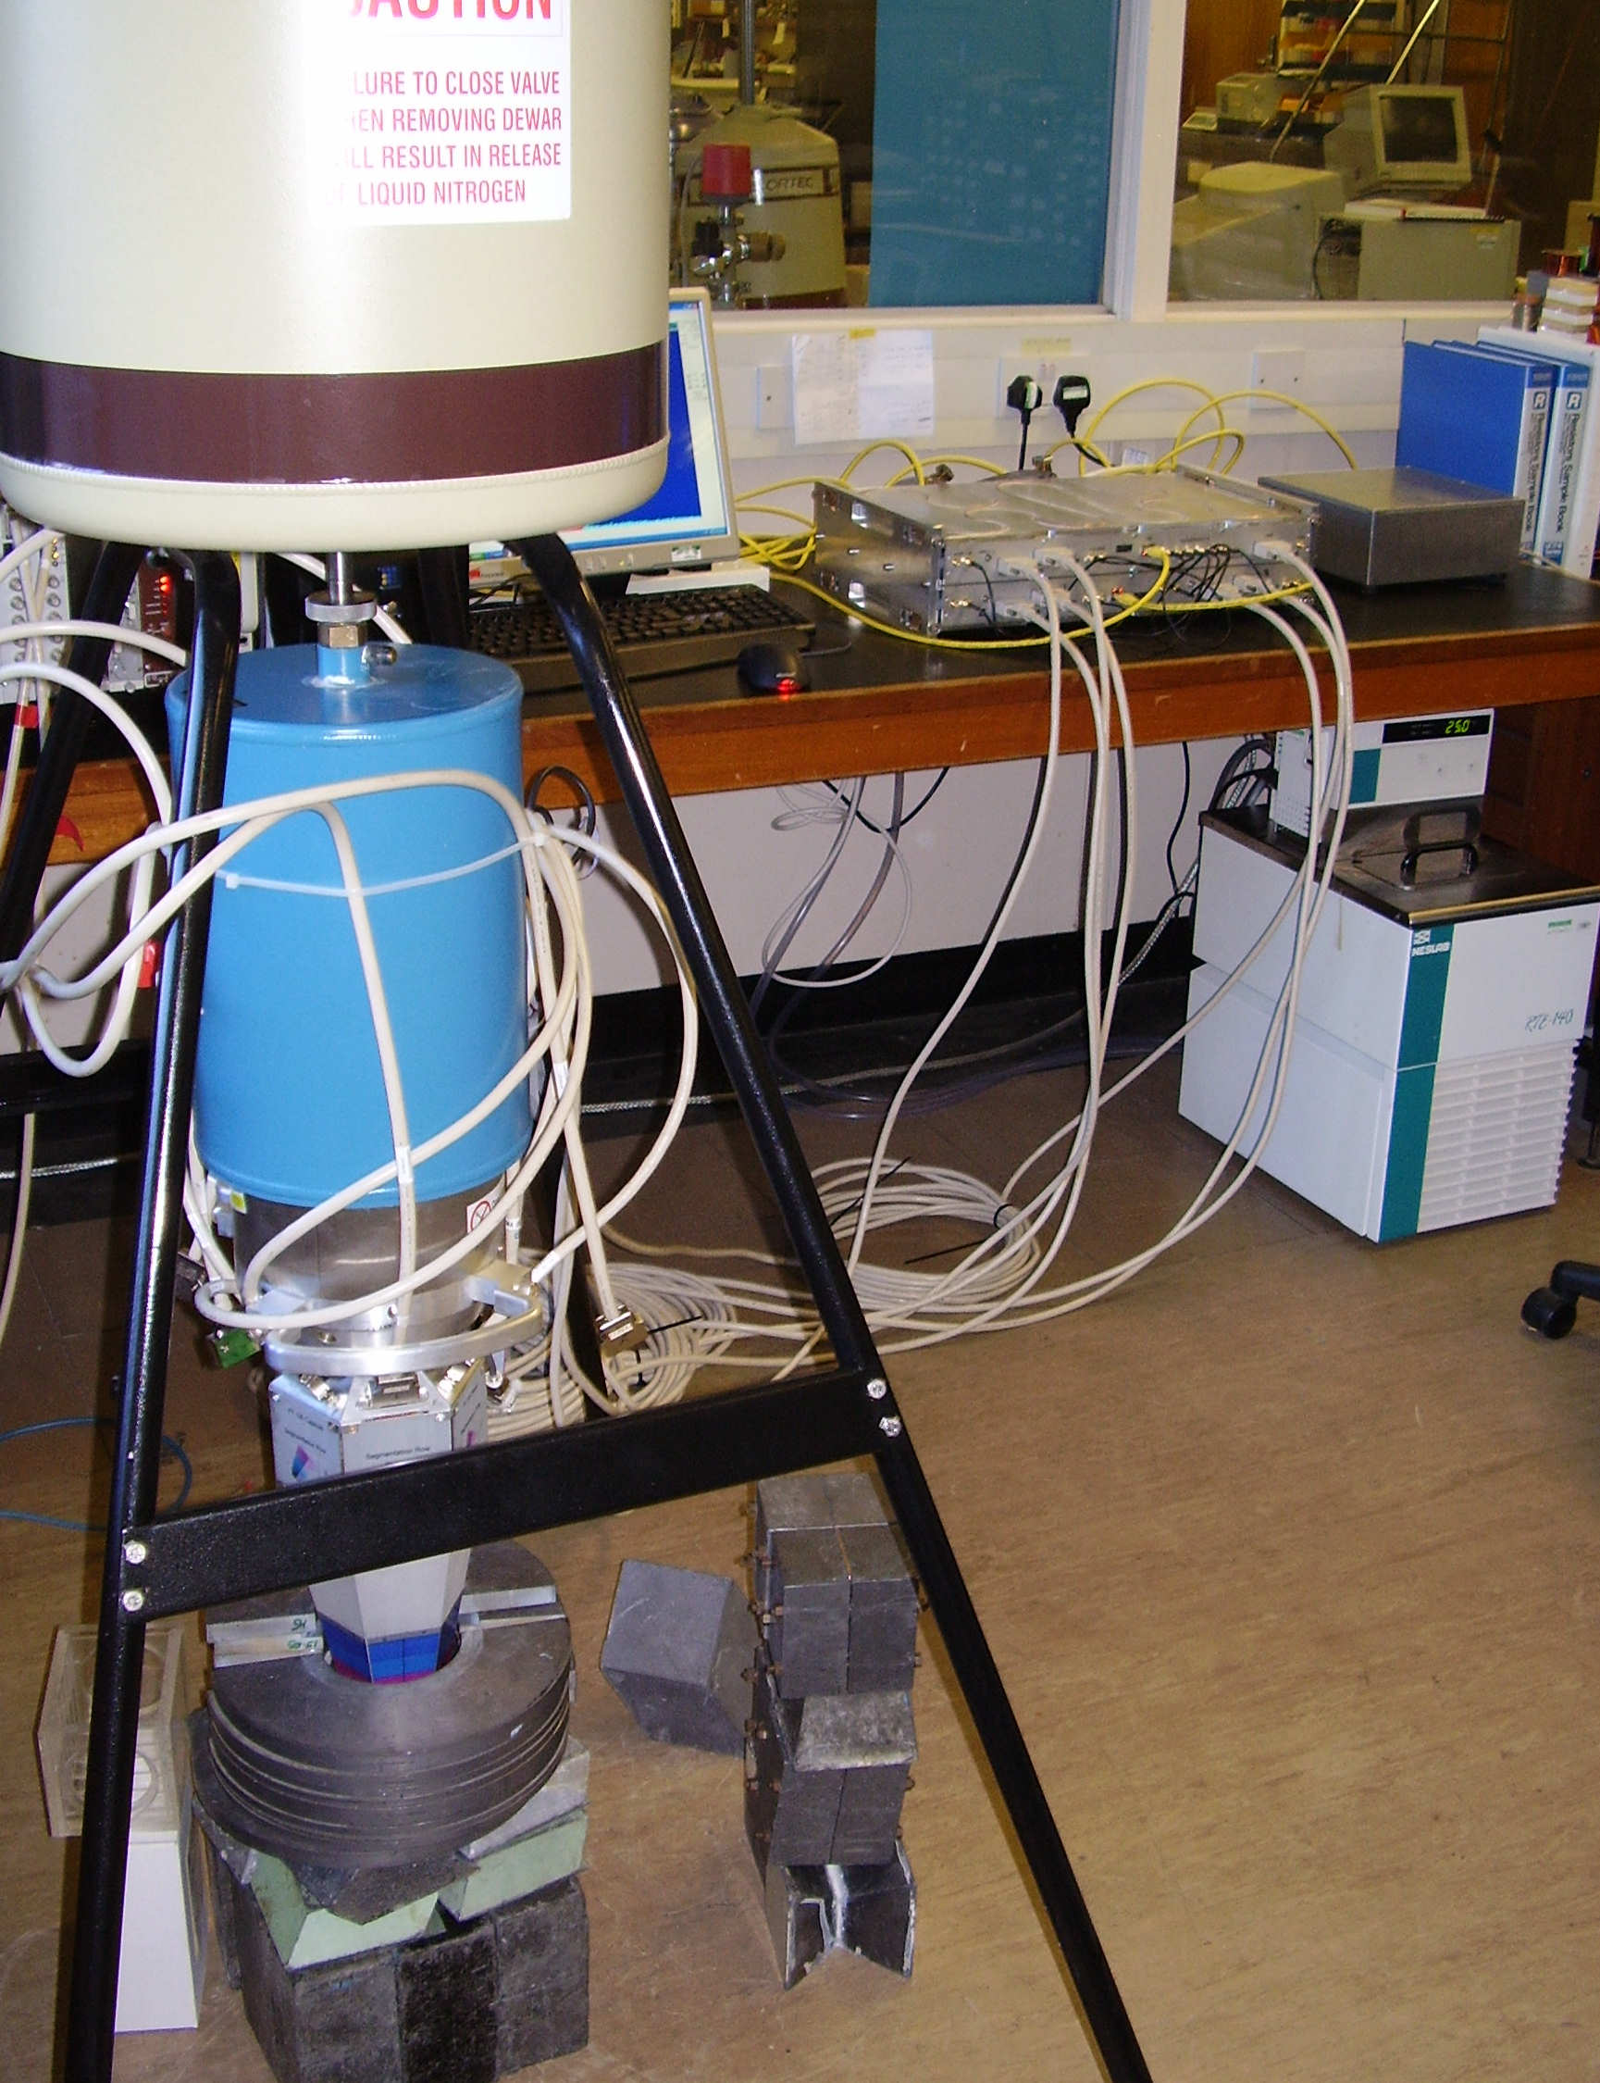 | If authorised by the GTS, several parameters are passed on to the Pulse Shape Analysis processor farm over high-speed PCI Express links. These parameters are the channel number, the energy, the raw data samples from the leading edge of the pulse (trace), and a timestamp (in 10-ns steps). The digitisers, produced by the UK, operate well. All 18 digitisers required are available and are being brought into operation as required.  During the research and development phase the pre-processing section of the electronics chain underwent a redesign which caused an overall delay to the electronics. This rework,  with Ian Lazarus (Daresbury) as the overall team leader, required significant effort. The new pre-processing electronics system is now being commissioned.
Figure 2.3 A digitiser under test using a single AGATA detector at Liverpool.

The “data-acquisition” section of the system, which will collate events and perform the tracking is making good progress, and growing as the number of detectors increases. Remote control, run control, and the various graphical user interfaces are still being developed; basic versions of all necessary software exist, but additional features are being added to improve performance and usability.

Infrastructure and ancillary detectors
Major progress has been made with the installation in Legnaro. The mechanical structure, designed and supplied by the UK, is installed. There exists the necessary power, liquid nitrogen autofill and cables etc. to operate the AGATA demonstrator. A module to enable “easy” electronic coupling of ancillary detectors to the AGATA system (the AGAVA module) has been developed. This will initially be tested with a relatively simple ancillary detector (DANTE, an array of MCPs within the target chamber).

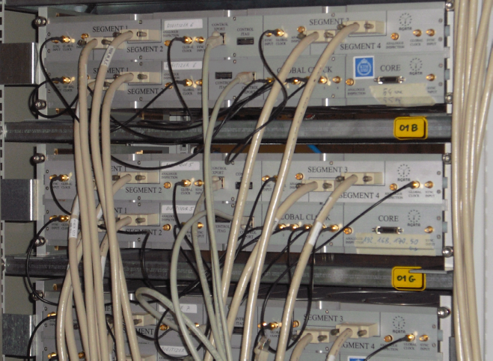 | Figure 2.4 The AGATA  digitisers in Legnaro.
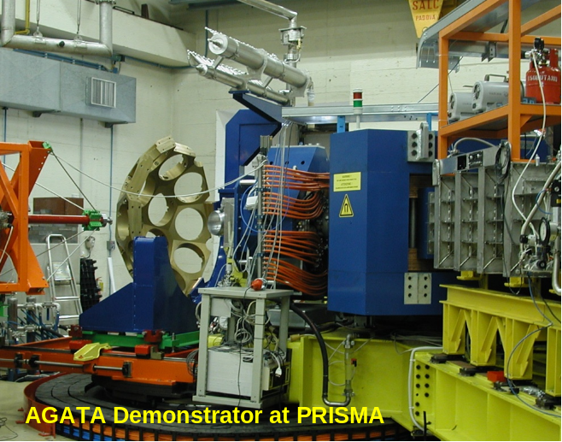 | Figure 2.5 The AGATA support structure at the entrance to the PRISMA magnetic spectrometer.

Progress and areas for concern
Overall, significant progress has been made on the AGATA project. Areas of concern and where work is still required are listed below.
- Detector reliability
- Detector characterisation
- Full production of the electronics (pre-processing)
- Acquisition control

AGATA commissioning
AGATA is being commissioned in a series of source and in-beam tests at Legnaro. To date, three tests have been conducted – a radioactive source test in February 2009, an extensive in-beam test in March 2009, and a brief in-beam test with an ancillary detector (DANTE) in late May 2009. In the March test, one AGATA triple module was used and data collected following the reaction of ³⁰Si at 70MeV on ¹²C target. Data analysis, which is still very preliminary, promises encouraging results. A spectrum, shown in Section 7(d)ii obtained during a run with both a target and a stopper (to catch long lived isomeric states) shows that the gamma rays of interest (1823 and 2333 keV) belonging to ⁴⁰K are emitted in-flight. This will allow the measurement of the position resolution of the detector from the broadening of the peaks in the Doppler corrected spectrum. Further in-beam tests including a high-multiplicity reaction and a reaction using the coupling of AGATA to the PRISMA spectrometer will be scheduled in the next six to nine months.

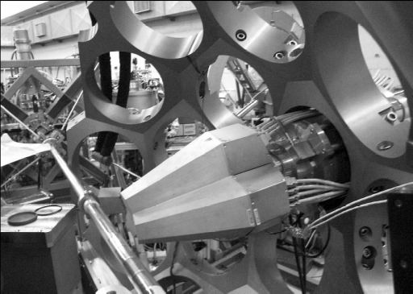  Figure 2.6 An AGATA triple cluster in position for an in-beam test in March 2009. | Careful planning of these tests is managed by the local Legnaro AGATA manager, Dr. Enrico Farnea. In addition to the development and detailed scheduling of all the AGATA components, the availability of beam from the Legnaro accelerators also has to be taken into account. For example the LINAC beams from ALPI will not be available until February 2010 which limits the masses and energies of the available beams.

Physics workshop
In November 2007, an initial workshop was held at the Legnaro National Laboratory to discuss the future Legnaro AGATA physics campaign. Following that workshop, a call for Letters of Intent for AGATA experiments at Legnaro was issued. In May 2009, a second AGATA Physics Workshop was held at Legnaro, to discuss the Letters of Intent along with additional new ideas for experiments at Legnaro. The workshop was organized by Prof. Sean Freeman (from the University of Manchester) who is the Legnaro AGATA Physics-Campaign Spokesperson, together with Prof. Andres Gadea (from Valencia/Legnaro). This workshop discussed an overall programme and the range of ancillary detectors that will be available. Presentations at the workshop were made by Regan (Surrey), Ollier (Daresbury), and Orlandi (UWS) from the UK.

Physics campaigns, the next phase and a new MoU
It is intended that AGATA will be deployed in a series of physics campaigns at major European accelerator laboratories. The Legnaro physics campaign will start in early 2010 and last for at least 15 months, utilising the wide range of stable beams available. Subsequent physics campaigns will be carried out at the GANIL laboratory in France and at the GSI facility in Germany. At GANIL the range of radioactive ions from the coupled cyclotrons and SPIRAL1 will be used with AGATA coupled to the EXOGAM and VAMOS spectrometers. At GSI, AGATA will be used at the target position of the fragment recoil separator (FRS) to study very exotic nuclei produced following high-energy fragmentation.

The phase of running physics campaigns, and building up the array towards a 1π device, is now governed by a new Memorandum of Understanding. The new MoU is discussed in detail in Section 4.

At the time of the submission of the UK AGATA Project Grant, it was expected that, following the Legnaro campaign, AGATA would be deployed first at GANIL and subsequently at GSI. However, in February 2009 GANIL management informed the AGATA collaboration that the GANIL laboratory would be shut down from mid 2011 until early in 2012 (during the expected period when AGATA would be installed) in order to carry out work required for the new SPIRAL2 facility at GANIL. Since this shut-down was announced, the AGATA collaboration has been in discussions with the GSI management with a view to bringing forward the AGATA installation at GSI to 2011, effectively swapping the timing of the GANIL and GSI campaigns. Discussions with GSI are presently ongoing and no decision by the AGATA Steering Committee has yet been made, regarding the location of the second physics campaign, post Legnaro. The change of plans and the resulting uncertainty in the siting of AGATA is necessitating several aspects of this grant to be rescheduled. In particular, work on the mechanical design on the new detector-support structure, which is naturally laboratory-dependent, cannot start until the siting decision is made.

3 The UK contribution to AGATA

The UK has contributed as a major partner to the research and development phase of AGATA. This contribution was made via two EPSRC responsive mode grants to the University of Liverpool and Daresbury Laboratory. The total award was £2.3M and the capital contribution to AGATA was £0.65M (0.95M€) representing about 20% of the total, with a manpower contribution of 46.5 FTE.

These data were collected by the AGATA Management Board and reported officially to the AGATA Steering Committee, which was responsible to the various funding agencies. A discussion of AGATA management is given in Section 4.

As stated earlier, the complete AGATA array will consist of 60 triple cryostats, made up of 180 detector capsules. In the current phase of development the collaboration aims to provide an additional 15 triple cryostats (45 detector capsules). This will be achieved by the members of the collaboration supplying these detectors and their related support (electronics, data acquisition etc.) systems. The UK bid for this phase of the project to STFC was for 20% of the capital equipment plus running costs and support manpower; the capital contribution in the bid was for nine detector capsules plus their related support systems and the mechanical-holding structures. Other partners have bid, or intend to bid, for the remaining capital. This information was specified in a new MoU which was signed by all countries, including the UK by STFC. This new MoU was designed to cover the increase of the number of detectors as well as the operation of AGATA. The level of award of 20% has been the “traditional” level of the UK’s contribution to major European projects, such as Euroball and Exogam. This is the level commensurate with status as a major partner in the project, and is not unreasonable considering the UK has no accelerator facility.

The STFC award to the UK was however at much reduced level of capital equipment than that which was requested, consisting of three detector capsules, a triple cryostat, digitiser electronics, and running costs. The PPRP recommendation recognised that the UK has specific expertise in mechanical and electronics design and project management and had leadership roles in these areas. The award included funds to enable UK mechanical engineers and designers to take responsibility for the mechanical structures for AGATA at the laboratories where it is sited. Funds were awarded for two mechanical structures. The award also enables UK electronic engineers have responsibility for the design and commissioning of the digitiser modules. In addition, the UK project has funds to support detector assembly and maintenance, detector characterisation, simulations (Monte Carlo) of the detector performance with typical reactions and commissioning the AGATA demonstrator with sources and in-beam. Running costs were awarded in proportion to the UK capital investment, which to date will be six detector capsules.

The current grant has duration of four years and will finish in 2012. The UK AGATA group intend to submit a bid in late 2011 for more capital equipment in order to increase the number of detectors funded by the UK above the present number of six. In addition the bid will include running costs and support manpower for detector assembly and maintenance, mechanical engineers and electronics engineers.

4 The AGATA Memorandum of Understanding

Background
The AGATA collaboration has defined that the full array will be realised in phases. In 2003 a Memorandum of Understanding (MoU) was signed by laboratories in 10 European countries. The purpose of this MoU was to establish the AGATA collaboration together with a framework to organise the project and to manage the first research and development phase of the project.

The MoU specified how the project was supervised by an International Steering Committee, with members representing the resource providers, and how it was managed by an International Management Board. The research and development phase of AGATA was defined, to build a demonstration sub-array and the associated new technology to prove the concept of tracking. This array was to consist of up to 15 germanium detectors, assembled in triple clusters, plus one prototype triple cluster. The demonstration sub-array – although a fraction of the full AGATA spectrometer – is a very powerful instrument in its own right and is known as the AGATA Demonstrator.

Throughout this phase, research and development has taken place to define the design of the array, to specify the digital electronics acquisition system, to deduce the algorithms to extract energy, time and position from the digitised signal, to tune the tracking algorithms to construct the full events and to design and implement all the necessary infrastructure to operate this complex device. By means of EPSRC responsive-mode funding, the UK has played a leading role in many of these areas.

Presently, the AGATA Demonstrator is assembled at the Legnaro National Laboratory and the first in-beam commissioning tests have taken place. This marks a transition of the project from the first “research and development phase” to a phase of operation with an associated physics programme, as well as the continual development of the spectrometer to a larger and more powerful instrument.

Since the submission and subsequent award of the current grant to the UK, a new Memorandum of Understanding has been agreed by the European AGATA collaboration. This MoU has been signed by John Womersley, representing STFC.

This MoU specifies in general terms
- The construction of the array in phases, from 15 detectors to the full 4π
(180-detector) array
- A more detailed description of the build up to a 20-module system (from 5)
- The operation of the device in physics campaigns in European laboratories.
The MoU contains a series of annexes, which define the collaboration and the expected commitment of each country to the project on an annual basis, for capital, effort, and operational costs. In addition a new management structure is specified, which is more appropriate for the “mixed” phase of operation - development and exploitation.

The main text of the MoU, together with some of the annexes, is reproduced below for information for the Oversight Committee.

Current AGATA MoU: main text

Introduction
The “Advanced GAmma Tracking Array” (AGATA) is a collaborative European project (hereafter referred to as the “Project” or the “AGATA project”) to construct and operate a gamma-ray tracking spectrometer. It is based on the successful research & development project started in 2003 which demonstrated the feasibility of achieving the ultimate goal of a 4π spectrometer through the technique of gamma-ray energy tracking in electrically segmented Ge detectors. The resulting AGATA spectrometer will have an unparalleled level of detection sensitivity to nuclear electromagnetic radiation. AGATA will allow the pursuit of a very rich science programme using both radioactive and stable ion beams as described in the AGATA Physics Case. To maximize the science output of AGATA, campaigns of experiments with complementary research programmes will be pursued at research facilities within Europe.

The full 4π AGATA system comprises 60 triple Cluster Ge detectors, the associated electronics, data acquisition and related equipment. The system will be built up and operated in phases. The aim of the first phase is to build up and operate 1/3 of the full AGATA system in four years from the date on when this MoU comes into effect. It is the intention to pursue the construction and operation of 2/3 and 3/3 of the full system in subsequent phases.

Parties of this MoU
This memorandum of understanding (hereinafter “MoU”) is between the Parties to this MoU (hereinafter “the Parties”). These Parties are listed in Annexe A.1. The institutes or institutions forming the AGATA Collaboration are listed in Annexe A.2 (hereinafter “the Collaborating Institutions”).

Purpose of this MoU
The purpose of this MoU is to specify what the Parties intend with respect to planning, funding, constructing and operating the AGATA project.

This MoU is the non-binding expression of the current intentions of the Parties. None of the Parties will be bound by any legal obligation to the other Parties or incur any associated expense.

The intention of the Parties and/or the Collaborating Institutions as appropriate is to provide the necessary capital and human resources to successfully carry out this project.

The first phase of the project is to operate an AGATA system that is currently planned to consist of twenty AGATA units of which five have already been funded in the R&D phase. Any changes in the scope of the detector system will be agreed at the AGATA steering committee, as described in Annex D.

The items forming the 20 unit AGATA system, their costing, the sharing of the required capital investment and human resources, and the construction schedule and the milestones for the first phase of the Project are given in Annexe B.

Annexe C gives the operation costs for the first four years of the Project. The Parties agree to operate the AGATA system in campaigns of experiments as the units become available.

For the duration of this MoU the AGATA system is expected to be sited for at least 25% of its total operation time each at GANIL/SPIRAL2 (Caen, France), GSI/FAIR (Darmstadt, Germany), LNL/SPES (Legnaro, Italy). The host collaborating institutions GANIL, GSI and LNL (hereinafter “Host” or “AGATA Host”) have agreed to host AGATA. AGATA will be an essential instrument for the future facilities FAIR, SPES and SPIRAL2.

Campaigns at any other host laboratory, in particular outside of the Collaborating Institutions, are subject to negotiations within the AGATA Steering Committee.

Formal letters of agreement between each Host and the AGATA Steering Committee, which represents the Parties as defined in Annexe D, will detail the commitment of the Host and the obligations of the Collaborating Institutions for each campaign.

Commencement, duration, withdrawal and extension of the MoU
This MoU will become effective when at least three Parties have signed including at least one Party from a country with a host collaborating institution.

This MoU shall continue in force until 31st December 2015. This MoU may be extended only by an amendment to the MoU.

Any Party may withdraw from the AGATA MoU by giving not less than twelve months notice in writing to the AGATA Steering Committee. It is expected that equipment provided by the Party will remain with AGATA for the period of this MoU.

Organisation and management
The AGATA organisation and the governance bodies for the construction and operation of AGATA are described in Annexe D.

AGATA is an open collaboration. New members may accede to this MoU through a written procedure defined by the AGATA Steering Committee.

Amendments and modification of the MoU
This MoU may be amended or modified at any time in writing if agreed by at least two thirds of the Parties.

General provisions on the MoU
Not reproduced here as the content is rather technical.

The full main text of the current AGATA MoU is available from
http://npg.dl.ac.uk/AGATA/AGATA_MoU_web.pdf

The Annexes are an integral part of the MoU; some of the annexes are reproduced below.

Annexe A: List of Parties and Collaborating Institutions

List of Parties
Bulgaria: Univ. Sofia, Bulgaria; Bulgarian Academy of Sciences, Institute for Nuclear Research and Nuclear Energy, Bulgaria;
Finland: Univ. Jyväskylä, Department of Physics, Accelerator Laboratory, Finland;
France : Centre National de la Recherche Scientifique – Institut National de Physique Nucléaire et de Physique des Particules, France;
Commissariat a l’Energie Atomique – Direction des Sciences de la Matière, France;
Germany: Gesellschaft für Schwerionenforschung mbH, Germany;
Italy: Istituto Nazionale de Fisica Nucleare, Italy;
Poland: Polish Academy of Sciences – The Henryk Niewodniczanski Institute of Nuclear Physics, Poland; University of Warsaw, Poland;
Romania: Horia Hulubei National Institute of Physics and Nuclear Engineering (IFIN/HH), Romania;
Sweden: Royal Institute of Technology, Stockholm, Sweden;
Turkey: Ankara University, Turkey;
UK: Science and Technology Facilities Council, UK;

Each Party is representing their national institutions collaborating in the AGATA Project and takes the institutional responsibility for the Project with the exception of Bulgaria, France and Poland where each Party represents their own institutes or institutions.

List of Collaborating Institutions

Bulgaria: Univ. Sofia, INRNE Sofia
Finland: Univ. Jyväskylä
France: GANIL Caen, LPSC Grenoble, IPN Lyon, CSNSM Orsay,
IPN Orsay, CEA/DSM/IRFU Saclay, IPHC Strasbourg
Germany: GSI Darmstadt, TU Darmstadt, Univ. zu Köln, TU München
Italy: INFN Firenze, INFN Genova, INFN Legnaro, INFN Milano, INFN Napoli, INFN Padova, INFN Perugia (Camerino)
Poland: IFJ PAN Krakow, University of Warsaw (HIL)
Romania: IFIN/HH Bucharest
Sweden: Chalmers Univ. of Technology Göteborg, Lund Univ.,
Royal Institute of Technology Stockholm, Uppsala Univ.
Turkey: Univ. Ankara, Univ. Istanbul, Technical Univ. Istanbul
UK: Univ. Brighton, STFC Daresbury Laboratory, Univ. Edinburgh,
Univ. Liverpool, Univ. Manchester, Univ. Surrey, Univ. West of Scotland, Univ. York

Annexe B.1: AGATA Equipment and Capital Investment

Each AGATA unit comprises a triple-cluster Ge detector with its associated electronics, data acquisition and storage system and related equipment. Specifications of all items will be produced by the AGATA management prior to production. All cost estimates are based on 2007 prices in Euro without tax. The cost of a unit was estimated to be 793k€ in the MoU. In addition 400k€ was estimated for common items (mechanics, electronics infrastructure and DAQ system).

Note: The UK (STFC) did not fund full “systems” as requested. Other countries in the collaboration have requested full systems.

Annexe B.2: Sharing of Capital Investment and Human Resources

The MoU specifies what bids Parties and/or Collaborating Institutions as appropriate are planning to make to contribute with the capital for 15 new AGATA systems. The MoU also specifies the human resources (physicists, engineers and technicians) that will be available to the AGATA project (personnel in person-months during the period for construction, installation and commissioning of the 20 unit AGATA system).

Table B.2.1 Capital investment and human resources for construction, installation, and commissioning of 15 new AGATA units, and planned sharing between the participating collaborating institutions of each country.

Country | Planned new capital investment in k€ | Planned personnel in person months
Bulgaria | 25 | 50
Finland | 25 | 50
France | 2460 | 450
Germany | 2460 | 400
Italy | 2460 | 500
Poland | 25 | 50
Romania | 180 | 50
Sweden | 1640 | 200
Turkey | 820 | 70
UK* | 2460 | 550
Total | 12555 | 2400

* The UK AGATA grant requested funds commensurate with these values but only a fraction of the requested funds were awarded: 893 k€ and a personnel investment of 470 person months.

Table B.2.2 Capital investment and human resources committed for the AGATA R&D phase and the 5 unit AGATA system.

Country | Funds committed in k€ (2003-2008) | Personnel in person months (2003-2007)
Bulgaria | 0 | 45
Finland | 2 | 8
France | 1400 | 1145
Germany | 1228 | 336
Italy | 1400 | 737
Poland | 0 | 60
Romania | 57 | 40
Sweden | 850 | 175
Turkey | 750 | 70
UK | 950 | 455
Total | 6637 | 3031

The Hosts will incur costs directly related to the installation and operation of the AGATA system. Estimates of these costs and the required human resources are given in table B.2.3.

Table B.2.3 Capital investment without general infrastructure costs and human resources planned to be provided by the Hosts for the installation, commissioning and operation of AGATA assuming an 18 months operation period at each site.

Country | Host | Planned capital investment [k€] | Personnel in  person months
Italy | LNL | 230 | 150
France | GANIL | 190 | 101
Germany | GSI | 200 | 171

The total capital investment needed for the construction, installation, and commissioning of the 20-unit AGATA system is summarised in table B.2.4.

Table B.2.4 Summary table of the capital investment for the 20-unit AGATA system and the planned sharing between the participating collaborating institutions of each country, which comprises the planned investment for 15 new AGATA units, the funds committed until 2008 for the R&D phase, prototyping and 5 units, and the planned capital investment by the Hosts.

Country | Planned new capital investment [k€] | Funds committed (until 2008) [k€] | Planned capital investment by the Hosts [k€] | Total capital investment  [k€]
Bulgaria | 25 | 0 | 0 | 25
Finland | 25 | 2 | 0 | 27
France | 2,460 | 1,400 | 190 | 4,050
Germany | 2,460 | 1,228 | 200 | 3,888
Italy | 2,460 | 1,400 | 230 | 4,090
Poland | 25 | 0 | 0 | 25
Romania | 180 | 57 | 0 | 237
Sweden | 1,640 | 850 | 0 | 2,490
Turkey | 820 | 750 | 0 | 1,570
UK | 2,460 | 950 | 0 | 3,410
Total | 12,555 | 6,637 | 620 | 19,812

Annexe C: AGATA operation

This Annexe describes the operation costs for AGATA and associated direct support staff. It also specifies the share between countries.

Note: This grant awarded operations costs for the UK contribution.

5 Project management and operation

Annexe D of the new MoU defines the management of the international project.

The organisation for the construction and the operation of the AGATA project comprises the following bodies:
- The AGATA Steering Committee (ASC), acting on behalf of the Parties, is responsible for the Project coordination and the science policy of the collaboration.
- The AGATA Collaboration Council (ACC), representing all the institutions collaborating under the AGATA project, advises the ASC on scientific matters.
- The AGATA Project Manager (PM) and the AGATA Management Board (AMB) are responsible for the execution of the Project along the lines defined by the ASC.

The terms of reference of each of these bodies is given in more detail below.

AGATA Steering Committee (ASC)

Membership: Members are nominated by the Parties of the MoU. Contributing Parties of a country which represent more than 10% of the total capital investment will have two members, all other contributing Parties of a country will have one member.

The AGATA Project Manager and the AGATA Spokesperson attend meetings for consultation only and therefore without voting rights. The ASC can invite others to attend as needed for consultation only, for example the Campaign Spokespersons and Local Campaign Managers.

Voting rights: Members have voting rights if they represent a Party having contributed at least one AGATA unit or the equivalent monetary value to the Project. Groups of Parties contributing together the equivalent of an AGATA unit can also have a vote by agreeing to join together. Additional voting rights will be attributed by ASC for each future commitment to the Project of one AGATA unit or the equivalent monetary value.

Terms of reference: The ASC is the decision-making body of the AGATA Collaboration and responsible for the allocation of resources supplied by the Parties and the collaborating institutions. The ASC will ensure that the primary criterion for deployment of any equipment is based on scientific merit.

The tasks of the Steering Committee are as follows:
- define the scientific policy of the AGATA Collaboration taking advice from the AGATA Collaboration Council.
- elect a chair and vice-chair among its members who will each serve for a period of two years.
- appoint a project manager and members of the AGATA Management Board.
- monitor the Project based on reports received from the Project Manager.
- decide on any modification of the Project proposed by the Project Manager.
- decide on the experiment campaigns for AGATA and the timetable for the deployment of AGATA systems at various facilities.
- appoint the Campaign Spokesperson for each experiment campaign.
- review the scientific progress of each experimental campaign based on reports received from the Campaign Spokesperson.
- review the running cost statements and allocations
- Decisions in the ASC shall be taken by consensus.

The ASC shall not make any decision unless a quorum of two thirds of the votes are represented.

Minutes of each meeting shall be drafted by the chairperson to the other members without delay. The minutes of each meeting shall be considered as accepted by the other members if, within thirty calendar days from receipt, the other members have not objected in writing to the chairperson.

The ASC chair signs on behalf of the ASC all written agreements.

Note: The current Chair of the ASC is Prof. Paul Nolan.

AGATA Project Manager (PM)

The AGATA Project Manager is appointed by the ASC to coordinate the execution and implementation of the project. For this purpose the PM can create and dissolve working groups as needed and after acceptance of the ASC. The PM will nominate the chairpersons of these working groups.

Note: The current project manager is Prof. John Simpson who will stand down once a new PM is appointed.

AGATA Management Board (AMB)

Membership of the AMB: The AGATA Project Manager; Chairpersons of the working groups; Chairperson of ASC (ex-officio). The AGATA Project Manager will chair the AMB.

The Local Campaign Manager(s) nominated by each Host are invited to attend.

Voting rights: All members have equal voting rights.

Terms of Reference: The AMB executes and implements the project. The AMB shall report to and be accountable to the ASC through the AGATA Project Manager.

The tasks of the AMB are as follows:
- supervise the effective and efficient implementation of the Project.
- collect information on the progress of the Project, examine that information to assess the compliance of the Project with the programme decided by the ASC and, if necessary, propose modifications of the programme to the ASC.
- provide reports of the progress of the Project to the ASC including an annual planning and resource report.
- advise the ASC on technical issues.
- work with the Local Campaign Manager of each Host to ensure the successful operation of AGATA.
- organise AGATA working group meetings as needed.

The working group structure for the R&D phase of the project is shown in the figure below.

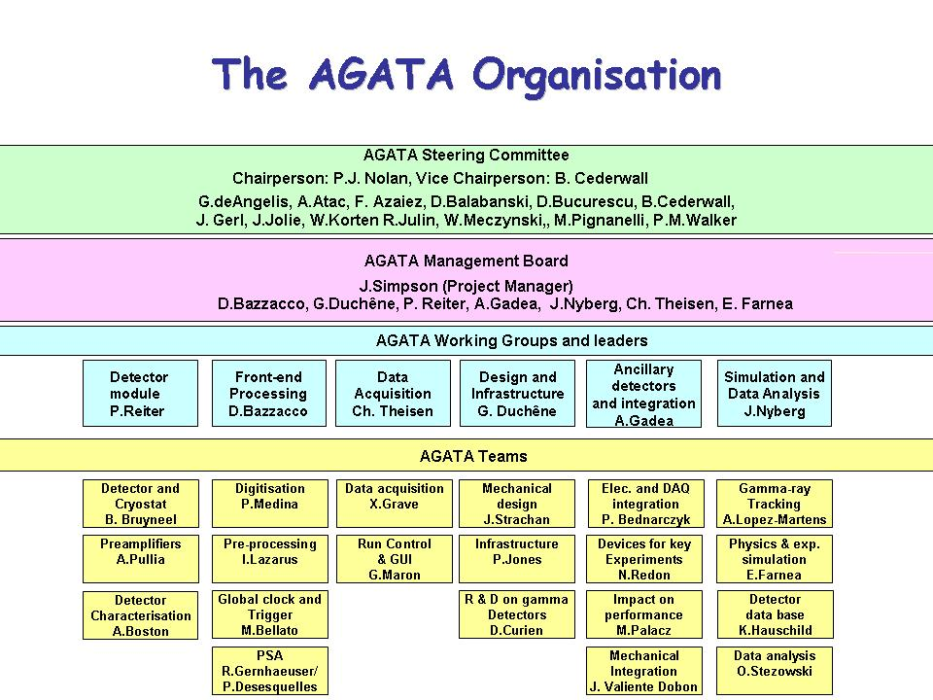
Figure 5.1 The current AGATA organisation. Andy Boston (Liverpool), Ian Lazarus (Daresbury), and Jon Strachan (Daresbury) are Working Group leaders.

The ASC and the AMB are currently discussing the appointment of a new AGATA Project Manager and the working-group structure. It is expected that the new structure will be in place before the next Oversight Committee meeting.

AGATA Collaboration Council (ACC) and AGATA Spokesperson

Membership: One representative from each collaborating institution and the AGATA Spokesperson. The AGATA Spokesperson chairs meetings of the ACC.

The Campaign Spokespersons are invited to attend.

Voting: All members have equal voting rights. The AGATA Spokesperson is excluded from any vote concerning the Spokesperson role.

Terms of Reference: The ACC is the advisory body of the ASC on scientific matters concerning the AGATA project.

The tasks of the ACC are as follows:
- elect the AGATA spokesperson who will serve for a period of two years.
- advise the ASC on scientific matters concerning the AGATA project and the research programme through the AGATA Spokesperson.
- nominate the Campaign Spokesperson for each experiment campaign to the ASC.
- hold meetings, at least annually, to receive reports from the ASC and AMB on the progress of the Project and from the Campaign Spokespersons on the progress of the research programme.
- hold an annual open meeting of the AGATA Collaboration to present the status of the Project and to discuss future experiment campaigns.

6 Overview of any call on contingency/WA

Presently, the major call on the contingency/working allowance (WA) is arising from the change in exchange rates. When the grant bid was made the estimates for the capital equipment were based on 2007 prices. The exchange rates assumed were
1.43 €/£ for many items and $2/£ for the electronics components.

Detector capsules
The major capital items are the three detector capsules. The cost in pounds estimated in the bid was £393k (inc. VAT). There is only one detector supplier, Canberra France, who priced the detector capsules in euros. The order was placed at a cost of £553k (inc. VAT). The increase in the basic detector price was ~6%, the major difference coming from the exchange rate (order was placed with a rate of 1.11 €/£). The order included stage payments so that 70% of the costs can be paid during 2009. This should attract the lower rate of VAT (15% until the end of 2009 and 17.5% thereafter). Overall the expected call on the working allowance is £160k. This was approved by the office as a call on the WA before the order was placed.

Triple cryostat
In the grant application, the triple cryostat was estimated to cost £68k (inc. VAT). The present estimate is £88k, representing an increase of £20k. This increase arises from the change in exchange rate. This order should be placed in the next two months.

Electronics
The award for electronics (digitisers) was £253k. This was made up of 8 digitisers at a total cost of £183k, and the upgrade cost of £70k. Most of the electronic components are priced in dollars, the exchange rate at the time of the bid was $2/£, whereas it is presently $1.6/£. The bid was also priced assuming that 15 digitisers of the current design would be built. There will be cost implications for ordering smaller quantities of components if less than 15 digitisers are made. The UK will fund 4 digitisers in 2009/10, with other members of the collaboration funding a further two. Following the upgrade, the UK will order a further four with the collaboration funding further units (the exact number is currently not known). For the first four digitisers the expected increase in cost is £32.5k (£12k from the exchange rate and £20.5k from the smaller number). The expected increase for the upgrade is £9k. There may be an increase in cost for the remaining four digitisers. As these will be purchased towards the end of the grant it is presently too early to estimate this increase.

Other capital items
The other capital items, such as the mechanical structures, will be bought in the UK and similar costs problems are not expected.

Running costs
In the grant application, the running costs were quoted in € and an award made in £ based on the 1.43 €/£ exchange rate. The UK award was £77.5k. The running costs are paid to the collaboration in euros. The increase in the sterling cost to maintain the euro value (assuming an exchange rate of 1.11.euros) is £22.3k. This will be paid annually and the increase in cost each year will be reported to the committee.

Research student
The research student who was appointed to a 3.5 year position at York has decided to leave. With the agreement of the office, a new student will be appointed in September 2009 on a three-year position. Initial estimates suggest this will cost around £1k more than is left in the budget, accounting for the funds that were spent on fees and stipend for the student who left. This will be monitored and a report made to the Oversight Committee when the situation becomes clearer.

Summary
The Oversight Committee is asked to note the increased cost of £160k for the detector capsules which resulted in use of the working allowance. The committee is also asked to note that there is likely to be an increased cost for the triple cryostat and the electronics. This cost is likely to occur within the next six month period. Other costs increases will be known later and will be brought to the committee at the appropriate time.

Financial summary (WA)
The working allowance is £265k. This was funded as part of the grant and is held in Liverpool. The current situation is summarised in the table below.

 |  | Orders placed | Estimates
WA in the grant award | £265k
Detector capsule order |  | £160k
Cryostat |  |  | £20k
Electronics |  |  | £41.5k
Running costs |  |  | £22.3k
Research student |  |  | £1k
Totals |  | £160k | £84.8k
WA remaining | £20.2k

7 Project programme by Work Package

7(a) Work Package 1 Detector-specification measurement

and cryostat assembly and commissioning

Leader: Dr. A. J. Boston – University of Liverpool

Institutes: Liverpool

7(a) i. Description of the work package

Background: The AGATA collaboration plans to purchase 45 germanium detector modules during the four-year period of this grant request. Three of these detector modules are for UK purchase. The collaboration wishes to establish three laboratories to carry out the acceptance tests on these detector modules and then to assemble three detector modules into one triple cryostat. The cryostat will either be purchased or developed within the collaboration. To date, all of this work has taken place at the University of Köln or at the recently established CEA detector laboratory at Saclay. It is proposed by the AGATA community that the University of Liverpool becomes the third site. It is the natural choice due to the experience of the academic staff at Liverpool and its well-developed infrastructure including the clean-room complex. This laboratory must plan to carry out the acceptance tests on 15 modules over the four-year period, and to assemble, test and commission five triple cryostats.

Current status: The collaboration has defined the design and specification of the detector modules and the triple cryostat. The detector team has five existing single-test cryostats for customer acceptance tests and characterisation measurements. The first three asymmetric triple cluster cryostats have been assembled in Köln, and are being delivered to Legnaro for the start-up of the AGATA Demonstrator. Hence, the technology will have been developed before the phase of the project for which this request was made.

Tasks
Detector specification measurements: The AGATA detector modules have a detailed performance specification against which the orders are placed with the commercial manufacturer. The measurements needed are time consuming and require a high level of expertise. Once a detector capsule is delivered, it must be mounted in a test cryostat, connected to 37 cold FETs, and cooled to LN₂ temperature. This task necessitates the employment of a skilled technician and a clean environment. Liverpool has the infrastructure for this work. Energy-resolution and efficiency measurements are then recorded and any potential faults diagnosed. The cross-talk measurements (between the different output channels) can only be made with the required sensitivity with coincidence digital electronics. These measurements would be very expensive if carried out by the manufacturer (the cross talk measurements cannot be done by the manufacturer) so for both economic and educational reasons, the collaboration has chosen to carry out these measurements itself.

The measurements for each detector module take around two months of continuous source measurements and data analysis. This can be longer if there are problems with the detector performance. The data obtained will be an important part of the database of performance specification that will be maintained by the collaboration.

Detector assembly for scanning measurement: Once individual detector modules have been accepted, single modules have to be assembled into cryostats for the scanning process, which builds up the pulse-shape database for the detector characterisation (Work Package 2). The assembly work will take place in Liverpool. The expectation is that not all of the individual detectors will need detailed characterisation, but this will be needed for the first period of this project (up to about 10 detectors) so that a comprehensive database can be assembled.

Triple-cryostat assembly: Once detector modules have been shown to meet the specifications, three modules are assembled into a triple cryostat. This task also necessitates the employment of a skilled technician and a clean environment. Once the assembly is complete the detector-performance specification has to be measured; in particular, attention needs to be given to any cross-talk that may have arisen in the process of assembly in the cryostat.

Outputs
- Individual detector modules fully tested and ready for use. Detailed measurements of the detector modules to fed into the experiment database.
- Individual detectors mounted into cryostats for use in Work Package 2.
- Assembled triple cryostats ready for use in experiments.

Justification: All of the above tasks are vital to AGATA. As the detector modules arrive they have to be tested and commissioned, and then assembled into triple cryostats ready for use in the array. The collaboration has decided that three centres are needed for this work. The University of Liverpool has the expertise and most of the infrastructure for this work and is the natural choice for a UK base. It is important that the UK takes on its share of important roles within the collaboration; this is an ideal task for the UK part given its expertise and track record.

Costs: Dr Helen Boston who will take charge of the day-to-day work. The detector specification measurements will take approximately 30 months of effort; this will be shared between a research student, in the first year of their PhD project, and Mr Mark Norman (an EO working in the detector laboratory at Liverpool). The assembly of detector modules into test and scanning cryostats and the assembly of detector modules into triple cryostats will take place in the Liverpool clean-room facility. This is a skilled technical task which will require a new staff member. This task will occupy a person full-time from the beginning of the second year of the grant award. Once the triple cryostats are assembled they will be tested by Norman and H Boston with student help.

This work will need a test cryostat for single-detector modules that are based in Liverpool, so that the measurements can be carried out. The other costs requested are for a vacuum pump, leakage-current meter, and oscilloscope for the clean room. There will also be consumables costs (such as liquid nitrogen) and a facility charge for use of the clean rooms. There is a travel request to cover a visit to Köln for training, collaboration meetings, and delivery of assembled detectors.

7 (a) ii. Commentary on the activities to date
Relevant University staff (H. Boston) and PhD students (C. Unsworth) have been trained at the University of Köln in detector module assembly. Mark Norman (Liverpool EO) and Steven Moon (Liverpool PRDA) have subsequently been trained in Liverpool. The detector-assembly and testing area has been established in the University of Liverpool Department of Physics detector laboratory; this includes all the supporting instrumentation and cryogenic systems. The AGATA asymmetric detector C001 has been re-assembled and tested, prior to scanning (WP2) in the laboratory. Examples of the internal warm-cold feed through assembly, cold segment FET blocks and test cryostat assembly are shown in Figures 7(a) 1 and 7(a) 2.

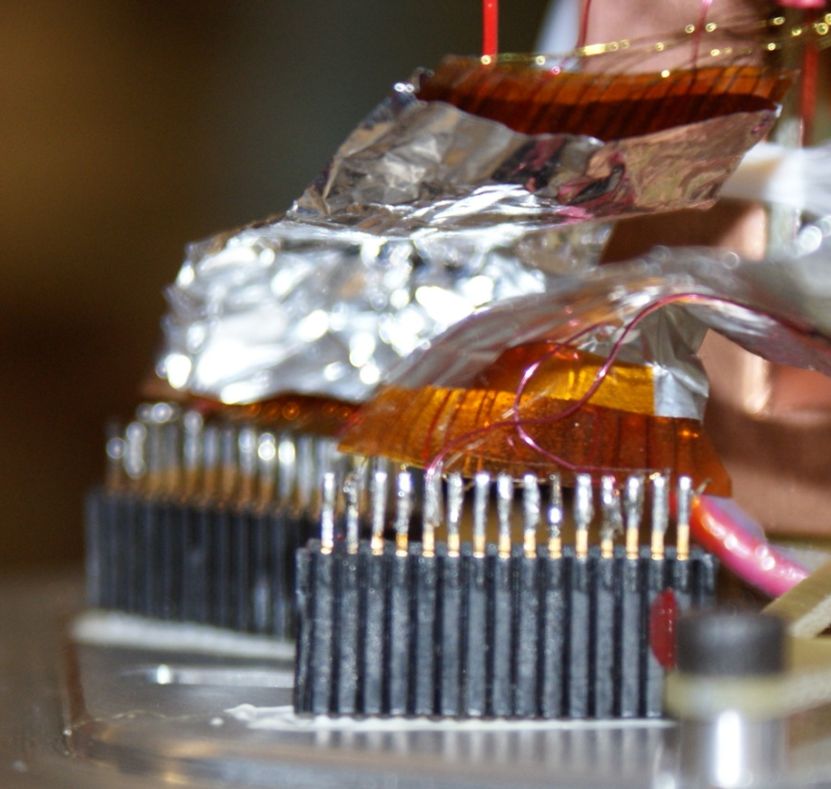 | 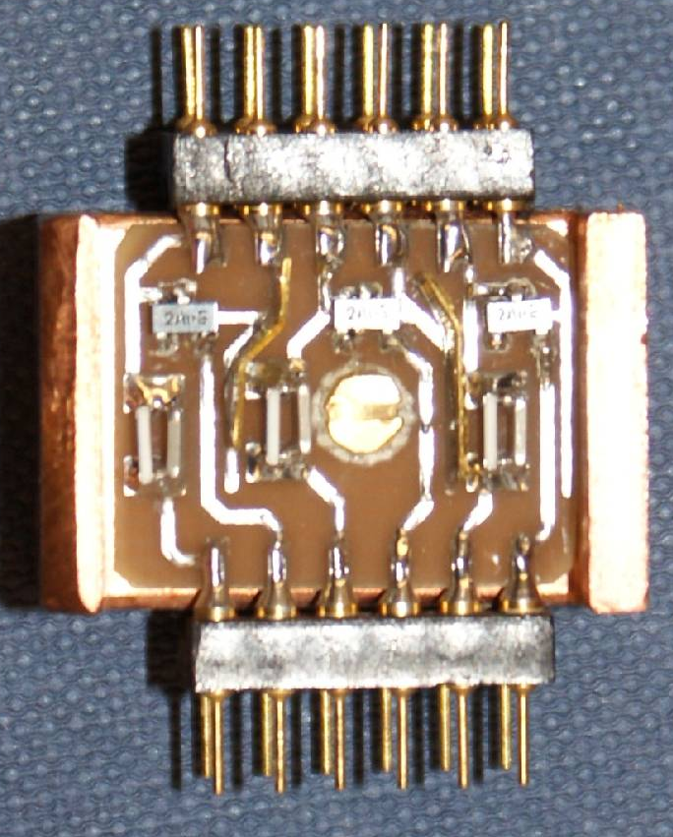
Figure 7(a) 1: AGATA warm cold feed through (left) and FET blocks (right)

Methodologies to troubleshoot and diagnose issues have been developed and valuable experience gained. The performance of the C001 detector system post assembly has been verified.

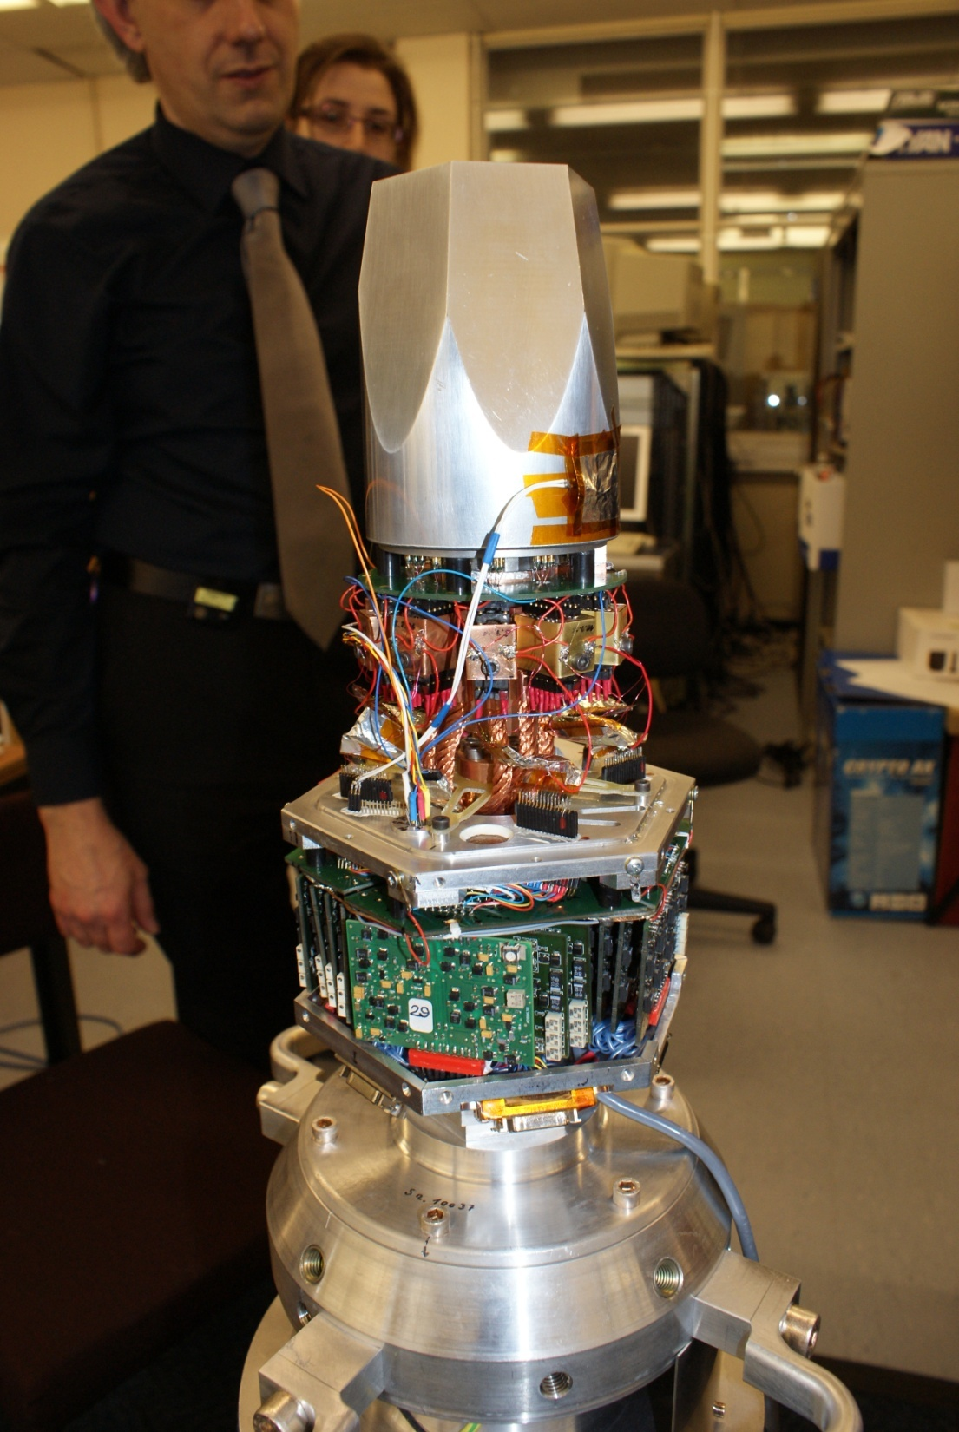
Figure 7(a) 2: AGATA C001 asymmetric detector assembly
7(a) iii. Programme of work for the next 6 months

The detector C001 will be repaired and commission for scanning. The detector acceptance setup will be commissioned, together with the infrastructure to assemble triple cluster modules. Following the successful test of a capsule Liverpool will request to the AGATA collaboration and Canberra France to be an accredited customer acceptance site. A suitable AGATA test cryostat will be relocated to the Liverpool detector assembly centre. The essential components for a test cryostat including cold/warm cryostat parts will be procured and made available for detector assembly. A new pumping system capable of servicing a triple cryostat will be commissioned. The Liverpool detector technician will be appointed and trained in the assembly/testing of the AGATA detector modules. Depending on collaboration priorities detector acceptance testing may commence in Liverpool during this period. A further detector for scanning will be commissioned.

Note on the milestones
The manpower has been re-profiled over 4 years to allow the possibility of continuity at the end of the period. This was agreed by STFC. The technician will start later and the initial work will concentrate on getting the Liverpool laboratory approved to be an official detector acceptance site. The work to assemble detectors will start towards the end of the first year.

7(a) iv. Financial Statement: Work package 1
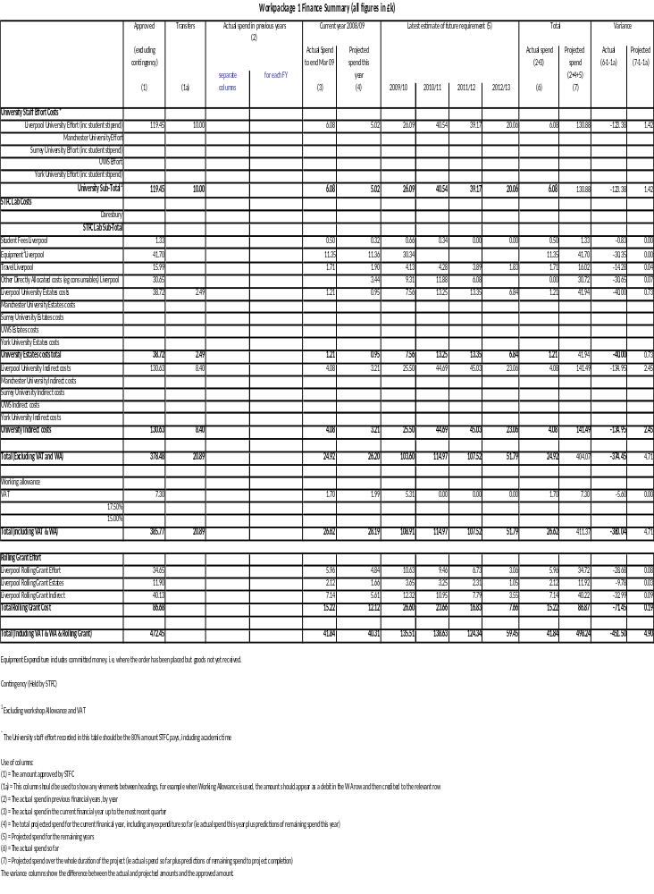

7(a) v. Resource usage: Work Package 1

Table of staff %age FTE

WP1
NAME | INSTITUTE | % FTE 2008/09 | % FTE 2009/10 | % FTE 2010/11 | % FTE 2011/12 | % FTE 2012/13 | Total Effort | Effort Remaining
A Boston | Liverpool | 0.050 | 0.125 | 0.125 | 0.100 | 0.050 | 0.450 | 0.400
H Boston | Liverpool | 0.050 | 0.150 | 0.200 | 0.200 | 0.100 | 0.700 | 0.650
Technician grade E | Liverpool | 0.000 | 0.500 | 1.000 | 1.000 | 0.500 | 3.000 | 3.000
Liverpool Student | Liverpool | 0.100 | 0.200 | 0.100 | 0.000 | 0.000 | 0.400 | 0.300
Rolling Grant
M Norman | Liverpool | 0.175 | 0.375 | 0.325 | 0.225 | 0.100 | 1.200 | 1.025

7(a) vi. Milestones: Work Package 1

Table 1: Milestones achieved in the last six months
Milestone No. | Work Package | Milestone | Target Date | Status
M1.1 | WP1 | Train staff in Köln | 02 Apr 09 | Complete

Table 2: Milestones due in the next six months
Milestone no. | Work Package | Milestone | Target Date
M1.2 | WP1 | Successful measurements on a detector  capsule and Liverpool to be an accredited detector acceptance centre | 05 Oct 09

Table 3: Overall Milestone List
Mile-stone No. | Work Package | Milestone | As at June 09 | Delay due to |  | Affects Critical Path? | See Note
 |  |  |  | UK? | Other Collaborators? | Affects Critical Path? | See Note
M1.1 | WP1 | Train staff in Köln. | 02 Apr 09
M1.2 | WP1 | Successful measurements on a detector  capsule and Liverpool to be an accredited detector acceptance centre | 05 Oct 09
M1.3 | WP1 | 1st detector successfully mounted | 05 Jan 10
M1.4 | WP1 | Successful installation testing of UK test cryostat | 07 Apr 10
M1.5 | WP1 | Successful mounting and commissioning of 3 detector modules into triple cryostats | 8 July 10
M1.6 | WP1 | 2 triple cryostats successfully assembled | 10 Jan 11
M1.7 | WP1 | 4 triple cryostats successfully assembled | 13 Jan 12
M1.8 | WP1 | 5 triple cryostats successfully assembled | 17 Oct 12

7(a) vii. Gantt chart: Work Package 1

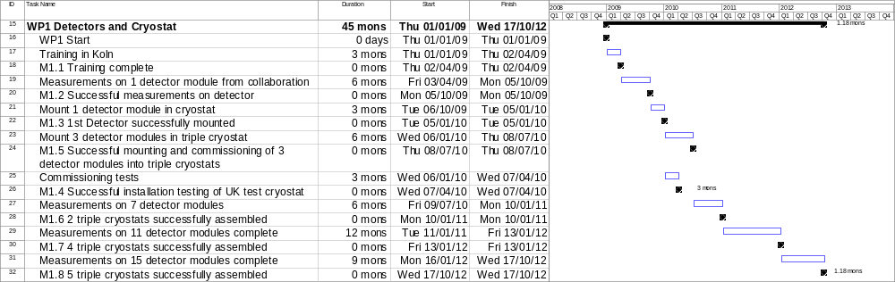

7(b) Work Package 2 Interaction position determination
using pulse-shape analysis

Leader: Dr. D. M. Cullen – University of Manchester

Institutes: Manchester, Surrey, and Liverpool

7(b) i. Description of the work package

Background: The AGATA Demonstrator will be commissioned at Legnaro National Laboratory in 2009. AGATA requires the accurate determination of the interaction positions of all the gamma rays detected.

Outputs
- Characterisation of asymmetric detectors.
- System available in Liverpool. Systems can be available in Manchester and Surrey for further work, if needed.
- A detailed database of experimental pulse shapes for the three different asymmetric detector geometries.
- Comparison between experiment and simulation using initially the MGS code, with the aim of sufficient accuracy to be able to predict the response of future detector modules.
- Investigation of other electric-field simulation codes such as JASS.
- A mapping between the experimental pulse shapes and the gamma-ray interaction positions for the whole detector volume, for a range of gamma-ray energies.
- Development of efficient algorithms to analyse the first commissioning data available from Legnaro.
- Optimisation of the algorithms for use in the online PSA farm, for use in different experimental situations.
- To provide position-determination data from the PSA codes for direct input to WP3 to allow the influence of the true position resolution on the GEANT simulations to be investigated.

Justification: The characterisation of the AGATA detectors is of vital importance to the project. AGATA cannot be exploited in physics experiments without a detailed knowledge of the gamma-ray interaction positions (determined from pulse-shape analysis). The UK is leading this work in the AGATA collaboration and is a world leader in this field. The analysis of this data is one of the areas where the UK has a leadership role in the collaboration. Dr A J Boston is the leader of the AGATA detector characterisation team. The Liverpool scanning table is the only fully operational system in the international AGATA collaboration.

Costs

Human resources: PDRA and student effort is needed close to the start of the project, as the majority of this work should be complete during 2009-2010 to allow analysis of the first data sets from Legnaro. H Boston and Norman have increased effort on this work package in the first year, compared with later years, corresponding to the completion of the detector-characterisation work.
Travel: This UK group (WP2) will meet every four months during the first two years of the project. There will also be visits to AGATA pulse-shape analysis meetings.

Equipment: Data storage, tape and disc backup plus computers for data analysis are requested in each institution. This equipment can be used later in the project for other work packages.

Tasks

Task 1: Detector Characterisation
AGATA has detector modules of three different geometries. The position response of each individual detector type (geometry) to gamma rays must first be experimentally characterised in order to validate a model of the detector performance that is being developed using an electric-field simulation code (the MGS code). The characterisation process involves experimentally scanning a collimated source across the detector to locate interaction positions in three dimensions (to an accuracy of about 1mm³) and collecting a statistically significant number of pulse shapes at each location (i.e. the time profile of the charge collection). This process is time consuming taking on average about 2 months per detector plus about 2 weeks setting up time. The collaboration has decided that at least three detectors of each geometry should be characterised in this way in order to determine the performance differences between the of detector modules, which are nominally the same.

Task 2: MGS 3D simulation code comparison
with experimental detector characterisation
The experimental data from the detector-characterisation scans (Task 1) will be compared with the predictions of the MGS simulation code which aims to solve the Poisson equation for detectors of the different geometries and predict the pulse shapes as a function of interaction position. There are a number of competing solutions including the MGS code which is being developed in Strasbourg. A Maxwell-3D simulation will be developed as part of this work. It is vital to the success of AGATA that reliable simulations are possible as the time taken to experimentally characterise all of the 180 planned detectors would be ~10 years.

Task 3: Pulse-shape algorithm development
The analysis and interpretation of the data from the AGATA Demonstrator experiments will rely on the pulse-shape versus position database information obtained from the characterisation scans. This work has started by aiming to get a reliable pulse-shape to position determination algorithm with sufficient accuracy over a range of positions and gamma-ray energies to allow initial analysis of the Legnaro data with a three-dimensional position determination accuracy of 4-5 mm. As the work continues and the algorithms are improved it should be possible to get accuracy closer to 2 mm. This will involve working with both the pulse-shape data base (Task 1) and the MGS simulations (Task 2). This work will be the responsibility of Manchester and Surrey who will concentrate on different aspects of the data from Legnaro.

7(b) ii. Commentary on the activities to date

Current status of Task 1

Liverpool has developed the protocol for scanning detectors. The Liverpool scanning table is shown in Figure 7(b) 1, below.

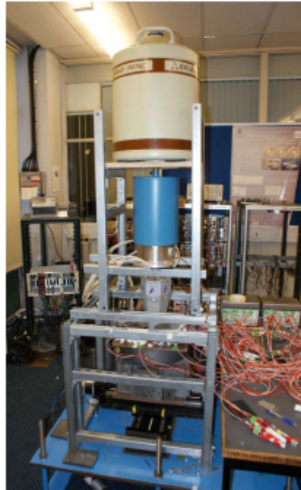
Figure 7(b) 1 The scanning system in Liverpool.

Two of the symmetric crystals have been scanned. These data will be published in 2 IEEE TNS in June 2009. To date, no asymmetric detectors have been fully characterised. The first asymmetric detector (C001) scan was delayed due to availability of a detector from the collaboration, and subsequently a cooling problem which has required the replacement of cold FETs. The detector repairs are part of the work at Liverpool under Work Package 1. Prior to the detector failure, singles scan and preliminary coincidence scan data was recorded. Results from the singles work can be seen in Figures 7(b) 2 and 7(b) 3, and is described below.

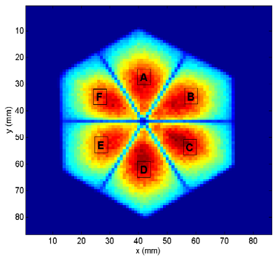 | 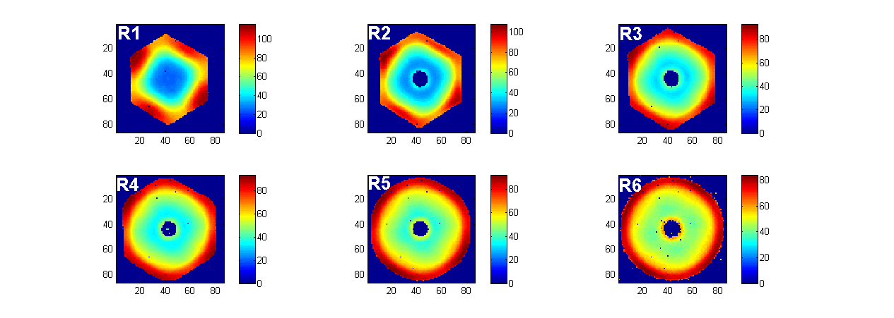
Figure 7(b) 2 Singles scan of C001 intensity (left), T30 rise time (right) for ring 1.

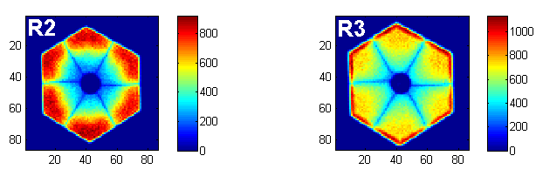
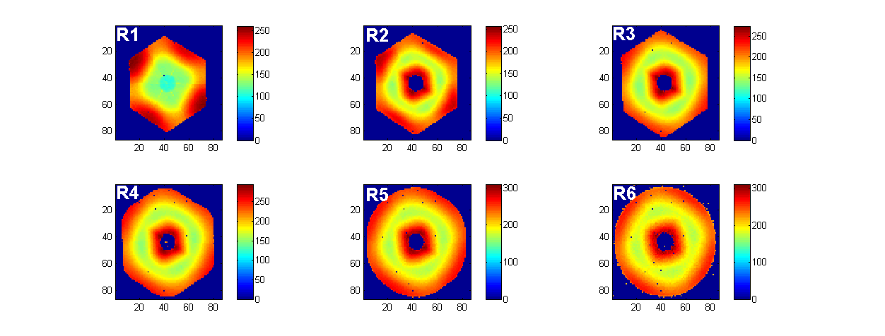
Figure 7(b) 3 Singles scan (i) intensity (top) (ii) T30 rise time (middle) (iii) T90 (bottom) for detector rings 2 (left) and 3 (right) respectively. The top plots are graded in counts, and the middle and lower plots have units of ns.

A data set of the experimental pre-amplifier pulse shapes observed as a function of the interaction position of a beam of gamma-ray photons was recorded, using modules purchased from the Gretina collaboration, which were recently commissioned in the Liverpool detector laboratory. A collimated source was used to measure the detector-response function and an automated x-y positioning table was used to move the source. Such a detector “scan” allows the experimental detector response function to be precisely measured, allowing comparison with the theoretical pulse shape database. A scan of the front face of the detector has been carried out using a 993.6 MBq ¹³⁷Cs source, collimated into a 1-mm diameter beam, yielding ~800 photopeak cps in the AGATA detector. Data were recorded on a 1-mm grid for 1 minute at each position. The system was triggered using an external CFD with a threshold of ~650 keV on the central contact in order to eliminate unwanted Compton scattered or background data.

The intensity plots clearly show the segmentation pattern of the detector and the presence of the core hole for rings 2 and 3. Also apparent is the offset of the horizontal segmentation line for rings 2 and 3, due to the electron and hole drift profile being influenced by the fast/slow axis orientations. The pulse shape rise time results for 10%-30% of the pulse shape (T30) and 10%-90% of the pulse shape (T90) clearly reveal the crystallographic lattice orientation of the crystal. The mapping of the six-fold crystal symmetry with the four-fold FCC lattice symmetry is easily observable. The large range of pulse-shape rise times facilitates the pulse-shape analysis that is essential for the success of the AGATA project. The scan of detector C001 revealed a 12° offset toward segment B from that specified by the AGATA collaboration.

Development of the scanning technique to improve the performance of the characterisation process is ongoing. Presently a full coincidence scan of an AGATA detector takes 2 months of data collection. The Pulse Shape Comparison (PSC) Scan method [Crespi, NIM A, April 2008], shown in figure 7(b) 4, will be much faster but validation of the method is needed.

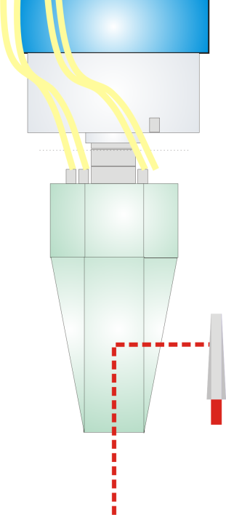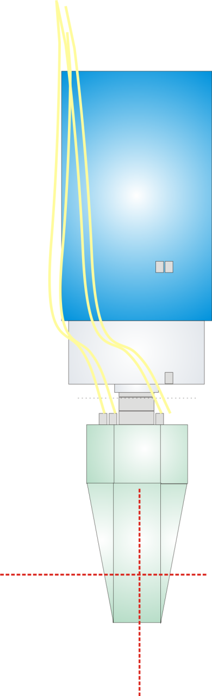

Figure 7(b) 4 Proposed new scanning methodology (left) existing concidence scan (right) proposed PSC method with two collimated beam measurements measured sequentially.

The method requires the chi-squared minimisation of pulses shapes recorded from two collimated beams injected at 90 degrees to each other in sequential measurements. This process requires only a singles scan and therefore would in principle allow a detector to be characterised in a fraction of the time.

Point source data was also recorded to allow Compton cone beam reconstruction algorithms to be applied to test the detector position sensitivity with the existing basis data set (see below). This work is being performed by two first year PhD students.

Current status of Task 2

Extensive work on the basis data set produced for the symmetric AGATA detector has show relatively good agreement between the experimental and theoretical bases can be achieved. The results shown in figure 7(b) 5 show the difference between the theoretical and experimental bases for ring 1 (left) and ring 4 (right). The arrows indicate the size of any discrepancy. A perfect agreement should be denoted by a point. The magnitude of the displacement between experiment and theory is summarised in table 7(b) 1, the average value of this displacement is found to be <3mm.

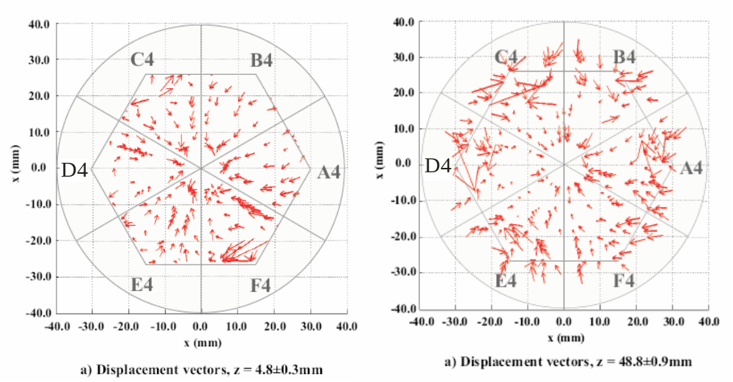
Figure 7(b) 5 Displacement vector plot showing the difference between the experimental and theoretical basis for a symmetric AGATA detector. (left) shows ring 1 (right) shows ring 4.

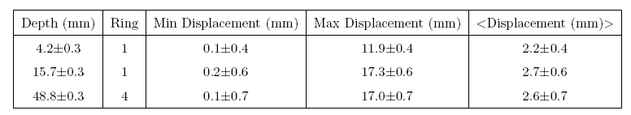
Table 7(b) 1 The magnitude of the displacement between the
experimental and theoretical basis for a symmetric AGATA detector.

It should be noted that there appears to be a net direction to which the arrows point – towards the centre of the segment. More work is required to fully understand the reason for this, but it is believed that the influence of differential cross-talk between the detector pre-amplifiers could explain this effect. The experimental “super-pulse” shown in figure 7(b) 6 indicates a typical experimental, theoretical, and residual pulse shape response for all channels in the detector for a given single interaction position in the detector. The discrepancy observed (in “Residual”) can be almost fully accounted for by applying a differential cross-talk correction on a channel by channel basis. This correction results in the requirement of a 36x35 symmetric correction matrix for each detector crystal. Work is in progress to automate this procedure for the asymmetric detectors.

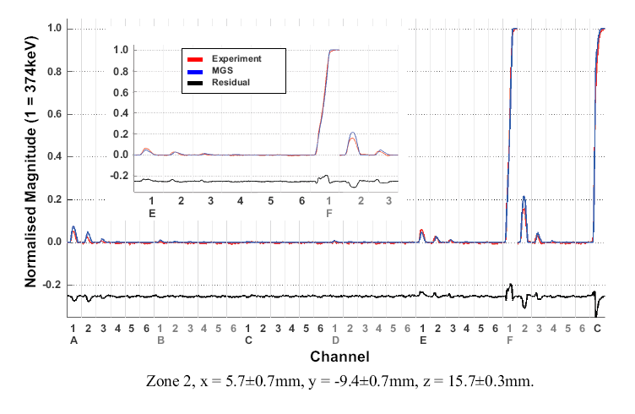
Figure 7(b) 6 Experimental, theoretical and residual pulse shape response for
all channels in the detector for a given single interaction position in the detector.

Theoretical electric-field calculations for three asymmetric AGATA detector shapes have been performed using MGS. Results showing the effective segmentation and pulse shape (T30) rise time profile are shown in figure 7(b) 7 and 7(b) 8, respectively.

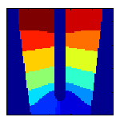 | Figure 7 (b) 7. The theoretical MGS calculated effective segmentation of the AGATA C001 detector crystal.
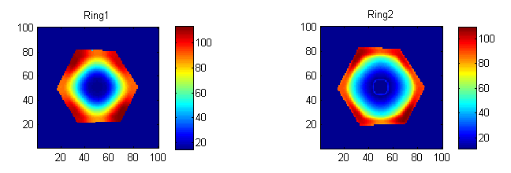
Figure 7(b) 8 The theoretical MGS calculated T30 pulse-shape
rise-time profile for rings 1 and 2 of the C001 detector.

The T30 rise-time plots show the profile calculated using detector input parameters supplied by Canberra France with the specified crystal axis orientation. It should be noted there is, in general, good agreement between experiment and theory, with the exception of the crystal-axis orientation. Experimentally this was found not to be within specified values. These results imply at least a quick “scan” of each detector crystal will be necessary in order to confirm actual crystal-axis profile since this information is crucial to generating a simulated data set.

The theoretical asymmetric triple-cluster basis set (MGS) was delivered to Legnaro on 1st April 09 to be used in the first in-beam experiments. Initial results from that experiment are promising indicating that the basis is working reasonably well. However, none of the three asymmetric crystals in the first triple cluster have been experimentally characterised, so uncertainties remain on the axis orientation of the crystals.

Current status of Task 3

The data from the asymmetric detector-characterisation scan (Task 1) will comprise about ~500Gb of pulse shapes. High-storage capacity computers (RAID arrays) have been purchased to store and analyse this data. These RAID arrays have just been installed and the data will be distributed as soon as the first asymmetric detector characterisation is complete. All of the staff at Manchester, Liverpool and Surrey have been appointed and are in post and the first collaboration meeting for Task 3 took place in Liverpool on 5th May 09. In addition, other meetings with the international AGATA project have been attended (AGATA week in Köln 30th March 2009, and the PSA meeting in Legnaro 21st - 22nd May 2009). The AGATA PSA team hold regular electronic telephone meetings.

7(b) iii. Programme of work for the next 6 months

Task 1: Detector Characterisation
The first asymmetric detector will be scanned at Liverpool and the results distributed by autumn 2009 for Task 2. The Pulse Shape Comparison PSC scan method will be validated. The next AGATA detector for characterisation will then be commissioned (WP1).

The Manchester PDRA will work on converting the output scanned data from the MIDAS format to ROOT format so that is can be more easily analysed in Liverpool, Surrey and Manchester with the PSA algorithms, as well as being generally available to the collaboration. Liverpool, Surrey, and Manchester will work on creating the pulse-shape data base and the comparison with the simulated pulse shapes for the asymmetric detector.

Task 2: MGS 3D simulation code comparison
with experimental detector characterisation
Experimental data will be compared with the MGS theory in order to refine the agreement between experiment and theory. The differential cross-talk correction will be implemented. The existing MGS code will be compared in detail with the Munich JASS code in order to decide on the best implementation for the Demonstrator phase. In Liverpool, the Maxwell 3D code will also be evaluated. This will first be done for the symmetric detectors. The work will be led by the Liverpool group.

Task 3: Pulse-shape algorithm development
The Manchester PDRA and Surrey student will work on the pulse-shape analysis codes. The main work will involve development of the pulse-shape codes to improve the accuracy of the interaction position. Real data will be used from the detector characterisation scan (Task 1) and also from the in-beam experiments so that the analysis of the data from the AGATA demonstrator will be possible in late 2009.

This position determination information will be passed to WP3 to allow the influence of the true position resolution on the GEANT simulation code to be investigated for some of the different experimental scenarios for which the AGATA demonstrator will be used.

Ultimately, these algorithms once developed will be implemented in the pulse-shape analysis (PSA) computer farm. The work will therefore require liaison with the software team responsible for this work to ensure that the algorithms are optimised for use in the farm where real-time analysis will be needed for future operation.
7(b) iv. Financial statement: Work Package 2

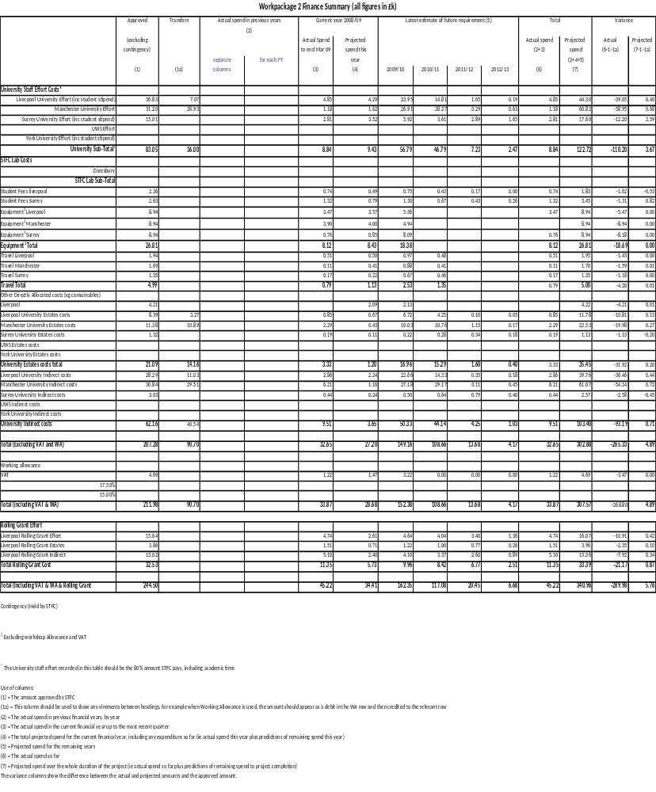
7(b) v. Resource usage: Work Package 2

Table of staff %age FTE

WP2
NAME | INSTITUTE | % FTE 2008/09 | % FTE 2009/10 | % FTE 2010/11 | % FTE 2011/12 | % FTE 2012/13 | Total Effort | Effort Remaining
H Boston | Liverpool | 0.070 | 0.090 | 0.025 | 0.010 | 0.005 | 0.200 | 0.130
Liverpool PDRA | Liverpool | 0.000 | 0.600 | 0.400 | 0.000 | 0.000 | 1.000 | 1.000
Liverpool Student | Liverpool | 0.150 | 0.225 | 0.125 | 0.050 | 0.000 | 0.550 | 0.400
D Cullen | Manchester | 0.033 | 0.072 | 0.043 | 0.020 | 0.012 | 0.180 | 0.147
Manchester PDRA | Manchester | 0.000 | 0.688 | 0.750 | 0.063 | 0.000 | 1.500 | 1.500
Z Podolyak | Surrey | 0.010 | 0.020 | 0.025 | 0.030 | 0.015 | 0.100 | 0.090
Surrey Student | Surrey | 0.251 | 0.400 | 0.200 | 0.125 | 0.075 | 1.050 | 0.799
Rolling Grant
J Cresswell | Liverpool | 0.025 | 0.050 | 0.050 | 0.050 | 0.025 | 0.200 | 0.175
M Norman | Liverpool | 0.050 | 0.075 | 0.050 | 0.025 | 0.000 | 0.200 | 0.150

7(b) vi. Milestones: Work Package 2

Table 1: Milestones achieved in the last six months
Milestone No. | Work Package | Milestone | Target Date | Status
M2.1 | WP2 | Theoretical asymmetric triple cluster basis set (MGS) delivered to Legnaro and used | 01 April 09 | Complete
M2.2 | WP2 | PDRA commenced work in Liverpool/Manchester | 01 May 09 | Complete

Table 2: Milestones due in the next six months
Milestone no. | Work Package | Milestone | Target Date
M2.3 | WP2 | Detector 1 available for scanning | 24 June 09
M2.4 | WP2 | Detector 1: basis data set available | 22 Sept 09
M2.5 | WP2 | Comparison of MGS electric field simulations with experimental pulse shapes complete and first interaction position algorithms ready | 23 Dec 09
M2.10 | WP2 | Preliminary analysis of AGATA Stage 0 data complete | 2 Dec 09

Table 3: Overall Milestone List
Mile-stone No. | Work Package | Milestone | As at June 09 | Delay due to |  | Affects Critical Path? | See Note
 |  |  |  | UK? | Other Collaborators? | Affects Critical Path? | See Note
M2.1 | WP2 | Theoretical asymmetric triple cluster basis set (MGS) delivered to Legnaro and used | 01 April 09
M2.2 | WP2 | PDRA commenced work in Liverpool/  Manchester | 01 May 09
M2.3 | WP2 | Detector 1 available for scanning | 24 June 09
M2.4 | WP2 | Detector 1: basis data set available | 22 Sept 09
M2.5 | WP2 | Comparison of MGS electric field simulations with experimental pulse shapes complete and first interaction position algorithms ready | 23 Dec 09
M2.6 | WP2 | Detector 1: PSA development tests of collimated beam reconstruction and flood measurement complete | 22 Jan 10
M2.7 | WP2 | Detector 1: PSA Development tests of Compton reconstruction complete. | 25 Mar 10
M2.8 | WP2 | Detector 2: basis data set available | 1 Jan 10
M2.9 | WP2 | Comparison of MGS electric-field simulations with experimental pulse shapes completed | 1 Feb 10
M2.10 | WP2 | Complete preliminary analysis of AGATA stage 0 data | 2 Dec 09
M2.11 | WP2 | Preliminary Analysis of AGATA stage 1 data complete | 2 Feb 10
M2.12 | WP2 | Detector 3: basis data set available. Start to develop in-beam algorithms. | 1 Mar 10
M2.13 | WP2 | Comparison of MGS electric-field simulations with experimental pulse shapes complete | 31 May 10
M2.14 | WP2 | Preliminary analysis of AGATA stage 2 complete | 6 Dec 10
M2.15 | WP2 | Algorithm efficacy satisfactory | 14 Mar 12
M2.16 | WP2 | Improved algorithms implemented in PSA farm | 16 Oct 12

7(b) vii. Gantt chart: Work Package 2
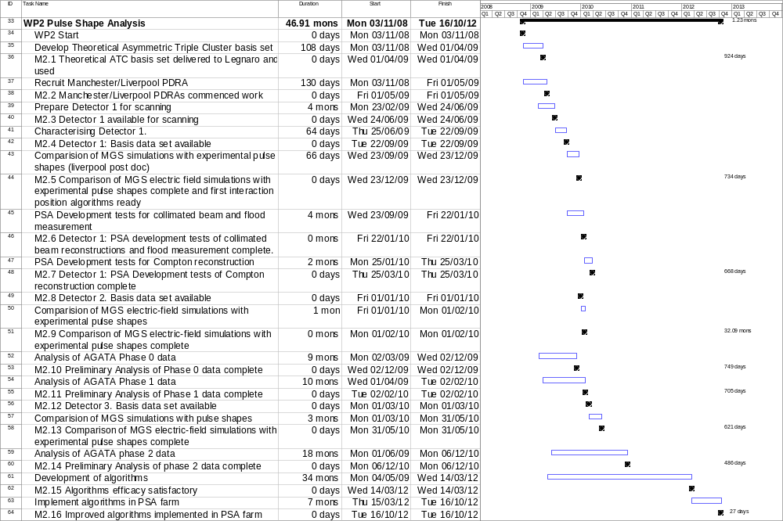
7(c) Work Package 3 Experiment simulations and
verification of tracking

Leader: Prof. R. Wadsworth – University of York

Institutes: York, Manchester, UWS, STFC Daresbury Laboratory

7(c) i. Description of the work package

Background
The overall objective of this work package is to obtain expertise in the UK for the simulation of AGATA, in particular for support of UK-led experiments. During the full grant period, the AGATA array will be located at three different laboratories, Legnaro, GANIL, and GSI. Because of the reduction in effort in the award, this work package will concentrate on simulating the performance of the array in the commissioning phase at Legnaro with different reactions and different ancillary detector systems. In the latter years, the project student will perform some simulations relevant to relativistic beam energies for experiments at GSI. Comparisons of the commissioning-phase simulations with the results from various test experiments at Legnaro will be performed.

Current status
Geometrical descriptions of several ancillary detectors [the annular detector used in the Köln in-beam test, a schematic shell, an array of position-sensitive detectors (DANTE), EUCLIDES/ISIS, Neutron Wall, DIAMANT, EXOGAM, HELENA, RFD, TRACE, CUP] have already been included in the AGATA GEANT4 simulation code. Event generators for fusion-evaporation, fragmentation, and direct reactions, and for the production of random cascades of discrete gamma rays have also been implemented. In 2009 and 2010, the array will be located at Legnaro. The AGATA simulation code has been coupled to realistic simulations of the PRISMA spectrometer, which will make it possible to evaluate the performance of the AGATA Demonstrator at its first installation site for deep in-elastic and multi-nucleon transfer reactions. Work has not yet been initiated which will enable the simulation of key experiments at GANIL and GSI, although some simulations comparing the performance of EXOGAM and the AGATA Demonstrator in a fusion-evaporation reactions have been made.

Tasks

These tasks will be undertaken as part of, and in close collaboration with, members of the AGATA simulations working group, which is lead by E. Farnea (Legnaro). This group holds regular meetings at the AGATA workshops.

Task 1: Implementation of the experimental facilities into GEANT4
This task is to ensure the experimental set-ups that will be used by UK groups at Legnaro are implemented into the existing GEANT4 AGATA-simulation package. This has already begun with implementation of ancillary detectors such as EUCLIDES, ISIS, neutron wall, DIAMANT, RFD, DANTE and the PRISMA spectrometer being complete at this time. There may also be the possibility to include non-active devices, such as a recoil-distance plunger in order to evaluate their effects on the performance of the array. This will be dependent on whether commissioning experiments require such devices. In addition, some work will be carried out by the York student for the GSI phase.

Simulation packages will be implemented for the tracking and particle-identification detectors for the FRS (many of which will be new) and the new LYCCA array for detecting outgoing fragments and charged particles. In all of the above cases, it will be important to simulate the spectral quality, taking into account the full kinematic and geometric reconstruction of the event when using the incoming and out-going particle-tracking detectors and selecting sub-sets of the event data by requiring coincidences with ancillary devices.

Output of Task 1
The output from this task will be a full implementation of the GEANT4 AGATA simulation package which will primarily be tailored to the specific phased commissioning of experimental set-ups for the AGATA demonstrator at Legnaro The ancillary detectors to be included will be DANTE, EUCLIDES and/or the Si ball and PRISMA as well as passive pieces of apparatus such as the recoil distance plunger.

Allocation of Task 1
UWS, York, and Daresbury will perform this task for Legnaro. The York student will take part in this work and also with the implementations of appropriate tracking and particle identification detectors for use with fast-beam fragmentation reactions at GSI. (The loss of effort related to the implementation of other detection systems at GANIL and GSI is due to the reduction of the work package for PDRA and other staff to years 1 and 2 of the grant, which primarily covers the Legnaro phase of operation.)

Task 2: Simulation of key experiments and reaction mechanisms
For Legnaro this will range from simple source simulation work to simulations of a range of reaction mechanisms such as, fusion-evaporation reactions with light targets in inverse kinematics (no ancillary detectors), Coulomb excitation reactions with medium-mass beams in inverse kinematics with simple ancillary detectors like DANTE, studies of high-multiplicity reactions with appropriate ancillary detectors and deep-inelastic and multi-nucleon transfer reaction studies using the PRISMA spectrometer. Within Task 2, simulations of both simple sources and a subset of the above reaction mechanisms will be performed. The package will also contain some work by the project student related to future relativistic many-particle fragmentation studies at GSI. In each case, only reactions appropriate to the key physics examples/ commissioning experiments will be investigated. The simulations will focus on aspects of the different responses of AGATA as appropriate to the experiments undertaken – for example, different reactions with stable beams or reactions with different gamma-ray multiplicities. In addition, for high recoil-velocity experiments at GSI the Doppler-broadening effects, the effect of the high levels of atomic background (primary and secondary Bremsstrahlung radiation) and the impact of high-energy particles (from beam interactions with tracking detectors) hitting the forward-angled detectors will be investigated.

Output of Task 2
The output from this task will be a set of GEANT4 simulations of key test experiments, employing the output from Task 1, using a range of reaction mechanisms. These simulations will be essential for the early phases of AGATA, firstly to enable comparison with test data to confirm anticipated performance, and secondly to enable detailed planning for future experimental campaigns. These simulations are also vital for the development of the interaction position algorithms developed in WP2.

Allocation of Task 2
UWS, York, STFC Daresbury Laboratory will perform simulations for the Legnaro phase. York will also perform some simulations relating to many particle fragmentation works at GSI using the project student.

Task 3: Verification of tracking algorithms
The ability to track the gamma-ray events to enable their full reconstruction is crucial to the success of the AGATA project. The tracking algorithms will be employed in the simulation and compared with the results of first in-beam test experiments. The comparison will be used to optimise the algorithms to suit the particular experimental conditions (e.g. gamma-ray multiplicity, levels of background, reaction rate), and to optimise the efficacy of the algorithms.

Output of Task 3
The output from this task will be a set of simulations, building on the output of Task 2 and work by other members of the collaboration, coupled to data analysis from the first commissioning runs that enable the testing and optimisation of tracking algorithms under different experimental conditions.

Allocation of Task 3
This will involve all institutes. The Manchester PDRA will provide direct input from WP2 of the position determination available from the various PSA codes. This will allow the influence of the true position resolution on the GEANT simulations to be investigated by York, Daresbury, and UWS for some of the different experimental scenarios the used with the AGATA Demonstrator.

Justification
Simulations provide vital information in many areas of physics. All of the above tasks are important in understanding the performance of the AGATA array when coupled with a variety of ancillary detectors under vastly differing experimental conditions. Significant differences between the simulations and reality need to be understood in order for the collaboration to extract the best performance from the array. The results from this package will also provide all of the UK groups with important information on the methodology of the analysis for their physics exploitation. This knowledge will also be important for the planning of future UK exploitation of AGATA.

Costs
The UWS PDRA and York EO will need to travel to Legnaro during the first three months to meet E. Farnea, so that they can obtain the relevant detector geometries in GEANT4 format and instructions for the installation of the codes that have been developed to date. Travel funds will also be required to attend UK collaboration meetings and for travel to AGATA collaboration meetings. Computers for data analysis are requested for the UWS and York EO and students.

7(c) ii. Commentary on the activities to date

The AGATA simulation code and the forward tracking codes produced by collaborators in Italy and France have been obtained, installed and tested in several UK institutions. In addition, efforts have also been put in to aid the understanding of the software environment required to use these codes for a variety of applications. The applications include simulations (a) using the AGATA array in standalone mode, (b) using various ancillary detectors, (c) to generate inputs for the AGATA simulation code using an existing gamma-decay level scheme and (d) to generate inputs involving charged particles and neutrons in addition to a known level scheme.

As part of the learning process, the built-in event generator of the AGATA simulation code has been used first to perform basic simulation work such as the prediction of the detector efficiency. The results were compared to previous simulation work done by other AGATA collaborators and were found in very good agreement. The use of external event generators for the generation of more realistic simulation inputs requires some additional codes and libraries like Gammaware (GW) and the statistical-model code evapOR. The GW application is available from collaborators in Orsay and has been installed successfully, along with the statistical-evaporation code, on the two systems in York and Daresbury. Following installation, initial tests of the software and the accompanying libraries have been completed and simulations of realistic gamma sources have been carried out at both institutes. Figure 7(c) 1 shows a simulated ⁶⁰Co spectrum for the full array using the Orsay tracking code. A similar simulation with the MGT code from Italy reveals a somewhat different peak to total value of 54% compared to 63% with the Orsay code. The results obtained from the MGT code using a single gamma line of 1 MeV gave a peak to total of 59%, in agreement with previous work with this code, whilst the Orsay code gave a figure of 69%. These results illustrate the need for detailed comparisons of both tracking codes.

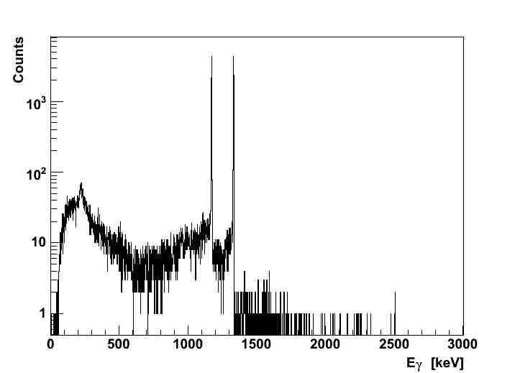 | Figure 7(c) 1 Simulation of the AGATA response to a ⁶⁰Co source placed at the centre of the full array. The Orsay forward tracking code was used for the gamma tracking. The simulation was performed for 5×10⁴ events and gives a peak-to-total ratio of 63%.
Initial preparations have also started towards adding ancillary detectors and non-detector material (such as detector-support structures and a plunger device) into the AGATA code. This work will continue in the next six months. Already, a single plastic-scintillator detector has been included inside the AGATA array [figure 7(c) 2] and simulation outputs have been tested as part of the learning process. In addition, a lead collimator on the front of a triple cluster has been included to study the contribution of photons scattered by the collimator toward the germanium crystals during the scanning process of the detector. This code has been distributed to the Liverpool collaborators in charge of the detector characterisation.

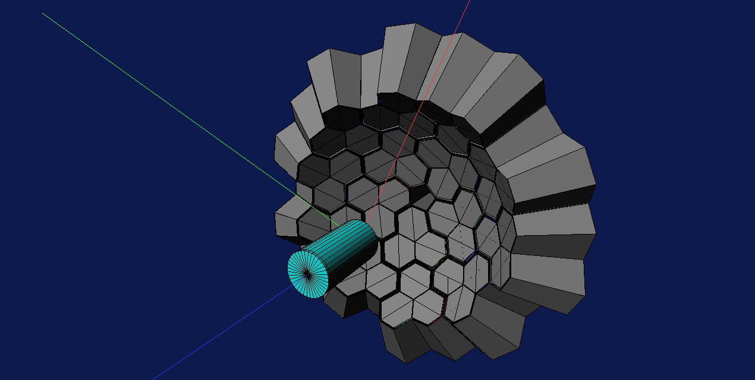 | Figure 7(c) 2 Picture of a plastic cup scintillator included along with a1π section of AGATA

Email exchange and meetings have taken place with the international AGATA collaborators who have relevant expertise in various aspects of simulation work. In particular, P. Joshi (York EO) visited Martin Palacz, who is in charge of the overall coordination of ancillary-detector simulation for AGATA. Extremely useful discussions, in particular, during the AGATA week, in Köln have also taken place with E. Farnea (Legnaro), A. Lopez-Martens (Orsay) and O. Stezowski (Orsay) for the installation and the understanding of the AGATA simulation code, the forward gamma tracking code from Orsay, and the GammaWare applications, respectively.

Within the UK, a meeting between UK AGATA collaborators has taken place in Daresbury on the 3rd of March where M. Labiche (Daresbury) presented an overview to the AGATA simulations, including some additional information on how to install and run the simulation package.

Summary

(i) The AGATA code with the detector geometries has been obtained, installed and tested.
(ii) The forward gamma-tracking codes have also been obtained, installed and tested.
(iii) The event generator library GW has been obtained and installed at York and Daresbury and initial tests have been performed.

All the above has been carried out in line with the milestones set for the first four months.

7(c) iii. Programme of work for the next 6 months

In the next six months it is expected that simulations will be generated using the above installed codes for the commissioning experiments, which were discussed at the AGATA Physics Workshop (18-20 May 2009) in Legnaro. In parallel, the data from the in-beam test experiment carried out in March at Legnaro (WP4) should provide the opportunity to validate the simulations.

During this period an additional PDRA will take his position at the University of West of Scotland and will be given all the support required to install a simulation system identical to the York and Daresbury systems. It is anticipated that this person will start working on simulations for AGATA coupled to the PRISMA spectrometer in this period.

Further development of the AGATA ancillary code library as well as the event generation codes will be carried out. The current event generator will be developed towards the next level of sophistication so as to include additional features such as the inclusion of charged-particle and neutron emission and towards a larger range of reaction mechanisms.

7(c) iv. Financial statement: Work Package 3
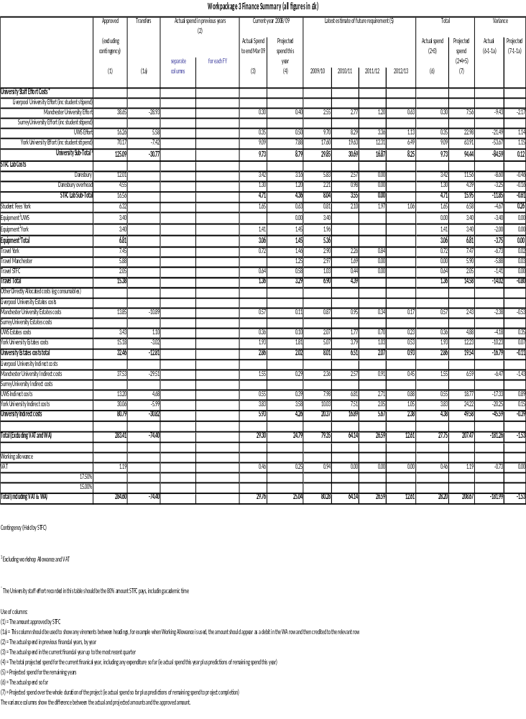

7(c) v. Resource usage: Work Package 3

Table of staff %age FTE

WP3
NAME | INSTITUTE | % FTE 2008/09 | % FTE 2009/10 | % FTE 2010/11 | % FTE 2011/12 | % FTE 2012/13 | Total Effort | Effort Remaining
D Cullen | Manchester | 0.033 | 0.072 | 0.043 | 0.020 | 0.012 | 0.180 | 0.147
Manchester PDRA | Manchester | 0.000 | 0.046 | 0.050 | 0.004 | 0.000 | 0.100 | 0.100
R Chapman | UWS | 0.015 | 0.045 | 0.045 | 0.045 | 0.030 | 0.180 | 0.165
UWS PDRA | UWS | 0.000 | 0.250 | 0.200 | 0.050 | 0.000 | 0.500 | 0.500
R Wadsworth | York | 0.036 | 0.072 | 0.072 | 0.072 | 0.036 | 0.288 | 0.252
P Joshi | York | 0.100 | 0.300 | 0.199 | 0.000 | 0.000 | 0.600 | 0.500
York Student | York | 0.200 | 0.250 | 0.630 | 0.575 | 0.300 | 1.955 | 1.755
M Labiche | Daresbury | 0.070 | 0.126 | 0.054 | 0.000 | 0.000 | 0.250 | 0.180

7(c) vi. Milestones: Work Package 3

Table 1: Milestones achieved in the last six months
Milestone No. | Work Package | Milestone | Target Date | Status
M3.1 | WP3 | Preparatory work complete | 02 April 09 | Complete
M3.2 | WP3 | Simulation codes set up in the UK | 05 July 09 | Complete

Table 2: Milestones due in the next six months
Milestone no. | Work Package | Milestone | Target Date
M3.3 | WP3 | Simulation for UK led experiments for the January LNL PAC | 31 Dec 09

Table 3: Overall Milestone List
Mile-stone No. | Work Package | Milestone | As at June 09 | Delay due to |  | Affects Critical Path? | See Note
 |  |  |  | UK? | Other Collaborators? | Affects Critical Path? | See Note
M3.1 | WP3 | Preparatory work complete | 02 Apr 09
M3.2 | WP3 | Simulation codes set up in the UK | 05 July 09
M3.3 | WP3 | Simulation for UK led experiments for the January LNL PAC | 31 Dec 09
M3.4 | WP3 | Simulations completed for commissioning experiments | 7 Apr 10
M3.5 | WP3 | Simulation for UK led experiments for the next PAC (LNL  or other) | 31 Dec 10*
M3.6 | WP3 | Validation between simulations and results from in-beam data sets. | 8 July 10
M3.7 | WP3 | Final comparisons with test data complete | 10 Jan 11
M3.8 | WP3 | Final report and evaluation complete | 9 May 12

* Depends on siting decision for AGATA.

Simulations will be performed for PAC meetings as required.
These tasks will result in additional deliverables.

7(c) vii. Gantt chart: Work Package 3

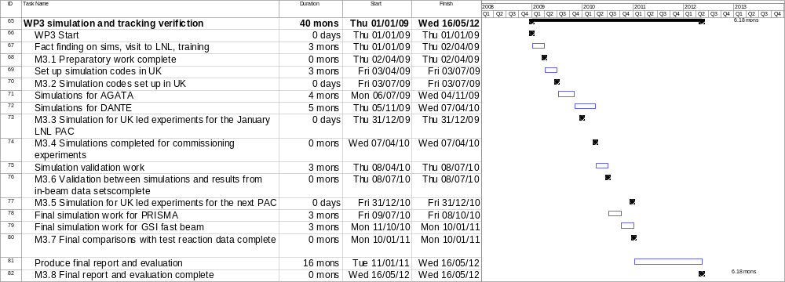

7(d) Work Package 4 Support for setup and running
of initial experiments

Leader: Dr. J. F. Smith – University of the West of Scotland

Institutes: UWS, Liverpool, Manchester, Surrey, York, and STFC Daresbury Laboratory

7(d) i. Description of the work package

In the initial phase of the AGATA project, five triple-clusters will be configured together at the Legnaro National Laboratory in Italy to form the AGATA Demonstrator. The Demonstrator will be used to show the validity of the pulse-shape analysis and tracking algorithms in real time, under real experimental conditions. This is the first occasion in which multiple AGATA triple-clusters are used together, with the associated signal-processing electronics and data acquisition. The Demonstrator will be installed around the target position at the entrance of the PRISMA magnetic spectrometer. Initially, tests will be carried out with radioactive sources and with simple in-beam reactions. Following these initial tests, commissioning experiments will be carried out, using the Demonstrator in conjunction with PRISMA. This will be followed by a physics campaign, in which the Demonstrator will be used in real experiments for a period of around one year. Following the period at Legnaro, the AGATA detectors will be moved to other laboratories, namely the GANIL laboratory in France, and GSI in Germany. Each of the laboratories presents different opportunities in terms of beam species, energies, intensities, and ancillary detectors. Descriptions of the Legnaro, GANIL, and GSI campaigns were given in the Technical Case of this original grant application, and the physics interests at each laboratory were outlined in the Science Case.

The purpose of Work Package 4 is to carry out the setup and installation of the AGATA detectors at the Legnaro National Laboratory in Italy, and to run the initial source and in-beam tests and to demonstrate the performance of AGATA in the commissioning experiments. This work will inform later campaigns using AGATA at the other laboratories, and will serve to equip the UK researchers with valuable expertise and experience.

The set-up and running of the initial experiments is a central part of the AGATA project which ties together the outputs of some work packages and provides input for others, specifically: WP2 (position determination), WP3 (simulations of experiments), WP5 (electronics and data acquisition), and WP6 (mechanical design). For this reason, all of the collaborating UK institutions are participants of this work package. Sufficient manpower and expertise is very important to ensure the timely and efficient implementation of the Demonstrator. There is a close association between the PDRA/EO and student effort on this work package with that of Work Packages 1, 2, and 3.

Tasks

- Installation of AGATA detectors as the AGATA Demonstrator at Legnaro National Laboratory.
- Running of the test experiments, with sources and in-beam, plus other commissioning experiments which are essential for the future physics programmes.
- Use the output of Work Package 2 (identification of interaction positions) and the tracking algorithms with real in-beam data to optimise the analysis packages.

Outputs

- Installation and commissioning of the AGATA Demonstrator at Legnaro National Laboratory.
- Experience of processing and analyzing data from AGATA with different reactions conditions i.e. reactions with different gamma-ray multiplicities, gamma-ray energies, recoil velocities, event rates and with varying gamma-ray backgrounds (radioactive-ion beam experiments).
- Dissemination of experience to the UK and international nuclear-physics communities via workshops and conferences.
- Comparison of the performance of AGATA in source and in-beam experiments with experimental simulations (input for Work Package 3).

7(d) ii. Commentary on the work package to date

The work covered by this package is “new” in the sense that the tasks began with the commencement of the present grant (autumn 2008). As stated above, all of the collaborating UK institutions are involved with this work package and most of the PDRAs and postgraduate students will contribute to the tasks. During this initial reporting period of the project, all of the postgraduate students have been appointed. Although all of the PDRA appointments have been made, the post-holders are not yet all in place: the PDRAs at Liverpool and Manchester started in May 2009, and the PDRA at UWS will start in July 2009. PDRA effort on this work package has therefore, to date, been limited. The UK effort in the initial experiments has been co-ordinated by the Work Package Leader in consultation with Dr. Enrico Farnea at Legnaro.

The ongoing developments in the set-up of the AGATA Demonstrator have been designated different stages, as listed below.

Stage 0 Test of a triple cluster with a radioactive source
Stage 1 In-beam test if a triple cluster
Stage 2 In-beam test of a triple cluster with a simple ancillary detector
Stage 3 In-beam test of multiple (three) triple clusters
Stage 4 In-beam test of triple clusters with the PRISMA spectrometer

To date (May 2009), Stage 0 has been completed, and Stage 1 is presently underway. It is expected that Stages 2-4 will be carried out within the next six months, before the commencement of the physics campaign in early 2010.
Test of a triple cluster with a radioactive source [Stage 0] (16th-20th February 2009)

The first test of a triple-cluster with a radioactive source took place in Week 8 (16th -20th February 2009) [Stage 0]. The purpose of the test was to check the functionality of various parts of the AGATA system: front-end electronics, data-acquisition system and GUI, auto-fill, and mechanical support. Several UK PDRAs and postgraduate students participated in the test, providing some of the necessary manpower. This first test also served to provide the UK participants with initial familiarization with the AGATA Demonstrator, with the laboratory, and with international collaborators.

In-beam test of a triple cluster [Stage 1] (16th-20th March 2009)

The first in-beam test of a triple cluster [Stage 1] took place in Week 12 (16th – 20th March 2009). There were several aims of this first in-beam test as listed below.
- To test the AGATA detectors in real experimental conditions.
- To test the data-acquisition system (pre-processing electronics and online analysis).
- To acquire data for subsequent offline optimizations.
- To measure the overall position resolution provided by the pulse-shape analysis algorithms.
The test used one asymmetric triple cluster mounted as close to θ=90○ as possible. A photograph of the experimental set up is shown below.

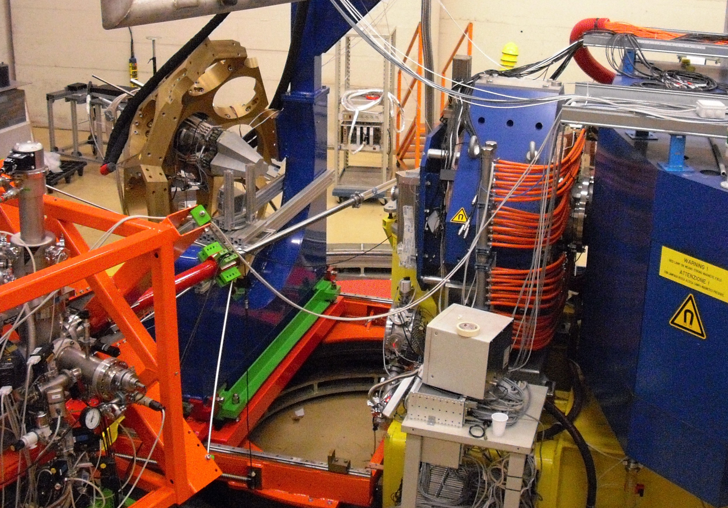
Figure 7(d) 1 AGATA at the target position of the PRISMA spectrometer.

The triple cluster is shown, mounted in the AGATA support structure in the upper left-hand corner of the photograph. The beam line can be seen in front of the AGATA detectors. The apparatus painted blue on the right-hand side of the photograph is the front of PRISMA. To give an idea of scale, the distance from the beam pipe to the entrance of the first focussing element of PRISMA (magnetic quadrupole) is 50 cm. In order to measure the effective position resolution, it was necessary to measure the Doppler broadening at two different target-to-detector distances. At different distances, all of the contributions to the Doppler broadening will be the same apart from that due to the effective opening angle of the detector – from which the position resolution can be deduced. It was therefore advantageous to maximize the Doppler broadening by (i) placing the detectors as close to θ=90○ as possible, and (ii) by choosing a reaction with a large recoil velocity. Therefore, a heavy-ion fusion-evaporation reaction was chosen, using inverse kinematics: a beam of ³⁰Si at energy 70 MeV was incident upon a thin 216-μg cm⁻² ¹²C target. In order to stop the recoiling reaction products, a thick ~16-mg cm⁻² foil was placed about 2 mm downstream of the target.

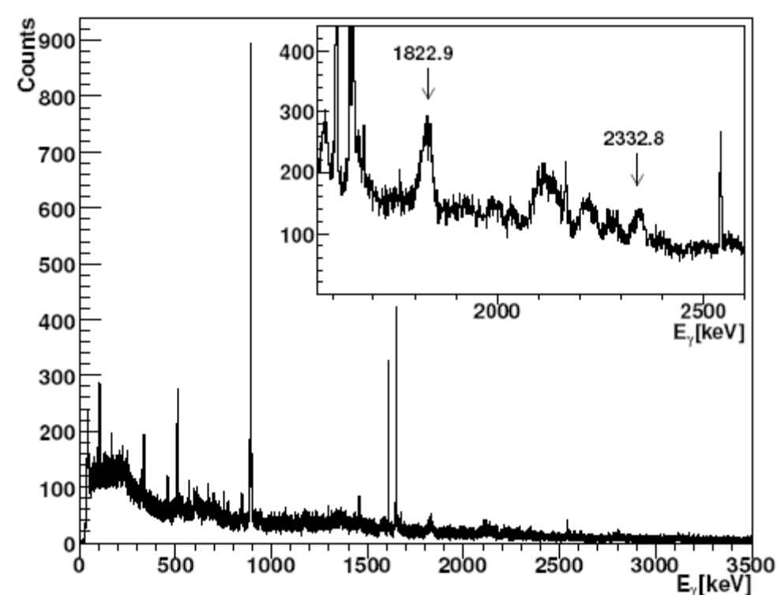

Figure 7(d) 2 In-beam spectra from the ¹²C(³⁰Si,pn)⁴⁰K reaction.

A gamma-ray spectrum from test is shown in Figure 7(d) 2; a Doppler correction has not been applied to the data. The sharp peaks correspond to gamma-ray transitions in recoils that are stopped in the Ni foil. The inset shows an expanded section of the spectrum, centred on two transitions at 1823 and 2333 keV, from the ¹²C(³⁰Si,pn) ⁴⁰K reaction. The Doppler broadening of these peaks, with no sharp (stopped) components, indicates that the transitions are emitted in flight. Doppler correction of the spectrum, and subsequent measurement of the Doppler broadening, will allow position resolution of the detector to be estimated.

The in-beam test used a full AGATA system to collect data to disk. Pulse-shape analysis and tracking were performed in real time, and the acquisition system was run in triggerless mode. As this was the first time in which the full system was running, the original digitized signals were stored to disk for offline analysis. The overall counting rate was therefore limited to 1.2 kHz per crystal, corresponding to a data rate of ~1GB per crystal per minute, resulting in about 14 TB of data.

This first in-beam test was run by a large collaboration of around 36 physicists from ten European countries. Of these collaborators, nine were from the UK; thus the UK provided a significant fraction of the effort and manpower needed to run the tests. In doing so, the UK participants received invaluable experience and knowledge of running the AGATA system which will be shared with the UK AGATA community.

Summary to date

The successful completion of two test experiments has been achieved, which has provided data for tasks in other work packages. In terms of deliverables, the outputs from this work package are, so far, limited. However, this is in line with expectations for this stage of the project. A contribution to the Legnaro Annual Report about the first in-beam experiment has been prepared and submitted. Furthermore, a presentation about the first test experiments was made at the IOP Nuclear Physics Conference at the University of Birmingham in April 2009 by Ryan Kempley (AGATA-funded postgraduate student) from the University of Surrey. Outputs in terms of data-analysis codes and further dissemination will be expedited when the PDRAs have settled into post, in mid 2009.

7(d) iii. Programme of work for the next 6 months

The schedule for the planned tasks on Work Package 4 is dependent on the accelerator functionality and schedule at Legnaro, on the production of electronics and on detector delivery. It is possible to make reasonably accurate plans for the next two months, but further ahead, plans are contingent on these factors. Within the next six months, more in-beam tests will be performed, with increasing complexity and it is presently expected that the physics campaign will start in early 2010.

The in-beam tests fall into two categories: official scheduled tests, and unofficial (so-called “parasitic”) tests. The official tests are those for which beam-time has been allocated by the Legnaro Programme Advisory Committee, and which are allocated time on the accelerator schedule. Presently there are eight days of official beamtime allocated to AGATA tests to be used before 31st July 2009. It is likely that these days will be scheduled from 29th June to 5th July. The optimal use of these days has yet to be decided, but the following conditions are possible.
- Use of two triple clusters (c.f. first in-beam test which used one triple cluster)
- A beam species with higher mass and energy, and thus higher recoil velocity (c.f. ³⁰Si at 70 MeV used in the first in-beam test)
- Use of a simple ancillary detector, such as the DANTE array of MCPs within the AGATA target chamber (for position determination of reaction products)
Following the next in-beam test, it is likely that further tests will take place later in the summer (August-September). It is hoped that by late summer it will be possible to have three triple clusters in place, which will mark the official commencement of the AGATA Demonstration phase.

In addition to the official scheduled tests, unofficial “parasitic” tests will be carried out where possible. These will take place in “spare” days in the schedule that are set aside for accelerator tests. Generally, these tests are more restricted than the official tests in that the beam species is decided by the subsequent experiment. However, such tests are still valuable for diagnostic purposes; a “parasitic” in-beam test took place from 30th May – 1st June 2009 studying Coulomb excitation of a ⁵⁸Ni beam.

It is presently envisaged that the physics campaign with AGATA will start in early 2010. An AGATA Physics Workshop took place in May 2009 to discuss proposals that will be submitted to the July 2009 Legnaro PAC meeting. At the workshop, it was decided that the first period of the physics campaign, should be restricted to experiments that do not require PRISMA. Furthermore, due to financial constraints at Legnaro, beams from ALPI will not be available until early 2010.

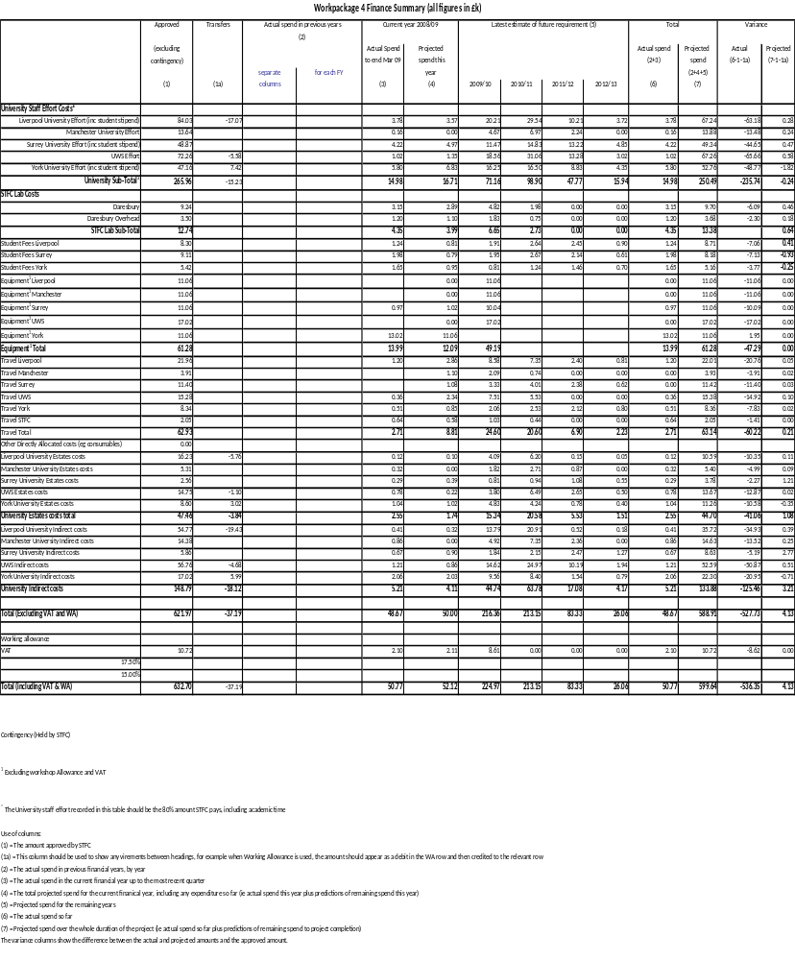
7(d) iv. Financial statement: Work Package 4
7(d) v. Resource usage: Work Package 4

Table of staff %age FTE

WP4
NAME | INSTITUTE | % FTE 2008/09 | % FTE 2009/10 | % FTE 2010/11 | % FTE 2011/12 | % FTE 2012/13 | Total Effort | Effort Remaining
A Boston | Liverpool | 0.010 | 0.020 | 0.020 | 0.015 | 0.005 | 0.070 | 0.060
Liverpool PDRA | Liverpool | 0.000 | 0.400 | 0.600 | 0.000 | 0.000 | 1.000 | 1.000
Liverpool Student | Liverpool | 0.251 | 0.575 | 0.775 | 0.699 | 0.249 | 2.550 | 2.299
Manchester PDRA | Manchester | 0.000 | 0.138 | 0.200 | 0.063 | 0.000 | 0.400 | 0.400
J Smith | UWS | 0.033 | 0.099 | 0.099 | 0.099 | 0.066 | 0.396 | 0.363
UWS PDRA | UWS | 0.000 | 0.442 | 0.800 | 0.258 | 0.000 | 1.500 | 1.500
Z Podolyak | Surrey | 0.015 | 0.030 | 0.040 | 0.050 | 0.025 | 0.160 | 0.145
P Regan | Surrey | 0.011 | 0.022 | 0.022 | 0.022 | 0.011 | 0.088 | 0.077
P Walker | Surrey | 0.011 | 0.022 | 0.022 | 0.022 | 0.011 | 0.088 | 0.077
Surrey Student | Surrey | 0.251 | 0.600 | 0.800 | 0.624 | 0.175 | 2.450 | 2.199
M Bentley | York | 0.027 | 0.054 | 0.054 | 0.054 | 0.027 | 0.216 | 0.189
P Joshi | York | 0.050 | 0.301 | 0.249 | 0.000 | 0.000 | 0.600 | 0.550
York Student | York | 0.300 | 0.250 | 0.370 | 0.425 | 0.200 | 1.545 | 1.245
M Labiche | Daresbury | 0.064 | 0.104 | 0.042 | 0.000 | 0.000 | 0.210 | 0.146

7(d) vi. Milestones: Work Package 4

Table 1: Milestones achieved in the last six months
Milestone No. | Work Package | Milestone | Target Date | Status
M4.1 | WP4 | Source test of a triple cluster | 18 Feb 09 | Complete
M4.2 | WP4 | In beam test of a triple cluster | 19 Mar 09 | Complete

Table 2: Milestones due in the next six months
Milestone no. | Work Package | Milestone | Target Date
M4.3 | WP4 | In-beam test of a triple cluster with ancillary detector | 6 July 09
M4.4 | WP4 | UWS PDRA started work | 1 July 09
M4.5 | WP4 | In-beam test of first 3 triple clusters | 31 Dec 09

Table 3: Overall Milestone List
Mile-stone No. | Work Package | Milestone | As at June 09 | Delay due to |  | Affects Critical Path? | See Note
 |  |  |  | UK? | Other Collaborators? | Affects Critical Path? | See Note
M4.1 | WP4 | Source test of a triple cluster | 18 Feb 09
M4.2 | WP4 | In beam test of a triple cluster | 19 Mar 09
M4.3 | WP4 | In-beam test of a triple cluster with ancillary detector | 6 July 09
M4.4 | WP4 | UWS PDRA started work | 1 July 09
M4.5 | WP4 | In-beam test of first 3 triple clusters | 31 Dec 09
M4.6 | WP4 | Commencement of Physics campaign at LNL | 4 Jan 10
M4.7 | WP4 | In-beam data available from LNL | 2 Feb 10
M4.8 | WP4 | Preliminary presentation of AGATA performance | 13 Sep 12
M4.9 | WP4 | Initial tests of algorithms completed and ready for implementation | 10 Feb 10
M4.10 | WP4 | Data analysis codes available at LNL | 15 Apr 10
M4.11 | WP4 | End of Physics campaign at LNL | 21 Mar 11
M4.12 | WP4 | AGATA detectors transferred to next host lab | 8 Aug 11
M4.13 | WP4 | In beam data available from next host lab | 7 Sep 11
M4.14 | WP4 | Data analysis codes available at next host lab | 16 June 11

* Milestones relating to other host laboratories depend on siting decision
7(d) vii. Gantt chart: Work Package 4

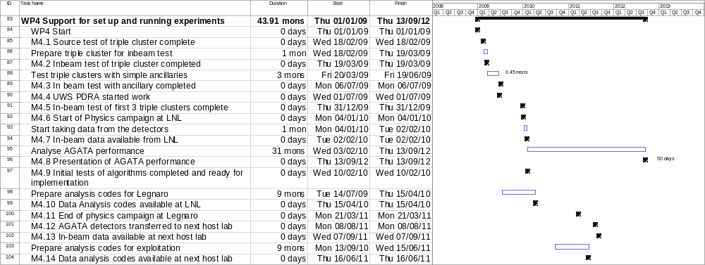

7(e) Work Package 5 Electronics and Graphical User Interface

(GUI) software

Leader: I. Lazarus - STFC Daresbury Laboratory

Institutes: STFC Daresbury Laboratory and University of Liverpool

7(e) i. Description of the work package

Background: The electronics designers and software engineers at STFC Daresbury and in the University of Liverpool physics department provide expertise in front-end electronics and data-acquisition systems that are at the leading edge of developments worldwide. The team works on behalf of the UK nuclear-physics community to develop and support state-of-the-art systems across Europe and beyond. Work is co-ordinated via Daresbury in-line with the demands of the approved UK nuclear-physics research programme. The team have high skill levels in system design as well as specific areas including low-noise analogue design, high-speed digital design, high-speed communications, programmable logic design using VHDL coding, and in software for real-time data acquisition and GUI design. They are experienced in working at all stages of a project from specification, costing and planning through design and implementation, to installation and commissioning.

Tasks to be undertaken in this grant are as follows.
- Complete installation and commissioning of AGATA Demonstrator.
- Ongoing support of AGATA Demonstrator
- Manufacture extra digitisers to the current design to cover early detector deliveries.
- Redesign of AGATA digitiser including prototyping and production.
- Manufacture redesigned digitisers for later detector deliveries.
- Design and retrofit an upgraded control card with internal web server to existing digitisers..
- Management of pre-processing team.

7(e) ii. Commentary on the activities to date

Current status: UK engineers are key players in the design of the AGATA demonstrator front-end electronics. Three sub-systems have been developed, the digitiser, the pre-processing, and the global clock/trigger system. A large part of the digitiser design and testing was done by Daresbury (Coleman-Smith) and Liverpool (Thornhill, Wells), collaborating with IPHC in Strasbourg. All production of digitisers is managed by Coleman-Smith at Daresbury. The team leader for the pre-processing is Lazarus from Daresbury although the work is mainly done in France and Italy. Lazarus and Coleman-Smith also contributed to the specification of the global clock and trigger system which is being implemented in Italy.

The manufacture of digitisers for the Demonstrator has been completed. The production run for the digitisers is finished. Initial testing in the UK of all 18 digitisers is finished; 13 have been shipped and five remain in UK awaiting shipping and in the meantime are in use for system support and for code upgrade tests. Of the 13 digitisers shipped out of UK, seven have been delivered to Legnaro for use in the system after final performance testing in Strasbourg. A further three digitisers are in Strasbourg, two awaiting performance testing and one configured in standalone mode. Three digitisers have been delivered to Turkey and are awaiting shipment to France for final performance testing.

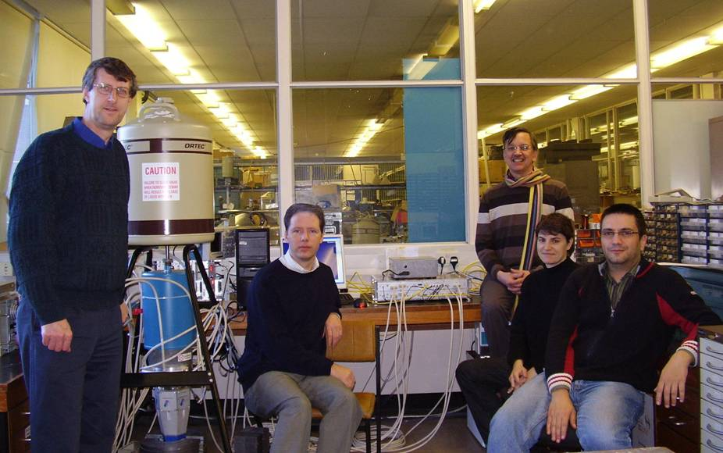 | Figure 7(e) 1 Part of AGATA Digitiser  team with digitiser. Left to right: Jim Thornhill (Liverpool), Dave Wells (Liverpool), Patrick Coleman-Smith (Daresbury) Camille Parisel (IPHC Strasbourg) and Patrice Medina (IPHC Strasbourg).

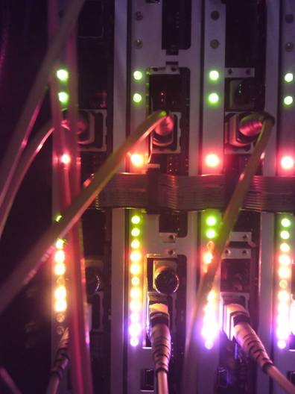 | 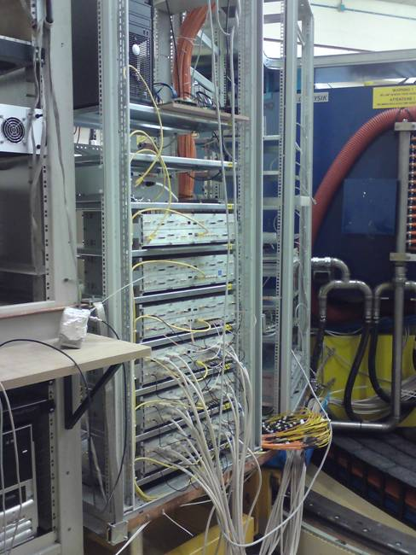
Figure 7(e) 2 Pre-processing electronics | Figure 7(e) 3 Digitisers in Legnaro (system commissioning)

The pre-processing electronics production is taking place in France from April to June 2009 with the only UK involvement being management of the pre-processing team by I. Lazarus.

System commissioning is under way at Legnaro and two successful test runs with one triple cluster have taken place, the first attended by Lazarus in February 2009. More runs are planned as the system builds up in size with the delivery of more detectors and electronics up to September 2009. Recently an upgrade to the digitiser firmware was written, tested, and installed to automate the over-temperature shut-down. The digitiser relies on a cooling-water supply and a worry was that the power might be turned on without cooling water or network connections. Previously the shut-down relied on the software monitoring the temperature sensors and so required network connections. The modification moves the temperature monitoring and shut-down into firmware running inside the digitiser. It has been tested in LNL and shown to operate at 40○ C.

Pucknell is an active member of the slow control software team, attending both face-to-face and video-link meetings. His experience and advice are sought by various parts of the collaboration when difficult questions arise about how to set up and control the complex systems in AGATA.

The team has recently decided that the software structures developed by Pucknell for control of the digitiser will be used for all the front-end electronics in AGATA. Pucknell has produced example implementations of the various protocols to be used which are available to other members as standards against which their implementations can be tested. The UK input is complete and other parts of the team will complete their front-end control code by the end of summer 2009 with advice and help from Pucknell where needed.

The AGATA week in Köln (March 30th to April 1st) was attended by Coleman-Smith, Cresswell, Lazarus, and Pucknell where progress reports were made by Coleman-Smith (digitiser), Lazarus (pre-processor) and Pucknell (slow control). A further meeting was held on 2nd April to open the discussions about the electronics for the next phase of AGATA. This was attended by Pucknell, Simpson and Lazarus who gave a presentation about the UK plans and proposals for digitiser enhancements. The discussions are by no means at a conclusion and further meetings will be required before an agreement is reached between the partners.

Tasks: The UK will take the lead in redesigning the AGATA digitiser. There are three main areas of improvement under consideration: firstly to improve low-energy resolution by updating the analogue to digital converters (ADC) and the VHDL code. This could be achieved either by using a higher resolution ADC or by over-sampling and averaging with a much faster 14-bit ADC. It is not yet clear whether this can be done in a way that can be retro-fitted to existing digitisers. The second area of improvement is to consider the possibility of improving the packing density (and hence reducing the weight and space requirements) of the digitiser and the pre-processing, for example by changing from 6 to 12 channels per segment card. This does, however, fundamentally change the mechanics of the digitisers and makes backwards compatibility (retro-fitting upgrades) either more difficult or perhaps impossible. In both cases the Xilinx field programmable gate arrays (FPGAs) will also be updated. Thirdly, the digitiser’s control interface will be upgraded to support an embedded web server and a suitable GUI will be implemented. The digitiser inputs also need to be updated to accommodate the new dual-range preamplifiers designed for the AGATA detectors.

The extent of the digitiser redesign work to be undertaken is under discussion within the wider AGATA collaboration. When the AGATA grant application was submitted, the plan was to continue to work on the digitisers in the same collaboration as for the Demonstrator phase with IPHC Strasbourg, STFC DL and University of Liverpool. However, at the April 2nd meeting in Köln it was stated that IPHC engineers will not be available for the next phase of AGATA, currently leaving just the two UK groups. It is not yet clear whether other partners will come in to replace IPHC or not. If not then the plans for the digitiser redesign will need to be revised to reduce the amount of work. In any case the digital-control interface will be upgraded by the UK to include an embedded web server on a new control card. However the extent of work to repackage and enhance the analogue and ADC parts is currently unclear.

It is planned that the first detectors to be delivered (2008/9, 2009/10, 2010/11) will be instrumented with digitisers made to the existing specification. A maximum of 30 crystals are expected by end of FY2010/11, so up to 12 more digitisers need to be built to the current design (18 exist already). Four of the 12 new digitisers will be funded from the UK grant; others by the collaboration. From 2011 onwards the new digitisers will start to become available, so the remaining 30 crystals (total TBC by collaboration) will be instrumented with the new, improved digitisers. A request was sent to the AGATA Management Board for funding to start manufacturing the first 12 digitisers (funding for eight digitisers is needed from outside UK, four funded by UK), but funds for only two are available from the rest of the collaboration making six in total rather than 12. Consequently the unit cost will be higher than planned because NRE costs will be shared over less cards, components will be ordered in lower quantities and hence will miss advantageous price-breaks and some components will be subject to minimum order quantities forcing extras to be bought. The exact price change will be known when a revised quotation is obtained to start the funds transfer from collaborators and the ordering process.

It is assumed that the AGATA work for pre-processing and the clock/trigger system will be based overseas and that the pre-processing will continue to be managed from UK by Lazarus. Coupling of ancillary detectors to a complex instrument such as AGATA is a difficult task and will require help, advice, and special interface software from the UK. Pucknell has considerable experience in this field which will prove invaluable to AGATA.

7(e) iii. Programme of work for the next 6 months

The main work will be to complete the installation and system test of the AGATA Demonstrator at Legnaro which is expected to be complete in late 2009. This is the top-priority task. In parallel with work on the Demonstrator, the other task to be undertaken is to agree on the AGATA EDAQ system upgrades in collaboration with the other AGATA partners. The plans for digitiser upgrades will be fed into this discussion and considered alongside all other possible system changes and upgrades. The plans for this upgrade must be fixed before the end of 2009 if the upgraded production units are to be available in 2012. The discussions with the collaboration are progressing slowly because many of our partners are not ready to make decisions about revised electronics yet.

Summary of tasks to be carried out in the next 6 months

 | Task | People Involved | End Date
1 | System commissioning in Legnaro (building up system from 1 to 6 triple clusters and associated EDAQ) | Pucknell, Coleman-Smith, Lazarus, Wells and Thornhill | Autumn 2009
2 | Conclude discussions on AGATA EDAQ system upgrades with AGATA partners. | Mainly Lazarus, Coleman-Smith,  and Pucknell | End 2009
3 | Obtain funding from collaboration and start production of 6 digitisers to current design for delivery by the end of 2010 | Coleman-Smith, Lazarus, Wells,  and Thornhill | Funding- Summer 2009  Delivery- end 2010
4 | Participate in AGATA slow control team (meetings and writing software) | Pucknell | Ongoing
5 | Manage pre-processing team | Lazarus | Ongoing
6 | Support the AGATA system in Legnaro as required after commissioning | All | Ongoing

Decision Points

April 2009 - first collaboration meeting to discuss design of AGATA phase 1 EDAQ including digitiser upgrade. This meeting is associated with 2 deadlines.
- An endorsement of the UK philosophy (build digitisers to existing design while designing upgrade) is required by the collaboration.
- The specification of the digitiser upgrade must be agreed before the end of 2009 so as not to delay the start of the design and hence availability of upgraded production unit in 2011.

End June 2009 - date to launch first batch of AGATA digitiser production (existing design). If no collaboration orders are received by this point then the options are either to build only the 4 units funded in UK (for which the cost increases by about 40% due to low quantities) or wait until AGATA partners find the money (risking late delivery of the full batch of 12). Presently appears that an order for 6 units in total will be placed with consequent cost increases, probably not 40%, but perhaps 25-30% (estimate).

7 (e) iv. Financial statement: Work Package 5
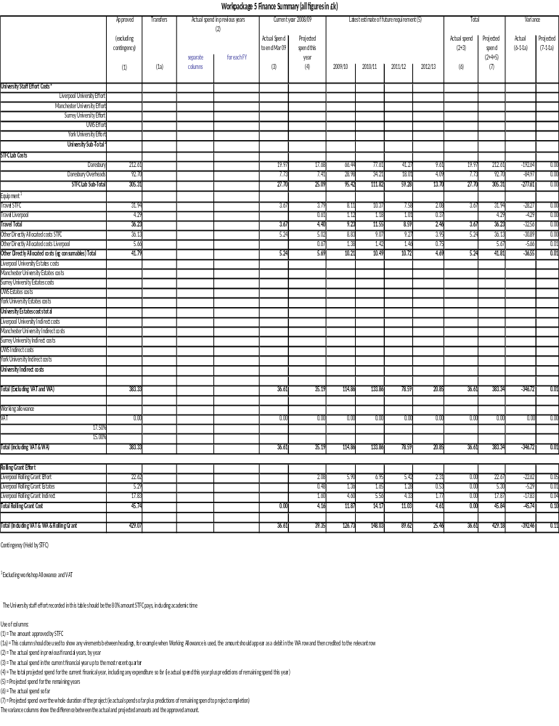

7(e) v. Resource usage: Work Package 5

Table of staff %age FTE

WP5
NAME | INSTITUTE | % FTE 2008/09 | % FTE 2009/10 | % FTE 2010/11 | % FTE 2011/12 | % FTE 2012/13 | Total Effort | Effort Remaining
P Coleman-Smith | Daresbury | 0.058 | 0.333 | 0.383 | 0.183 | 0.042 | 1.000 | 0.942
I Lazarus | Daresbury | 0.058 | 0.298 | 0.358 | 0.183 | 0.042 | 0.940 | 0.882
VHDL Engineer | Daresbury | 0.058 | 0.304 | 0.374 | 0.180 | 0.033 | 0.950 | 0.892
V Pucknell | Daresbury | 0.128 | 0.214 | 0.122 | 0.025 | 0.000 | 0.490 | 0.362
S Letts | Daresbury | 0.000 | 0.000 | 0.093 | 0.063 | 0.125 | 0.042 | 0.042
J Thornhill | Liverpool | 0.025 | 0.065 | 0.065 | 0.050 | 0.025 | 0.230 | 0.205
D Wells | Liverpool | 0.025 | 0.075 | 0.100 | 0.075 | 0.025 | 0.300 | 0.275

7(e) vi. Milestones: Work Package 5

Table 1: Milestones achieved in the last six months
Milestone No. | Work Package | Milestone | Target Date | Status

Table 2: Milestones due in the next six months
Milestone no. | Work Package | Milestone | Target Date
M5.1 | WP5 | Agree detailed design specs for upgraded digitisers | 4 Dec 09
M5.2 | WP5 | Funding agreed for first batch of digitisers | 30 Jun 09

Table 3: Overall Milestone List
Mile-stone No. | Work Package | Milestone | As at June 09 | Delay due to |  | Affects Critical Path? | See Note
 |  |  |  | UK? | Other Collaborators? | Affects Critical Path? | See Note
M5.1 | WP5 | Agree detailed design specs for upgraded digitisers | 4 Dec 09
M5.2 | WP5 | Funding agreed for first batch of digitisers | 30 Jun 09
M5.3 | WP5 | Deliver 6 digitisers to original design | 5 Jan 10
M5.4 | WP5 | Design of prototype upgraded digitiser complete | 9 Dec 10
M5.5 | WP5 | Tests of prototype upgraded digitiser complete | 13 June 11
M5.6 | WP5 | Start phased delivery of upgraded digitisers | 12 Sep 11
M5.7 | WP5 | Complete phased delivery of upgraded digitisers | 17 Sep 12

7(e) vii. Gantt chart: Work Package 5

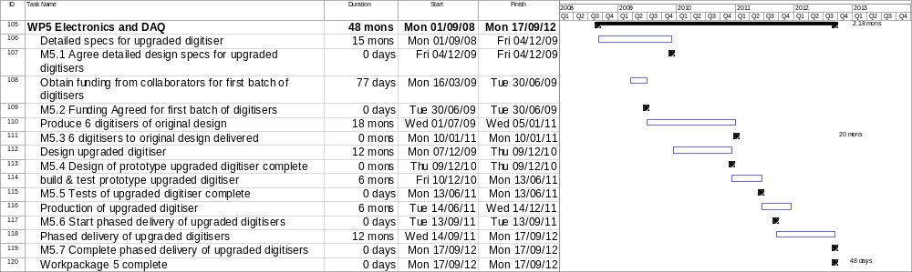

7(f) Work Package 6 Mechanical design

Leader: Mr J. Strachan – STFC Daresbury Laboratory

Institutes: STFC Daresbury Laboratory and Liverpool

7(f) i. Description of the work package

Background: The UK mechanical design team at Daresbury, Liverpool, and Manchester has provided and will continue to provide mechanical-engineering and design support to the experimental UK nuclear-physics community. Through the use of advanced 3D-modelling techniques and FEA software, they have been able to design highly-complex structures for supporting arrays of radiation detectors for photons, charged particles, and neutrons. This team is co-ordinated and led by the Daresbury mechanical engineer who is involved in the design meetings with the other collaborators and has a vital role to liaise with the host laboratory. The team comprises of skilled and experienced 3D-CAD design engineers who carry out the detailed design work typically requiring several tonnes of detectors with the individual elements to be positioned to an accuracy of a millimetre. They also have responsibility for the design of many ancillary-detector systems. This team is world class and has designed almost all the large gamma-ray spectrometers currently in use in Europe, as well as many specialised charged-particle and neutron-detector systems. The work is carried out in close collaboration with the physicists who provide the scientific lead in the projects.

All of the mechanical-design work to date for AGATA has been performed by the UK. This is mostly the work performed during the previous grant. This has included the following tasks.
- The conceptual design of the 180-detector geometry. This involved converting the geometry from the simulation packages into the 3D CAD design package and then including all the mechanical-design constraints.
- The design of the detector module. This involved collaboration with the commercial suppliers of the capsules and cryostats.
- The design support structure for the Demonstrator array at Legnaro.
- The design of the support of the array on the platform of PRISMA. This involved using part of the sub-structure previously designed in the UK.
- The design of associated items including, table-top detector mounting systems, layout of the liquid-nitrogen distribution system, layout of front-end electronics (the digitisers, Work Package 5).
- Finite-element analysis calculations.
- Co-ordination of the procurement of all parts by INFN (Legnaro).
- Commissioning and inspection of key mechanical components.
- Providing leadership of the AGATA mechanical-design team.

The design of the AGATA mechanical structure for Legnaro is complete. The mechanical structure was manufactured in Italy. The UK mechanical-design team provided expertise in inspection of the key mechanical parts (detector-support flanges and cryostats) by visiting Legnaro and Köln and using a Coordinate Measuring Machine (CMM). The mechanical team also assisted in assembly of the support structure using a laser tracker to ensure key tolerances were met during the present grant The full responsibility for all mechanical parts of AGATA rests with the UK mechanical engineer.

Tasks: The UK will provide the mechanical design for installation of AGATA at the next two host sites - GANIL and GSI. At GANIL it is envisaged that AGATA will be coupled to the EXOGAM gamma-ray spectrometer and the VAMOS recoil spectrometer. The UK designed all the mechanical structure of EXOGAM and the front-end of the VAMOS spectrometer. At GSI, AGATA will be located at a focal point of the Fragment Recoil Separator, where the RISING gamma-ray spectrometer is currently located. The UK designed all the versions of the RISING spectrometer. Therefore, again the UK has all the necessary expertise to perform the mechanical design task. Indeed, the UK is currently the only country that can perform this work in the collaboration. The tasks for both set-ups will include conceptual design, detailed CAD design, FEA analysis, procurement co-ordination, trial assembly in the UK (Daresbury), commissioning, and project co-ordination. In addition to the mechanical design the physicists in the UK collaboration will participate strongly in the overall conceptual design of both set-ups to determine the optimum detector arrangements.

Justification: The mechanical-design tasks are essential for the science exploitation of AGATA. Each facility has its own mechanical constraints and specific designs are required to couple to the host laboratory beam lines and existing spectrometers. In all laboratories existing AGATA mechanical parts will be used as appropriate, for example the detector-support flanges will be reused and transported between laboratories. At whichever host laboratory is decided upon following Legnaro, a new support structure for AGATA will be required. Technical support is required at Daresbury for the trial assembly of both frames before shipment and installation at the host sites. Since manufacture of the components will either be in UK universities or by UK industry, trial assembly in the UK is the most cost effective method of delivering a fully-operational system.

Outputs:
- Conceptual design drawings.
- Mechanical specification controlled using the STFC ISO9000 project-management system.
- General arrangement drawings.
- Mechanical-design drawings for the manufacture of components.
- Project documentation, specification, design reviews, FEA documentation.
- Project plans.

Costs: The costs are mostly for the mechanical-design effort. This design work will be performed by Griffiths (Daresbury) and Seddon (Liverpool) and the overall project-management and mechanical-engineering work by Strachan (Daresbury). The design work at both host sites is estimated to take 10 months design work plus 3 months of mechanical-engineering effort. It should be noted that the full mechanical design work for the AGATA Demonstrator, including the conceptual design for the full 180-detector array has taken ~3FTE. The team (Strachan and Griffiths) are also responsible for providing ongoing advice and help to the set-up at Legnaro. This is estimated as 1.5 months effort over the period until the end of 2009. Technical effort is also required for the survey of the mechanical parts. This will be provided by Austin and Palin (Daresbury) requiring 1 month per set-up. Technical effort of 2 months per set-up is required for assemble in the UK and installation at the host laboratory. Workshop effort is required in the University of Liverpool. A facility charge was awarded for the workshop based on nine month’s effort.

There will also be travel costs associated with meetings. The UK mechanical-design team meets quarterly and the AGATA mechanical-design team meets overseas, twice per year.

The UK has been successful in bidding for costs associated with the mechanics at both the host laboratories. The UK was awarded £50k for first set-up and £45k for the second set-up. Other costs associated with the mechanics will be provided by other countries in the AGATA collaboration. It is the responsibility of the wider AGATA collaborations to ensure all the costs are covered.

7(f) ii. Commentary on the activities to date

Since the beginning of the Grant two main tasks have been pursued.
- Layout work to investigate how the AGATA array may be installed at GANIL
- Support for AGATA at Legnaro.

In addition the first interactions with GSI personnel have taken place in case the array is located at GSI first (before GANIL).

Layout work for AGATA at GANIL

Initially, it was intended that the host laboratory for the next physics campaign (after Legnaro) was to be GANIL. Based on this intention, preliminary layout schemes were produced showing the AGATA array mounted on the VAMOS platform and incorporating the EXOGAM array, this is the first image of Figure 7(f)1. Studies were made to examine the combination of AGATA and EXOGAM-Clover-type detectors and to investigate how the detectors would be optimally arranged with between five and eight AGATA triple clusters. The centre image in Figure 7(f)1 shows that with five AGATA triple clusters, eight EXOGAM Clovers can used at with the array positioned 130mm from the target. If eight AGATA triple clusters are installed, the array has to be positioned at 234mm from the target if 8 EXOGAM clovers are also required. When it was confirmed that GANIL would not be able to host AGATA during the Phase 1 timescales work on this layout was halted.

This work was performed by GANIL staff in close collaboration with the UK who produced all the previous mechanical design.

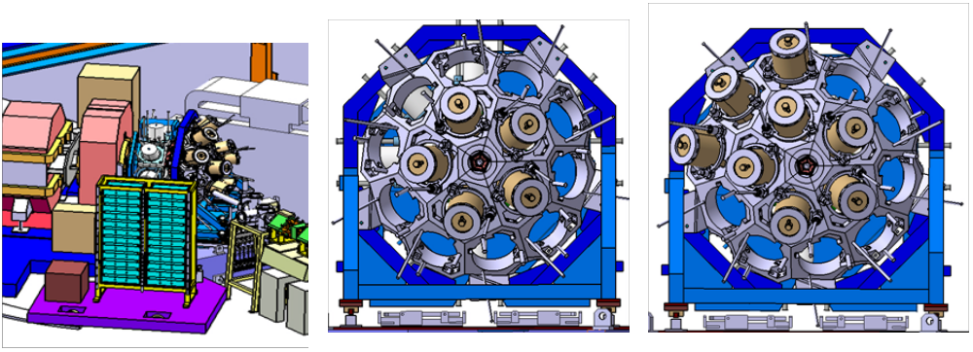
Figure 7(f) 1 Left: AGATA with EXOGAM at the target position of the VAMOS spectrometer. Centre: AGATA with 8 ATCs plus 8 Clovers of EXOGAM at 130mm
from the target. Right: AGATA with 8 ATCs at 130 mm plus 13 Clovers
of EXOGAM (5 at 130mm and 8 at 234mm) (right).

Support at Legnaro

At the beginning of the grant it had been shown that a single detector could be mounted successfully in the array. However, the mounting of multiple detectors had not been attempted. During this work, two detectors have been mounted side-by-side in the array and the UK led these trials. In order to ensure that the detectors can be mounted accurately in the array a setting jig was designed in the UK and procured. When it was attempted to align a detector in the setting jig, shown in Figure 7(f) 2, it was noticed that the detector did not come into contact with the jig squarely, this prevented the used of the alignment fixture in setting the detector. In detail the detector moved transversely by ~1mm during the stage of final positioning.

In the grant period, Finite Element Analysis was undertaken by the UK to determine the cause of the problem and a replacement threaded rod was designed, manufactured, and tested. This has since been tested in Legnaro by the UK team. It was found that the problem was considerably reduced such that the alignment fixture can be used to set the detectors, however further studies need to be taken to eliminate the problem completely. The image on the left of figure 7(f) 2 shows the shaped plates of the alignment fixture which reflect the position of the detector when it is correctly located. The image on the right of figure 7(f) 2 shows the detector in the jig with feeler gauges being used to position the detector to within 0.1mm of its design location.
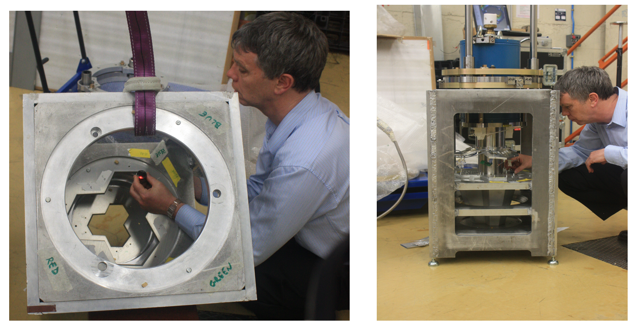

Figure 7(f) 2 The detector setting jig being employed by J. Palin (Daresbury) at Legnaro National Laboratory.

A dummy detector and a working detector were aligned in turn in the fixture, and these were installed in the detector-array support structure. Then, the distances between the two end-caps were measured using feeler gauges, the gap measured is shown in the image on the left of figure 7(f) 3. The design distance of the gap is 0.5mm. This exercise was repeated with the detector moved to a second location in the structure and the gaps again measured. The gap at the front was found to be between 0.55 and 0.85mm, the gap at the rear between 0.15 and 0.5mm. A laser tracker was then used to confirm that the detector was in its correct location with reference to the support structure and target point. The laser tracker is shown measuring an endcap through the support structure in the image on the right image of figure 7(f) 3.
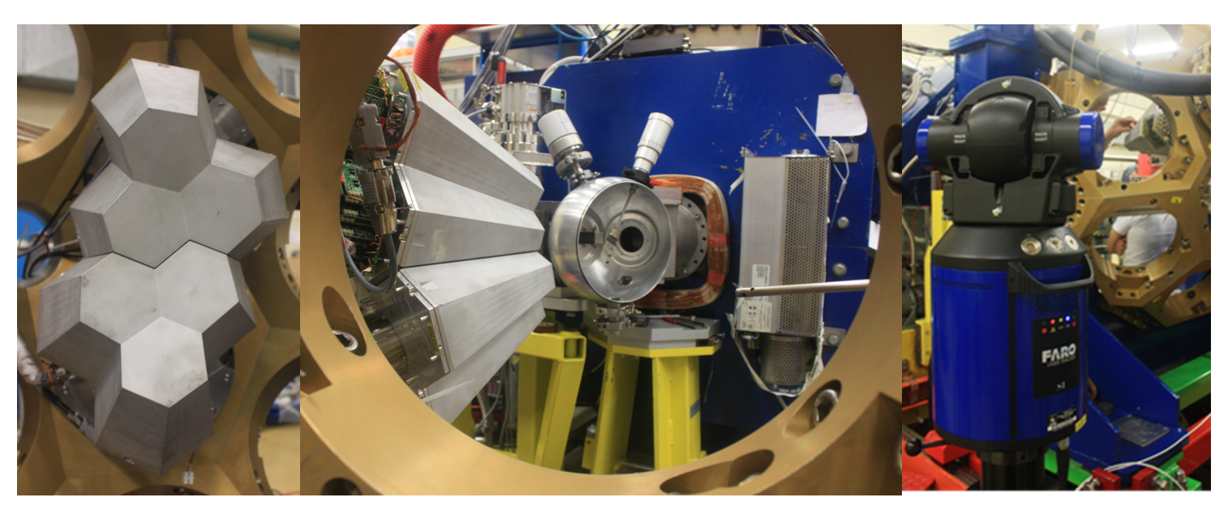
Figure 7(f) 3 Detectors in the support structure at Legnaro.

This proved that the alignment jig can be used to position the detectors so that when they are installed in the support structure they are at their design location.

A procedure for installation of the triple clusters was proposed by the UK mechanical engineer. This is suitable for the installation of the ~70kg detectors for the Demonstrator set-up in Legnaro where the number of detectors is limited. A different procedure will be incorporated into the design of the arrays when the number of detectors has increased.

7(f) iii. Programme of work for next 6 months

It is expected that during July 2009 a decision will be taken as to which laboratory will be the next host for AGATA. When this decision is taken work will be required to establish a detailed mechanical specification for the support structure. This should be completed in the next period and design work based on the specification will be underway.

Further work will be undertaken to resolve the issue of the detector moving slightly when moving into its final position in the support structure. This will include further FEA to investigate possible deflections within the support rings.
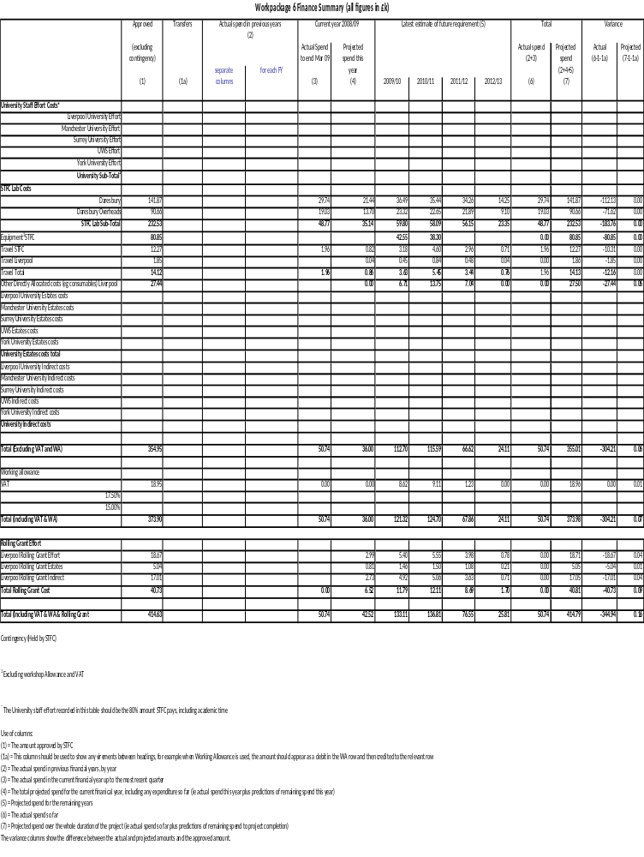
7(f) iv. Financial statement: Work Package 6

7(f) v. Resource usage: Work Package 6

Table of staff %age FTE

WP6
NAME | INSTITUTE | % FTE 2008/09 | % FTE 2009/10 | % FTE 2010/11 | % FTE 2011/12 | % FTE 2012/13 | Total Effort | Effort Remaining
J Strachan | Daresbury | 0.222 | 0.240 | 0.233 | 0.207 | 0.058 | 0.960 | 0.738
R Griffiths | Daresbury | 0.245 | 0.420 | 0.420 | 0.367 | 0.137 | 1.590 | 1.345
A Austin | Daresbury | 0.000 | 0.047 | 0.033 | 0.047 | 0.033 | 0.160 | 0.160
Technician | Daresbury | 0.000 | 0.099 | 0.071 | 0.099 | 0.071 | 0.340 | 0.340
D Seddon | Liverpool | 0.085 | 0.150 | 0.150 | 0.105 | 0.020 | 0.510 | 0.425

7(f) vi. Milestones: Work Package 6

Table 1: Milestones achieved in the last six months
Milestone No. | Work Package | Milestone | Target Date | Status

Table 2: Milestones due in the next six months
Milestone no. | Work Package | Milestone | Target Date
M6.1 | WP6 | Agree design spec for next host lab | 22 Oct 09

Table 3: Overall Milestone List
Mile-stone No. | Work Package | Milestone | As at June 09 | Delay due to |  | Affects Critical Path? | See Note
 |  |  |  | UK? | Other Collaborators? | Affects Critical Path? | See Note
M6.1 | WP6 | Agree design spec for next host lab | 22 Oct 09
M6.2 | WP6 | Design of support structure for next host lab complete | 26 Aug 10
M6.3 | WP6 | Support structure installed at next host lab | 30 Mar 11
M6.4 | WP6 | Agree design spec for subsequent host lab | 28 Feb 11
M6.5 | WP6 | Design of support structure for subsequent host lab complete | 02 Jan 12
M6.6 | WP6 | Support structure installed at subsequent host lab | 04 Sep 12

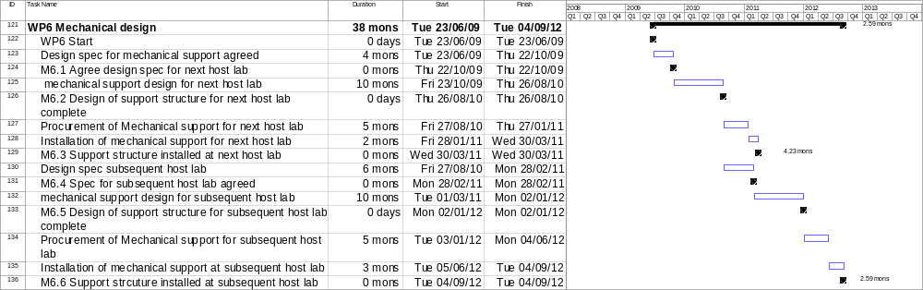
7(f) vii. Gantt chart: Work Package 6

7(g) Work Package 7 Project management

Leader: Prof. P. J. Nolan – University of Liverpool

Institutes: Liverpool and STFC Daresbury Laboratory

7(g) i. Description of the work package

Background
AGATA is a large international collaboration consisting of over 40 European institutes in 10 countries. The collaboration has a well-organised management structure which is defined by a Memorandum of Understanding (MoU) signed by all of those involved, as discussed in Section 4.

The UK will play its role in this management. In addition there is a UK management structure which has a number of roles. These include: (i) the management of the project funded by the UK research council; (ii) liaison between all of those in the UK working on the project to ensure delivery of the UK responsibilities; (iii) that the UK has an agreed policy; (iv) management of the UK part of any EU funding awarded to the project; and (v) the dissemination of information to the UK community concerning AGATA developments.

Current status
The research and development phase of AGATA (the Demonstrator) has been governed by an MoU which has now ended. The project is now operating under a new MoU. The new MoU proposes a modified management structure as AGATA will be deployed at a number of different European laboratories and there will be a group at each laboratory with operational responsibility. During the current reporting period the international management has continued to follow the format of the research and development MoU.

The UK management structure will develop depending on what funds are awarded by STFC and the UK responsibilities in the project.

Tasks
The AGATA management will have the following committees.

- The AGATA Collaboration Council (ACC), representing the nuclear-physics community collaborating in the project.
- The AGATA Steering Committee (ASC), representing the AGATA resources (funding agencies), and responsible for the science policy of the collaboration and the project management.
- The AGATA Management Board (AMB), responsible for the execution of the project along the lines defined by the ASC.

The AGATA Collaboration Council will meet once per year and will be open to all collaborators.

7(g) ii. Commentary on the activities to date

The ASC has met three times since the start of this grant: November 2008 in Orsay France, March 2009 in Legnaro, and June 2009 in Stockholm. Prof. Paul Nolan became Chair of the ASC in April 2009; he holds this role for two years.

The AMB has met 4 times since September 2008. The minutes of these meeting provide an up-to-date record of the overall status of the project. Approved minutes are available at http://npg.dl.ac.uk/AGATA/AMBMinutes/index.html

The AMB has also held 9 phone conferences in-between the face-to-face meetings.

The technical implementation of AGATA is the responsibility of the Project Leader and the Management Board. Prof. J. Simpson is the Project Leader; he runs the Management Board and chairs the AMB meeting and phone conferences.

The Working Groups have various team leaders associated with the tasks being carried out as detailed in Section 5. Currently the UK has three team leaders: Lazarus leading the Pre-processing Electronics team, A. Boston leading Detector Characterisation team, and Strachan leading Mechanical Design team.

Following the announcement of the current grant, a local UK AGATA Management Committee was set-up. The membership includes each WP leader, principal Investigator (PI), when not already represented, plus the Project Spokesperson, Technical Co-ordinator and Project Manager.

The current membership is as follows.

Paul Nolan University of Liverpool, Project Spokesperson,
WP7 leader, WP8 leader, PI Liverpool
John Simpson STFC Daresbury Laboratory,
Technical Coordinator, PI Daresbury
Andy Boston University of Liverpool, WP1 leader
Dave Cullen University of Manchester, WP2 leader, PI Manchester
Robert Wadsworth University of York, WP3 leader, PI York
John Smith University of the West of Scotland, WP4 leader, PI UWS
Ian Lazarus STFC Daresbury Laboratory, WP5 leader
John Strachan STFC Daresbury Laboratory,
WP6 leader, acting project manager
Mike Cordwell STFC Daresbury Laboratory, deputy project manager
Zsolt Podolyak University of Surrey, PI Surrey

The UK AGATA management committee has met four times since the start of the project; November 2008 at Daresbury, January 2009 at Surrey, March 2009 at York and June 2009 in Liverpool. The committee will continue to meet a three month intervals. Approved minutes are available at
http://npg.dl.ac.uk/AGATA/UK_Management/index.html

The UK has appointed John Smith (UWS) to be the overall co-ordinator of UK physicist effort in the operation of AGATA in Legnaro.

The UK held a “kick-off” meeting for the new project at Daresbury Laboratory on 3rd March 2009. This meeting summarised the status of the project, the roles of the UK in the wider collaboration, and the tasks of the current grant. The meeting was open to all working on the project in the UK including the PDRAs and research students.
The talks from the “kick off” meeting are available from
http://npg.dl.ac.uk/NPG/Meetings/UK_Agata_Meeting_Mar09/

7(g) iii. Programme of work for the next 6 months

The new MoU requires the establishment of a new international management structure. This will be discussed at the ASC meeting in June. Regular, quarterly, meetings of the UK Management Committee will continue.

7(g) iv. Financial statement: Work Package 7
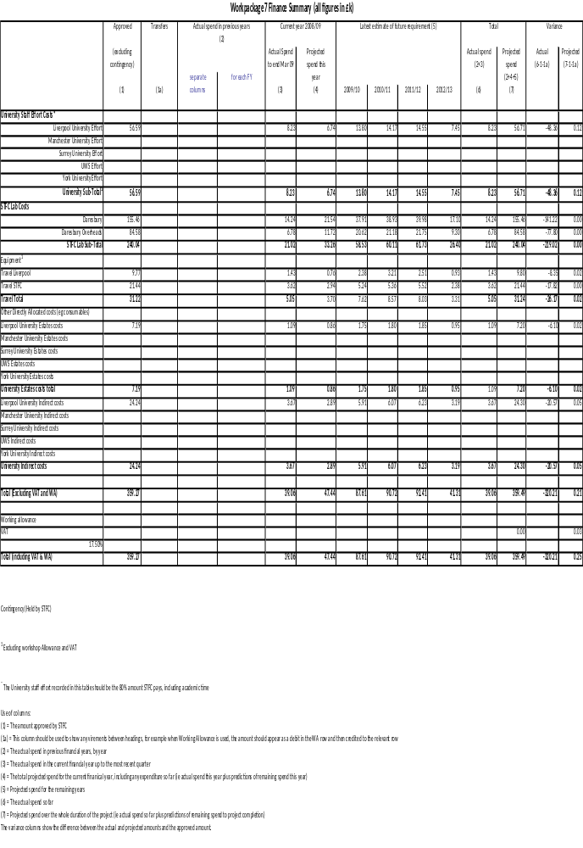
7(g) v. Resource usage: Work Package 7

Table of staff %age FTE

WP7
NAME | INSTITUTE | % FTE 2008/09 | % FTE 2009/10 | % FTE 2010/11 | % FTE 2011/12 | % FTE 2012/13 | Total Effort | Effort Remaining
J Simpson | Daresbury | 0.110 | 0.189 | 0.189 | 0.189 | 0.079 | 0.756 | 0.646
Project Manager | Daresbury | 0.292 | 0.500 | 0.500 | 0.500 | 0.208 | 2.000 | 1.708
P Nolan | Liverpool | 0.090 | 0.180 | 0.180 | 0.180 | 0.090 | 0.720 | 0.630

7(g) vi. Milestones: Work Package 7

Table 1: Milestones achieved in the last six months
Milestone No. | Work Package | Milestone | Target Date | Status
M7.1 | WP7 | Agree UK Membership of AGATA collaboration meeting | 1 Sept 08 | Complete
M7.2 | WP7 | Establish UK management structure | 30 Sept 08 | Complete
M7.3 | WP7 | 1st Meeting of UK Management group | Nov 08 | Complete
M7.4 | WP7 | 2nd Meeting of UK Management group | Jan 09 | Complete
M7.5 | WP7 | 3rd Meeting of UK Management group | March 09 | Complete
M7.6 | WP7 | 4th Meeting of UK Management group | June09 | Complete

Table 2: Milestones due in the next six months
Milestone no. | Work Package | Milestone | Target Date
M7.7 | WP7 | 5th Meeting of UK Management group | Sep 09
M7.8 | WP7 | 6th Meeting of UK Management group | Jan10

Table 3: Overall Milestone List
Mile-stone No. | Work Package | Milestone | As at June 09 | Delay due to |  | Affects Critical Path? | See Note
 |  |  |  | UK? | Other Collaborators? | Affects Critical Path? | See Note
M7.1 | WP7 | Agree UK Membership of AGATA collaboration meeting | 1 Sept 08
M7.2 | WP7 | Establish UK management structure | 30 Sept 08
M7.3 | WP7 | 1st Meeting of UK Management group | Nov 08
M7.4 | WP7 | 2nd Meeting of UK Management group | Jan 09
M7.5 | WP7 | 3rd Meeting of UK Management group | March 09
M7.6 | WP7 | 4th Meeting of UK Management group | June 09
M7.7 | WP7 | 5th Meeting of UK Management group | Sep 09
M7.8 | WP7 | 6th Meeting of UK Management group | Jan10
M7.9 | WP7 | 7th Meeting of UK Management group | March 10
M7.10 | WP7 | 8th Meeting of UK Management group | June 10
M7.11 | WP7 | 9th Meeting of UK Management group | Sep 10
M7.12 | WP7 | 10th Meeting of UK Management group | Jan11
M7.13 | WP7 | 11th Meeting of UK Management group | March 11
M7.14 | WP7 | 12th Meeting of UK Management group | June 11
M7.15 | WP7 | 13th Meeting of UK Management group | Sep 11
M7.16 | WP7 | 14th Meeting of UK Management group | Jan 12
M7.17 | WP7 | 15th Meeting of UK Management group | March 12
M7.18 | WP7 | 16th Meeting of UK Management group | June 12

7(h) Work Package 8 Equipment procurement and running costs

Leader: Prof. P. J. Nolan – University of Liverpool

Institutes: Liverpool and STFC Daresbury Laboratory

7(h) i. Description of the work package

Background and Current status
In its first phase, AGATA has developed all of the equipment (detectors and electronics etc.) needed for the project. During the first phase, the UK funded ~20% of the capital spend of £5M, this is equivalent to approximately three detector capsules and associated equipment including development costs. In the current phase corresponding to the present grant award more detectors need to be bought in order to achieve the aim of 1π operation by 2011. Once AGATA becomes operational towards the end of 2009 running costs (common fund) will be needed.

Tasks
The UK will fund three detector capsules and associated equipment during this grant plus running costs. The spend can be divided into three areas: (i) detector capsules, cryostats and cables; (ii) electronics; and (iii) running costs. There needs to be close co-operation with the AGATA community on the details of what is purchased and the timing.

7(h) ii. Commentary on the activities to date

The specification of the detector capsules has been agreed with the collaboration and three detector capsules were ordered from Canberra France in March 2009. Delivery is expected to start in August 2010. The delivery will follow detector capsules ordered by other members of the collaboration. Work has started on defining the specification of the triple cryostat, for these detector capsules against which an order can be placed.

Work has started with the AGATA Management Board and electronics experts in the collaboration to define the plan to provide electronics AGATA over the next few years. This will cover how many modules of the current design to build (and the timescale) plus a discussion of any upgrades needed to the present design to ensure they can still be built over the next five years.

The AGATA Steering Committee and AGATA Management Board have agreed the running costs and their split for the next few years. The running costs will be reviewed annually. This is managed by the AGATA Project Manager and the local AGATA campaign manager. In 2009 the budget for AGATA running has been agreed by the AGATA Steering Committee. In a paper submitted in March 2009 by E. Farnea and J. Simpson the UK agreed to contribute 20.5k€ in 2009. These funds will be used by Daresbury Laboratory and the University of Liverpool for a range of items including, shipping costs, mechanical repairs, parts, and consumables for the detector laboratory.

7(h) iii. Programme of work for the next 6 months

- Agree the specification of the triple cryostat and place an order.
- Agree a plan with the collaboration and place the first electronics order.

Note on the financial statement

The detector modules were ordered with a stage payment plan. This is 20% on supply of, and agreement to, engineering drawings, 50% on evidence that germanium crystals of appropriate quality have been procured, and 30% on detector-module delivery. This agreement resulted in an 8% reduction in the price. Since the grant was originally costed the exchange rate has changed significantly. The costings were done with a rate of 1.43 €/£, the order was placed at 1.11 € /£. This is partially offset by the reduction in VAT during 2009 (15% cf. 17.5%). An expected call on the working allowance of £160k was agreed by the office before the order was placed.

7(h) iv. Financial statement: Work Package 8

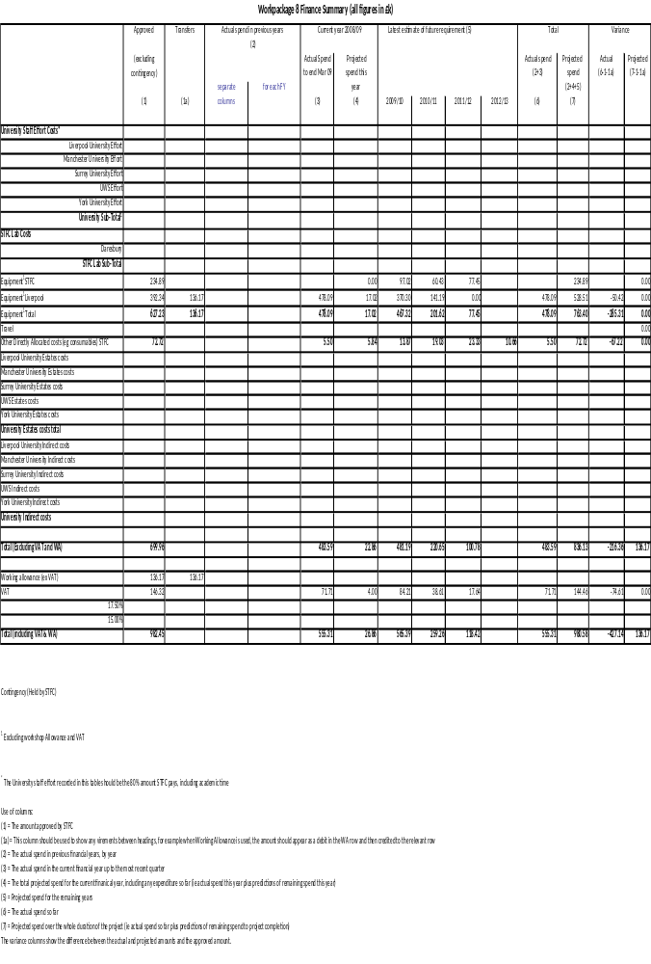

7(h) v. Milestones: Work Package 8

Table 1: Milestones achieved in the last six months
Milestone No. | Work Package | Milestone | Target Date | Status
M8.1 | WP8 | Order AGATA detector capsules | 3 March 09 | Complete
M8.2 | WP8 | Agree running costs with collaboration | 3 March 09 | Complete
M8.3 | WP8 | Payment of first running cost instalment | 3 March 09 | Complete
M8.4 | WP8 | First payment (20%) for detector capsules | 4 May 09 | Complete

Table 2: Milestones due in the next six months
Milestone no. | Work Package | Milestone | Target Date
M8.5 | WP8 | Order triple cryostat and electronics modules | 3 July 09

Table 3: Overall Milestone List
Mile-stone No. | Work Package | Milestone | As at June 09 | Delay due to |  | Affects Critical Path? | See Note
 |  |  |  | UK? | Other Collaborators? | Affects Critical Path? | See Note
M8.1 | WP8 | Order AGATA detector capsules | 3 March 09
M8.2 | WP8 | Agree running costs with collaboration | 3 March 09
M8.3 | WP8 | Payment of first running cost instalment | 3 March 09
M8.4 | WP8 | First payment (20%) for detector capsules | 4 May 09
M8.5 | WP8 | Order triple cryostat and digitiser modules | 3 July 09
M8.6 | WP8 | Make second payment for detector capsules | 5 Oct 10
M8.7 | WP8 | First deliveries of digitiser expected | 8 Apr 10
M8.8 | WP8 | Payment of second running cost instalment | 15 Mar 10
M8.9 | WP8 | Delivery of triple cryostat | 8 July 10
M8.10 | WP8 | Delivery of detectors starts | 9 Aug 10
M8.11 | WP8 | Delivery of detectors complete | 10 Jan 11
M8.12 | WP8 | Order second batch of digitisers | 13 June 11
M8.13 | WP8 | Third running costs instalment | 1 Mar 11
M8.14 | WP8 | Fourth running costs instalment | 15 Mar 12

7(h) vi. Gantt Chart Work Package 8

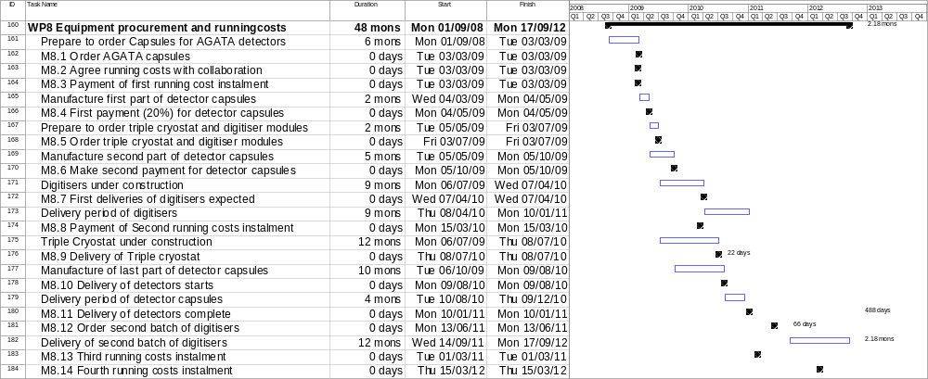

8 Financial statement, whole project
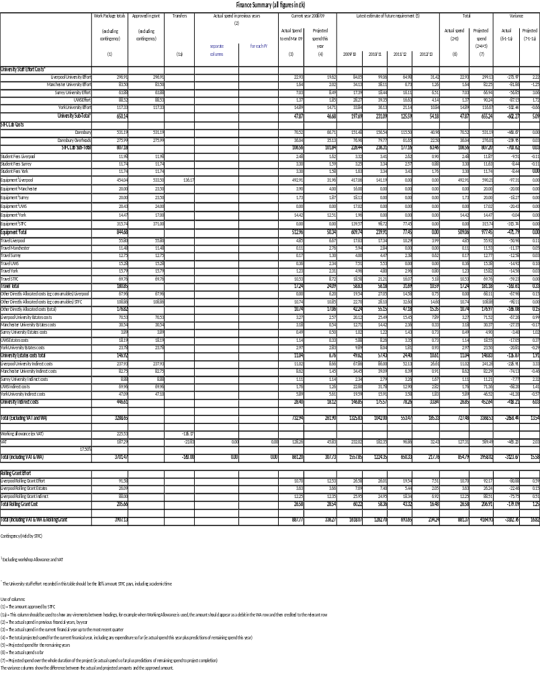

9 Overall project plan
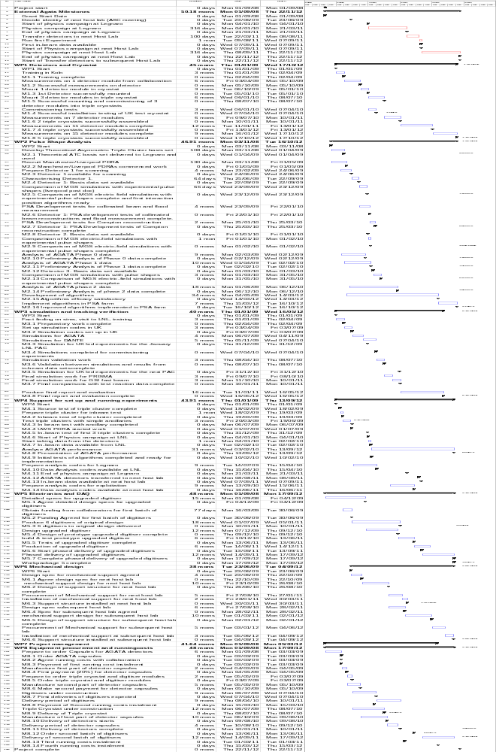
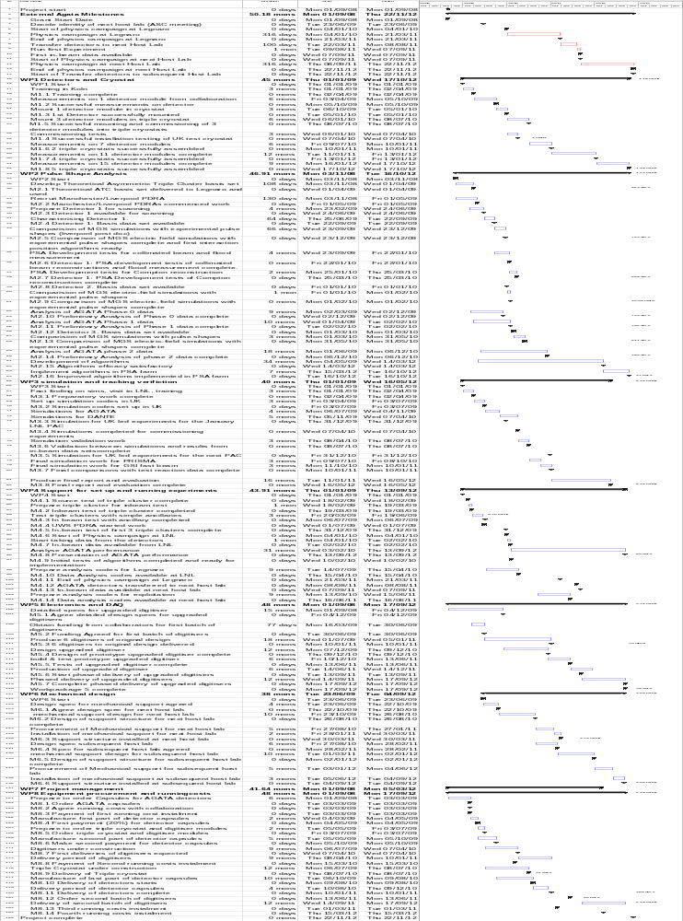

10 Risk register

Ref WP1 | Cost | Risk Description | Potential Impact on Project | Inherent Risk Score |  |  | Existing Controls | Mitigating  factors | Residual risk score |  |  | Comment | Risk owner | Risk closed date | Cost  (£k) | Schedule Impact  (Mons) | Contingency working allowance
 |  |  |  | L | I | LxI | Existing Controls | Mitigating  factors | L | I | LxI
1.1 | £472k | Ge delivery | Delay of assembly | 3 | 2 | 6 | Retain money | Investigate second supplier | 3 | 2 | 6 |  | Nolan | 12/12 | 0 | 6 | 0
1.2 |  | Ge failure | Effort for re-testing | 2 | 2 | 4 | Realistic specification | Allow time in programme | 2 | 1 | 2 |  | H. Boston | 12/12 | 0 | 7 | 0
1.3 |  | Cryostat failure | Reassembly | 2 | 2 | 4 | Skilled staff | Allow time in programme | 2 | 1 | 2 |  | H. Boston | 12/12 | 300 | 2 | 30

Ref WP2 | Cost | Risk Description | Potential Impact on Project | Inherent Risk Score |  |  | Existing Controls | Mitigating  factors | Residual risk score |  |  | Comment | Risk owner | Risk closed date | Cost  (£k) | Schedule Impact  (Mons) | Contingency working allowance
 |  |  |  | L | I | LxI | Existing Controls | Mitigating  factors | L | I | LxI
2.1 | £245k | LN failure | Detector failure | 1 | 2 | 2 | Safety shutdown | Operating procedures and training | 1 | 2 | 2 |  | H. Boston | 12/12 | 16 | 2 | 2
2.2 |  | Electronics  failure | No data collection | 1 | 2 | 2 | Use is a clean environment | Spare channels | 1 | 2 | 2 |  | Lazarus | 12/12 | 20 | 3 | 2
2.3 |  | Delay of beam time | Delay in in-beam test | 1 | 2 | 2 | Rescheduling | Negotiate priority beam time | 1 | 2 | 2 |  | AGATA project manager Simpson | 12/12 | 4 | 3 | 1
2.4 |  | Delay of components for demonstrator | No data to be analysed | 3 | 2 | 6 | Regular review | Reschedule availability of parts and allow time in programme | 2 | 2 | 4 |  | AGATA project manager Simpson | 12/09 | 0 | 6 | 0
2.5 |  | PS Analysis skills deficient | No personnel to analyse data | 2 | 2 | 4 | Ensue wide advertising of positions | Re-advertise or approach suitable candidates | 1 | 2 | 2 |  | University PI’s | 12/09 | 10 | 4 | 2
2.6 |  | Failure of detector Pre Amps | Delay as there are currently no spares | 3 | 2 | 6 | Skilled Staff | Procure spare pre-amps | 3 | 1 | 3 |  | H Boston | 12/09 | 2 | 2 | 0

Ref WP3 | Cost | Risk Description | Potential Impact on Project | Inherent Risk Score |  |  | Existing Controls | Mitigating  factors | Residual risk score |  |  | Comment | Risk owner | Risk closed date | Cost  (£k) | Schedule Impact  (Mons) | Contingency working allowance
 |  |  |  | L | I | LxI | Existing Controls | Mitigating  factors | L | I | LxI
3.1 | £284k | Availability of nuclear physicists with necessary skills | Delay in modelling and data analysis | 1 | 2 | 2 | Tailored adverts widely circulated | Re-advertise position or approach suitable candidates | 1 | 2 | 2 |  | University PI’s | 12/12 | 10 | 4 | 1.5
3.2 |  | Delay in data from WP2 for verification | Delay in verification of simulated and real data | 2 | 3 | 6 | Continuation of simulations | Close liaison with WP2 | 1 | 3 | 3 |  | AGATA project manager Simpson | 07/09 | 0 | 3 | 0

Ref WP4 | Cost | Risk Description | Potential Impact on Project | Inherent Risk Score |  |  | Existing Controls | Mitigating  factors | Residual risk score |  |  | Comment | Risk owner | Risk closed date | Cost  (£k) | Schedule Impact  (Mons) | Contingency working allowance
 |  |  |  | L | I | LxI | Existing Controls | Mitigating  factors | L | I | LxI
4.1 | £633k | Manpower availability | Delay in work | 1 | 2 | 2 | Make a plan | Arrange well in advance | 1 | 2 | 1 |  | Nolan | 12/12 | 10 | 4 | 1.5
4.2 |  | Availability of experts from AGATA community | Delay in work | 2 | 3 | 6 | Agree schedule | Make project plan well in advance | 1 | 3 | 3 |  | AGATA project manager Simpson | 12/12 | 0 | 6 | 0
4.3 |  | Beam delivery failure | Delay in data collection and analysis | 1 | 3 | 3 | Liaise with host laboratory | Negotiate priority  beam time | 1 | 2 | 2 |  | Host laboratory | 12/12 | 4 | 3 | 1
4.4 |  | Laboratory infrastructure | No beam and/or failure of detectors | 1 | 2 | 2 | Appoint host laboratory coordinator | Make a plan with host laboratory | 1 | 1 | 1 |  | Host laboratory | 12/12 | 4 | 3 | 1

Ref WP5 | Cost | Risk Description | Potential Impact on Project | Inherent Risk Score |  |  | Existing Controls | Mitigating  factors | Residual risk score |  |  | Comment | Risk owner | Risk closed date | Cost  (£k) | Schedule Impact  (Mons) | Contingency working allowance
 |  |  |  | L | I | LxI | Existing Controls | Mitigating  factors | L | I | LxI
5.5 | £429k | Sourcing digitiser components | Delay in completion | 2 | 2 | 4 | Be aware of the situation | Procure as early as possible | 1 | 2 | 2 |  | Lazarus | 12/11 | 0 | 3 | 0
5.6 |  | Obsolete electronics | Delay in completion | 3 | 2 | 6 | Procure as early as possible | Investigate specialist broker for supply | 2 | 2 | 4 |  | Lazarus | 12/11 | 5 | 3 | 1.5
5.7 |  | Delay in recruitment of VHDL expert | Significant delay in the electronics | 3 | 3 | 9 | Plan use of this expertise in advance | Investigate availability of additional expertise in the collaboration | 3 | 3 | 9 |  | Lazarus | 12/09 | 0 | 6 | 0
5.8 |  | Unable to fill VHDL post | Significant delay in the electronics | 1 | 3 | 3 | Recruit as early as possible | Investigate availability of additional expertise in the collaboration | 1 | 3 | 3 |  | Lazarus | 12/09 | 0 | 6 | 0
5.9 |  | Unable to fill VHDL post or find effort in the collaboration | Significant delay in the electronics | 1 | 3 | 3 | Investigate availability of additional expertise in the collaboration | Use contractor | 1 | 3 | 3 |  | Lazarus | 12/09 | 100 | 3 | 10

Ref WP6 | Cost | Risk Description | Potential Impact on Project | Inherent Risk Score |  |  | Existing Controls | Mitigating  factors | Residual risk score |  |  | Comment | Risk owner | Risk closed date | Cost  (£k) | Schedule Impact  (Mons) | Contingency working allowance
 |  |  |  | L | I | LxI | Existing Controls | Mitigating  factors | L | I | LxI
6.1 | £415k | Availability of designer  /engineer | Delay in design | 1 | 2 | 2 | Plan in advance | Use other STFC or external sources | 1 | 2 | 2 |  | Simpson | 12/11 | 100 | 3 | 10
6.2 |  | Delays in component delivery | Delay in availability | 2 | 2 | 4 | Order in sufficient time | Have more than one source | 1 | 2 | 2 |  | Simpson | 12/11 | 30 | 3 | 6
6.3 |  | Skilled workshop availability | Delay in availability | 2 | 2 | 2 | Plan in advance | Investigate alternative supplier | 1 | 2 | 2 |  | Simpson | 12/11 | 50 | 3 | 5

Ref WP7 | Cost | Risk Description | Potential Impact on Project | Inherent Risk Score |  |  | Existing Controls | Mitigating  factors | Residual risk score |  |  | Comment | Risk owner | Risk closed date | Cost  (£k) | Schedule Impact  (Mons) | Contingency working allowance
 |  |  |  | L | I | LxI | Existing Controls | Mitigating  factors | L | I | LxI
7.1 | £359k | Management  ineffective | Project inefficiently run | 1 | 2 | 2 | Ensure meeting take place ass scheduled to monitor all aspects of the project | Replace leaders | 1 | 2 | 2 |  | Nolan | 12/12 | 0 | 4 | 0
7.2 |  | Collaboration breakdown | Insufficient expertise or resources for the project | 1 | 1 | 1 | Regular management meetings | Look for new collaborators | 1 | 1 | 1 |  | AGATA Steering committee | 12/12 | 0 | 12 | 0
7.3 |  | Countries not being able to secure their funding | Efficiency and effectiveness drops | 2 | 2 | 4 | Revise plan in light of resources | Agree physics priority in line with resources available | 2 | 2 | 4 |  | AGATA Steering committee | 04/11 | 0 | 12 | 0

Ref WP8 | Cost | Risk Description | Potential Impact on Project | Inherent Risk Score |  |  | Existing Controls | Mitigating  factors | Residual risk score |  |  | Comment | Risk owner | Risk closed date | Cost  (£k) | Schedule Impact  (Mons) | Contingency working allowance
 |  |  |  | L | I | LxI | Existing Controls | Mitigating  factors | L | I | LxI
8.1 | £982k | Under estimation running costs | Insufficient funds for operation of AGATA | 2 | 2 | 4 | Plan based on past experience | Review regularly, keep contingency | 2 | 2 | 4 |  | Nolan | 12/12 | 40 | 0 | 12
8.2 |  | Failure of Ge detectors out of warranty | Efficiency and effectiveness drops | 1 | 3 | 3 | Only allow detectors to be handled by experts | Ensure well trained staff | 1 | 3 | 3 |  | AGATA project manager Simpson | 12/12 | 320 | 12 | 32
8.3 |  | Increase in raw Ge costs | Insufficient funds | 2 | 2 | 4 | Place orders as soon as possible | Investigate alternative suppliers | 2 | 2 | 4 |  | AGATA project manager  Simpson | 12/12 | 120 | 0 | 24
8.4 |  | Failure of electronics | Efficiency and effectiveness drops | 2 | 3 | 6 | Purchase additional electronics | Use additional electronics | 2 | 3 | 6 |  | Nolan | 12/12 | 555 | 9 | 55
8.5 |  | Only one Ge supplier | Price increase and delay from manufacturer | 3 | 4 | 12 | Place orders well in advance, obtain fixed price quote | Encourage alternative supplier | 3 | 4 | 12 |  | Nolan | 04/12 | 120 | 9 | 48
8.6 |  | Computing and PSA | Insufficient for effective operation | 2 | 3 | 6 | Monitor computing power as AGATA builds up | Plan for additional  computing power if needed | 1 | 3 | 6 |  | Nolan | 06/10 | 80 | 2 | 20

11 Publications and conference presentations

Publications

- Performance of an AGATA asymmetric detector
A.J. Boston, M.R. Dimmock, C. Unsworth, H.C. Boston, R.J. Cooper,
A.N. Grint, L.J. Harkness, I.H. Lazarus, M. Jones, P.J. Nolan,
D.C. Oxley, J. Simpson, M. Slee, and the AGATA collaboration
Nuclear Instruments and Methods in Physics Research, A604 (2009) 48
doi:10.1016/j.nima.2009.01.228

- Position resolution of the prototype AGATA triple-cluster detector from an in-beam experiment
F. Recchia, D. Bazzacco, E. Farnea, A. Gadea, R. Venturelli, T. Beck,
P. Bednarczyk, A. Buerge, A. Dewald, M. Dimmock, G. Duchêne,
J. Eberth, T. Faul, J. Gerl, R. Gernhaeuser, K. Hauschild, A. Holler,
P. Jones, W. Korten, Th. Kröll, R. Krücken, N. Kurz, J. Ljungvall,
S. Lunari, P. Maierbeck, D. Mengoni, J. Nyberg, L. Nelson,
G. Pascovici, P. Reiter, H. Schaffner, M. Schlarb, T. Steinhardt,
O. Thelen, C.A. Ur, J.J. Valiente-Dobon, and D. Weißhaar
Nuclear Instruments and Methods in Physics Research, A604 (2009) 555
doi:10.1016/j.nima.2009.02.042

- The position sensitivity of an AGATA prototype detector
M. Dimmock, A.J. Boston, H.C. Boston, J.R. Cresswell, L. Nelson, P.J. Nolan, C, Unsworth, I. Lazarus, and J. Simpson
IEEE TNS in press June 2009

- Coincidence analysis of an AGATA symmetric detector
M. Dimmock, A.J. Boston, H.C. Boston, J.R. Cresswell, L. Nelson, P.J. Nolan, C, Unsworth, I. Lazarus, and J. Simpson
IEEE TNS in press June 2009

Conference presentations
- AGATA detector source and first in-beam test at Legnaro
Ryan Kempley (University of Surrey)
IOP Nuclear Physics Conference, 6-8th April 2009, Birmingham

- Characterisation of an asymmetric AGATA detector
Carl Unsworth (University of Liverpool)
IOP Nuclear Physics Conference, 6-8th April 2009, Birmingham

- Microscopic investigations of the proton sub-shell Closure at Z=74 and Tri-axial neutron magic number at N=116 using deep-inelastic collisions with AGATA and PRISMA and Neutron-rich nuclei in the vicinity of ²⁰⁸Pb
Paddy Regan (University of Surrey)
AGATA Physics Workshop, Legnaro National Laboratory,
18th-20th May 2009

- Rigid ground-state rotation
James Ollier (STFC Daresbury Laboratory)
AGATA Physics Workshop, Legnaro National Laboratory,
18th-20th May 2009

- Evolution of shell structure and intruder states in neutron-rich sd-fp shell nuclei
Ricardo Orlandi (University of the West of Scotland)
AGATA Physics Workshop, Legnaro National Laboratory,
18th-20th May 2009

- Talks at the UK AGATA meeting 3rd March 2009
Paul Nolan (Liverpool) UK AGATA Project
John Simpson (Daresbury) AGATA status
Marc Labiche (Daresbury) AGATA Simulation overview
Andy Boston (Liverpool) Detector characterization
Ian Lazarus (Daresbury) Electronics
Carl Unsworth (Liverpool) C001 Characterization measurements at Liverpool
The talks from this meeting can be found at: http://npg.dl.ac.uk/NPG/Meetings/UK_Agata_Meeting_Mar09/

